Virunga Lesson Cycle
Callanan Middle School
Patterson

(W) Means on website
Underline what should be said to the class
If there is a blue word click on it while holding down “ctrl”

Habitat Preservation
7.17 Explain how and why individuals, governments, and other groups, bring about positive change in the world.
SS.7.27 Analyze how Iowa is helping bring about meaningful change in the world.

The purpose of this lesson cycle is for students to examine how rangers in the Virunga National Park bring about positive change in the Congo. Teams investigate dangers facing mountain gorillas and the environment. Students will raise awareness by creating a social media campaign by focusing on Iowans can bring about positive change.

Section | Link
Intro to VNP | Link
VNP Documentary | Link
Life After Virunga | Link
Go Fund Me | Link
Assessment | Link

Intro to VNP Home Next

Success Criteria

Each student will summarize the history of the Virunga National Park.
As a class, we will read the article titled Virunga National Park (VNP) History. Each student will write a summary that makes a claim, uses evidence, and explains that evidence. Have another student check and sign that your paragraph has these three parts. When you are finished, place your paper into the black bin.

Day 1
Opening Discussion –
Virunga Trailer - Link  Virunga Article/Discussion Question  - page, 3  Visuals– Claim, Evidence, Explanation  What is the Virunga National Park? What has been happening in the Virunga National Park? | Resources/Materials/Extension  Virunga High School Article (W)  Extension: Link

Virunga National Park History – Class Copy

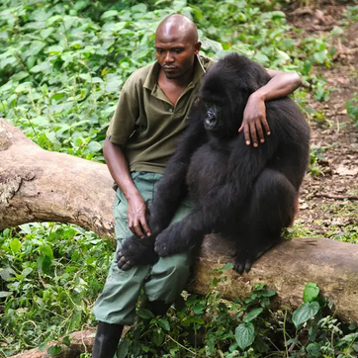
Virunga National Park is one of the most protected areas on the planet. There are many different types of animals and plants that live in the park. The park contains two of the world’s most active volcanoes. For much of its long history, though, Virunga National Park has been severely threatened by armed fighting. Thanks to the work of the park’s rangers and police officers, Virunga has been able to survive. Certain African leaders, the European Union, conservationists, philanthropists, and private donors have also played an important role in Virunga’s survival.

The park was founded in 1925 by King Albert 1st of Belgium and originally known as Albert National Park. Virunga was the first national park on the continent of Africa. The park was founded primarily to protect the mountain gorillas living in the forests of the Virunga that were controlled by the Belgian Congo. Later, Virunga was expanded north to include the Rwindi Plains, Lake Edward, and the Rwenzori Mountains.

In the first 35 years, poaching (illegal hunting) was kept to a minimum and sustainable tourism (people vacationing) became popular due to the work of a large body of handpicked Congolese rangers and dedicated police officers. People buying land and using the park’s resources, such as fishing and hunting by the local population, became an ever-growing problem.

When the Belgians granted Congo independence in 1960, the new country went through a time period where there was a lot of fighting. It wasn’t until 1969 when Congo’s President Mobutu began to take a personal interest in protecting nature that the park reestablished. In the process, it was renamed Virunga National Park and the first Congolese Wildlife Authority (ICCN) was established. The ICCN is still in charge of Congo’s protected areas to this day.

Things went well for Virunga for the better part of the 1970s. Countries outside of the Congo loaned (gave) money to improve the park’s roads and buildings. Virunga became a popular destination (place) for people on vacation. During this time period, Virunga welcomed an average of 6,500 visitors per year.

In the mid-1980s the Mobutu government began to lose its hold on power and the country began a long slide into chaos and war. Virunga suffered terribly. Hunters killed many of the park’s large animals, roads and buildings were destroyed, and many rangers were killed. The ICCN slowly lost control of Virunga.

Over the twenty-five years that followed, the ICCN has had a really tough time. Some of things that they had to go through were people running away from war, destruction of the forest for farm land, and creation of rebel groups. The Kivu War, the most recent of Congo’s conflicts, happened in the park itself, with rebel forces even controlling the park headquarters and kicking out the park’s staff. By the end of 2008, it seemed as if Virunga National Park was finished.

The political situation in the DRC has dramatically improved since then. The park is back in the hands of the ICCN and is enjoying a comeback. Countries and people are giving money to build schools, road, and hospitals in the area. Virunga’s leaders are smart and capable, and morale (attitude) among the rangers is at an all-time high.

VNP Documentary Previous Home Next

Success Criteria

As a class, watch the Virunga documentary to learn about the dangers facing the gorillas and the park rangers. In your team, discuss the relationship between the protagonist (good guys) and the antagonists (bad guys) in the documentary. Each student will write a reflection that shares your thoughts about the documentary so far. When you are finished, place your paper into the black bin.

Day 2
Opening Discussion – Difference between documentary and movie, speaking French due to cultural diffusion
Netflix Virunga Documentary  Day 1 0 - 40 minutes  -page 5, documentary reflection | Resources/Materials/Extension

Virunga Documentary on Netflix
Time | Reason to Skip
2:45-4:00 | Black and white photo of severed hand, faraway shots of dead bodies
11:45-13:10 | Dead gorilla killed by poachers, not graphic
57:30 -58:41 | Dead Elephant, graphic, skip for everyone
102:00-106:00 | Excessive cursing, skip for everyone
125:30 | Boy with bandage

Day 1 of Documentary  1-30 minutes  50-57 minutes | Day 2 of Documentary  57:00-102:00 minutes  106:00-End

Day 3
Opening Discussion – Why would rebels want to kill the gorillas? (Have students discuss why the rangers wouldn’t have anything to protect.) Why don’t the filmmakers fight back? (They are.)
Netflix Student Sheet Needed  Day 2, 55 -1:40 minutes  -page 5, documentary reflection | Resources/Materials/Extension

Name: Block: Teacher:
Virunga Documentary
Write a three-sentence summary of what you watched today. (Write three sentences about what happened in the documentary.)

_____________________________________________________________________________________________________________________________________________________________________________________________________________________________________________________________________________________________________________

Choose one of the following to write about:
- Do you like the documentary so far? Explain.
- Ask a question about something you don’t understand.
- Predict or say what you think is going to happen next.
_____________________________________________________________________________________________________________________________________________________________________________________________________________________________________________________________________________________________________________

Name:

Block: Central Idea of Cartoon

Teacher:

Directions: Carefully examine the political cartoon in front of you. Circle the parts of the cartoon that you looked at to help you understand its meaning, then number the circles to show the reader your thinking.

Topic | 2 | 3 | 4
Summary of Source | Demonstrates the ability to identify evidence from a source. | Demonstrates the ability to describe specific evidence and determine the main idea of a source by providing an accurate summary. | Demonstrates the ability to analyze the importance of the source as related to the concepts.

1. Identify the central idea of the cartoon. Hints: think about what the title for this source could be or think about what you would search on Google to find this source on the internet. One sentence maximum.
______________________________________________________________________________________________________________________________________________________________________________

2. What details does the author provide to develop the central idea of this cartoon? How do these details help “prove” the authors point/central idea? Provide text/picture evidence in your response.
____________________________________________________________________________________________________________________________________________________________________________________________________________________________________________________________________________________________________________________________________________________________

3. What does this cartoon have to do with Virunga National Park and other challenges facing African countries that have been recently decolonized?
________________________________________________________________________________________________________________________________________________________________________________________________________________________________________
____________________________________________________________________________________________________________________

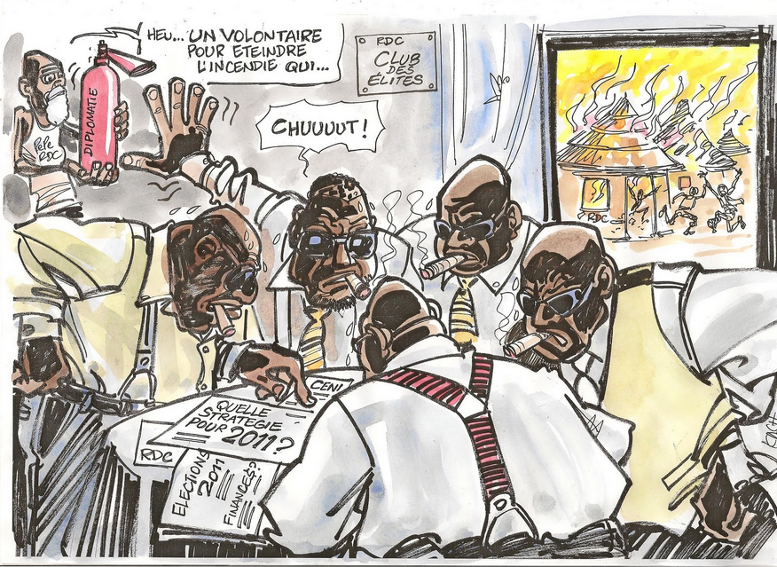
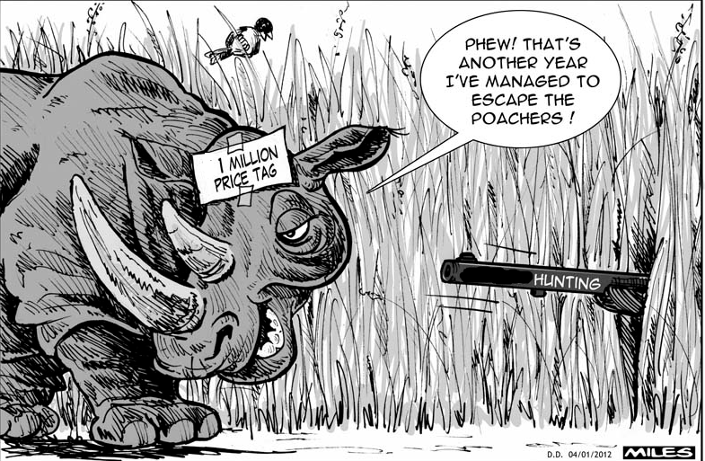
Hunters
Hunters Andrew Patterson
Literacy and Assessment Personal Narrative
EDUC 275

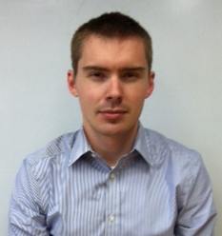

My name is Andrew Patterson. I am currently a teacher for Des Moines Public Schools. For the past four years, I have been teaching at Callanan Middle School. The current course that I teach is called Global Studies. In Global Studies, we learn about people, places, and environments in different regions of the world with an emphasis on Africa, Asia, and Oceania. Students review how to use maps and other geographic tools to acquire, process, and synthesize information. In each unit of study, we examine a region’s characteristics, history, and culture so as to better understand the world in which we live.

I’m originally from Omaha, Nebraska. My affection for Nebraska football has been replaced by a love of U.S. soccer over the last couple of years. Both of these interests provide plenty of heartache and disappointment that sustain me throughout the cold Iowa winter.

I believe that your favorite books provide a glimpse of who you truly are. My favorite books include An Autobiography of Malcolm X as Told to Alex Haley, Master and the Margarita, and 1984. I’m currently reading a novel called Station 11. It is really well written and I would recommend it to anyone who needs a distraction from…

Exit Slip

What key idea relative to literacy assessment that was new to you?

A key idea relative to literacy assessment that was new to me how the author in a rather nonchalant way stated that several things that I have been previously taught about literacy assessment were no longer true. For example, the whole concept of how “children are classified as either visual or auditory learns” has been found repeatedly as not valid.

Teachers are regularly encouraged to assume nothing. I will need to take use that mindset when reading the Assessment for Reading Instruction textbook. Long held beliefs and experiences that I have are apparently wrong.

What is one important key consideration relation to assessment that you want to remember?

An important key consideration that I want to remember is that “assessment is the first step in addressing the most urgent needs of our developing learners.” From experience, the hard part making sure that I follow through and use the data collected to help traditionally marginalized students.

What questions do you have?

It took me a considerable amount of time to read the first two chapters of Assessment for Reading Instruction. This was partly due to the writing style but also how the author was throwing out jargon and references that I’ve never encountered before. My questions are, did anyone else find this reading time consuming and have trouble relating to what the author was writing about?

ers

Poster Instructions OLD RESOURCEs
Life After Virunga Previous Home Next

Success Criteria

Teams will investigate if life has improved after Virunga.
As a class, we will create a list of protagonists (good guys) and antagonists (bad guys) in the documentary. As a class, we will come up with guiding research questions. In teams, students will gather specific evidence to determine if life has improved after the documentary.

Day 4
Warm Up – What happened to Emmanuel De’Merode after the documentary was made? Link
There are two versions of the Virunga project. The advanced version is explained in the Virunga PowerPoint.  Pass out a blank colored piece of paper to each student. Have students fold the paper so creates small boxes for them to write notes. See visuals for help. Have both groups start to conduct research about Virunga National Park. Mancala if students start to tire of research after 15 minutes. | Resources/Materials/Extension  John Green Congo - Link  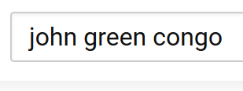  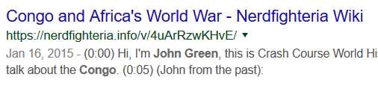

To start of this part of the project, I had students identify the major groups in the documentary and why they would be in the news after the end of filming. Students researched the answers and placed a checkmark next to the question they answer. I then gathered the research and typed up an overview. Students share research and gather high quality pictures.

Example:

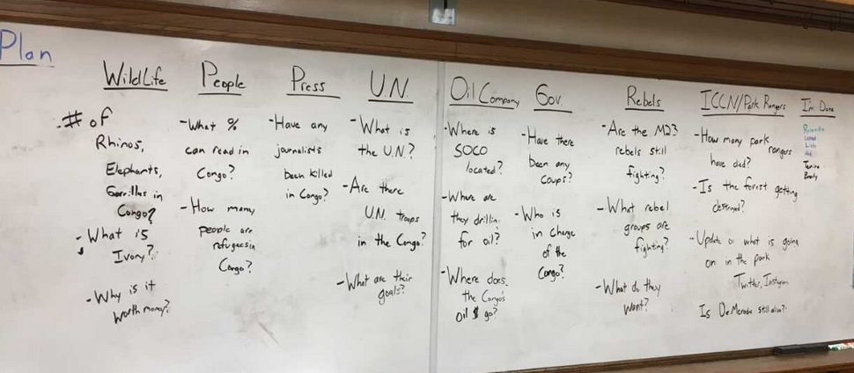

Days 5/6
Warm Up – Have students Google how long in hours it would take to drive from Kinshasa to Virunga.
Have them answer, why do they think that it takes so long to drive? If you were to drive in a car on an interstate in Des Moines, how long would this take you? Why would the Congolese government want to keep its best and loyal troops near the capital?

Why do rebel groups feel safe that they can attack the rangers in the park? Why is this a problem for De Merode?
-Large group create maps of parks, resources, and rebel activity. | Resources/Materials/Extension  -Offer high achievers the high school resource option in visuals  -Examine political cartoon  -John Green Congo video?

High School Option
The rest of the class is going to create a series of maps about the Congo. You can either work on that project or the high school version. If you decide to work on the high school version, create a page in OneNote called Virunga Notes. The main purpose of the assignment is to explore the two-resource provided.
Name:

Block: Class Research: Virunga National Park

Teacher:

ICCN/Park Rangers
How many park rangers have died?

Is Virunga National Park getting destroyed?

What has been happening in the park these last couple of months?

What has happened to De Merode?

Rebels
Are the M23 rebels still fighting the government?

What rebels groups are fighting?

What do they want?

Government
Have there been any recent coup d’états in the Congo?

Who is in charge of the government?

SOCO
Where is SOCO located?

Where are they drilling for oil?

Where does the Congo’s oil $ money go?

Wildlife
# of rhinos, elephants, and gorillas in the Congo.

What is Ivory?

Why is it worth money?

People
What % of people can read in the Congo?

How many people are refugees in the Congo?

Press
Have any journalists been killed in the Congo?

U.N.
What is the U.N.?

Are there U.N. troops in the Congo?

What are their goals?

Name:

Block: Virunga National Park Maps

Teacher:

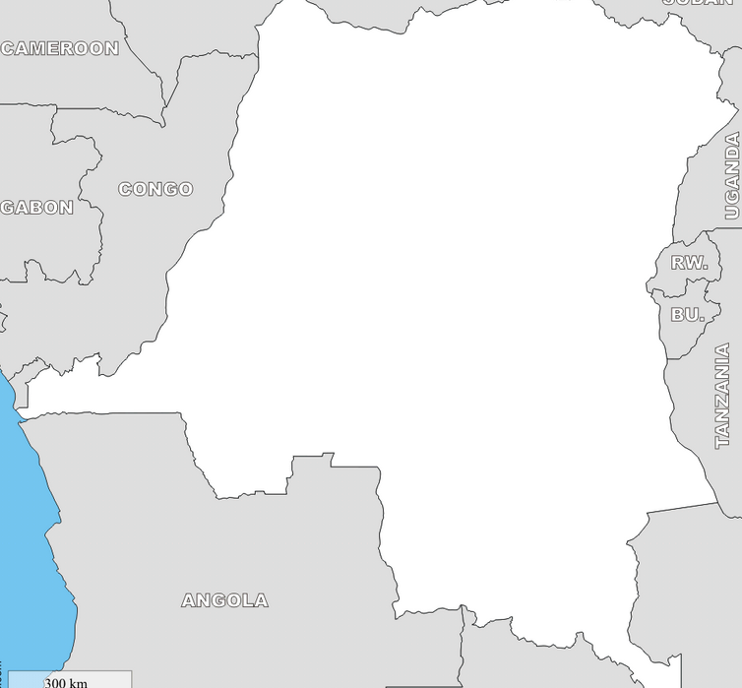
Map of Congo showing…

The colors mean…

Map of Congo showing…

The colors mean…

Map of Congo showing…

The colors mean…
Go Fund Me Previous Home Next

Success Criteria

Step 1: Each student will explain how and why park rangers in the Congo bring about positive change in Virunga National Park. Using either Prezi or PowerPoint online, create a presentation that meets the requirements on the T.V. When you think you are finished, have another student look over your presentation to make sure you met all the requirements

Step 2: Each student will create a GoFundMe campaign to encourage fellow Iowans to assist the park rangers. Create a campaign on the website called GoFundMe. Link your PowerPoint online or Prezi presentation to within your GoFundMe. There is an instruction sheet up front that outlines step by step expectations. When you think you are finished, have another student look over your presentation to make sure you met all the requirements

Day 7
Opening Discussion - Show how to create an online word document. Why is it important to use the waffle and not just save on the computer? Use the snip tool.
Find pictures and save them on word document. Register for Prezi. Students who struggle can use online PowerPoint. Students who struggle even more or lose computer privileges, can make a poster,  -Advanced group can starting creating GoFundMe/Prezi as detailed on page… | Resources/Materials/Extension

Day 8
Opening Discussion – Show how to sign up for Prezi. Why is it important to use your school email when registering for websites?
Create/work on Prezi/PPT/GoFundMe  Prezi Video - Link | Resources/Materials/Extension

Day 9
Opening Discussion – Show part of Joseph Kony 2012. Identify what parts exactly. Why was this video so effective at getting people to try and bring about change?
Create/work on Prezi/PPT | Resources/Materials/Extension

Day 10
Opening Discussion - Why is it important that you share the link in OneNote for our projects?
Finish project, submit via OneNote  Mancala, Sporcle, Bourdain, Bizarre Foods, John Green Extension, see Day 4 | Resources/Materials/Extension  Assessment?

Virunga Fundraising Project – Class Copy
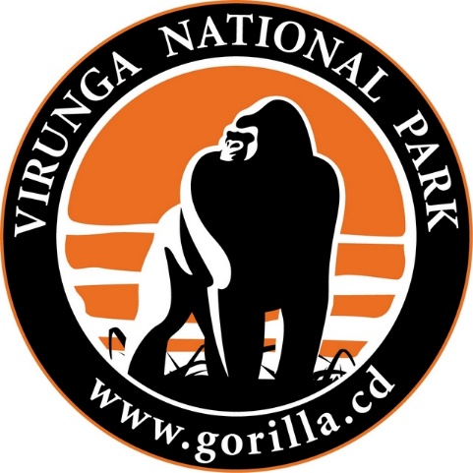
Using your school email, create an account at the website GoFundMe. You will need to register with your actual government information since you’re trying to raise money. Your goal is to raise money for the Virunga National Park. This donation will help buy a new pair of boots for a park ranger.

In the description of your GoFundMe profile, you should provide information about the park, the mission of the park rangers, and the different dangers that face both the gorillas and the rangers. Use your Virunga research and the pictures that you gathered.

Answers to commonly asked questions:
- You may use the school’s postal/zip code, if you want, when registering.
- You can say that the purpose of the fundraiser is to raise money for the animals
- The person receiving the money should be Mr. Patterson. See the back of this sheet for more details.
- Set the fundraiser’s end date to May 15, 2019.
- You should make sure your GoFundMe has information about all three threats facing the park (rebels, poachers, and SOCO). It should also include information that you gathered in your research about why there is fighting in the Congo

Helpful Links
Prezi  www.prezi.com  -trailer that explains what Prezi is and how to make on is: http://bit.ly/1P6ST3K  Virunga Movie Website -  www.virungamovie.com  -this website has excellent photos that you can use for both your Prezi and your GoFundMe account | Virunga Website  https://virunga.org/  -official website of Virunga National Park  WWF Global  http://bit.ly/1jW2rly  -information about mountain gorillas and the dangers facing them

Send your Money to Mr. Patterson/Callanan
Since the Virunga National Park is outside of the United States, you need to link your account/send your money to Callanan. If you don’t do this, your account will be frozen by GoFundMe for suspicious activity. Please copy and paste the below section into the description of your GoFundMe message.
I am currently a student at Callanan Middle School. My teacher, Mr. Patterson, is having us raise money for the Virunga National Park. All money raised by this campaign will be sent to Callanan Middle School. Once all funds have been collected from different campaigns, a lump sum donation will be made to the national park. If you have any questions, please don’t hesitate to contact our teacher, at Andrew.patterson@dmschools.org.
____________________________________________________________________________________
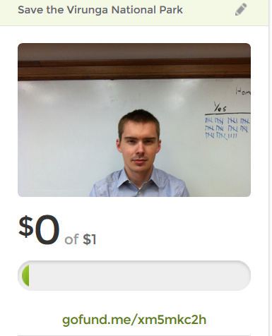
Sharing GoFundMe with Mr. Patterson
When you think you are finished, please reread the requirements and the commonly asked questions. This means you too, Ivan K and Audrey Bissmeyer! Copy and paste the link of your project in an email to Mr. Patterson.

Names:

Block:

What have we been learning about?

How can we at Callanan help? What will this look like?

How is your team going to…

Get Computers? – Mr. Patterson

Get Pencils? – Mr. Patterson

Get Folders? -

Put Away Folders? -

Get Papers? –

When people in your group need help, what can you do instead of waiting for Mr. Patterson?

Do you know how to…?

I’m trying to do this… can you help me?

I think I know the answer, but I was wondering if…?

Did Mr. Patterson want us to…?

What if we…?

Do you know how to…?

I’m trying to do this… can you help me?

I think I know the answer, but I was wondering if…?

Did Mr. Patterson want us to…?

What if we…?

Do you know how to…?

I’m trying to do this… can you help me?

I think I know the answer, but I was wondering if…?

Did Mr. Patterson want us to…?

What if we…?

Do you know how to…?

I’m trying to do this… can you help me?

I think I know the answer, but I was wondering if…?

Did Mr. Patterson want us to…?

What if we…?

Assessment Previous Home

Success Criteria

Each student will explain how and why park rangers in the Congo bring about positive change in Virunga National Park. Students will describe how their project uses credible information that allows fellow Iowans to assist the park rangers. When finished, keep your reflection on your table. You may have computer free time.

Day 11
Opening Discussion – After assessment, make sure to share project.
Virunga Reflection  Page 20-21 | Resources/Materials/Extension  Bourdain, Congo episode

Name:

Block: Virunga Reflection

Teacher:

Goal: Explain how and why park rangers in the Congo bring about positive change in Virunga National Park. Students will create a website that uses credible information that allows fellow Iowans to assist the park rangers.

1. Explain how and why park rangers in the Congo bring about positive change in Virunga National Park. What are they trying to do? What are the dangers that they are facing?
________________________________________________________________________________________________________
____________________________________________________
____________________________________________________
____________________________________________________
____________________________________________________
2. How does your website/project allow people in Iowa to help the park rangers? Why should people in Iowa care about what is happening on the other side of the world when there are unsolved problems in the United States?
____________________________________________________
____________________________________________________
____________________________________________________
____________________________________________________
____________________________________________________
____________________________________________________
____________________________________________________
3. Reread the blue sheet your team worked on. How effective was your team? Was everyone able to accomplish their goal? What is something that you can commit to work on the next time we work in teams?
____________________________________________________
____________________________________________________
____________________________________________________
____________________________________________________
____________________________________________________
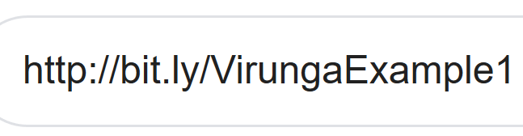
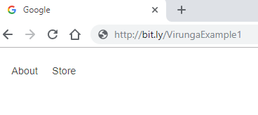

4. Using a computer, go to the example website listed above. Take a couple of moments, look through this website. What makes this website so effective at accomplishing our goal? Compare the website to your GoFundMe. What are some specific changes you should make to your GoFundMe in order to make it more effective? As a group, make those changes.
____________________________________________________
____________________________________________________
____________________________________________________
____________________________________________________
____________________________________________________
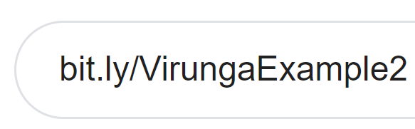
____________________________________________________

5. Using a computer, go to the example website listed above. Take a couple of moments, look through this website. What makes this website so effective at accomplishing their goal? Compare the website to your GoFundMe. What are some specific changes you should make to your GoFundMe in order to make it more effective? As a group, make those changes.
____________________________________________________
____________________________________________________
____________________________________________________
____________________________________________________
____________________________________________________
____________________________________________________
6. Early in our unit about Virunga, we watched part of a documentary on YouTube called Kony 2012. The documentary and the movement have been criticized by some journalists. On a separate piece of paper and using Google/YouTube, identify the main points of criticism and decide for yourself if these arguments are right.

Old Resources

Virunga Lesson Cycle Class Copy
Patterson

You have the option of creating a poster to share what is happening in Virunga National Park or finishing your Nelson Mandela poster. An important change that I need to stress is that each student must work on their own poster. In the past when Mr. Patterson has let more than one student work on a poster, it turns into one person watching the other work. If you started creating a Mandela poster online with Piktochart, Mr. Patterson wants you to start working on the Virunga poster. Also, make sure your poster has name, block and teacher in the bottom right hand corner when it is held vertically.

Virunga Poster Instructions

*If you started working on a Nelson Mandela poster and you only used one side, I would recommend creating your Virunga poster on the other side. If you used both sides or didn’t start a poster, you may grab a new one.

Before you start this step, you should make sure that you have the following things completed:
- Paragraph of what is going in Virunga National Park
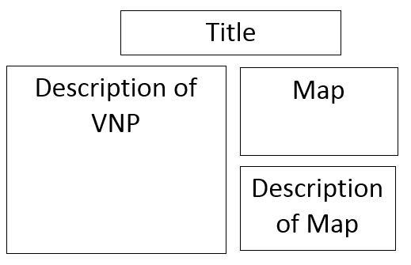
- Physical map of national parks in the Congo, along with a written description of the map
- Thematic map of the Congo showing armed rebels groups, along with a written description of the map

Directions: Create a poster that explains to the viewer what is happening inside Virunga National Park. Your poster should have a title, a description of what is going on in Virunga, a physical or thematic map, along with a description of that map.

Nelson Mandela Poster Instructions

Remember, one person at time is working on a poster. If you decide to work on the Nelson Mandela poster, it means that you’re finishing on that you already started. If you don’t have one started, or if you can’t find yours, start working on the Virunga Poster described above.

In times of trouble countries often have artists create posters that are supposed to inspire a sense of nationalism (pride in your country) when people look at them. In February, Callanan will celebrate black history month. While most students at Callanan would recognize Nelson Mandela, few could explain what he stood for.

Directions: Create a poster that uses the slogan/phrase “We are all Nelson Mandela.” Make sure you use the necessary imagery, and colors that will allow students to make inferences about what kind of person Mandela was. Before you touch any colors, you need to sketch out a rough draft so get everything spaced out.

Old Resource

Class Copy If used, rewrite directions and questions.
Congo and the Great African War
Virunga Project Extension

When the Democratic Republic of the Congo gained its independence, it was soon affected by both conflict and coup d’états. Watch the John Green video on the decolonization of the Congo. After watching the video, you’re going to have to do some research/ investigating on other websites in order to answer the questions below.

John Green Video: http://bit.ly/1S3UdTA

Directions: Answer the following questions on a separate piece of paper. You don’t need to write in complete sentences. Thank you, Mr. Patterson!
- Who was Patrice Lumumba?  - What happened to him?  - Who was responsible for this? | - Did the United States/Europeans sponsor a coup?  - What happened to the Congo during his rule?

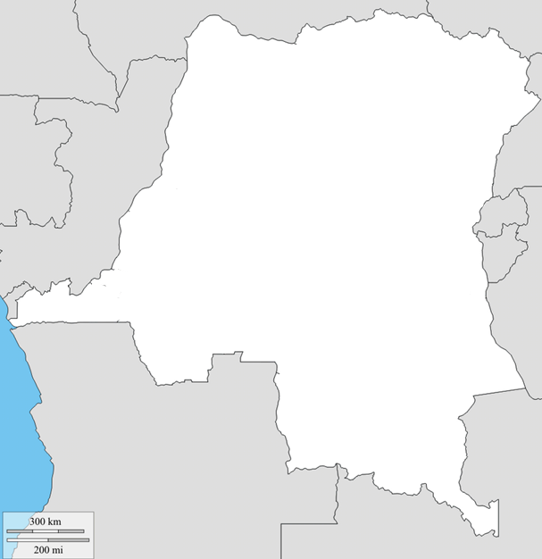
SUDAN
UGANDA
RWANDA
BURNUDI
TANZANIA
C.A.R.
CONGO
ANGOLA
ZAMBIA
Map Key

