Name:

Block: Developed vs. Developing Countries

Teacher:

Part I
Directions: Answer the below questions in complete sentences. If you are struggling to answer the questions for this section you should check your notebook or use the green Global Studies book in the back of the class.

What is a country or state? Pg. 80

What is a developed country (1st world country)? Pg. 76

What is a developing country (3rd world country)? Pg. 77

Part II – Identify Countries
Use Document A and the map on page 138-139 of the green book to list out at least ten countries that fall into each column

Developed Countries | Developing Countries
Part III – Characteristics of Countries
Using Document B and a computer fill in the chart below.

 | America (North America) | Zimbabwe (Africa)
Urbanization
Life expectancy at birth

Total fertility rate per woman

Mother’s mean age at first birth

Literacy
Drinking water total

GDP Per Capitia

GDP – composition by sector

Transnational Issues

Other facts you found interesting

Part IV – Reflection
On a separate piece of paper answer the below questions with your group, these questions are challenging and can’t be answered in one sentence. If possible use what you have learned from other parts of this assignment to help reinforce your stance.

Are there any patterns where the developed and underdeveloped countries are located?
Why do you think that pattern exists?
Do you think that that pattern have ever looked different?
How might your life be different if you lived in a third country?
Developed vs. Developing Countries

Document A
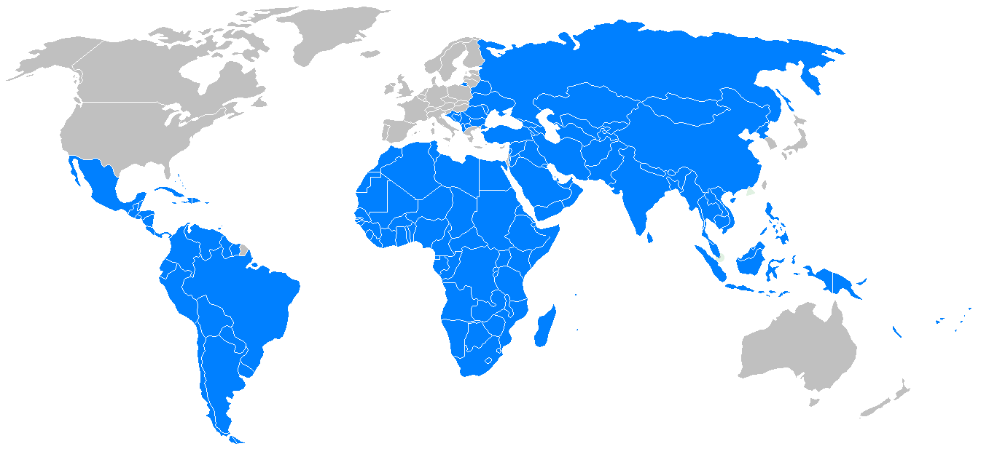

*Before making copies it would be beneficial to mark the regions with patterns so it shows up better on black and white copies. It would also be beneficial to display the map in color if possible. Link

Document B
Follow the directions outlined below. Do NOT ask questions until you have actually tried following the directions.

1. Log on to the computer
2. Click “Ok” to any pop up that comes up.
3. Click on the internet icon
4. Go to Google
5. Type “CIA World Factbook”
6. Click on the top option
7. Use the colored map to get to the correct country page. The United States is a blue country and Zimbabwe is a green country. You will have to read through the information to find what you need.

