True Cost Lesson Cycle
Southeast Asia
Patterson

(W) Means on website
Underline what should be said to the class
If there is a blue word click on it while holding down “ctrl”

Learning Objective
Students will examine the connection between globalization and multinational corporations.

Day 1
Learning Target – I will watch a documentary in order to learn about the hidden cost of globalization (countries working together).

Warm Up – No Warm Up
Netflix True Cost Documentary  -page 2/3 | Resources  Materials  Extension  Times to Skip  57 brief nudity, 1:06 bloody protestor

Day 2
Learning Target – I will watch a documentary in order to learn about the hidden costs of globalization (countries working together).

Warm Up – Using visuals from Southeast Asia vocabulary ppt, define: Globalization with the student. When is globalization a good thing? (When discussing, bring up when it is bad)
Netflix True Cost Documentary  -page 2/3 | Resources  Materials  Extension

Day 3
Learning Target – I will watch a documentary in order to learn about the hidden costs of globalization (countries working together).

Warm Up – No Warm Up
Netflix True Cost Documentary  -page 2/3  True Cost Visuals (W)  -Discuss slides 1 and 2  -page 5, have students start to fill out chart. | Resources  Materials  Extension

Day 4
Learning Target – I will analyze song lyrics to understand the author’s stance (beliefs) on consumerism (people buying things). Or I will gather information to identify trends or patterns in countries that make items found at Callanan.
Warm Up – What message is Mackelmore trying to get across in this video? Link Use the links below and description below.

Or Why did Mr. Patterson have us research these categories?

Origins of Items  -page 5-7, already on OneNote  If you don’t want to use Macklemore idea, you can just focus on the Origins of Items and have students look at Macklemore when finished. OneNote will need to be created:  Students should focus on the second verse:  https://genius.com/Macklemore-and-ryan-lewis-wings-lyrics  Why did I show this to you?  What is Macklemore’s purpose in the song?  What does this have to do with True Cost? | Resources  Materials  Extension  Need questions for what happens when students are done  Possibly start day five with these questions:  Why did Mr. Patterson have us research these categories? Where have we seen them before?  Do you notice any patterns?  Try to steer the conversation to how we know what is good, what country has the highest standard of living. Show Gap Minder, have them collect data on the  Get them to think about countries with the highest standard of living.  Qatar is going to be biased because not all countries have natural resources, look at Lux.  Sign up for Weebly using school email

Day 5 – Optional depending on timing with end of the year
Learning Target – I will

Warm Up – Play this video: https://www.youtube.com/watch?v=RBQ-IoHfimQ What were they trying to get people in Britain to think about? How are they playing with emotions?
Do something advertising and emotions on OneNote  shampoo, try and associate emotions with products, shampoo  https://www.youtube.com/watch?v=ImUpZhR7FAQ  If not, you can sign up for Weebly using your school email. | Resources  Materials  Extension  Students

Name:

Block: True Cost - Documentary

Teacher:

1. What is Lucy Siegle’s job?
____________________________________________________
2. Today, what percentage of clothes are made in America?
____________________________________________________
3. What happened in Dhaka?
____________________________________________________
4. Who does Kate Ball-Young work for?
____________________________________________________
5. How many countries are celebrating the 15th anniversary of fair trade?
____________________________________________________
6. What happened to the woman started a union?
____________________________________________________
7. What plant is used to create the majority of clothes?
____________________________________________________
8. What is the largest seed company in the world?
____________________________________________________
9. What health problems is Dr. Singh tracking in India?
____________________________________________________
____________________________________________________
10. In the last 16 years, how many farmers have committed suicide in India?
____________________________________________________
11. What does successful advertisements do in the United States?
____________________________________________________
12. What is the dirty shadow of the fashion industry?
____________________________________________________
13. How much textile waste does the average American create?
____________________________________________________
14. What company hates the word consumption?
____________________________________________________
15. What are some of the different factors (things) that go in to the true cost of what be buy?
____________________________________________________
16. What does GDP only measure?
____________________________________________________
17. A woman takes us to visit her family. What does she say she wants?
____________________________________________________
____________________________________________________
18. How much money does H&M make a year?
____________________________________________________
19. What do workers in Cambodia want?
____________________________________________________
20. Why do countries keep their wages low?
____________________________________________________
____________________________________________________
21. What do companies say they do in their voluntary code of conduct?
____________________________________________________
____________________________________________________
22. According to the old dude that graduated from Stanford, what can’t be questioned?
____________________________________________________
____________________________________________________
23. Why is the fashion industry in Bangladesh?
____________________________________________________
____________________________________________________
24. Who gave a speech in America that we need to have a revolution of values?
____________________________________________________
____________________________________________________

Name:

Block: Items

Teacher:

Item | Country | Estimated Value | Minimum Wage | Corporate Taxation Rate | Industry % of Econ.
Chair | United States | $28.88 | $7.25 | 35% | 19.4%

Step 1
Directions: Using objects in this room, find items that are made in different countries. Please do not repeat countries, if at all possible. For each time, make sure to fill in the name and country it was made.

Step 2
Directions: Using Google, find out how much the item costs at a local store or online. This is just to provide a rough estimate. You don’t need an exact answer.

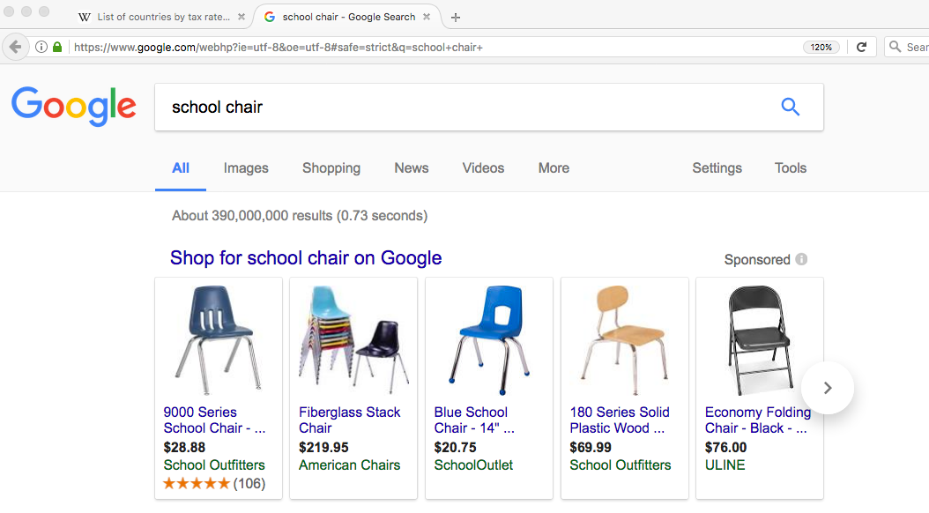

Step 3
Directions: Minimum wage is the lowest amount a company can pay a person to work by hour. Using this website link, find out the minimum wage in each country. You will need to write down the number in this column.

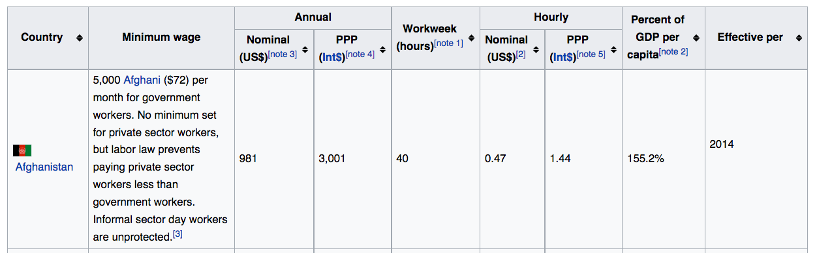

If you don’t know how to use the search trick, watch the first minute of this video: https://youtu.be/COFQ4mU4aok

Step 4
Directions: The corporate taxation rate is how much money a company has to pay a country. You need to write down the number that appears here: Link

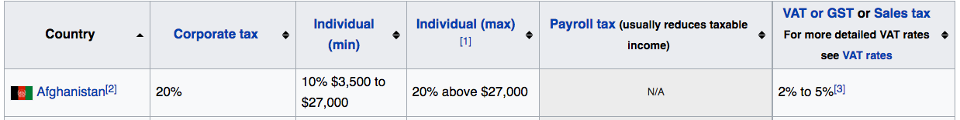

Step 5
Directions: Identify (figure out) how important industry (factories) and making things are the country’s economy. Using CIA World Fact Book link, go to each country’s page and click under the economy section. You need to write down this number:

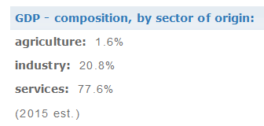

If you are confused how to do this step, start watching this video at 1:15:
https://youtu.be/COFQ4mU4aok

Name:

Block: Driving Questions

Teacher:

Part 1
Directions: Choose one or more of the following questions to respond to. In your writing, include specific examples from the documentary when answering the question.

- In your opinion, are poor working conditions in sweatshops justified because the standard of the country is so low? (Workers choose to work there after all.)
- How does successful advertisement propaganda target our emotions?
- This documentary is called True Cost. Why did they filmmakers choose that name?
- What did Martin Luther King Jr. mean when talked about the need for a “revolution of values?”

“We as a nation must undergo a radical revolution of values. We must rapidly begin … the shift from a thing-oriented society to a person-oriented society. When machines and computers, profit motives and property rights, are considered more important than people, the giant triplets of racism, extreme materialism and militarism are incapable of being conquered.”

- How does the average American contribute to the problems shown in the documentary?

Part 2
Directions: Using a computer, find a political cartoon that relates to both the documentary and what you wrote about for part 1. Copy and paste this cartoon in to a page on OneNote titled True Cost Documents. Add to your writing in for part 1. What point is the cartoon artist trying to make? How does it relate to the documentary we watched?

Here are a potential list of topics to search for that were covered in the documentary:

- Unions  - Cotton  - Consumerism | - Capitalism  - Black Friday  - Fashion | - Organic  - Sweatshops  - Minimum Wage
Part 3
Directions: In the documentary True Cost, the narrator states that successful advertisers connect their product to a buyer’s emotions. Find an advertisement that tries to link an emotion with using their product. This can be a picture or video. Paste a link of to this advertisement in OneNote in the page True Cost Documents. Add to your writing in for part 1 and 2. How does the advertisement connect using their product to an emotion? How can this contribute to the problem in the United States of people buying too much?

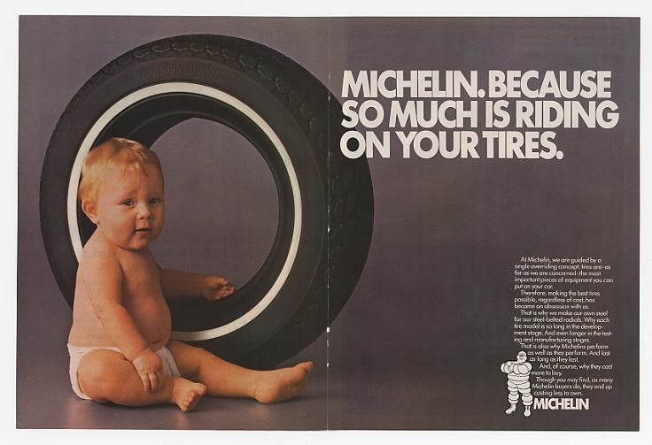

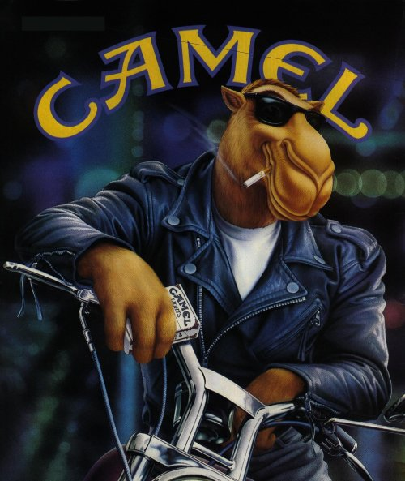
Part 4
Directions: With the sale of cigarettes declining, the tobacco industry decided that they need to change their advertisement strategy. From 1987 – 1999, Joe Camel was used a mascot for a brand of cigarettes that appeared in ads on TV and on in magazines. Using Google, figure out why the government stopped tobacco companies from using Joe Camel.

In your opinion, should the government take steps against advertising that is manipulating? What should these steps be? Make sure you explain your think and reference your research of Joe Camel.

Documentary Musings/Order of Issues
Define sweatshop, at origin of the word
Blood, carrying people to the hospiltal when they mention Daka

Explain the purpose of a union

Explain organic

25 minutes, shift to spray

Worker Conditionings
Cotton, pesticides
Propaganda/Consumerism
Organic Cotton
Pollution, chromium
Sustainable fashain
Minimum wage demands/protests
Voluntary Code of Conduct
Consumer Capitalism, Black Friday

Possibly tie into Flint Michigan

Positive example of Patagonia

Criticism of the documentary, black Friday

35 minutes, students find an advertisement propaganda cars shampoo

Possible day 4 assignment, connect vocabulary words to commericals/consumerism computers needed

Find a political cartoon, connect it to the documentary, label document

