Continents and Oceans Dice Game
Directions: Shortest person playing goes first. Role two dice. Corresponding to the number that is rolled the person needs to say the state and physical feature out loud and write it correctly. After the person says an answer, they pass the dice to their partner. If the person who rolled their dice doesn’t pronounce or spell it correctly, then they don’t write anything. The first person to have their answer sheet filled wins!

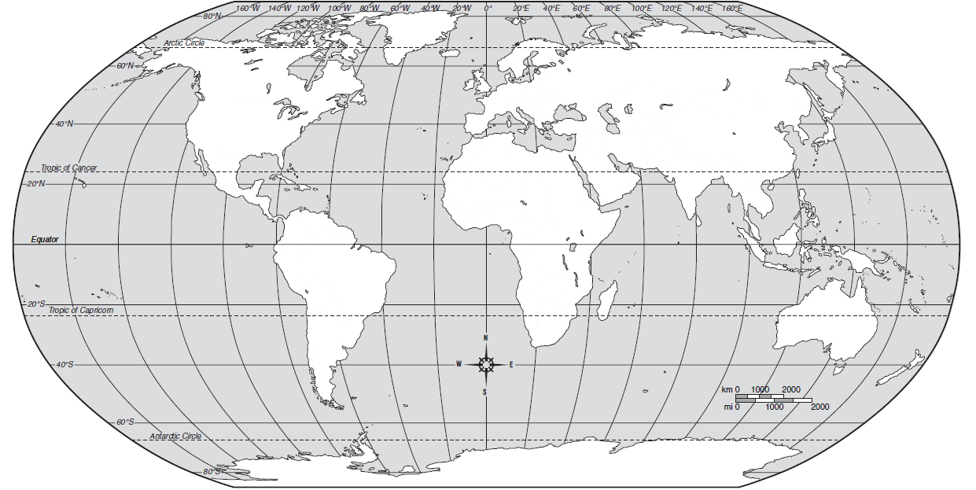
11
4
5
3
7
10
12
9
8

5
2. Fill in one box on your paper | 3. | 4.
5. | 6. Erase one answer off opponents sheet | 7.
8. | 9. | 10.
11. | 12.

Regions of the World Dice Game
Directions: Shortest person playing goes first. Role two die. Corresponding to the number that is rolled the person needs to say the state and physical feature out loud and write it correctly. After the person says an answer, they pass the dice to their partner. If the person who rolled their dice doesn’t pronounce or spell it correctly, then they don’t write anything. The first person to have their answer sheet filled wins!
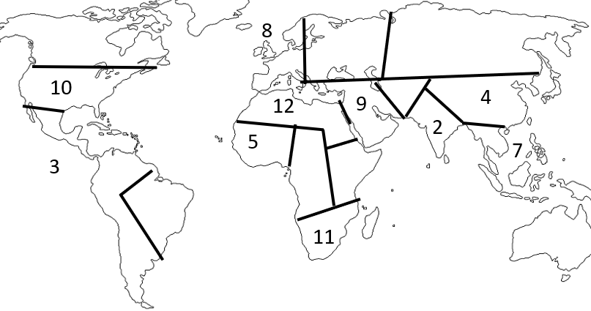
2. Fill in one box on your paper  5 | 3. | 4.
5. | 6. Erase one answer off opponents sheet | 7.
8. | 9. | 10.
11. | 12.

Countries of Africa Dice Game
Directions: Shortest person playing goes first. Role two die. Corresponding to the number that is rolled the person needs to say the state and physical feature out loud and write it correctly. After the person says an answer, they pass the dice to their partner. If the person who rolled their dice doesn’t pronounce or spell it correctly, then they don’t write anything. The first person to have their answer sheet filled wins!
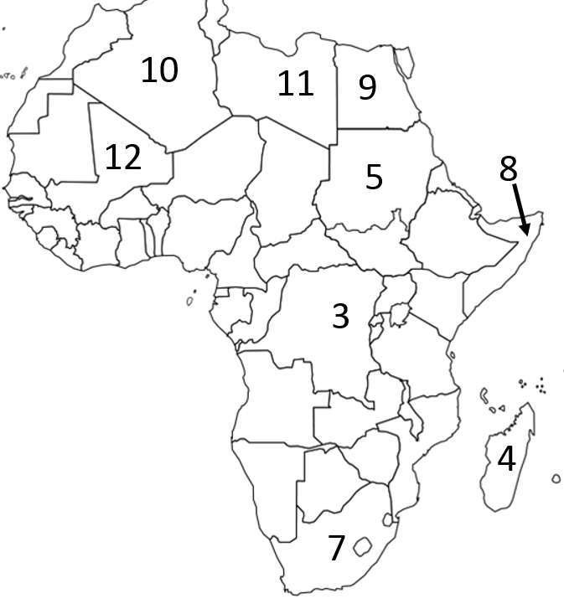
2. Fill in one box on your paper  5 | 3. | 4.
5. | 6. Erase one answer off opponents sheet | 7.
8. | 9. | 10.
11. | 12.

Congratulations!

If you are reading this, it means that you are done taking map quizzes until we start our next region of study!?!?!? If this news brings a tear to your eye, Mr. Patterson understands, that is why there is always a box Kleenexes waiting for you in his room. Instead of playing the dice game and taking quizzes, you’re going to be using a computer to play one of the two games below while everyone else tries to be as amazing as you. For each of the games, you can play by yourself or with anyone else who has received this slip.

Flags of the World - http://bit.ly/1LFcFNq
Can you match the correct country to the corresponding flag? If you can, you’re more brilliant than Mr. Patterson, but only if you can match more than 44. For this quiz you may use a red Africa book.

Countries of Africa - http://bit.ly/1JVRiLf
Can you name the 54 countries of Africa? If you can, you’re more brilliant than Mr. Patterson, he can only name 38. For this quiz, you can’t use a book or a phone… that would be cheating!

Congratulations!

If you are reading this, it means that you are done taking map quizzes until we start our next region of study!?!?!? If this news brings a tear to your eye, Mr. Patterson understands, that is why there is always a box Kleenexes waiting for you in his room. Instead of playing the dice game and taking quizzes, you’re going to be using a computer to play one of the two games below while everyone else tries to be as amazing as you. For each of the games, you play by yourself or with anyone else who has received this slip.

Flags of the World - http://bit.ly/1LFcFNq
Can you match the correct country to the corresponding flag? If you can, you’re more brilliant than Mr. Patterson, but only if you can match more than 44. For this quiz you may use a red Africa book.

Countries of Africa - http://bit.ly/1JVRiLf
Can you name the 54 countries of Africa? If you can, you’re more brilliant than Mr. Patterson, he can only name 38. For this quiz, you can’t use a book or a phone… that would be cheating!

