Pages from Stock Market Crash Instructions that you will need to print:
- Teacher instructions, page 1
- Round instructions, page 5-9
- Create Stock Record on white board, page 11
- Stocks (multiple copies), page 13
- You will also need monopoly money
- When you post stocks, times that number by 10 so students don’t have to do math
- Print extra 100 dollar bills
- To start off the simulation on the, have a student roll a die. Have a series of envelopes at the front of the room. Make a show grabbing a stock sheet from the envelope chosen by the roll. This will make it appear that there are all new numbers.
- When the market crashes, flip a coin. Heads, start from the top. Tails, start from the bottom. Roll a die, the number that comes up is bankrupt and loses everything.
- Same thing can happen for the down turn in year 3. Maybe only have the stock lose half its value.
- Offer to explain any changes in the market,
- Add extra columns so people don’t know when the games ends
- Continue playing by cutting in half the stock market crashes

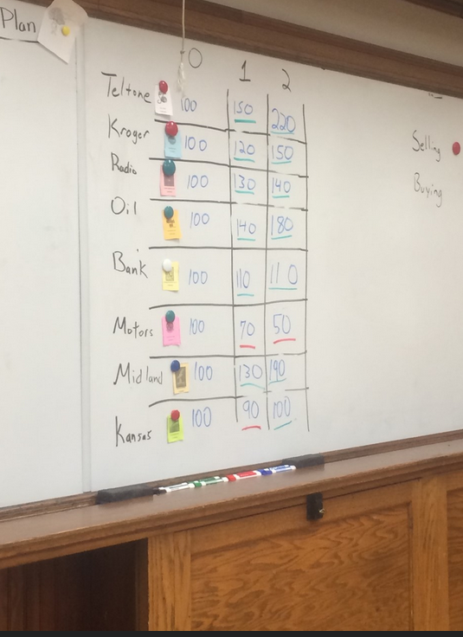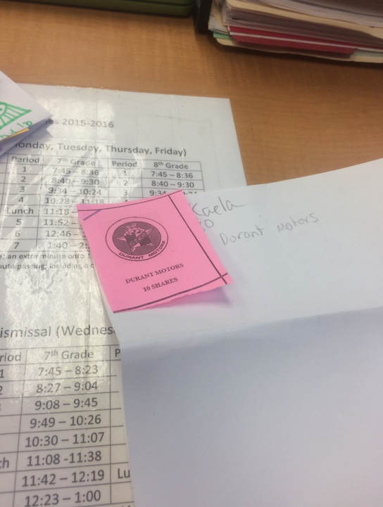
Stocks | 0 | 1 | 2 | 3 | 4 | 5 | 6 | 7
Teltone | 100 | 150 | 220 | 190 | 240 | 220 | 170 | 60
Kroger | 100 | 120 | 150 | 130 | 120 | 140 | 130 | 80
Radio | 100 | 130 | 140 | 130 | 150 | 170 | 140 | 40
Oil | 100 | 140 | 180 | 160 | 210 | 130 | 70 | 20
Bank | 100 | 110 | 100 | 100 | 120 | 120 | 130 | 120
Motors | 100 | 70 | 50 | 40 | 70 | 120 | 130 | 120
Midland | 100 | 130 | 190 | 190 | 220 | 180 | 140 | 30
Kansas | 100 | 90 | 100 | 90 | 110 | 100 | 120 | 80

Stock Descriptions for the Stock Market Game – Class Copy

The following companies and their descriptions are based off of existing companies. Just like in real life, some companies are successful, while others fail. Read the follow descriptions carefully and decide how you want to spend your money.

You will be given $400 to invest or money to spend. Each share or piece of colored paper will cost a $100. As the game goes on, sometimes the colored pieces of paper will be worth more; sometimes they will be worth less. Try and figure out if there are patterns.

Tel-Tone
This telephone company just started selling stocks. They want to raise 12 million dollars to create a new telephone system. This new telephone would change how people use technology. The leaders of this company are young and have no idea what they are doing. Buying Tel-Tone’s paper is very risky. However, their stock is growing right now. It has tripled in value in less than two months.

Kroger Foods
Kroger Foods is a newly created grocery store company. It has factories in ten major cities and sells mostly fruit and tomato products. Since this company is so new, experts don’t know if Kroger Foods is going to make a lot of money or lose a lot of money. Food companies and grocery stores need good weather so farmers can grow their food.

Radio/Internet Company
This company has long been considered one of the better buys in the field of electronics (technology). They seem to have a bright future. Most experts see this business as a good, long-term investment, which is safe and provides security for people that own pieces of paper. In order for this company to keep growing, it needs to keep inventing new technologies.

Mammoth Oil
Owned and operated by Daniel Skye. Mammoth Oil is currently drilling in Texas. Their newly opened field, which experts think maybe the largest oil field in the world, has 25 producing oil wells. Skye is rumored to have the support of important government leaders that will help his company keep growing. Mammoth has borrowed a lot of money to look for new oil though.

The National Bank of Gotham City
This bank is one of the oldest and wealthiest banks in the country. The owner is proud of saying that his bank still operates on the same values for the last 150 years. Their piece of paper is so stable that when it once dropped in value, people got really nervous. This bank has made money for the last hundred years.

Durant Motors
Durant Motors started when twelve different carmakers started to work together. However, bringing these companies together cost a lot of money. The company is attempting to make a low cost car and has hired Curtis Jackson to run its factories in order to pay this money back. People think that this company will either make a lot or lose a lot of money over the next couple of years

Midland Utilities (Power Company)
Owned and operated by the genius Tom Riddle, Midland is part of a billion dollar company that has buildings in 32 states. Midland makes electricity for important cities and towns throughout the country. Midland has developed and is using giant steam turbines to make power. This company is one the most powerful in the country and is fairly stable.

Kansas Pacific Railroad
K&P has been around for over 60 years. The company owns a variety of different things including a vast network of railroads. In the past, they have shown to reliably make small profits. This is impressive considering that many other railroads are losing money. K&P are currently looking to build more railroads in different countries.

Name:
Block: Stock Market Reflection

Teacher:

Directions: Answer the following questions in complete sentences.

1. How much money did you end the game with?
____________________________________________________________________________________________________________________________________________________________
2. How did your group try and make money during the game?
________________________________________________________________________________________________________________________________________________________________________________________________________________
3. What does this game have to do with China right now? Link
____________________________________________________________________________________________________________________________________________________________
____________________________________________________
____________________________________________________
____________________________________________________

4. Why should China’s leaders worried be worried that the stock market is losing so much money? Think back to the Mandate of Heaven and the Cultural Revolution.
____________________________________________________________________________________________________________________________________________________________
____________________________________________________________________________________________________________________________________________________________

