Southeast Asia - Dice Game
Directions: Tallest person playing goes first. Role two die. Corresponding to the number that is rolled the person needs to say the country or physical feature out loud and write it correctly. After the person says an answer they pass the dice to their left. If the person who rolled their dice doesn’t pronounce or spell it correctly then they don’t write anything. The first person to have their answer sheet filled wins.
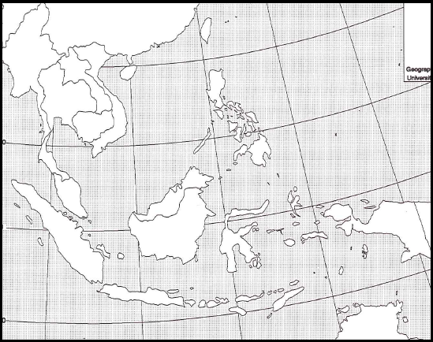
12
8
5
7
111
10
9
3
2. Fill in one blank on your sheet 3.________________ 4.________________

5. ____________ 6. Erase an answer off your opponent’s sheet 7._______________

8.__ __________ 9.________________ 10._______________
4

11.___________12. ________________

