Name:

Block: Southeast Asia –Thematic Maps

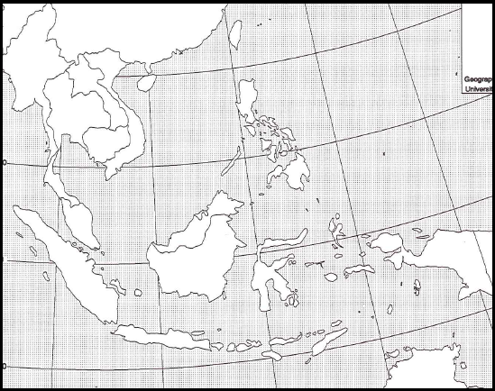
Teacher:

Color | Life Expectancy
 | +79 years
 | 76 -78 years
 | 70 –75 years
 | - 69 years

Color | Avg. Earnings
 | + $30,000
 | $15,001 -29,999
 | $5,001 – 15,000
 | -$5,000

Southeast Asia – Thematic maps

Step 1
Directions: Using Google, gather information on Southeast Asian countries in order to fill out the chart below.
For example: Cambodia GDP per capita

Average Life- is how long the average person in a country can expect to live in a certain country.
GDP Per Capita- is how much money the average person in a country can expect to earn in a year.

Step 2
Directions: Create two thematic maps. Remember a thematic area shows an area and an issue within that area. The first map you need to create needs to show the average life expectancy of a person in the East Asia. The second map you will create shows the average earnings of a person in East Asia.

To help you label these details you may use a purple Asian book, page 260. Make sure your map is presentable. Please do not rush while doing this assignment. Make sure you include a map title and key. Names of countries should be in CAPS. Capitals should be marked with a small star and circle around it.
Example:
Color | Life Expectancy
 | +79 years
 | 76 -78 years
 | 70 –75 years
 | - 69 years

Color | Avg. Earnings
 | + $30,000
 | $15,001 -29,999
 | $5,001 – 15,000
 | -$5,000

Country | Avg. Life | GDP per Capita
Cambodia
Myanmar
Malaysia
Laos
Vietnam
Thailand
Indonesia
Philippines

Step 3 - Directions: On a lined piece of paper, answer the following questions in one big paragraph. Make sure that you specific evidence and properly cite the document. Make sure you use both citations and text evidence. When you think that you are finished, staple the lined piece of paper to the back of your map and raise your hand.

Define standard of living. What is the richest country in Southeast Asia? Provide specific evidence (numbers). What is the poorest country in Southeast Asia? Provide specific evidence (numbers).

