Name: _________________________________ Block: __________ Teacher:________________________

(Title)_______________________________

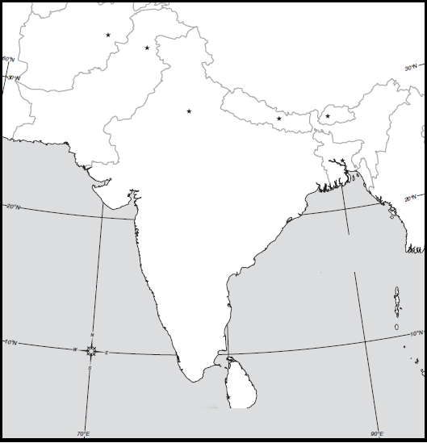

Map Key:

South Asia - Political Map

Directions: Include the below details on your South Asia political map. To help you label these details you may use a purple Africa book using page 260. If the color you are supposed to use is being used by someone else than use a different color.

Make sure your map is presentable. Please do not rush while doing this assignment. Make sure you include a map title and key. Names of countries should be in CAPS. Capitals should be marked with a small star and circle around it.
Example:

Color | Label Country & Capital
Pink | Afghanistan – Kabul
Yellow | Pakistan – Islamabad
Green | India – New Dehli
Purple | Nepal – Kathmandu
Pink | Bhutan – Thimphu
Pink | Bangledesh – Dhaka
Orange | Sri Lanka - Colombo

Latitude and Longitude
1. Karachi, Pakistan Latitude- Longitude-

2. Mumbai, India Latitude- Longitude-

3. Chennai, India Latitude- Longitude-

4. Kabul, Afghanistan Latitude- Longitude-

5. Kathmandu, Nepal Latitude- Longitude-

6. Colombo, Sri Lanka Latitude- Longitude-

7. New Delhi, India Latitude- Longitude-

Answer Key
Latitude and Longitude
1. Karachi, Pakistan Latitude- 25 N Longitude- 67 E

2. Mumbai, India Latitude- 19 N Longitude- 73 E

3. Chennai, India Latitude- 14 N Longitude- 80 E

4. Kabul, Afghanistan Latitude- 35 N Longitude- 69 E

5. Kathmandu, Nepal Latitude- 28 N Longitude- 85 E

6. Colombo, Sri Lanka Latitude- 7 N Longitude- 80 E

7. New Delhi, India Latitude- 29 N Longitude- 77 E

