Name:

Block: South Asia – Vocab/Map Quiz

Teacher:

Level 2_Understanding/Skills____________________________________________________________
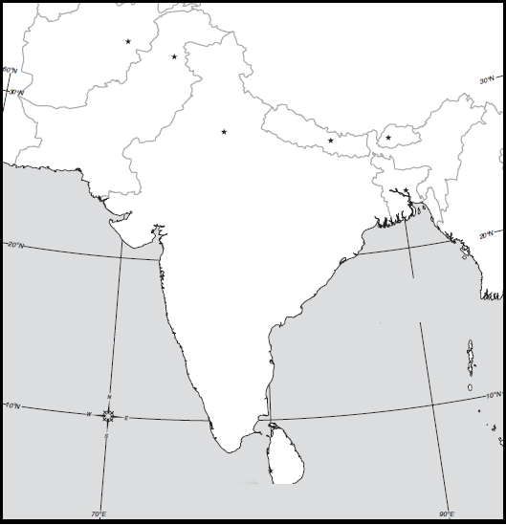
5
6
4
1
7
2
3

Directions: Use the map above to identify the political and physical features of South Asia.

1.  2.  3.  4. | 5.  6.  7.

Level 3_Understanding/Skills____________________________________________________________
Directions: Provide a definition for each vocabulary word below. The definition must show mastery of the vocabulary word before it can be marked correct. You may provide an example or use the word in a sentence if you feel necessary.

Cash Crop
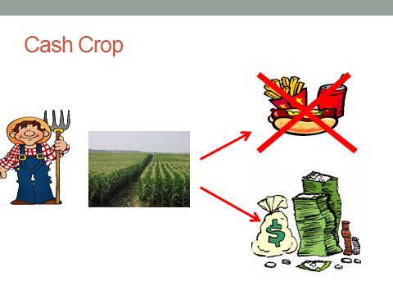
Scarcity
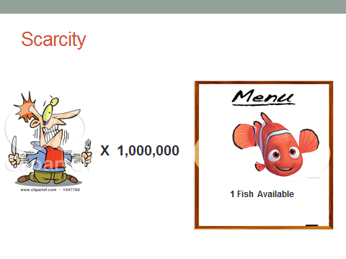
Sustainability
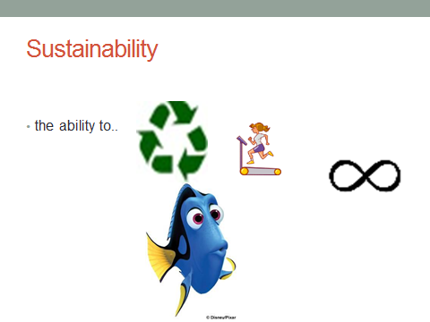
Monsoons
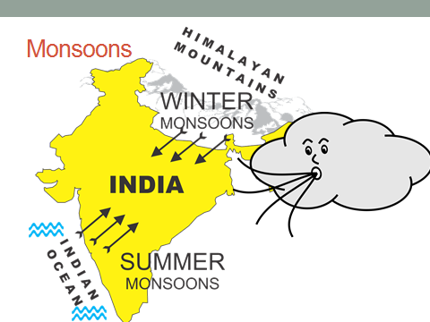
Typhoons
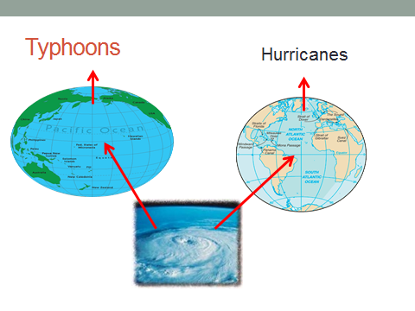
Standard of Living
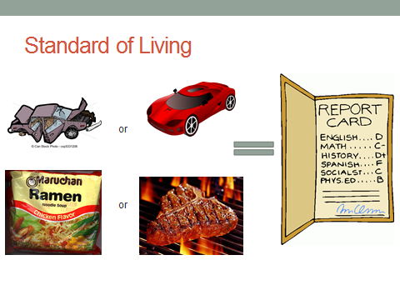

Caste System
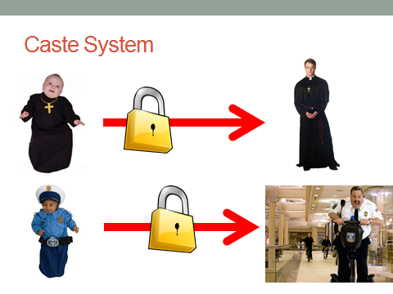
Opium
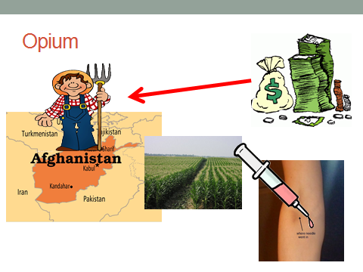
Upper Class
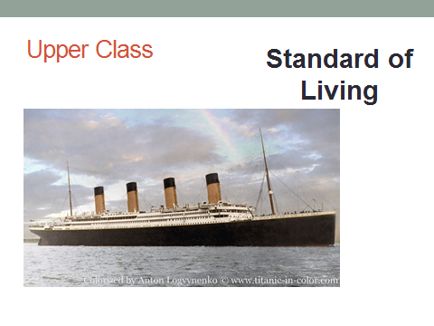

Middle Class
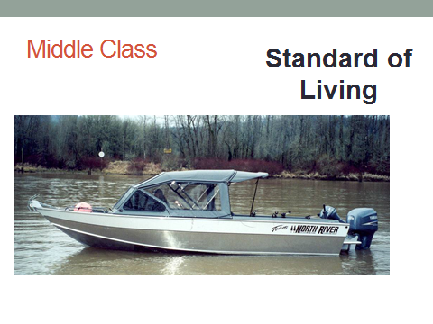
Lower Class
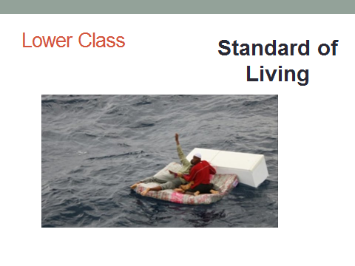

Name:
Help!!!!!
How am I supposed to remember all this?
If only there was a place where all the answers were so we could study….. Oh wait!
Vocabulary http://quizlet.com/_k9fx2
Map Practice http://www.sporcle.com/games/g/asia

Block: Vocabulary Sentences

Teacher:

Directions: Include each vocabulary word in a sentence. The vocabulary word must be underlined and used in a way that shows mastery of the definition.

Cash Crop-

Scarcity-

Sustainability-

Monsoons-

Typhoons-

Standard of Living-

Caste System-

Opium-

Upper Class-

Middle Class-

Lower Class-

