Scramble for Africa (10 days set aside)
Callanan Middle School
Patterson

(W) Means on website
Underline what should be said to the class
If there is a blue word, click on it while holding down “ctrl”

Purpose
The purpose of this lesson cycle is for students to understand the long-term impact of European colonization on Africa. Students will work in teams to play an academic game similar to the boardgame Risk. They will conquer territory with the objective of securing resources for their European countries based off historical needs. Students will understand the hidden costs of colonization indigenous cultures by analyzing a short story.

Standards
3A – Explain costs and benefits of the diffusion of culture, ideas, and goods (SS.7.13).

Students will learn how colonization impacted Africa through the diffusion of religion, languages, and ideas.

3C – Assess the impact of colonization on indigenous cultures around the world (SS.7.14).

Student will assess the emotional and financial impact of European colonization by analyzing the short story The Invaders.

Topic | Resources
Scramble for Africa Game | Link
Thematic Map and Postgame Analysis | Link
Interpreting the Invaders | Link
Assessments | Link

Scramble for Africa Game Home Next

In teams, students will play an academic game that follows the historically based instructions (Retrieval – Executing).

Within the rules of the game, students will identify/recognize a strategy that will make their country powerful (Retrieval – Recognizing).
__________________________________________________________________________________________

Day 1
Opening Discussion – Before airplanes, how did countries move armies around the world? -See Logic Flow*
South American Resource Map (W)  -page 48  South American Simulation Practice  -page 3 | Resources/Materials/Extension  Country signs, color resource maps, colored pencils, pennies, notecards  First round of Africa simulation, CNN news?

Logic Flow*
Explain to students that we are going to play a game. The game may seem confusing at first but eventually it will make sense. Have groups display their European country sign from the Great Powers lesson cycle. If you have more groups than countries, make a France 1 and France 2 and so on. Display the South American resource map of South America. Have pennies and colored pencils ready. Have students write bid slips, use dice and board to figure out how students should come up and colonize gameboard.

As a class, read through the directions and show what it means to start and expand colonies. Use sticky notes to show examples how to take over territory. Revisit the warm up question, most of the time armies moved around the world on foot and on boat. Colonies must start on the water.

Tell students that they need to concentrate on the following for each round:

Round 1 – Start Two colonies near water
Round 2 – Expand each colony by one penny
Round 3 – Climate based turn. Start 1 colony and/or expand. Goal is to control area considered tropical, if possible. Page 18-19 in yellow atlas.
Round 4 – Start/expand to get as much resources as possible.

Day 2
Opening Discussion – In the game yesterday, why do colonies and countries want to have access to an ocean?
Play Scramble for Africa Game (W)  Africa Resource Map (W)  Computer to look up climate map of Africa, where India would be. (Atlas or textbook will also work).  Have teams write bid slips, teacher can color. | Resources/Materials/Extension  -If time allows, start reflection.

Class Copy – Taking Over South America
Starting a Colony– Draw a dot with your color the size of a penny where you want to start a colony. A country’s new colony must be touching an ocean or the sea.

Extending a Colony- Extend your territory by tracing a penny in previously uncolored area of South America; one of the penny’s edges needs to touch an area already under your control

Natural Resources- are things that are found in nature that humans consider worth money.

Ordering your Armies- As leaders of your countries you need to explain what you want your armies to do. In order for your generals to carry out your orders they need two things:

1. You will need a map of South America.
2. You will need a notecard that explains what modern country you want to colonize and why that land.

For example:
“I want to start a colony in Argentina because Portugal needs cattle.”

Map Key
Britain - Red  France - Blue  Belgium - Green  Spain - Purple | Germany - Orange  Italy - Pink  Portugal - Brown

Class Copy – Taking Over South America
Starting a Colony– Draw a dot with your color the size of a penny where you want to start a colony. A country’s new colony must be touching an ocean or the sea.

Extending a Colony- Extend your territory by tracing a penny in previously uncolored area of South America; one of the penny’s edges needs to touch an area already under your control

Natural Resources- are things that are found in nature that humans consider worth money.

Ordering your Armies- As leaders of your countries you need to explain what you want your armies to do. In order for your generals to carry out your orders they need two things:

1. You will need a map of South America.
2. You will need a notecard that explains what modern country you want to colonize and why that land.

For example:
“I want to start a colony in Argentina because Portugal needs cattle.”

Map Key
Britain - Red  France - Blue  Belgium - Green  Spain - Purple | Germany - Orange  Italy - Pink  Portugal - Brown

Thematic Map and Postgame Analysis Previous Home Next

Students will use data to create a visual representation of official languages of African countries (Retrieval – Executing).

Students will compare their map to their block’s Scramble of Africa gameboard. Students will identify trends/patterns (Analysis – Matching).

Students will connect patterns identified in documents to the takeaways of Scramble for Africa. Students will explain the impact of colonization on modern day Africa (Analysis – Generalizing).
__________________________________________________________________________________________

Day 3
Opening Discussion – Who won the game yesterday?*
Scramble for Africa Reflection  -pages 6 - 7  Cultural Diffusion Map (W)  Scramble for Africa Lesson Cycle Visuals (W) | Resources/Materials/Extension  Africa Book ISBN

*Logic Flow: This is an interesting warm up. Students will usually claim that their group “won” the game and the European country that has the least amount of color on the map as the one who lost. Try and direct the conversation so students talk about the people living in Africa. If a European country “lost,” it meant they didn’t get to steal resources but their country still existed but when Africa lost in real life it meant they were conquered by a foreign power and some of their stuff was stolen.

At some point, you will need to show students the ethnic boundary map for the back of the reflection. Explain that each circle represents a different group of people, religion, and language. When European countries divided up Africa, they drew borders through these nations leading to problems that exist to this day (sometimes cutting off villages from water supplies, separating friends, and grouping together enemies).

Show students how to create a writing outline on the whiteboard to guide their work. For advanced students, possibly make them find their own research and have them plot it on a map.

Day 4
Opening Discussion – Have students examine political cartoon, show class how to circle and cite, and use while explaining.
Make sure to go over student movement, sharpening pencils, etc.…  Cultural Diffusion Map (W)  -Have students record findings and record research in OneNote. If it’s the first time, create specific visuals using student log in. | Resources/Materials/Extension

Day 5
Opening Discussion– Have you ever been to a McDonald’s outside the United States? Was it the same or different than the ones in Des Moines? First McDonald’s Drive Thru - Link
-Skip ahead and show parts where employees show where they need to go.
Top Ten International Menu Items – Link
Cultural Diffusion Map (W)  -writing prompt in OneNote\  Scramble for Africa Visuals (W) | Resources/Materials/Extension  Political cartoon exit ticket  -Day 5 visuals for more information  Sporcle games, create visuals/PowerPoint

Using visuals, have students make connections between language map and colonization. Introduce the idea of cultural diffusion. Show example of McDonalds map. Potentially, ask students to generate their own list. Examples of other countries having an impact on the United States.

Name:

Block: Scramble for Africa Reflection

Teacher:

Directions: Answer the following questions in complete sentences unless it says list your answers. When you use an underline word, please mark it with a highlighter.

1. What natural resources did your country want to get out of Africa?
______________________________________________________________
______________________________________________________________
____________________________________________________________________________________________________________________________
______________________________________________________________

2. Did your group win or lose the “Scramble for Africa?” Explain your answer; remember each country wanted to get different natural resources out of Africa, so there can be multiple winners.
______________________________________________________________
______________________________________________________________
______________________________________________________________
______________________________________________________________
______________________________________________________________
____________________________________________________________________________________________________________________________
______________________________________________________________
3. How did your group decide what part of Africa to colonize?
______________________________________________________________
______________________________________________________________
______________________________________________________________
______________________________________________________________
4. Using page 56 in your red Africa textbook, what was the Scramble for Africa? Include the definition of colonize and provide text evidence in your response.
______________________________________________________________
______________________________________________________________
______________________________________________________________
______________________________________________________________

5. Referencing the map on page 55 in your red Africa book, how close was our class map to the one in the book?
______________________________________________________________
______________________________________________________________
______________________________________________________________
______________________________________________________________
6. If the European countries were only interested in stealing natural resources, how do you predict they would treat the native Africans?
______________________________________________________________
______________________________________________________________
______________________________________________________________
______________________________________________________________
7. According to the map on page 55, which two European countries controlled the most territory in Africa?
______________________________________________________________
______________________________________________________________
______________________________________________________________
______________________________________________________________
______________________________________________________________
8. Compare the maps on Africa on page 55 and 228, do you notice any similarities? Provide an explanation of your thinking. ______________________________________________________________
______________________________________________________________
______________________________________________________________
______________________________________________________________
9. The tribal map that Mr. Patterson has put on your table shows the parts of Africa that have the same language and culture. Make an inference, when the Europeans created the borders of modern African countries, did they think about grouping together people who were similar? How might this be a problem?
______________________________________________________________
______________________________________________________________
______________________________________________________________
______________________________________________________________
10. According to the map on page 55, what two countries were not yet ruled by Europeans by 1900? Make a guess, why do you think these countries were never colonized?
______________________________________________________________
______________________________________________________________
______________________________________________________________

Interpreting the Invaders Previous Home Next

Students will draw their mental image of the short story The Invaders (Comprehension – Symbolizing).

Student will identify and use a line of text that shaped their thinking within their art (Retrieval – Executing).

Students will assess the emotional impact of European colonization on local people (Analysis – Generalizing).
__________________________________________________________________________________________

Day 6
Opening Discussion – Show the students the part in True Cost (Netflix – TIME) where people are just grabbing things without looking for what they need. At certain points, that is what was happening in the game we played. People were just getting as much as they wanted. At times, this happened in the Scramble for Africa game and in real life. The problem was that it was group people together who didn’t always get along. Figure out how to access Netflix videos on school computers. Download on external hard drive. Stream on Amazon.
The Invaders (W)  Story will need to be annotated. Make sure to label document A. See Invaders Questions (W)  -Read short story out loud. Make sure to preface the story by telling student to think of an image while the teacher reads | Resources/Materials/Extension  TED talks  Political Cartoon  Blank paper/pencils per student

*Pass out a blank piece of paper to each student. Have students draw while you read. When you finish reading, give them five minutes of silence to continue drawing.

The short story called the Invaders uses mystery to build suspense. What clues does the author provide that helps us understand who the invaders are? How do we know that the invaders aren’t aliens? Give students questions to mark on their sheets but don’t have them write anything down. They are just annotating or making up their paper. Have them mark important lines. Make sure to show example. Explain what annotating means. If students finish early, they can work on their sketch for the poster.

Day 7
Opening Discussion – Why is it sometimes helpful to write on what you read?
Have students work in groups to answer the corresponding questions. Make sure to reinforce proper headings.  Invaders Questions (W)  -painting/sketching, reread for specific requirements, post those accordingly. Possibly ask them to incorporate a line of text | Resources/Materials/Extension  -Sketch first and then paint, talk w/ about not rushing. Water colors/poster paper

Day 8
Opening Discussion – Proper citation of political cartoon. Turn in.
The Invaders (W)  -painting/sketching. Have students include written text somewhere on painting.  Scramble for Africa Visuals (W)  -Students that finish early can watch John Green video. If shown, have transcript ready. link. | Resources/Materials/Extension  Bourdain Episode in Visuals - Senegal  Flocabulary Video – Link  Rachel.smith@dmschools.org  callananflo
Name:
Block: Central Idea of Cartoon

Teacher:

Directions: Carefully examine the political cartoon in front of you. Circle the parts of the cartoon that you looked at to help you understand its meaning.

Topic | 2 | 3 | 4
Summary of Source | Demonstrates the ability to use evidence to identify the main idea. | Demonstrates the ability to describe specific evidence and determine the main idea(s) of a source by providing an accurate summary. | In addition to the level 3, the response demonstrates the ability to analyze the historical significance of the source as related to the concept(s).

1. What is this cartoon about? What point is the author trying to make?
__________________________________________________________________________________________________________________________________________________________________________________________

2. How does the author get across the point of the cartoon? What does he or she want us to look at?
__________________________________________________________________________________________________________________________________________________________________________________________
__________________________________________________________________________________________________________________________________________________________________________________________

3. Why is it important for people to understand what is going on in this cartoon?
__________________________________________________________________________________________________________________________________________________________________________________________
__________________________________________________________________________________________________________________________________________________________________________________________
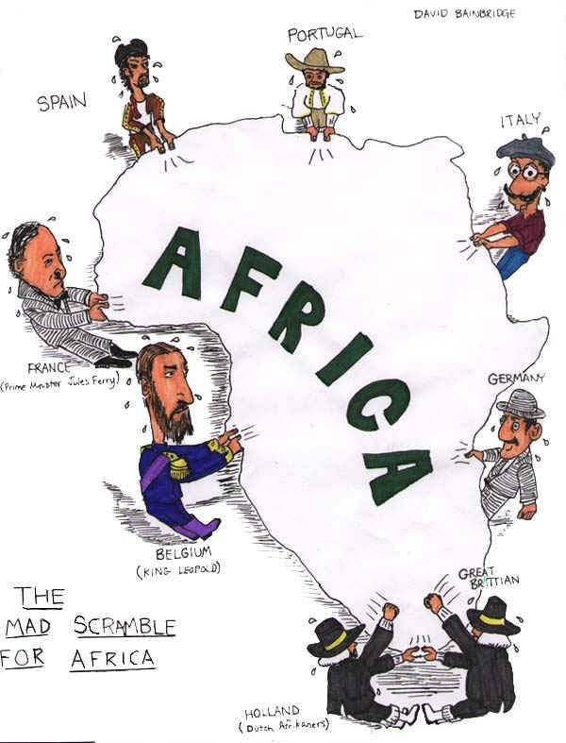
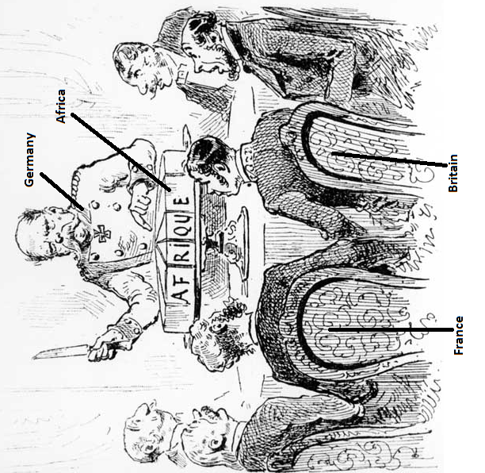

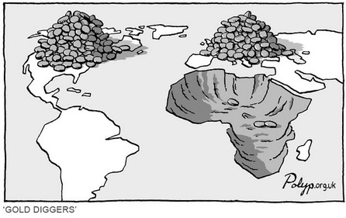
Assessments Previous Home

High School Challenge (Rigor Task)

Teams will create an academic game that explains how colonization resulted in cultural diffusion and impacted indigenous cultures in South America. Teams will analyze other team’s games and give feedback to make them more historically accurate. Students will share their revised games with other teachers in DMPS (Knowledge Utilization – Problem Solving).

Impact of Colonization (Traditional Assessment)

Students will answer who, what, when, where, and why questions about colonization and cultural diffusion (Retrieval – Recalling).

Students create an accurate political map of Africa by carrying out a specific set of directions (Retrieval – Executing).

__________________________________________________________________________________________

Day 9
Opening Discussion –
Impact of Colonization (Traditional Assessment)  -pages 16-17  High School Challenge (Rigor Task)  -page 15 | Resources/Materials/Extension  African Political Map  -pages 18- 19  African Country Flag  Sporlce geography?

High School Challenge - Scramble for South America

Most students in Des Moines Public Schools will take a high school class called AP Human Geography. We just learned about the colonization of Africa in Global Studies, students in Human Geography will learn about the same concept/idea but focused on South America.

By yourself or in a group (maximum of three), come up with a game that will help high school students understand the impact of colonization on South America.

Your game should include the following:
Historically Accurate – Similar to the Scramble for Africa and the War games we played in class, the game that your team creates must be based on actual events. In your research, you will need to figure out which countries colonized South America and what resources they needed.

Visuals and Instructions – The finished version of your project should be a ready to play game. You will need to have instructions, round directions, resources maps, visuals, etc.… created either electronically or on paper.

Natural Resources – It will be important for students to learn and understand natural resources. Students should be able to answer the following questions: What are natural resources? Why did countries want them? A potential idea is to include this information in the directions and/or round instructions.

Cultural Diffusion – It will be important for students to understand the impact of colonization on people living in South America (religion, language, food, dance, sports, etc.…). A potential idea is to identify a topic or issue for students to research. If you choose to take this route, you should include a description of the connections that students want to make.

It is okay to look at the documents from the games we played in class to come up with some ideas. There is no set due date for this project. Mr. Patterson is planning on giving your group several days to work on this. If you are using your time wisely, Mr. Patterson is open to giving you more class time. If students choose to work with other students, the quality of the game/descriptions should reflect this (the more people working on the project, the better it should be). If students choose to not work in a team, they can listen to Spotify on the computer using headphones. If you have questions about this, please ask Mr. Patterson. Students can use OneNote, Online Word, Online PowerPoint, or handwrite this project. In several days, the rest of the class will be take a quiz/test. Since you are working on this project, you don’t need to take the test. In years past, students that worked on this project, and included all the requirements, got a very good grade for the unit.
__________________________________________________________________________________________

Standards
3A – Explain costs and benefits of the diffusion of culture, ideas, and goods (SS.7.13).

3C – Assess the impact of colonization on indigenous cultures around the world (SS.7.14).

Name:

Block: Impact of Colonization

Teacher:

1. What is colonization? Why would countries want to have colonies?
________________________________________________________________________________________________________________________________________________________________________________________________________________________________________________________

2. What are natural resources? Why would countries want to get different natural resources?
________________________________________________________________________________________________________________________________________________________________________________________________________________________________________________________

3. Explain the idea/concept of cultural diffusion. If possible, provide an example.
_______________________________________________________________________________________________________________________________________________________________________________________________________________________________________________________

4. Describe the war game we played in class. What did countries need to do in order to win? Be as specific as possible.
__________________________________________________________________________________________________________________________________________________________________________________________
__________________________________________________________________________________________________________________________________________________________________________________________
____________________________________________________________________________________________________________________________

5. Open your red Africa book to page 55 and 228, the Democratic Republic of the Congo fought a war recently because it didn’t like the shape of its country. Which European country created the borders of the Democratic Republic of the Congo? Why could this European country be partially responsible for this war? Make sure you explain your thinking.
__________________________________________________________________________________________________________________________________________________________________________________________
__________________________________________________________________________________________________________________________________________________________________________________________
__________________________________________________________________________________________________________________________________________________________________________________________
______________________________________________________________________________________________________________________________________________________________________________________________________________________________________________________________________________________________________________________
6. Why do most people speak English in the United States and Spanish in Mexico? Explain your answer.
__________________________________________________________________________________________________________________________________________________________________________________________
__________________________________________________________________________________________________________________________________________________________________________________________
__________________________________________________________________________________________________________________________________________________________________________________________
__________________________________________________________________________________________________________________________________________________________________________________________
____________________________________________________________________________________________________________________________

Name: Block: Teacher:

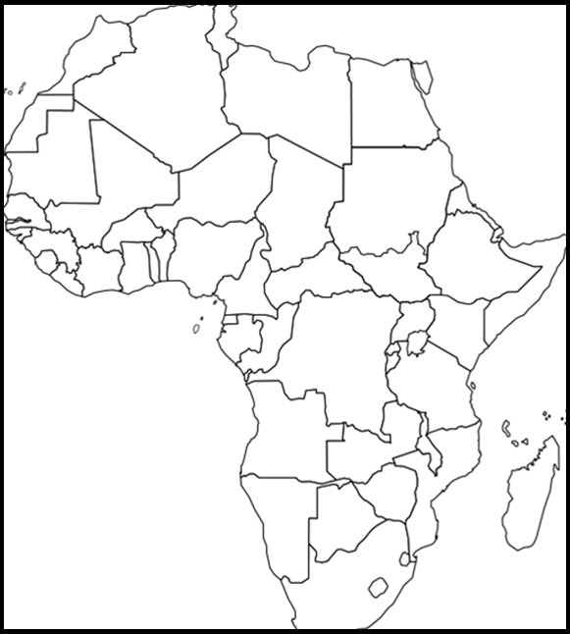
(Title) _______________________________________________

Map Key:

Africa - Political Map

Directions: Include the below details on your Africa political map. To help you label these details you may use a red Africa book using page 228. If the color you are supposed to use is being used by someone else, use a different color.

Make sure your map is presentable. Please do not rush while doing this assignment. Make sure you include a map title and key. Names of countries should be in CAPS. Capitals should be marked with a small star and circle around it .

Color | Label Country & Capital
Red | Somalia
Yellow | Ethiopia
Green | Sudan
Purple | Democratic Republic of Congo
Green | South Africa
Purple | Mali
Purple | Zimbabwe
Red | Madagascar
Purple | Kenya
Purple | Cameroon

Latitude and Longitude
1. Nouakchott, Mauritania Latitude- Longitude-

2. Antananarivo, Madagascar Latitude- Longitude-

3. Cape Town, South Africa Latitude- Longitude-

4. Luanda, Angola Latitude- Longitude-

5. Khartoum, Sudan Latitude- Longitude-

6. Libreville, Gabon Latitude- Longitude-

7. Addis Ababa, Ethiopia Latitude- Longitude-

8. Mogadishu, Somalia Latitude- Longitude-

