JUDIASM – Doc. C
- Judaism is around 3,500 years old and is the oldest of the world's great monotheistic religions (religions with only one God). It's also the smallest, with only about 12 million followers around the world.
- Followers of Judaism are called Jews.
- The main holy city of Judaism is Jerusalem.
- The Jewish symbol is a six-pointed star. This is called the Star of David. It is a symbol for one of their early leaders.
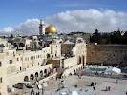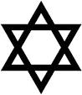
Beliefs
- Jews believe that there is a single God who not only created the universe, but with who every Jew can have an individual and personal relationship. They believe that their God cares about them.
- They await the Messiah or savior, who will be an earthly king. This king will arrive to save them from all evil in the world. They believe in heaven, but that God determines where they go after life on earth. If they are a bad person, they will go to hell.
- Jews should give 10% of the income to help the poor.
- In the Jewish holy book, there are ten commandments (rules) that they must follow.
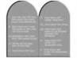
1

Judaism Holy Book
- The most holy Jewish book is the Torah (the first five books of the Christian Bible). Others include Judaism's oral tradition (story telling), the written form of which is known as the Talmud.
- The Torah (scroll of teachings) contains the five books revealed to Moses by God.
- Hebrew is the holy language of the Jewish people.
Judaism Place of Worship
- Jews worship (pray) in synagogues or temples. Men and women usually sit separately.
- Worship is led by a local leader called a rabbi.
- Most people who are Jewish go to the synagogues on Friday evenings.
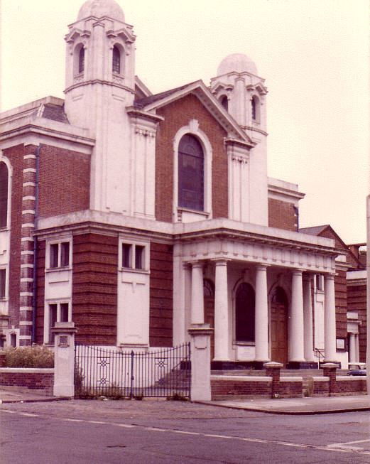
2

CHRISTIANITY - Doc. C
- Christianity is the world's largest religion, with about 2.2 billion followers worldwide. It is based on the teachings of Jesus Christ who lived in near Israel 2,000 years ago.
- Followers are called Christians.
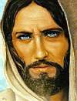
Christian Beliefs
- Christians believe that Jesus Christ was the Son of God.
- God sent Jesus to Earth to save humanity from the consequences of its sins (from the bad things that people were doing).
- Christians believe that after he was killed, Jesus rose from the dead.
- Christians believe that Jesus was the Messiah, the leader promised in the Jewish holy book
- Christians believe that there is only one God.
- Christians believe that God made the world and universe.
- Christians believe that they can have a personal relationship with God, and that they are saved by faith (belief in him).
- Christians believe in heaven and hell.
- Christians often give money to the church/poor.
1

Christian’s Holy Book
- The Bible is the Christian holy book. It is divided into the Old and New Testaments. Parts of the writing contained in the Old Testament are special to Jewish and Muslim people. The New Testament describes Jesus and his followers.

Christian Place of Worship
- The Christian place of worship is called a Church, which are often built in the shape of a cross.
- Prayer is usually lead by a priest, pastor or reverend leads services. Those are all different names of religious leaders.
- The most common day of worship in Christianity is Sunday.
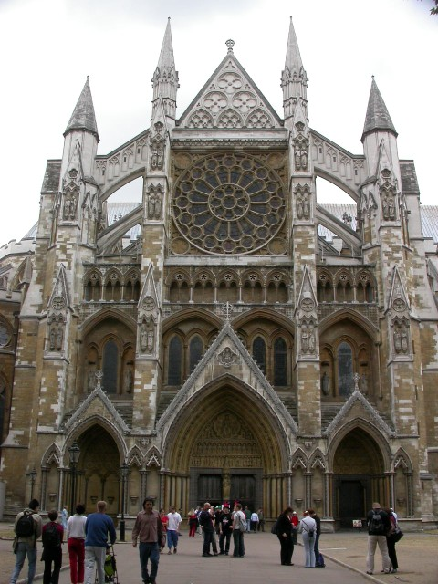

2
ISLAM - Doc. C
- Islam is the second most popular religion in the world with over a billion followers. Islam began in Saudi Arabia and was revealed to a person who became known as the Prophet Muhammad. Those who follow Islam are called Muslims. Muslims believe that there is only one God, named Allah, who speaks Arabic.
- The Muslim calendar has 354 days and is based on the 12 crescent moon cycles.
Islam Holy Book
- The Muslim holy book is called the Qur'an. It is 'the word of God'. Muslim beliefs and practices are rooted in the Qur'an.
- Muslims treat the Qur'an with great respect because they believe that the Qur'an is from Allah (God), and every word and every letter is considered sacred.
- Muslims regard the Qur'an as the \ word of God.
- It is read from right to left and written in Arabic.
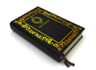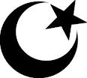
Islam Place of Worship
- The Muslim building for worship is called a Mosque.
- Worshippers are called to prayer 5 times a day from minarets – towers on the mosque corners.
- Mosques contain only designs, no pictures, paintings, and statues of people or animals.
- The most important day to visit the mosque is Friday.
1
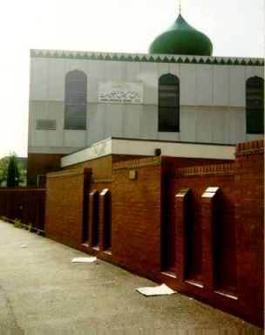
Five Pillars Belief system/law code
- Declaration of Faith
"I bear witness that there is no god, but God; I bear witness that Muhammad is the prophet of God." By saying this, one enters Islamic faith. There is only one God.
- Prayer
Muslims are required to pray five times a day, washing themselves before prayer and facing in the direction of Mecca while praying.
- Give money to the poor
Muslims are required to give away a percentage of their earnings to those less fortunate, regardless of their religion.
- Fasting during the month of Ramadan
Muslims fast (don’t eat or drink during the day) for one month each year, a period called Ramadan. During this time, Muslims reflect on their behavior and strive to purify their thoughts.
- Pilgrimage to Mecca: Hajj:
If they have the money to, Muslims are required to travel to a city called Mecca once in their lifetime to worship at the Kaaba.

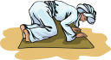
2

