**Population Growth in China**

**East Asia**

**Patterson**

(W) Means on website

Underline what should be said to the class

If there is a blue word click on it while holding down “ctrl”

|  |  |
| --- | --- |
| **Day 1** | |
| **Learning Target** – I will use text evidence to add strength to my writing.  **Warm Up** –  -Before the doing the warm up activity, pass out culminating assessment (page) and have them store it in their folder.  (See below for full details, Population Growth Activity (W) )  When did most people join the circle?  What will happen if that growth continued? | |
| DBQ China’s One Child Policy (W)  -page ½  -Print and have stapled DBQ essay, and documents A, B, D, E | **Resources**  Tape,  **Materials**  **Extension** |

Population Growth Activity (W)

Print out three copies of page 4. Have an area marked off on tape. Pass out the slips of paper and have students complete the activity described in the document. When finished, have the students return to their seat and answer the warm up questions.

Explain that most of this growth is concentrated in several parts of the world. This creates enormous strain on a country. Show this class this video, [link](https://www.youtube.com/watch?v=SObnO6jnAD8). Make sure to point out China. Ask them to watch China. The reason we are studying this issue now is because population growth is a major issue in East Asia.

|  |  |
| --- | --- |
| **Day 2** | |
| **Learning Target** – I will become familiar with academic vocabulary words.  **Warm Up** – China’s One Policy is very controversial. List some good things and bad things that come from the rule. Get one of those large pieces of paper used in PD and make a t-chart. Keep running track over the course of the learning cycle. | |
| East Asia Vocab & Word War Il (W)  Discuss idea of population growth, have students write down definition  Word in the Balance Documentary – [Link](https://www.youtube.com/watch?v=VkIS79WV9wM)  -page 6/7  record where classes left off. | **Resources**  **Materials**  **Extension**  Start working on level 4  Additional videos of gender imbalance |

|  |  |
| --- | --- |
| **Day 3/4** | |
| **Learning Target** – I will determine if China’s One Child Policy was a good or bad idea.  **Warm Up** – Day 3, In America, who takes care of old people when they can no longer work? Discuss answers and explain that the social safety net is expensive. Parents in countries with low standards of living are motivated to have more children so they can take care of them. This puts strain on the country.  Day 4, How can China’s average birthrate be a fraction of a person | |
| China’s One Child Policy  -page 10  Split class, see document already created. Definitely split class with blocks 5 and 6. | **Resources**  Candy, chips (poker chips, Legos)  **Materials**  **Extension**  One for all activity  DBQ Revise in Word |

During days three and four, split the class into two different parts. One group will work on China’s One Child Policy while the other will complete the China’s One Child Policy. Groups will flip after.

|  |  |
| --- | --- |
| **Day 5** | |
| **Learning Target** – I will explain through writing why the Chinese accepted communism so readily.  **Warm Up** – No Warm Up | |
| Population growth Assessment Day  -pages 3/4    World in the Balance - [Link](https://www.youtube.com/watch?v=MmuvOppSmxc)  -page 8/9 | **Resources**  **Materials**  **Extension** |

|  |  |
| --- | --- |
| **Day 6/7** | |
| **Learning Target** – I will create a thematic map to analyze the standard of living of East Asia countries.  I will create a product (presentation) that uses multiple sources to add validity (strength) to the final version.  **Warm Up** – No Warm Up | |
| Gap Minder centered on Level 4  -page 5  East Asia Thematic Maps (W)  Extension documentary - [Link](https://www.youtube.com/watch?v=Gx0paNK-KpQ) | **Resources**  **Materials**  **Extension**  Examine population growth in South Asia for more details.  Look more closely at TED talks |

Split class, students that are working on Level 4, grab a computer

**Name**

**Block Population Growth - Assessment**

**Teacher**

|  |  |  |  |
| --- | --- | --- | --- |
| **Topic** | **2** | **3** | **4** |
| **Economic Interdependence** | **Explain/define core ideas behind China’s One Child Policy:**  Communism, Population Growth, China’s One-Child Policy (rule) | **Evaluate (**identify the advantages and disadvantages in order to give your opinion) of China’s One Child Policy.  **Explain** through writing if you think that the One Child Policy was a good or bad idea. | Compare and contrast data (info) between countries in order to determine if countries should worry about their population growth. |

**What is communism?**

****________________________________________________________________________________________________________________________

________________________________________________________________________________________________________________________

**What is population growth?**

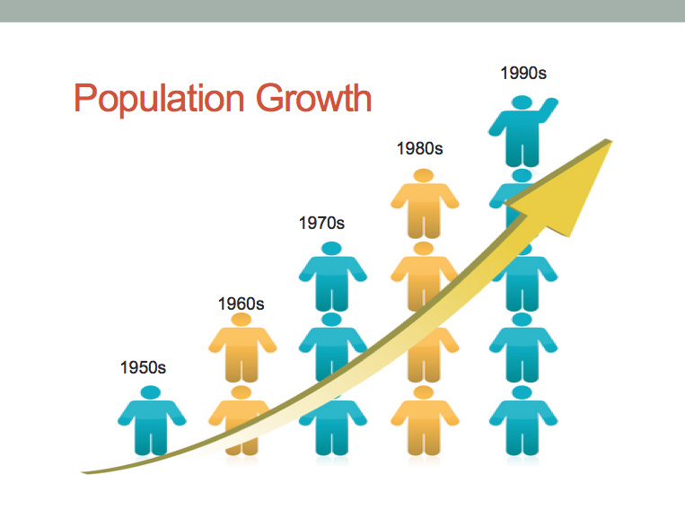_______________________________________

_______________________________________

_______________________________________

_______________________________________

______________________________________________________________________________

**What was China’s One Child Policy** (rule)**?**

________________________________________________________________

________________________________________________________________

________________________________________________________________

________________________________________________________________

**Directions:** Fill out the chart below by listing the advantages and disadvantages of China’s One Child Policy (rule). Do not use complete sentences. At a minimum, have three examples for each side.

|  |  |
| --- | --- |
| **Advantages** (Good Things) | **Disadvantages** (Bad Things) |
|  |  |

**In your opinion, was China’s One Child Policy (rule) a good idea or a bad idea**?

Make sure to explain your reasoning. You will probably have to write at least a couple of sentences at the minimum. You could write about your bullet points above.

________________________________________________________________

________________________________________________________________

________________________________________________________________

________________________________________________________________

________________________________________________________________

________________________________________________________________

________________________________________________________________

________________________________________________________________

________________________________________________________________

________________________________________________________________

________________________________________________________________

________________________________________________________________________________________________________________________________

________________________________________________________________________________________________________________________________________________________________________________________________

**Gap Minder – Level 4 – Class Copy**

|  |  |  |  |
| --- | --- | --- | --- |
| **Topic** | **2** | **3** | **4** |
| **Economic Interdependence** | **Explain/define core ideas behind China’s One Child Policy:**  Communism, Population Growth, China’s One-Child Policy (rule) | **Evaluate (**identify the advantages and disadvantages in order to give your opinion) of China’s One Child Policy.  **Explain** through writing if you think that the One Child Policy was a good or bad idea. | Compare and contrast data (info) between countries in order to determine if countries should worry about their population growth.  Gap Minder Level 4 |

<http://bit.ly/2otVjzc>

Gap Minder is a website that visually organizes information from the CIA World Fact Book to make it easier to analyze (examine closely). For this assignment, we will focus on the modern era (time) of world history, 1945 to today; since this is the period that countries around the world the world gained their independence from European colonization.

As you start to explore the website, you will notice outliers in the data. (An outlier is a person or a thing that is situated away from a group.)

Using the options menu, select China and watch the circle move as the timeline plays out. You will begin to notice several things about China. For example, China’s large population makes it much larger than other countries. Also, when you isolate China and then play the timeline, you will notice how the circle doesn’t just move in one direction. Due to failed programs like the Great Leap Forward, their standard of living regresses (goes down) at times.

Your assignment is to choose an outlier to focus on for this project and to try to understand what caused this deviation (movement away) from the main group**. What happened in the country? If there was a problem, what laws/rules/programs did that country’s government try and pass? Did the U.S.A. do anything about the situation? Should it have? How did this issue affect that country’s standard of living?**

You are by no means limited to the year 2016. You can “go back in time” to any point you want. You will have two days in class to work on this level 4. What you create when answering the above questions is up to you. This means you can create a PowerPoint, Prezi, OneNote, video, etc…

If possible, it would be helpful that to **include pictures and videos** to help the reader visualize the issue you looked at.

**Name:**

**Block: World in the Balance – China Revs Up**

**Teacher:**

1. How many people are considered in the middle class in China (Good standard of living) ?

2. What does Dan Jaffee measure with his research?

3. What does the U.S. export (send out of the country)?

4. Where are people moving to in China?

5. What were the five big things described?

6. Of the ten dirtiest cities, how many are in China?

7. Describe the Great Leap Forward.

8. What did Deng Xio Ping dismantle (take apart)?

9. What natural resource powers most of China?

10. What is the problem that natural resource in #9?

11. As families in China become more affluent (wealthy), what do they want to buy?

12. What is the dirty little secret?

13. What is the one thing that China needs now?

14. What happens if they don’t do it?

15. What is “trickle-down economics?”

16. Describe farming in China.

17. What happened in 1998?

18. How does environmental protection (why do people start to are about the environment) come about in most countries?

19. Why is this a problem in China?

20. What is the largest burden (biggest thing hurting) on the environment in the U.S. and China?

**Name:**

**Block: World in the Balance – People’s Paradox** (Problem)

**Teacher:**

1. By the end of the century, by what percentage is Japan’s population expected to shrink?

2. Where is the Taj Mahal? Why was it built?

3. In what part of India are birth rates low?

4. What is the “son” preference? Why does the family want to have another one?

5. What percentage of marriages in India, are “arranged?” Arranged meaning that family chooses who the person is going to marry.

6. What could happen if the woman fails to have a son?

7. What happens when women get an education and start working?

8. What are towns and villages running out of?

9. What is the magical number of children per family?

10. Why do Japanese women need to work since 1989?

11. Why do you think the young people leave the country?

12. How did globalization (countries/people from around the world, work together) impact the old couple’s plans for the future?

13. What happens when a country’s workforce shrinks (gets smaller)?

14. An American will pollute (hurt nature) more than _______ when compared to children in India over their lifetime.

15. What is happening to the environment (nature) in Sub-Saharan Africa as countries try to develop?

16. World Population in 1800 = ____ billion

2000 = ____ billion

Copy and paste this page into OneNote so students can access it. Orange or blue grab computers, definitely split class for afternoon

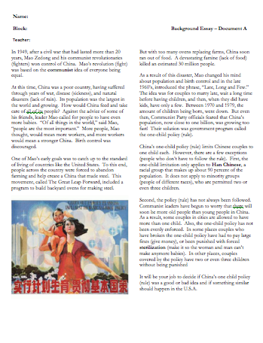**China’s One Child Policy**

**Step1**

**Directions**: A couple of days ago, Mr. Patterson passed out primary and secondary resources about China’s One Child Policy (rule). Answer all of the questions on each page. Make sure to answer all parts of the question and when asked, write in complete sentences.

**Step 2**

**Directions**: Finish watching the documentary about the impact of China’s One Child Policy (rule). As you watch the film, answer the corresponding questions.

[Link](https://www.youtube.com/watch?v=VkIS79WV9wM)

Remember, if the video comes up as restricted. Copy and paste the link in to another web browser.

**Start at:**

Block 1 - time

Block 2 -

Block 3 -

Block 5 -

Block 6 –

When you have finished with both steps 1 and 2, look to see what Mr. Patterson is doing. If Mr. Patterson is still playing the game/talking with the other group, you have his permission to be on your phone or draw. When Mr. Patterson is done helping that group, raise your hand so he can check your work.