Fallout (Natural Disaster Planning) Lesson Cycle
Geography
Patterson

(W) Means on website
Underline what should be said to the class
If there is a blue word click on it while holding down “ctrl”

The purpose of this lesson cycle is for students to work together to develop a plan to evacuate hundreds of thousands of people on foot after a natural disaster. Personally, I don’t formally grade this lesson cycle in my classroom. Rather, I help students/groups start the problem solving process and help foster teambuilding skills that we will build on throughout the year. This lesson cycle can be easily adapted for any state.

Day 1
Learning Target – I will play a game and reflect on the on the purpose. (Display LT on PowerPoint but not on board, encourages students to think about it at the correct time.)

Warm Up – Why did Mr. Patterson have us play that game? (General discussion, no need to answer on actual warm up sheet)
Teambuilding Game/Group Norms  -Play teambuilding game before the warm up, have students discuss why we took class time to do so. Have a general discussion, no need to have them formally write it down. Transition this conversation into creating common group rules for project. (Possibly do cup game with limitations.)  -page 4  -Groups work on map Research #1. Make sure to explain what side of the map they are using.  -pages 5/6 | Resources  Materials  Extension  Link to teambuilding cup game

Day 2
Learning Target – I will analyze a political map and practice skills that are necessary to complete a rigorous task.

Warm Up – No Warm Up
Map Research #2  -Make sure to go through how to find cities with coordinates, possibly use smart board to display grid. Also, show how to find distance on a map and add them up. Also, have students make a compass rose on a sticky note.  -pages 7/8 | Resources  Materials  Extension

Day 3
Learning Target – I will develop a list of requirements for the evacuation of refugees across Iowa.

Warm Up – No Warm Up
Fallout Visuals  -Display visuals and have students brainstorm different things that people will need in case of a natural disaster. Initially put list on the whiteboard, synthesize information and put on giant notepad. See page 3 for logic flow.  -pages 9/11 , step 1 | Resources  Materials  Extension/Musing  Give out directions as need be, keep it as simple as possible.

Day 4
Learning Target – I will create an evacuation route (escape path) for refugees (people) that meets specific requirements.
Warm Up – Why would you not want to sleep along the side of the highway? Discuss idea of leap frogging from safe place to place. Display the visual from the step by step directions and reference it during discussion.
-page 9/11 , step 2/3 | Resources  Materials  Extension

Day 5
Learning Target – I will create an evacuation route (escape path) for refugees (people) that meets specific requirements.

Warm Up – How many miles is it from Orange City to Akron?
Explain that on certain maps, there are tiny black and red numbers. These show how the mileage between different places. Red has stars and black is just off the road. Display the visual from the step by step directions and reference it during discussion. Draw on front board. Practice finding the coordinates for Orange City and Akron. Take them through that process. See fallout visuals for picture.
-page 9/11 , step 3/4 | Resources  Materials  Extension

Day 6
Learning Target – I will create an evacuation route (escape path) for refugees (people) that meets specific requirements.
Warm Up – What is the next direction? Use Orange City and Akron visual again, display sentence frame on instruction sheet, as a class, work on first direction, second direction use warm up as work space
-page 9/11 , step 5 | Resources  Materials  Extension  -Sporcle Geography games, create leaderboards

Day 3, Warm Up, Project Intro Logic Flow, Use Visuals in PowerPoint

The idea of this discussions is for students to come up with the requirements that are going to shape their projects. Try and get the students to say the things in bold.

Our first project centers on this idea that we see in movies and videogames all of the time where a virus, bomb, whatever has made a large area uninhabitable.

In theory, let’s pretend that this happened disaster happened in Chicago. Large parts of the city look like this: Picture of destruction

Immediately after a disaster that destroys large city, what are some things will happen? What will happen to the people that survived? What happened to the people who lost their homes? What should the government do to help? How will they get the aid to the affected areas? Gov. will use interstates to get aid, airports will be compromised

Picture of refugees

-Aid to people in affected area, start rebuilding process
-What if that can’t happen right away?
-People will need to get to a safe place to go

How does this impact Iowa?
Where will people becoming from if the disaster is happening in Chicago? Eastern side of Iowa and move them to safe places in Nebraska

Many won’t have cars and will be traveling on bicycle and foot, why would it be unfair to ask them walk from across Iowa in a day? Limit the amount of travel required, Day Requirement

Why wouldn’t you want to ask people toe walk along the interstate? No interstate travel due to danger, also so gov. can get supplies to Chicago

Take backroads, small towns. Sometimes these backroads come to small towns. Why might it be a problem if the government has 10,000 people spend the night in a town like Carbon, Iowa with a population of 34? Towns that are too small can’t support large groups of people, think about the bathrooms, police, etc…

If possible, work in day requirements so the government knows where to send supplies. What do these refugees need when they spend the night somewhere? Basic needs, government needs to have supplies sent in advance. Seven day mapout.

Names of Groups Members:
Block: Map Project Rules

Teacher:

____________________________________________________________________________________________________________________________________________________________________________
________________________________________________________________________________________________________________________________________________________________________________________________________________________________________
______________________________________________________________________________________________________________________________________________________________________________
____________________________________________________________________________________________________________________
________________________________________________________________________________________________________________________________________________________________________________________________________________________________________
____________________________________________________________________________________________________________________
________________________________________________________________________________________________________________________________________________________________________________________________________________________________________
____________________________________________________________________________________________________________________
________________________________________________________________________________________________________________________________________________________________________________________________________________________________________

Name:

Block: Map Research #1

Period:

Directions: The answers to these questions can be found on the back of the Iowa Highway Map. You need to answer these questions in complete sentences and throw back the underlined parts.

Part 1
1. Who is the governor of Iowa?
______________________________________________________________________________________________________________________________________________________________________________
2. Who is the lieutenant governor of Iowa?
______________________________________________________________________________________________________________________________________________________________________________
3. How many welcome centers are there in Iowa?
______________________________________________________________________________________________________________________________________________________________________________
4. What do some of the welcome centers have that others don’t?
______________________________________________________________________________________________________________________________________________________________________________
5. What is the name of the website for state park information?
______________________________________________________________________________________________________________________________________________________________________________
6. What phone number would you call for travel information in Iowa?
______________________________________________________________________________________________________________________________________________________________________________
7. Amtrak is the name of a railroad company. How many stops does Amtrak have in Iowa?
______________________________________________________________________________________________________________________________________________________________________________
8. What does the acronym DNR stand for?
______________________________________________________________________________________________________________________________________________________________________________
9. In what city is the Iowa Tourism Office located?
______________________________________________________________________________________________________________________________________________________________________________
10. How many individual city maps are shown on the back of this map?
______________________________________________________________________________________________________________________________________________________________________________
11. What river borders one side of the city of Burlington?
______________________________________________________________________________________________________________________________________________________________________________
12. What was the population of the state of Iowa in the year 2014?
______________________________________________________________________________________________________________________________________________________________________________
13. What river runs along the north edge of Marshalltown?
______________________________________________________________________________________________________________________________________________________________________________
14. What is the number of the main highway that runs east and west through the city of Burlington?
________________________________________________________________________________________________________________________________________________________________________ ______

Group Names:

Block: Map Research #2

Teacher:

Part I
Directions: Using your map, follow the road directions for each question and see where your trip takes you. Use the back of the map to find what area of Iowa you need to look for your starting location.

1. a. Begin at Fairfield
b. Follow Highway 34 west to Albia.
c. Go South from Albia on Highway 5 to Centerville.
d. At Centerville, go west on Highway 2 to Highway 25.
e. Take Highway 25 north to Highway 34.
f. Go northeast on Highway 34 until you come to a town.
g. What is the name of the town?

2. a. Begin at Harlan
b. Go east on Highway 44 to Panora.
c. At Panora, go north on Highway 4 until you come to Jefferson.
d. At Jefferson, go west on Highway 30 to Carroll.
e. What lake is just south of your location?

3. a. Begin at Dubuque
b. Go south on Highway 61 until you come to Interstate 80.
c. Go west on I-80 to Highway 38.
d. Go north on Highway until it intersects with Highway 30.
e. Go west on Highway 30 until you come to Highway 1.
f. Go south on Highway 1 towards Solon.
g. What lake is just west of your location?

4. a. Begin at Spencer.
b. Go south on Highway 71 to the intersection with Highway 20.
c. Go west on Highway 20 to Correctionville.
d. At Correctionville, take Highway 31 south until it intersects with Highway 141. What town is at the intersection?

5. a. Begin at Sidney
b. Go east on Highway 2 until you reach Highway 63.
c. Go north on Highway 63 until you come to Highway 34.
d. At Highway 34, go west to Highway 14.
e. What town lies at this intersection of Highway 34 and Highway 14?

6. a. Begin at Dyersville
b. Go west on Highway 20 to Interstate 35.
c. Go north on I-35 to Highway 3.
d. Go east on Highway 3 to Highway14.
e. At Highway 14, go south to Highway 57.
f. What town is at this intersection?

7. a. Begin at Birmingham
b. Go south to Highway 16.
c. Follow Highway 16 east to Highway 61.
d. Go south on Highway 61 until it ends at Highway 218.
e. What city are you at?

Part II
Directions: Start at Marshalltown and provide step by step instructions for a path that will take you to the town Spencer. Be sure to include the name of the highways as well as the direction you travel. Don’t use the phrases such as turn right or turn left, instead use directions and exact mileage. There are several routes that you could plan, but your challenge is to complete the trip in exactly seven steps.

For example: Go South on Highway 13 for 10 miles until you reach Spencer.

a.

b.

c.

d.

e

f.

g.

Day #
Route Logistics  1st  Starting Point (Bigger than 10,000 people)  Rest Point (Bigger than 500 people)  Ending Point (Bigger than 10,000 people) | Directions:  3rd
Total Daily Miles:
2nd
Hospital Locations:
4th

Nearest Military Base:

Day #
Route Logistics  1st  Starting Point (Bigger than 10,000 people)  Rest Point (Bigger than 500 people)  Ending Point (Bigger than 10,000 people) | Directions:  3rd
Total Daily Miles:
2nd

Hospital Locations:
4th

Nearest Military Base:

Class Copy
Natural Disaster Planning

Step 1
Using the back of the map, write down the names of all the cities that are larger than 10,000 people and their map coordinates. Then use a marker and lightly circle the city. Make sure you can see still see name of the city and roads after you do this.

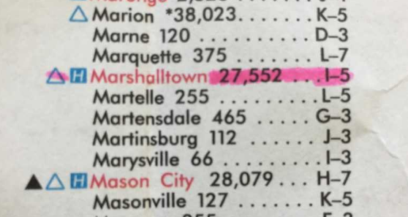
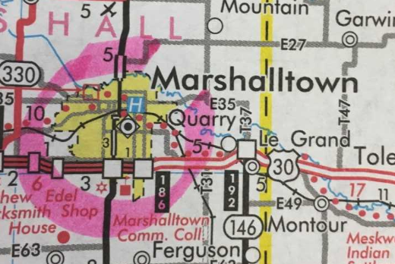

_____________________________________________________________________________________
Step 2
Figure out the start, end, and rest points for each day. Make sure that the places you’re stopping are have enough people living there. Once you have finished this step, complete box #1 for all days. Lightly highlight/mark the path that you are planning.

Day 1 Start Day 1 Rest Day 1 End Day 2 Start Day 2 Rest Day 2 End

_____________________________________________________________________________________
Step 3
Using the black and red numbers, add up the total number of miles that you are asking people to walk each day. Complete box #2 for all days.
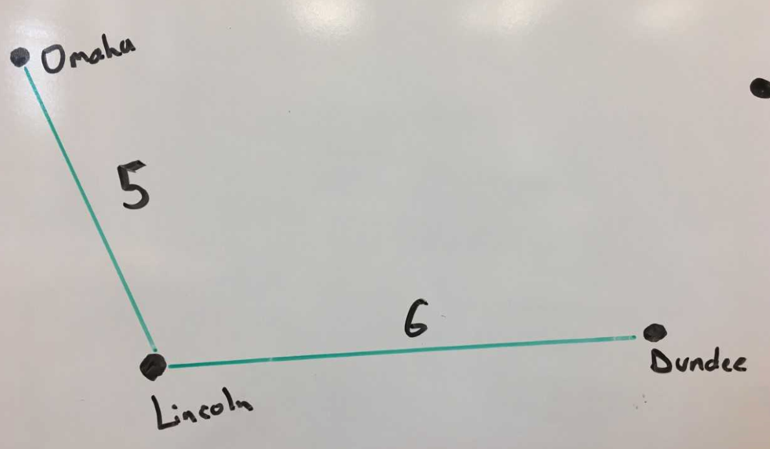

Walking on the green road from Dundee to Omaha, you would travel eleven miles.

Step 4
Write down the directions that people should follow. I strongly suggest that you use the sentence starter below.

Template: Go_______________ on ______________ for _______________.
Direction Road Miles

Example: Go_____North______ on __Highway 80____ for ______10______.
Direction Street Miles

_____________________________________________________________________________________
Step 5
Using a computer, identify the nearest hospital and military base for each day’s starting point. This step is going to take some problem solving.

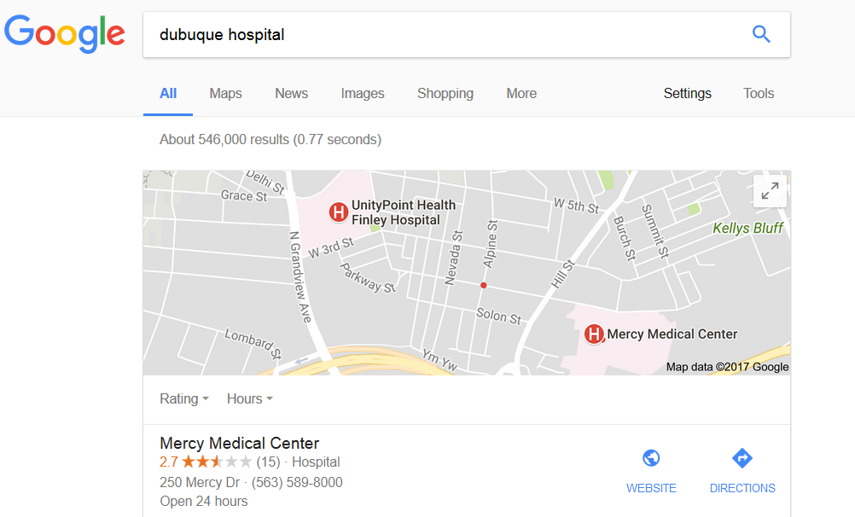
Hospital Research Suggestion:
Name of city, hospital

Military bases are a little more complicated. You will need to first figure out where there are military bases in Iowa. You should then mark them on the map. This will help you see which base is closest.

Random Musings

Over the next couple of days, each group is going to plan out an evacuation route in case of an emergency. In order for people to survive, we need to plan for the problems that we discussed.

Natural Disaster and Geography
Show pictures and trailers of natural disaster aka Chicago getting destroyed, brainstorm what will happen to the people of Chicago and how it would happen in the United States, start the program
Possibly Frye Fest details

Within the Project
Breakout Kit
Sporcle and map quizzes

Suggested Basic Route Requirements
- The planned route must start on the eastern border of Iowa and finish on the western border.
- The route must take exactly seven days to complete.
- You need to choose towns where people leaving Chicago can rest and spend the night,
- These rest places must have a population larger than 10,000, rest points must have a population larger than 500.
- Since the military will be sending tanks and troops to restore order in Chicago, we need to keep the interstates clear of people. Therefore, your proposed path should never ask people to walk along major interstates, usually marked in green.
- The total amount traveled can never exceed 100 miles

Contracts, different color
Within the Project
Breakout Kit
Sporcle and map quizzes
General Lesson Cycle Musings
Major Medical Supplies possibly located
Outbreak of disease
Major Unviersities

Students are given codes to solve.
Intercepting numbers over a frequency.
Steal supplies and return
Description of medical supplies

