Name:

Block: Maps of Region (MOR) – Political Maps

Teacher:

1946 – Political Map | Why do these borders exist?
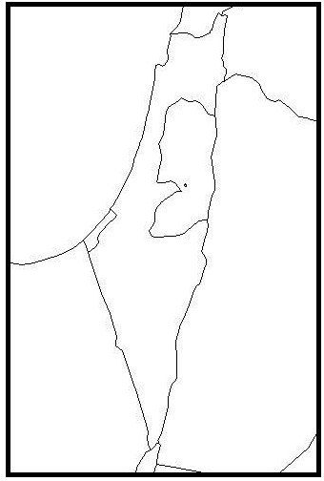 | ________________________________  ________________________________  ________________________________  ________________________________  ________________________________  ________________________________  ________________________________  ________________________________  ________________________________  ________________________________  ________________________________

1947 – Political Map | Why do these borders exist?
________________________________
________________________________
________________________________
________________________________
________________________________
________________________________
________________________________
________________________________
________________________________
________________________________
________________________________

1967 War – Political Map | Why do these borders exist?
________________________________
________________________________
________________________________
________________________________
________________________________
________________________________
________________________________
________________________________
________________________________
________________________________
________________________________

Current – Political Map | Why do these borders exist?
________________________________
________________________________
________________________________
________________________________
________________________________
________________________________
________________________________
________________________________
________________________________
________________________________
________________________________

Document A – Creation of Israel (Class Copy)
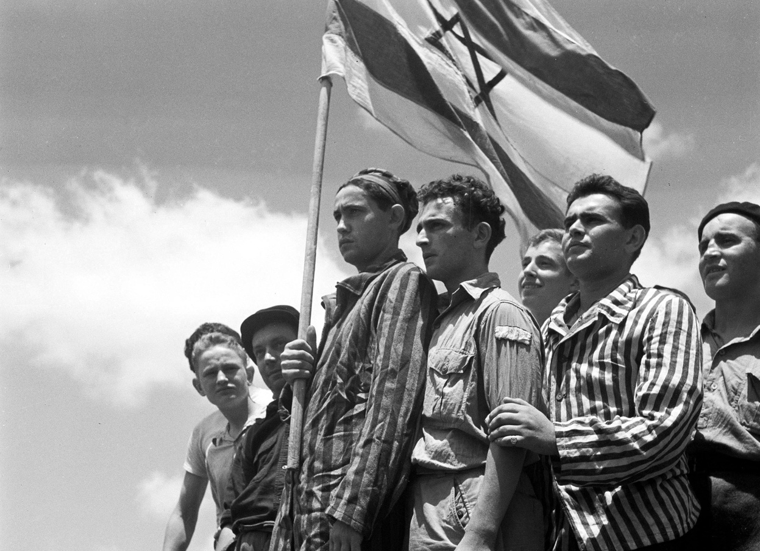
Introduction
The Palestine (Muslim) vs. Israel (Jewish) argument is mostly about land. Both sides, the Jews and the Muslims, both claim the same territory/land along the eastern shore of the Mediterranean. The Jews call this land Israel, the Palestinian (Muslims) who also live there, call it Palestine. Nationalism makes the situation more complicated. Nationalism, which first appeared in the 18th century, means creating a feeling of togetherness and pride in a country. Often speaking the same language and sharing the same values and way of life, they have a common love of their country.
Israeli nationalism started as soon as the country was set up in 1948. Palestinian nationalism began more slowly because the Palestinians never truly had a country of their own, but by the 1980s, it was a powerful force. The Arab-Israeli became a clash between two groups of people, as well as a battle over land.
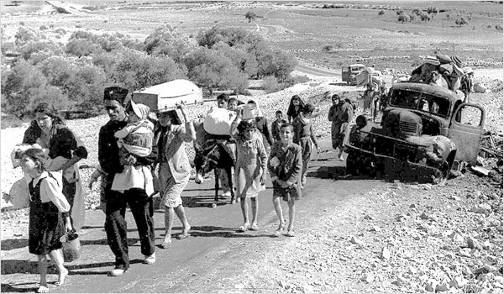
Religion and race make the conflict more complicated. Some Israelis, unshaking in their Jewish religion, believe they are Gods chosen people and he has given the land of Israel to them. Similarly, some Palestinians, who are Muslims, believe it is their holy duty to drive out ‘unbeliever’ Jews. This fight between religions makes the conflict/drama harder to solve.
Often, people consider themselves Jewish or Muslim that live outside of the area make poor decisions. For example, some Palestinians have carried out suicide bombings that sometimes kill innocent people. After the September 11, 2001 terrorist attacks on New York and Washington, the Arab-Israeli problem became more complicated when United States invaded both Iraq and Afghanistan and started to give more money to the Israelis.
Another important thing to understand is that the conflict has been going for a supper longtime. By 2003, it had lasted for more than 50 years, and the longer it goes on, the more difficult is became to come to an agreement. People have grown up knowing nothing but the fighting between the Jews and Muslims. They often grew up learning stereotypes and learned to hate the other side. (Think of Gabriel asking his father to kill the Israeli soldiers with a knife!)
Holocaust
In the 1920s, many European Jews moved to America. However, when people started to lose their jobs in the 1930s (called the Great Depression), the US to stopped people who were Jewish from moving to America. This happened at the same time as the Nazi party was attacking German Jews with great violence in Europe. In 1939, the British decided to stop people from entering their country as well. Although some people managed to sneak in, it meant that millions of Jews had no place to go when Hitler started attacking them.
World War 2 ( 1939-45) increased American interest in the Palestinian situation because US politicians wanted the support of American-Jewish business leaders to help them in the war effort. As consequence of the Great Depression and events during the war, Americans started saying that they thought the Jewish people deserved their own country. Meanwhile, the British were trying to make sure that the Muslims living in the Middle East liked them because they wanted their oil/gasoline. At the same time, because they were at war with Hitler, the British felt that needed to support the people Hitler Hated most, the Jews. By 1945, this balancing had become too much: Britain had either the money nor the will solve the growing drama between the Israelis and Palestinians.
Israel, 1948-49
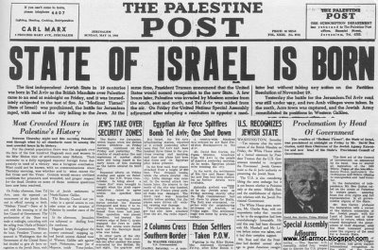
By the spring of 1948, the Palestinian situation was out of control, with Jews and Arabs in open (but undeclared) combat. Following killings by both sides in April, on 14 May 1948 the Jewish leadership of President Chaim Weizmann and Prime Minster David Ben Gurion declared that they were going to start a new nation, Israel. The mostly Muslim countries of Egypt, Lebanon, Transjordan, Syria and Iraq declared war on Israel the following day. Their aim, they said, was to free Palestine.
The fighting lasted on and off until early in 1949. After early defeats, the better led and more heavily armed Israeli forces won several victories and ended up with a country 21 per cent larger than before. There were Arabs (Muslim) gains, too: Jordan controlled the West Bank and Egypt controlled Gaza Strip.
The biggest losers were the Palestinians, who now had no immediate hope of establishing their own country. Israel now controlled most of their territory and their Muslim friends had betrayed them.
Document B – Six Day War (Class Copy)
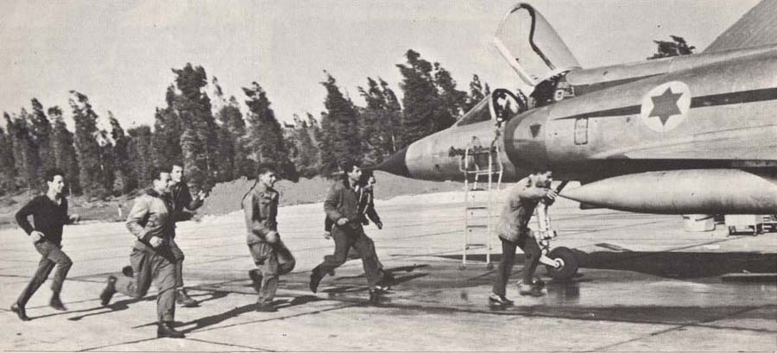
The Six-Day War, 1967
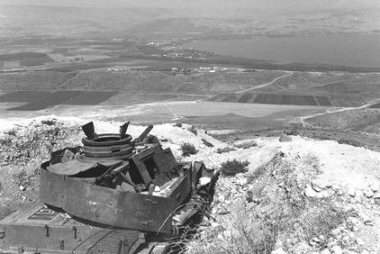
The thing that started the third Jewish-Muslim war was when an anti-Jewish government elected in Syria. Israeli (Jewish) fears mounted and serious fighting continued into 1967. In May, acting on a fake Russian report that Israeli troops were gathering for an attack on Syria, Egypt’s ally, the Egyptians moved its army close to Israel.
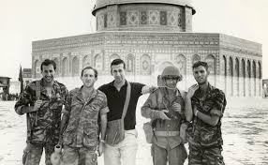
On 22 May, Egyptian leader Nasser stopped all boats from entering the Israeli city of Elat. Two weeks later, feeling sure they were about to be attacked, the Israelis launched a surprise air attack on Egypt, Jordan and Syria destroying most of their air forces. Without air cover, the poorly coordinated Arab (Muslim) armies were defeated by the better-equipped Israelis.
In less than a week, the Israelis had captured Egyptian territory all the way to Suez Canal. Israel had also taken over all of the West Bank and captured the vital Golan Heights on the border with Syria. They also took control of all Jerusalem, a city that had earlier been divided between itself and Jordan. Israel had tripled in size. Meanwhile, the Palestinian people had to try and find a safe place to live.

Document F – Cycle of Violence (Class Copy)
Intifada
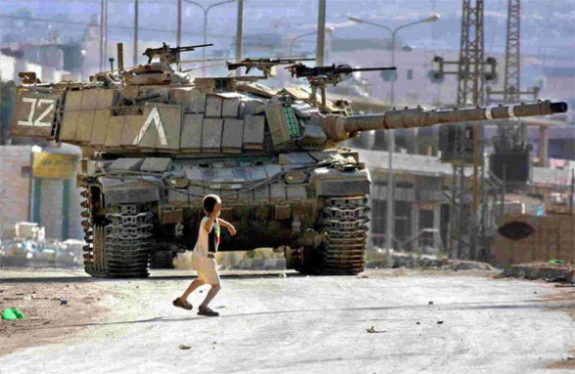
Both the Jews and Muslims have groups that can be considered as radical or extreme.
The main Jewish extremist group is called the Zionists who believe that all Israel’s territory was God-given. They also called for more Jewish towns to be built in the West Bank, which Israel had captured in 1967.
Not everyone in Israel agrees with the Zionists. Some of them feel guilty about their country’s aggression, and have tried to make peace with the Palestinians. As violence mounted during the 1980s, both sides became more set in their positions.
One of the main Muslim extremists groups is called Hamas. Hamas often uses violence to try and get what it wants. They often attack targets that can’t fight back, like bus stops or restaurants. In 1987, the Palestinians/Israeli conflict changed when the Palestinians of the West Bank and Gaza Strip began a violent resistance known as the Intifada. Men, women and children made life difficult as possible for the Israelis. They went on strike, refused to have any form of business or contract. Some even resorted to violence.
Many Palestinians didn’t think that they should choose violence. Some villages, like Bi’lin in the Five Broken Cameras, tried to use nonviolent protests to get what they wanted with limited success. 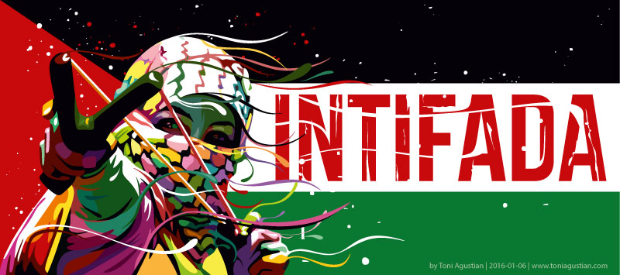

Terror and Counter-Terror
Following the murder of Israel’s Prime Minister Rabin in 1995, the peace talks between Jews and Muslims began to fall apart. There were talks and even agreements, but always the efforts of the USA, the Palestinians, and Israeli governments of the left and right failed because of extremists in all countries. Tired of all the talk and empty promises, in 2000, the Palestinians launch a second Intifida.
Palestinian extremists organized by the terrorist groups Hamas and Islamic Jihad, turned to suicide bombings. Young people, told they would become martyrs, tied explosives around their bodies and detonated them in crowded places popular with Israelis, like shopping malls or night-clubs and on packed buses. The death, mutilation and destruction are difficult to imagine.
Each time this happened, the Israelis responded by making arrests, flattening the houses or neighborhoods from which they believed the bombers have come, and killing suspected terrorists and people who liked them. Both sides killed innocent people. And each attack and counter revenge attack brought new suffering and grief, feeding the never ending cycle of hatred and revenge.
Name: highlighters or makers to designate what info is high standard of living and which is poor

Block: Israel vs. Palestine – Document G

Teacher:

Directions: Use the CIA World Fact Book to collect the information about the below countries. Look for the category labels that are in bold; this will be how it is labeled on the website. The words not in bold are there to help you understand what the category means. Each category will answered in order; make sure you are taking your time, completely finish a country before moving to another.

Category Country-> | United States | Israel | West Bank | Gaza Strip
Population Growth Rate
Did your country get bigger last year?
Death Rate
What percentage of your population died last year?
Urbanization
How many of your people lived in cities?
Mother’s mean age at first birth
What is the average age of a woman when she first gives birth?
Life Expectancy at Birth
l----Economy---l l--------------------------------------- People and Society --------------------------------------l
When someone is born how long can they expect to live?
Drinking Water Source
What percentage of people in your country have access to clean water?
Literacy  What percentage of people in your country can read and write? | Unavailable
School Life Expectancy
How many years does the average person your country stay in school?
Unemployment, youth ages 15-24
What percentage of young people can’t find work
GDP – Per Capita
How much money does the average person in your country make?
Population below poverty line
What percentage of your population is poor?

Name:

Block: Biased Cartoon

Teacher:

Directions: When you finish this station, take this sheet and staple it behind your student sheet that already has your name, block, and teacher.

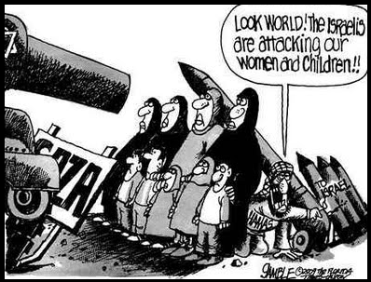

As a Palestinian, I think the cartoon…  _________________________  _________________________  _________________________  _________________________  _________________________  _________________________  _________________________  _________________________  _________________________  _________________________  _________________________  _________________________ | As an Israeli, I think the cartoon…  _________________________  _________________________  _________________________  _________________________  _________________________  _________________________  _________________________  _________________________  _________________________  _________________________  _________________________  _________________________

Title: _____________________________________

Map Key

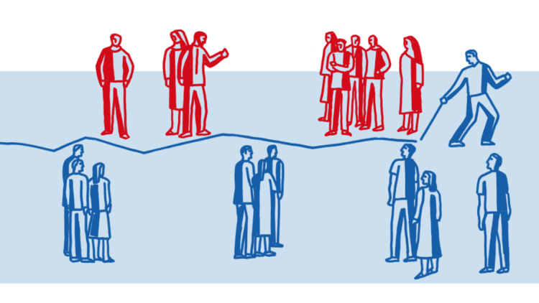
Israel isn't, and will never be, an apartheid country!

Fighting against Israel has gone through three different stages.
The first stage was the attempt to destroy Israel by armies. It began with Israel's creation in 1948, when Muslim armies nearly captured Tel Aviv and Jerusalem, and ended in the 1973 Yom Kippur War, when Israeli army finally stopped Muslim countries from attacking them.
The next stage, starting in the early 1970s, sought to destroy Israel through terrorism. Suicide bombers nearly scared the country so much that people were afraid to go out in public, but by 2005 they too were defeated.
However those people say that Israel is creating a system of apartheid are helping to take part in the third stage to destroy Israel.
This third stage is when Israel's enemies launched the third, and potentially most threatening attack yet to try and take away Israel’s friends and make people hate a peaceful country. These people who attack Israel with words are using an extremely destructive word, “apartheid.”
Apartheid come from a South African language, apartheid means "apart-hood." It comes from the deeply held racist beliefs of South African whites who, after World War II, created barriers both through laws and fences to separate whites and blacks in their country. The apartheid, separation was total: separate restaurants, separate toilets and drinking fountains, separate houses, hospitals and schools. Blacks were denied the right to vote based on their skin color.
Today, the word "apartheid" is used by Israel's enemies to attack the Jewish state. These people point to the separation between Israelis and Palestinians, separate Israeli and Palestinian roads, and separate schools, hospitals and court systems. Although Israelis can elect their leaders, opponents of Israel say, Palestinians cannot. They claim that Israel has created an "apartheid wall" between Jewish and Muslim areas.
Yet none of this being described even resembles apartheid. The vast majority of settlers and Palestinians choose to live apart because of cultural and historical differences, not forced segregation, though thousands of them do work side by side. The separate roads were created in response to terrorist attacks — not to segregate Palestinians but to save Jewish lives. And Israeli roads are used by Israeli Jews and Arabs alike. The separation of schools is, again, a cultural choice similar to that made by Jews, Muslims, and Christians. Many Palestinians/Muslims, however, study in Israeli colleges such as Ariel University, located in a settlement. Thousands of Palestinians, many of them from Hamas-controlled Gaza, are treated at Israeli hospitals.
Israelis can vote for their leaders, and so too can the Palestinians, but the Palestinian Government has refused to hold elections for years. Palestinians are indeed tried under Israeli (originally British) military codes for “endangering the security of the community,” but other cases are referred to Palestinian courts.
Israel has erected a security barrier between it and most of the West Bank. But the barrier, is an important counter-terrorism tool, is not permanent and has been moved several times to give Palestinians what they want. It is no more an apartheid wall than the fence between the United States and Mexico.
The West Bank represents a complex situation that six Israeli prime ministers have tried to solve. Unfortunately, Palestinian leaders turned down Israeli peace offers and have now abandoned peace talks in favor of being friends with Hamas. Hamas wants to create a Palestinian state in the West Bank and Gaza from which all Jews have been kicked out. That is truly apartheid.
Outside of the West Bank, in Jerusalem and elsewhere in Israel, Jews and Muslims walk around freely and increasingly live in the same communities. Muslims serve in Israel's government, in its army and as judges. And though discrimination in Israel, as in America, remains a problem, there is no forced separation. Go to any Israeli mall, any restaurant or hospital, and you will see Muslims and Jews interacting.
What actually is going on in Israel hasn’t prevented Israel's enemies from saying that a system of apartheid. People who use this word, use it because they don’t want peace but rather want tot take away Israel’s friends. We Jews remember how each attempt to kill us as a people, whether in the Inquisition or during the Holocaust, had leaders attack us, try to attack us as community. People who practice apartheid are considered okay to attack.
Israel is not an apartheid state and will not become one, even if the Palestinians continue to reject peace. However those who claim that apartheid exists in Israel and are just helping that third final stage of people trying to destroy to the country of the Jews. They are also insulting the South African blacks who were the victims of true apartheid.
___________________________________________________________________________________
Underline and mark the text that answers the following questions:
- What are the three stages/phases of destruction that Israeli’s have faced?
- How does the author define apartheid?
- According to the author, what did apartheid look like in South Africa?
- What do Israelis’ enemies say is happening in Palestine and Israel?
- How does the author prove these enemies wrong?

___________________________________________________________________________________
Step 1: Read thru the entire article.

Step 2: Underline and mark the text that answers the following questions:
- What are the three stages/phases of destruction that Israeli’s have faced?
- How does the author define apartheid?
- According to the author, what did apartheid look like in South Africa?
- What do Israelis’ enemies say is happening in Palestine and Israel?
- How does the author prove these enemies wrong?

Step 3: Outline- Use the highlighted text to plan out a paragraph response to the prompt below. Remember, you don’t need to write in complete sentences for the outline.

Why doesn’t a state of apartheid exist in Israel?
___________________________________________________________________________________
Sentence | 1 | 2 | 3 | 4 | 5
Idea for Sentence | Throw Back Question
Document | -
___________________________________________________________________________________

Step 4: Using the outline, respond to the prompt. Make sure that you use and cite specific text evidence that helped shape your opinion.

Step 5: The opposing side is reading an article that says a state of apartheid does exist. The author to this article isn’t to be trusted. Research who this person is, who he works for, where they went to school and anything else that could have shaped their perspective on this issue.

Saree Makdisi, a professor of English and comparative literature at UCLA, is the author of "Palestine Inside Out: An Everyday Occupation."

Does the term 'apartheid' fit Israel? Of course it does.

The drama created after one of President Obama’s most trusted advisors said “that Israel risked creating a country based on apartheid” reminds us that this word carries a lot meaning, that sometimes people’s reactions to this word aren’t based on fact or logic.
It reminds me of similar drama when other major leaders used the "A-word" in connection with Israel, it is interesting to examine how emotional and instant people’s reactions were.
"Israel is the only democracy in the Middle East, and any linkage between Israel and apartheid is nonsensical and ridiculous," said a government leader in Washington D.C. Well if this leader disagrees with Obama’s adviser, then there isn’t a debate right? No way could a state of apartheid exist, right?
The short answer to that ridiculous question, NO! Small and simple phrases, not based on facts, are often used by some political leaders in America, but anyone who actually looks at the situation between Israel and Palestine will realize that apartheid does apply.
"Apartheid" isn't just a word used as an insult; it's a word with a very specific definition.
The agreed upon college definition is that apartheid are laws written "for the purpose of creating domination of one group over for the purpose of systemically oppressing them (keeping them down)."
The college definition goes to say that a system of apartheid includes a system that:
- Restricts peoples access to a high quality of life and freedom
- People can be arrested, with little to no cause
- Their belongings and property can be taken away
- Their rights to leave and return to the country are restricted
- The rights to move around the country and where they can live are restricted
- Creating separate areas for people based on culture/ethnic groups
- Forbidding “mixed” marriage between racial/ethnic groups
Now that we have outlined the characteristics that make up an apartheid country, let’s take a closer look at what is happening between Israel and Palestine.
Muslims and Jews living in Palestine(West Bank and Gaza)
Israel has created a system of housing laws that enforces separation, whether it’s by actually written rules or by unwritten rules.
It's obvious, of course, that Jewish settlements in the West Bank don’t have many Palestinians. In Israel itself, however, hundreds of communities have been created for Jews on land taken from Palestinians, in which separation has been enforced. An example of how this is enforced is that towns/communities has a “group of residents” that decide who can live in the community.
Also, a large part of Israel contains land that only Jews can buy. There isn’t a law that says Muslims can’t but this territory, Muslims just never get approved to buy the land, on Jews do.
Jews living in the West Bank enjoy greater freedom and rights than the Palestinians do. Jews are protected by Israeli law, while Muslims living in the same area are forced to follow laws created by the Israeli military.
An example of how this is unfair, Jews can travel freely through West Bank and Israel, while Palestinians face being arrested and jailed for little no reason. The Palestinians can’t change the laws because they aren’t citizens. This freedom of movement denies Palestinians access to many schools, hospitals, and religious sites.
Palestinians (Muslims) living in Israel
Meanwhile, Muslims that live in Israel, have to face fifty laws/rules that are unfair to them.
One of the worst of these laws is that a Jew can leave Israel and come back whenever they want. Muslims can not only not do this, but they are also prevented from bring family members into the country.
The educational systems for the Muslims and Jews is separate and unequal. While overcrowded Palestinian schools in Israel crumble, Jewish students are given access to more resources and brilliant teachers like Mr. Patterson.
(Why does Mr. Patterson always write about himself? Man I can’t wait until 8th grade, that way I can fall asleep in class listening to Mr. Fisher go on, and on, and about ‘merica!)
It is not legally possible in Israel for a Jewish citizen to marry a non-Jewish citizen. And a series of laws and rules say that people can’t live in which particular spaces makes mixed marriages all but impossible
And so it goes on, in almost every part of life in Palestine and Israel. From birth to death, people’s lives are different depending who you are.
The existing laws, written and enforced by Israel are creating this inequality.
Muslims/Palestinians — have had their property taken away, freedoms reduced, kicked out of certain areas, humiliated, punished, thrown in prison, and at times driven to the edge of starvation
Israelis/Jews — have freedom of movement, since their business have been encouraged to succeed by the government, they have, at times at the cost to Muslims
The question that should really be answered is not whether the term "apartheid" applies to Israel and Palestine. It is why is there so much drama when a leader uses to describe what’s actually happening?
Underline and mark the text that answers the following questions:
- What happens when people use the word “apartheid?”
- How does the author define apartheid?
- Based on this definition, how does apartheid exist in the West Bank and Gaza?
- Based on this definition, how does apartheid exist in Israel?
- Who is creating and enforcing these unfair laws/rules?

___________________________________________________________________________________
Step 1: Read thru the entire article.

Step 2: Underline and mark the text that answers the following questions:
- What happens when people use the word “apartheid?”
- How does the author define apartheid?
- Based on this definition, how does apartheid exist in the West Bank and Gaza?
- Based on this definition, how does apartheid exist in Israel?
- Who is creating and enforcing these unfair laws/rules?

Step 3: Outline- Use the highlighted text to plan out a paragraph response to the prompt below. Remember, you don’t need to write in complete sentences for the outline.

Explain, with examples, how apartheid exists in both Israel and Palestine.
___________________________________________________________________________________
Sentence | 1 | 2 | 3 | 4 | 5
Idea for Sentence | Throw Back Question
Document | -
___________________________________________________________________________________

Step 4: Using the outline, respond to the prompt. Make sure that you use and cite specific text evidence that helped shape your opinion.

Step 5: The opposing side is reading an article that says a state of apartheid doesn’t exist. The author to this article isn’t to be trusted. Research who this person is, who he works for, where they went to school and anything else that could have shaped their perspective on this issue.

‘Michael Oren, Israel's ambassador to the United States from 2009 to 2013, is a senior fellow in international diplomacy at the Interdisciplinary Center Herzliya and a fellow at the Atlantic Council.

