Name:

Block: Individual and the Economy - Vocab

Teacher:

Directions: For each vocabulary word, finish the sentence starters provided and answer any questions posed for each concept (idea). It will be necessary to write out your answers on a lined piece of paper and then staple it to this sheet.

1. Natural Resources
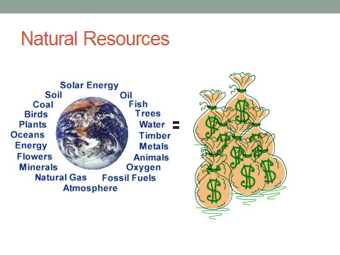
- Natural resources are…

- An example of a natural resource commonly found in the Middle East…

- Does having a lot of natural resources mean that a country will always have a high GDP per Capita and long life expectancy?

- What did we look at/do in class to learn about the idea of natural resources?

2. Standard of Living (SOL)
- Standard of Living means…
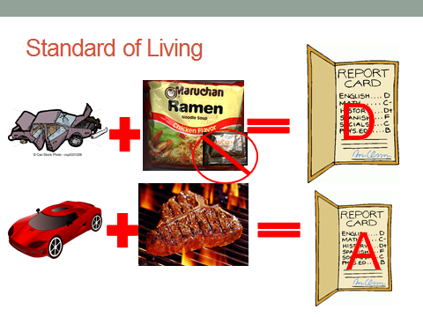
- Two commonly looked at categories to measure SOL are…

- In your opinion, why are these numbers used to measure SOL?

- What are some of the problems of relying on these numbers?

- What did we look at/do in class to learn about the idea of standard of living

Go to: http://quizlet.com/_15uvrg

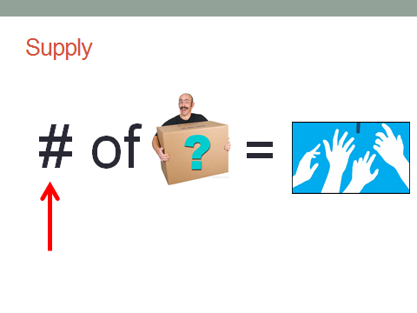
3. Supply
- Supply means the…

- In our OPEC simulation/game, the resource that we supplied was…

- Country’s wanted to supply…. When the price was….

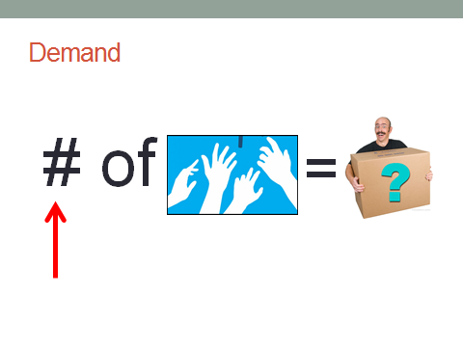
4. Demand
- Demand means the…

- In our OPEC simulation/game, a country’s resource was in demand when it…

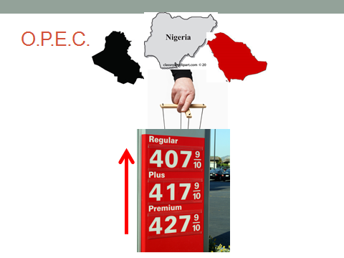
4. OPEC
- The purpose of OPEC is to…

- In order for OPEC to work, countries must…

- OPEC tries to accomplish this by…

Go to: http://quizlet.com/_15uvrg

Name: OLD RESOURCES

Block: Vocabulary Quiz

Teacher:

Directions: Match the vocabulary word with the corresponding definition.

1. ______ Supply | A. The amount of something available.
2. ______Demand | B. Materials produced by the Earth that are valuable to human society.
3. ______ Natural Resource | C. The amount of something that is wanted.
4. ______ Standard of Living | D. A group of countries that controls the supply of oil in the attempt to raise prices.
5.______O.P.E.C. | E. The average quality of life for a person living in a community.
6.______Crude Oil | F. Natural resource, taken from the ground, that is used to create gas that powers cars.

Study Help
Go to: http://quizlet.com/_15uvrg

Name:

Block: Vocabulary Quiz

Teacher:

Directions: Match the vocabulary word with the corresponding definition.

1. ______ Supply | A. The amount of something available.
2. ______Demand | B. Materials produced by the Earth that are valuable to human society.
3. ______ Natural Resource | C. The amount of something that is wanted.
4. ______ Standard of Living | D. A group of countries that controls the supply of oil in the attempt to raise prices.
5.______O.P.E.C. | E. The average quality of life for a person living in a community.
6.______Crude Oil | F. Natural resource, taken from the ground, that is used to create gas that powers cars.

Study Help
Go to: http://quizlet.com/_15uvrg

Name:

Block: Vocabulary Sentences

Teacher:

Directions: Use the following words vocabulary words in complete sentences. When you use the word in the sentence please highlight it. You can’t simply just copy the definition from class; rather you’re showing that you understand the definition by using it in a sentence.

1. Supply
__________________________________________________________
__________________________________________________________
__________________________________________________________

2. Demand
__________________________________________________________
__________________________________________________________
__________________________________________________________

3. Natural Resources
__________________________________________________________
__________________________________________________________
__________________________________________________________

4. Standard of Living
__________________________________________________________
__________________________________________________________
__________________________________________________________

5. O.P.E.C.
__________________________________________________________
__________________________________________________________
__________________________________________________________

6. Crude Oil
__________________________________________________________
__________________________________________________________
__________________________________________________________
Name:

Block: Vocabulary Quiz

Teacher:

Directions: Define the following vocabulary words in complete sentences, when you use the vocabulary word please highlight it. The definition you write must show that you fully understand the definition of the word.

1. Supply
__________________________________________________________
__________________________________________________________
__________________________________________________________

2. Demand
__________________________________________________________
__________________________________________________________
__________________________________________________________

3. Natural Resources
__________________________________________________________
__________________________________________________________
__________________________________________________________

4. Standard of Living
__________________________________________________________
__________________________________________________________
__________________________________________________________

5. O.P.E.C.
__________________________________________________________
__________________________________________________________
__________________________________________________________

6. Crude Oil
__________________________________________________________
__________________________________________________________
__________________________________________________________

