Oil Lesson Cycle
Southwest Asia Task 3 – (Imperfect Cartel)
Patterson

(W) Means on website
Underline what should be said to the class
If there is a blue word click on it while holding down “ctrl”

Standard Being Taught | How standard will be assessed | Outline
b.) Evaluate OPECs past, and predict future success. |  | Simulation – Flaws of OPEC  Graph of Oil Prices  Pre-OPEC, OPEC, New Drilling  Times Article

Day 1
Learning Target – I will play an academic game that shows will show the limitations of OPEC.

Warm Up - No Warm Up
OPECSimulationIndependentSellers (W)  Warm Up should use pictures from oligarchy reflection | Resources  Materials  Extension

Day 2
Learning Target – I will graph crude oil prices in order to analyze (examine closely) supply and demand.

Warm Up – Give students ten minutes to work on the reflection. Discuss answers.
OPECSimulationIndependentSellers (W)  -reflection sheet, discuss, tie in Extension  Graph Oil Prices OneNote  -–OneNote page started, create video | Discussion  See OneNote pictures for teeter tooter example, ask students what they buy with a million dollars  Talk about Mansa Musa, Salt and Gold, Supply and Demand  Diamonds, Natural Resource, De Beers,  Watch again video

Day 3
Learning Target – I will learn how fracking changed the world by analyzing various secondary sources.

Warm Up – No Warm Up
Fracking Episode NPR Change to Change to Planet Money  Instructions in OneNote | Resources  Extension  CostofCheapGasTimesArticle – (W)  -GT reading, find/scan copy  Planet Money: #681 The Oil Kingdom

Day 4-9
Learning Target – I will

Warm Up -
CIA Project Intro/Calendar  -page 3-9  Civil Service Exam (Individual and Economy Assessment)  Create video for analyzing data  Work completion chart | Resources  Materials  Extension  Students should receive CIA instructions in envelopes, this is also how they should turn in/organize their work  Saudi Arabia Uncovered (OneNote)  Link

Musings
Revise CIA project, apply with prediction of which country is most likely to have a coup de’tat and be destabilized by the low price of oil.
Before students think that they are done, have them find someone who is also finished not sitting at their table that has the same answers.
Remove mother’s median age at first birth since data doesn’t exist for some countries
For advanced students, have them look in to Task Day 8, Iran and Argo
For lower students that claim that they are done, use maps from Task 1.
Everyone should take the civil service exam on a specific day, if they haven’t.
Have Students listen to
NPR Story Planet Money Oil Kingdom
Align CIA chart to example in second task
Align chart to Mid East Task 2, switch learning target information, Create completion chart, Shorten warm up

Welcome to the Central Intelligence Agency

The Central Intelligence Agency (CIA) is responsible for gathering information about foreign political and military issues, analyzing this data, and then helping people in the government make the right decisions. Here, your goals and mission will be to protect the national security of the United States.
_____________________________________________________________________________________Career Opportunities

At the CIA, we provide intelligence (information and inferences) to the president and Congress for decisions of national importance. Our analysts, (people who examine data) are skilled global studies experts who study and evaluate (give judgment on) information from primary and secondary sources. CIA analysts monitor (track) and assess (prioritize) political developments, leadership, economic issues, military threats and science and technology that are occurring around the world.

https://goo.gl/uDHUau
_____________________________________________________________________________________
Job Description – Economic Analyst

Work Schedule: | Full Time
Salary: | $50,864 – $99,296*
Location: | Washington, DC metropolitan area
*Higher starting salary possible depending on experience level.

Economic analysts examine how trading, natural resources, and money issues affect US security interests. They work closely with other political, leadership, and military CIA workers to write intelligence papers and briefings for the president and other officials.

Economic analysts will examine (look at closely) terrorist and criminal groups, how illegal money is put into banks, find information about politicians stealing money, and learn more about how countries may hurt the United States by cutting off natural resources.

Economic analysts need to show that they understand:
Topic | 2 | 3 | 4
Individual in the Economy | Define the following key concepts:  A.) scarcity, trade-offs, supply, demand  B.) economic institutions | A1.) Understand how resource imbalance leads to economic problems within a region.  A2.) Understand what determines a person’s quality of life.  B1.) Evaluate an organization/group that is trying to bring about change. | Evaluate whether an imbalance could or even should be solved.

_____________________________________________________________________________________
Application Process
The following items must be attached to your application:
- A letter addressed to the head of the CIA where you explain who you are and why the CIA should hire you instead of the other people applying.

- A completed and graded Civil Service Exam (assessment).

- An example of you doing research that shows your ability to analyze a pressing economic situation.
_____________________________________________________________________________________
Applicants from Iowa

Each state has a regional recruiter that works for the C.I.A. Your recruiter is Mr. Patterson. Mr. Patterson will help you with your application process so that you have the best chance getting hired. Mr. Patterson has also created a checklist for you, along with a calendar, to track your progress.

Checklist | Description | Signature of Completion
Can OPEC Survive? | Day 1/2  Gather information to fill out chart.  Day 3  Analyze data and complete essay frame.  Day 4  Plan out and write two paragraphs
Civil Service Exam | Day 5  Take the Civil Service Exam for Individual and the Economy.
Cover Letter | Day 6  A letter addressed to the head of the CIA where you explain who you are and why should the CIA hire you instead of the other people applying.

_____________________________________________________________________________________

Turn in your application in this order:
1. Cover Letter
2. Graded Civil Service Exam
3. OPEC, can is survive?
4. OPEC paragraphs

Name:

Block: Civil Service Exam

Teacher:

Topic | 2 | 3 | 4
Individual in the Economy | a) supply, demand, standard of living, natural resource | a.1) Understand how/why OPEC tries to balance supply and demand.  a.2) Understand how natural resource imbalance leads to economic problems within a region.  a.3) Understand what factors determine a person’s quality of life.  b.) Evaluate OPECs past, and predict future success. | -Should Qatar host the 2022 FIFA World Cup?  -Why is OPEC allowing oil prices to be so low?  -What will happen when oil isn’t worth anything?

Directions: Provide a definition for each of the vocabulary phrases for this unit. It is not required but may be helpful to connect your definition to what we did in class.

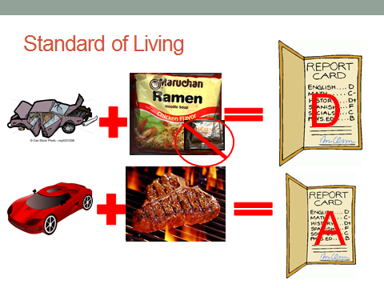
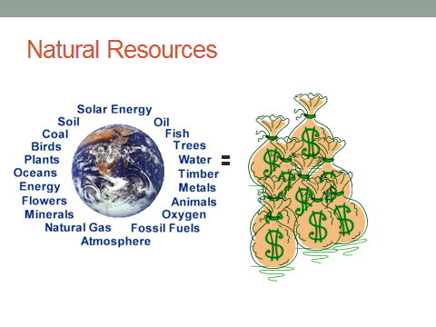

2

1

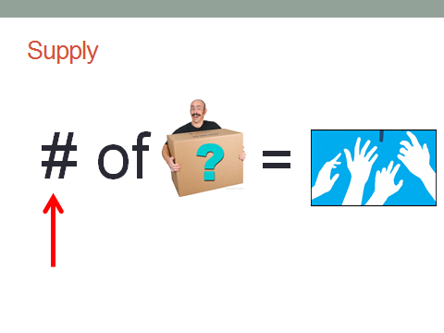
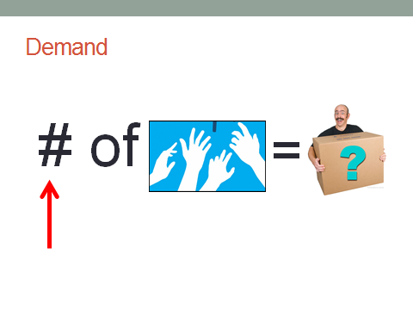

3

4
6. When we were learning about supply and demand, Mr. Patterson drew this seesaw on the whiteboard. To the best of your ability, explain what his cringe worthy drawing is showing.
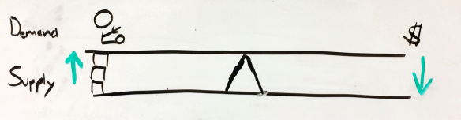
_____________________________________________________________________________________
Category | Meaning of Category | Yemen | Qatar
GDP per Capita | Average Income per person | 1,070 | 80,440
Life Expectancy | Average life span of person | 65 years | 79 years
Literacy Rate | % of people that can read | 54% | 100%
Oil Reserves | Amount of natural resources | None | Large Amount

7. Based off the chart above, compare the standards of living between Yemen and Qatar. Use specific information (numbers) that shaped your opinion. Based off this information, does a country have an advantage? Make an educated guess as to why.
_____________________________________________________________________________________
8. Why would having a high standard of living help a country better respond to common issues facing countries in the Middle East? In your response, you could write about some of the issues below.
- Terrorist organizations  - Refugees  - War/Coup de ’tats | - Low literacy rate  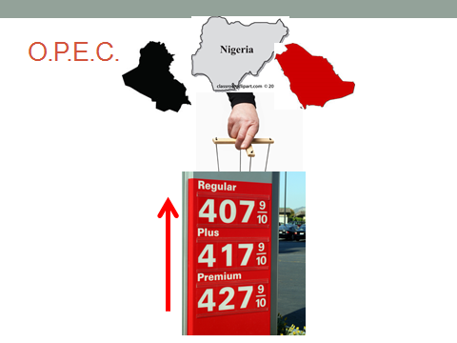  - Famine (lack of food)
____________________________________________________________
9. What is the purpose of OPEC? What does it try and control?
How does it do this? *Hint, think back to the first oil simulation
we had in class.
____________________________________________________________
10. What are some challenges facing OPEC countries now that the price
of crude oil is falling? How does this threaten OPEC countries working
together? In your opinion, are low oil prices going to bring about the end of OPEC? *Hint: think back to the second oil simulation we had in class. Also, you may use information from your OPEC, Can it Survive? chart to add validity to your answer.

OPEC, Can it Survive? Class Copy

Part 1
Directions: Go to the following websites. Before filling out the information on your chart, you should read through the entire article and watch any videos that loaded on the website. The one exception is the CIA World Fact Book
1. Document A - http://cnb.cx/1M6p5yo

This document includes an article and video. There is a chart halfway thought the article that provides most of the information, however make sure you take your time.

2. Document B - http://bit.ly/1zYJC2i

This document has a rotating flags at the top. These flags represent countries in OPEC. For each country, read the profile, fill out the information

3. Document C – http://1.usa.gov/1A5ceXE
This document takes you to the CIA World Fact-Book. All the countries you’re collecting data are on are in the Middle East expect for Nigeria (Africa) and Venezuela (South America).

GDP per Capita can be found in the Economy tab. Life expectancy of total population can be found in the People and Society tab (or you can just use Google).
4. Document D – https://goo.gl/ccfdU5

Cash reserves is how much cash/money your country has in its back accounts to spend. Only record this number in the millions.

5. Document E- http://bit.ly/17YMuVx

Use the link at the top of this website to find the number of successful/attempted coup de ‘tats for each OPEC country.

Ranking OPEC Countries

Part 3
Directions: Go through each category and rank each country. A 12 would be the country most impacted by the low price of crude oil. A 1 would be the county least impacted by the low price of crude oil.

Annual Value of Oil Sold by Country
- Highest number gets a 12, the second highest number gets an 11.

# of Barrels of Oil Sold a Day
- Highest number gets a 12, the second highest number gets an 11.

Oil Price Needed to Balance Budget
- Highest number gets a 12, the second highest number gets an 11.

GDP per Capita (average amount of money a person makes)
- Lowest number gets a 12, the second lowest number gets an 11.

Life Expectancy (how long the average person lives in the country)
- Lowest number gets a 12, the second lowest number gets an 11.

Cash Reserves (How much money does the country have in the bank)
- Lowest number gets a 12, the second lowest number gets an 11.

# of Coup de ‘tat (number of times the government has been overthrown)
- Highest number gets a 12, the second highest number gets an 11.

_____________________________________________________________________________________
Part 4
Directions: Think about what does our data show? Add up each country’s rankings by row. The countries with the highest four totals, are the ones impacted most by the low price of oil. Using your data, fill out the OPEC, can it survive? chart. There is a video in OneNote that will show you how this works.
_____________________________________________________________________________________
Part 5
Directions: On a lined piece of paper or in OneNote, use your data to identify and prove what two countries are most impacted by the low price of crude oil. These would be countries that that USA wouldn’t want to give move to because they probably won’t be able to pay it back. When finished, your two paragraphs should have both text evidence and citations.

OPEC Country Data Chart Name: Block: Teacher:

Document-> | A | A | B | B | C | C | D | E
Category-> | Annual Value* | Share of GDP** | Oil $ to Balance | # of Barrels of a Day. | GDP Per Capita | Life Expectancy | Cash Reserves | # of Coup***
Algeria
Angola
Ecuador
Iran
Iraq
Kuwait
Libya
Nigeria
Qatar
Saudi Arabia
U.A.E.
Venezuela

*The yearly value of the oil sold by the country.
**The percentage that oil that country relies on.
***Number of times the government’s been overthrown since 1960
OPEC, Can it survive? – OPEC Data chart on backside of where students collected the data

Question: In your opinion, which countries are most impacted by the low price oil?

Country #4
Country #3
Country #2
Country #1

EVIDENCE
EVIDENCE
EVIDENCE
EVIDENCE

C.I.A. Application Calendar OLD RESROURCE
Suggested Calendar
Week | Day 1 | Day 2 | Day 3 | Day 4 | Day 5
1 | C.I.A. Application Process Overview  OPEC Viability (W) – Part 1  -start gathering data for the Country Data Chart | OPEC Viability (W) – Part 2/3  -complete Country Data Chart  -rank OPEC countries | OPEC Viability (W) – Part 4/5  -make inferences about OPEC data  -determine the impact of oil on the United States | Civil Service Exam  If you want, you may play the Oiligarchy Game while your exam is being graded | Olympic Relocation (W)  Day 1
Week | Day 6 | Day 7 | Day 8 | Day 9 | Day 10
2 | Olympic Relocation (W)  Day 2 | Olympic Relocation (W)  Day 2  -Write CIA cover letter  -Submit application as specified in directions

Name: Old School Level 2s

Block: Assessment - Individual and the Economy

Teacher:

Directions: Match the vocabulary word with the corresponding definition.
1. ______ Supply | A. The amount of something available.
2. ______Demand | B. Materials produced by the Earth that are valuable to human society.
3. ______ Natural Resource | C. The amount of something that is wanted.
4. ______ Standard of Living | D. A group of countries that controls the supply of oil in the attempt to raise prices.
5.______O.P.E.C. | E. The average quality of life for a person living in a community.
6.______Crude Oil | F. Natural resource, taken from the ground that is used to create gas that powers cars.

Directions: There are several different factors (reasons) that determine the standard of living of a country. For each factor, label whether a country wants a high number or a small number.

 | Category | Meaning of Category
7.____________ | GDP per Caita | Average Income per person
8.____________ | Life Expectancy | Average life span of person
9. ____________ | Literacy Rate | % of people that can read
10. ___________ | Oil Reserves | Amount of natural resources

Name:

Block: Oil Prices: What is behind the drop? http://goo.gl/aG6yYW

Teacher:

Import- how much a country buys from another country
Export- how much a country sells to another country
Domestic- things made within a country
States- is what we think of as a country

Part 1 - Directions: On a lined piece of paper, answer the question for each section and include text evidence in each response. The online article should be labeled as Doc. T and your lined piece of paper should be stapled behind this page.

- What is the current price of oil?
- Why has the price of oil been dropping so fast? Why now?
- Who benefits from the price drop?
- Who loses?
- What happened to OPEC?
- Is there a conspiracy (secret plan) to bring the price of oil down?
- When are oil prices likely to recover?

Part 2 - Directions: Click on the interactive graphic marked by the arrow. Sketch out the first graph that appears. Using the rest of the graphs on the interactive graphic, explain the different parts of the graph you created.
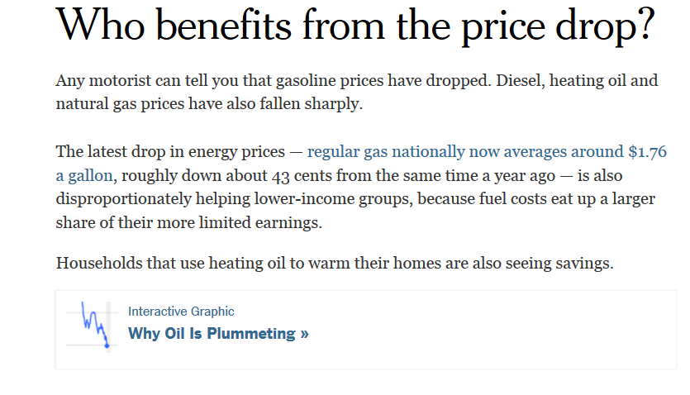

Step 4.5 - NPR News Clip
Go to Google and search planet money saudi arabia. Click on the top link. This will take you to a 15 minute radio show that explains the impact of low oil prices. If you have headphones, listen in class. If you don’t have headphones, you can take your computer out in the hall and listen to it. Not only should you not be sharing a computer but you also shouldn’t be sitting next to each anyone if you’re in the hall.
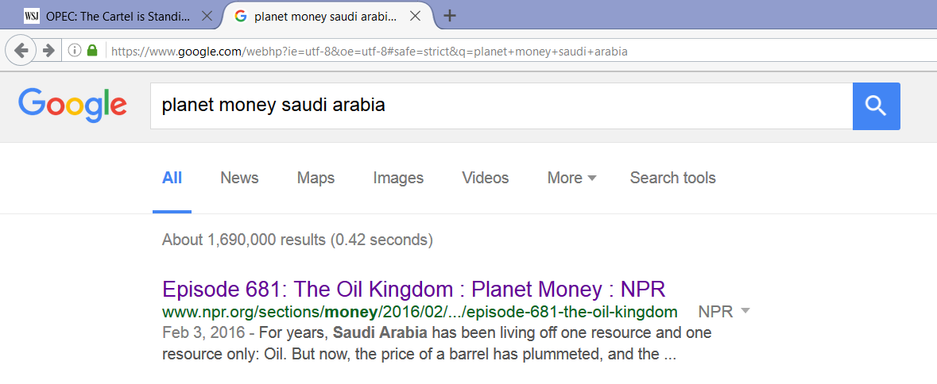

After/while listening to the Planet Money podcast, answer the following questions. You can either answer the questions individual or in one big paragraph. Please include examples that were discussed in the program.
- What is the resoruce curse?
- How has/is Saudi Arabia trying to end it?
- How does the person interviewed think that taxes will change Saudi Arabia?
_____________________________________________________________________________________

Step 5 – More Information
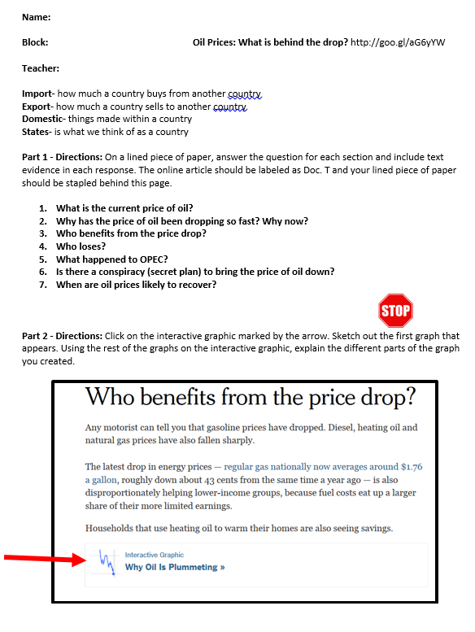
If you feel like you could use more infromation or do not know what to write for part 5, revist the article that you have in your folder.

