Oil Lesson Cycle
Southwest Asia Task 2 – (Supply and Demand)
Patterson

(W) Means on website
Underline what should be said to the class
If there is a blue word click on it while holding down “ctrl”

Standard Being Taught | How standard will be assessed | Outline
a.1) Understand how/why OPEC tries to balance supply and demand. | Supply and Demand F.F.  I.E. Level 2-3 | Oiligarchy Game  Simulation – Need for OPEC  History of OPEC, Graph  Thematic Map

Day 1
Learning Target – I will play an academic game that shows will show why OPEC was created.

Warm Up - No Warm Up
OPEC Middle School Simulation Price Controls (W)  -Reflection should be HW | Resources  Materials  Extension

Day 2
Learning Target – I will learn how/why OPEC tries to balance supply and demand by examining various secondary sources.

Warm Up – Who won the game yesterday? (Discuss who should have won.)
Vocabulary: Supply, Demand, OPEC  -hand out Oil Vocab sheet (W)  Brief History of OPEC/Writing Template  -page 4, 5, 6  -OneNote created with links, print template front to back, make sure you add page numbers  -Visual of requirements in Task 2 | Resources  Materials  Extension  Fill out Nelson Mandela example, make sure to show what to do if you need more space, use numbers in the box on an extra piece of paper.

Day 3
Learning Target – I will learn how/why OPEC tries to balance supply and demand by examining various secondary sources.

Warm Up – Why is this Pokemon card selling for $2,500? See visuals for picture/follow up points
Brief History of OPEC/Writing Template  -Visual of requirements in Task 2  -Create video of what to do when done,  -put name on board, grab a political cartoon, finish, make sure you cite evidence, wait for your name to be called, then only then is it “free time” | Resources  Materials  Extension

Day 4
Learning Target – I will write paragraphs that have text evidence, citations, and that are aligned to a writing outline.

Warm Up –
Use Nelson Mandela example from page 4. Show how to create an outline based on the facts/evidence gathered. Practice saying the paragraph out loud once the outline is created. Display visuals. Type up sample paragraph on the back computer that meets the requirements that are displayed on TV.  Staple writing checklist, track who completes it successfully. Everyone turns in what they have at the end of class, stapled in specific order. | Resources  Materials  Musings  Have a link to the Oiligarchy game in OneNote.  Get list of transition words from Gina.  Block 1, 3, two paragraphs, everyone else is one.  Pull in D’Asia, Keke, Molham, Lydia, show what to do  Arba, Jersom – Make sure they have something to focus on.

Day 5
Learning Target – I will listen to a podcast about crude oil, and synthesize the information I gathered to create…

Warm Up -
Remind students of what to do when there is Computers/Headphones on T.V.  Today’s Task  Students watch intro to Planet Money Video, work on “We buy Oil.” When timer expires, transition to Oiligarchy game. You should not transition before the timer unless you show Mr. Patterson your finished product.  We Buy Oil – Planet Money– OneNote Vid Created  Explore Oiligarchy Game – OneNote Video Created | Resources  -Planet Money Oil, OneNote  -Oiligarchy, OneNote  -Headphones/computers  Materials  Extension

Day 6
Learning Target – I will listen to a podcast about crude oil, and synthesize the information I gathered to create…

Warm Up - If you bought ten dollars of gas at Kum and Go, how much of your money would go to crude oil? See Task 2 visuals
Today’s Task  Students will continue to work on either episodes #1 or #2. Start to fill out Oiligarchy game with handout this time.  Oiligarchy Game (W) –page 1/2 OneNote created | Resources  -Planet Money Oil, OneNote  -Oiligarchy, OneNote  -Headphones/computers  Materials  Extension

Day 7
Learning Target – I will learn how crude oil is processed (refined) so humans can use it in cars.

Warm Up - There were villagers in Nigeria who didn’t like it when you drill in their country. What can you do to stop them? Question is from Oiligarchy, tie in Virunga.
Figure out some sort of demonstration for students to watch.  Student can either do it in small groups or play Oiligarchy/finish their game sheet. Have a Today’s Task ready in OneNote. | Resources  Materials  Extension  If students have everything finished, there is a second, more detailed Oiligarchy reflection they can use.

Day 8
Learning Target – Use this idea on the last day of the CIA project, if extra time is needed.

Warm Up -
America, Iran, Oil, and Tehran  Strategic Oil Reserve  Who and the what – Central Idea of Trailer  Use template to access to plan out paragraph  Planning out paragraph, will be assessed in a week? | Resources  Materials  Extension  Students can work on Oil #4. If not used, make a note and have students save it for later.

Brief History of OPEC – Document F
Vocabulary
OPEC- is a club of oil producing countries that try to control the price of crude oil/gas.

Introduction
OPEC is a club of countries that was created in 1960. The club was created so that countries that have a large amount of oil, could work together to make sure that they could make enough money to raise their citizens’ standard of living. OPEC does this by getting countries to agree on how much oil they want to sell.

By agreeing on how much oil they are going to sell, OPEC is able to balance supply and demand to maximize the amount of money each country in their club could make.

By 2014 OPEC club is made up of twelve members: Algeria, Angola, Ecuador, Iran, Iraq, Kuwait, Libya, Nigeria, Qatar, Saudi Arabia, the United Arab Emirates and Venezuela. According to the United States government, the amount of oil that OPEC club members decide to sell is an important reason that determines oil prices around the world. If they decide to sell a lot of oil, the price goes down. If they decide to sell only a tiny bit, it makes the price go up.

Before OPEC was created in 1960, the oil supply was controlled by a group of oil companies known by the nickname of “seven sisters.” The “seven sisters” oil companies were mostly American and British companies. OPEC countries wrote laws stating that these companies had to do what they wanted, if they didn’t do that, than their companies and oil would taken from them. Due to these laws/rules, OPEC club member countries became incredibly powerful. In December 2014, OPEC country ambassadors (leaders) were named in the top 10 most powerful people in the world.
Document G
BBC Video – 1 minute summary
http://bbc.in/1zrzGx3

1973 Oil Embargo (Ban)
In October 1973, OPEC declared an oil ban in response to the United States and Western Europe's support of Israel. The result was a rise in oil prices from $3 per barrel to $12 starting.

American gas stations put a limit on the amount of gasoline that could be bought by a person, closed on Sundays, and limited the days gasoline could be purchased based on license plates. Even after the embargo (ban) ended, gas prices continued to rise over the following years.

The Oil Embargo (ban) of 1973 had an important effect on the United States. The government got involved made it illegal to drive faster than a 55 mph limit at the end of 1973. Daylight saving time was extended year round to reduce electrical use in the American home. Smaller, more fuel-efficient cars were built. People were asked to decrease their thermostats to 65 degrees and factories changed their main energy supply to coal. All of these different things were supposed to lower the amount of oil/gas that Americans used. By following these new rules, Americans were safer and polluted less.

One of the most lasting effects of the 1973 oil embargo (ban) was a global economic turndown. A global economic turndown is a phrase you’ll learn more about in high school but is essentially when countries around the world have lower standards of living.

The amount of people looking for work rose, what you could buy for a dollar declined. Americans stopped buying cars that used a lot of gas. Although the embargo only lasted a year, during that time oil prices had quadrupled (x4) and OPEC nations discovered that their control over the supply of oil was a powerful.

Document H Document I
1973 Nightly News – 6 min. video Yom Kippur War – article/pictures
http://bit.ly/1AV8Ktr http://bit.ly/1AodCnc

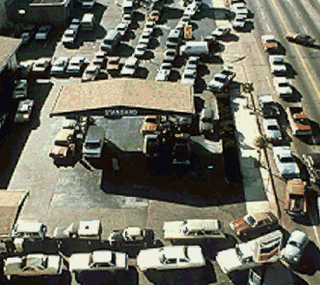
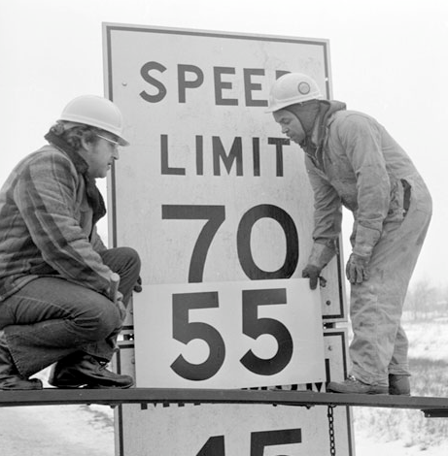
Document J
<------

Document K
----->

Important OPEC Facts
- OPEC countries agree on how much oil should be available for people to supply. The smaller the supply, the higher the price of oil.
- OPEC member countries supply about 40% of the world's daily oil.
- OPEC members have 75% of all oil still in the ground.
- OPEC members must all agree to raise or lower the supply. Saudi Arabia is the most powerful country in the organization.
- OPEC countries promise to follow the amount the supply limit they agree on, however they are supposed to follow the honor system. Most people think that OPEC countries often sell more oil than they are supposed to.
Document L
NPR Article – Overview of 1973 Oil Embargo
and its long term impact on the United States
http://n.pr/1vKPrUp

Name: Print front 2 back Block: Teacher: OPEC & America

Claim: OPEC is a powerful club of countries that impacts daily life in the United States.

4
2
1
3
Documents: F, I, L
Did the oil embargo (ban) positively impact the United States in any way?

Documents: F, I
What was the Yom Kippur war?
Who was fighting?
Why did OPEC get involved? What did this have to do with OPEC? Revise, currently not answered

Documents: F, K, H, L
How did the oil embargo (ban) negatively impact the United States?

Documents: F, G
What is OPEC?
What does the organization try and do?
Why do they do this?

EVIDENCE
EVIDENCE
EVIDENCE
EVIDENCE

Name: Block: Teacher: Nelson Mandela Example

Claim/Thesis: Nelson Mandela used nationalism to end the racist system of Apartheid.

4
2
1
3

Documents: F, G
What is Apartheid?
Where did it take place?
How did it work?

EVIDENCE
EVIDENCE
EVIDENCE
EVIDENCE

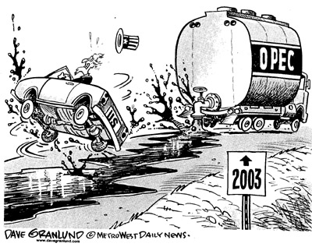

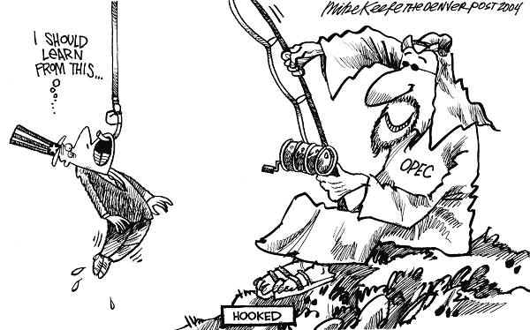
Name:

Block: Author’s Point of View - Cartoon

Teacher:

Topic | 2 | 3 | 4
Author’s Point of View | Identifies author’s purpose or point of view, but with some misconceptions within the context/unit of study. | Demonstrates the ability to accurately identify and explain an author’s purpose or point of view using textual and/or contextual evidence. | Demonstrates the ability to accurately identify and explain an author’s purpose or point of view using textual and contextual evidence and can justify or challenge it.

1. Political cartoon artists often use symbols to get their points across. A symbol is a something that stands for something else. For example, the American flag often stands for America. Circle and number any symbols you recognize in the cartoon above.

2. What point is the artist trying to make in this political cartoon? In your response you should explain and cite the symbols found in the cartoon.

3. Who (individuals or groups) would agree/disagree with the above political cartoon?

4. Do you agree with the author’s message? Explain your answer.
____________________________________________________
____________________________________________________
____________________________________________________
____________________________________________________
____________________________________________________
____________________________________________________
____________________________________________________
____________________________________________________
____________________________________________________
____________________________________________________
____________________________________________________
____________________________________________________

America, Oil, and Iran – A Love Triangle
Fearing that their supply to oil was going to be cut off, the American government decided that they needed to make sure that they had a friend in the Middle East besides Israel. This attempt at making friends, and the eventual breakup of this relationship, explains why the country of Iran doesn’t trust the United States to this day.

Watch the following videos. Yes, the history of Iran video is old, like super old, however it does a decent job providing an accurate summary of American-Iran relationship.
Fargo Trailer (Doc K) – 2 min. History of Iran (Doc L) – 10 min.
http://bit.ly/1EjxBcR http://bit.ly/18eySGg

Photo Gallery of Anti-American Protests (Doc M) -
http://abcn.ws/1AKZitM

Type up your response to the following prompt. You may either do this on a lined piece of paper or on OneNote. While you are putting your opinion on paper, you should cite the evidence that you used to come to that opinion.

Based on these videos, are the anti-American demonstrations in Iran justified?

_____________________________________________________________________________________

America, Oil, and Iran – A Love Triangle
Fearing that their supply to oil was going to be cut off, the American government decided that they needed to make sure that they had a friend in the Middle East besides Israel. This attempt at making friends, and the eventual breakup of this relationship, explains why the country of Iran doesn’t trust the United States to this day.

Watch the following videos. Yes, the history of Iran video is old, like super old, however it does a decent job providing an accurate summary of American-Iran relationship.
History of Iran (Doc L) – 10 min. Fargo Trailer (Doc K) – 2 min.
http://bit.ly/18eySGg http://bit.ly/1EjxBcR

Photo Gallery of Anti-American Protests (Doc M) -
http://abcn.ws/1AKZitM

Type up your response to the following prompt. You may either do this on a lined piece of paper or on OneNote. While you are putting your opinion on paper, you should cite the evidence that you used to come to that opinion.

Based on these videos, are the anti-American demonstrations in Iran justified?

Name:

Block: Point of View Assessment

Teacher:

Topic | 2 | 3 | 4
Author’s Point of View | Identifies author’s purpose or point of view, but with some misconceptions within the context/unit of study. | Demonstrates the ability to accurately identify and explain an author’s purpose or point of view using textual and/or contextual evidence. | Demonstrates the ability to accurately identify and explain an author’s purpose or point of view using textual and contextual evidence and can justify or challenge it.

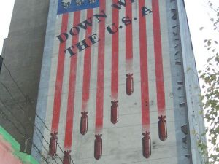
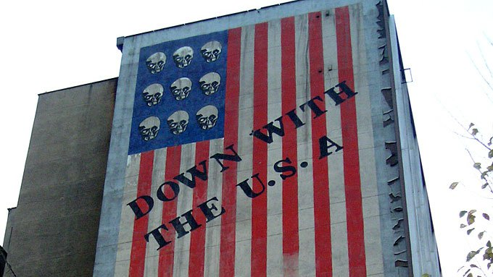

Directions: On a separate lined piece of paper, answer the following questions in complete sentences. When you’re finished, staple your lined piece of paper behind this sheet.

1. Accurately identify and explain the purpose of this anti-American graffiti in Iran. Make sure that you explain what symbols you were looking at to help you come to this conclusion.

2. Is this anti-American graffiti in Iran justified? This is an opinion question. You must take a stance and justify your position with evidence beyond these two pictures. You can include information from videos, readings, summits and even Mr. Patterson.

