Oil Lesson Cycle
Summative Assessment – make sure links work, organizing visuals

Middle East
Patterson

(W) Means on website
Underline what should be said to the class
If there is a blue word click on it while holding down “ctrl”

Behavioral Science
Iowa Core - SS.7.14. Examine what causes inequalities and examine how they exist within a society.

District Suggested - SS.7.14 Examine the causes of inequality within a society.

Economics
Iowa Core - SS.7.19. Explain how external benefits, costs, supply and demand, and competition influence market prices, wages, and outcomes.
Iowa Core - SS.7.20. Investigate the impact of trade policies and barriers on a nation and its citizens.

District Suggested - SS.7.19 Explain how supply and demand impact standard of living.
District Suggested - SS.7.20 Investigate how international trade and rules between countries, companies, and people can help improve quality of life.

Students will compare and contrast countries with high and low standards of living to determine the issues that cause inequality within communities. While playing an academic game, teams will develop a winning strategy when all options appear equal. Students will graph their game data to show how trends correlate to the economic principles of supply and demand. Students will speculate how countries could use the supply-demand seesaw as an economic weapon (1973 Oil Crisis). Teams will take a stance about which OPEC country is impacted the most by low price of crude oil and what should be done to help people living there.

Topic | Estimated Length
Middle East Research | 2 Days
OPEC Simulation | 3 Days
1973 Oil Crisis | 2 Days
Oiligarchy Game | 2 Days
Summative Assessment | 4 Days

Middle East Research Home Next
Taxonomy Level | Learning Targets (What are students learning?)
Retrieval – Executing  Analysis – Classifying  Analysis – Matching | Students will identify and gather data points that provide insight into the quality of life for countries in the region.  Using data, students will create a way to rank the countries in the region by quality of life.  Students will compare and contrast countries with high and low standards of living to determine the issues that cause inequality within communities.

Day 1
Learning Target: Using data, students will create a way to rank the countries in the region by quality of life.

Opening Discussion: Discuss how the Middle East is unique because you have extremely rich countries right next to extremely poor countries. Why is this happening? Will this continue? What will it mean for US in the United States? Explain that we have done research and plotting on a timeline before but the next time we do this, it is going to be a grade which means Mr. Patterson won’t be able to help as much as he usually does.
-Students will gather research about the quality of life in the region. If students want to choose their own data points, that is fine.  Middle East Research Visuals (W)  In visuals for this section, there is a slide that shows rankings and plotting should be done. | Resources/Materials/Extension  Class set of computers  Yemen Frontlines - Link

Day 2
Learning Target: Students will compare and contrast countries with high and low standards of living to determine the issues that cause inequality within communities.

Opening Discussion: Create a timeline on the white board. As class, plot out where the Middle Eastern countries are located. Have the class choose two countries to focus on, suggest Qatar and Yemen if possible. Have students gather research about what is going on the country and how it is impacting the overall quality of life. Have teams share out their findings. Possibly organize information into categories, example natural resources, government, and conflict being fought in country. Record information on different color paper as a team.
-Students gather research on current events, share out findings, and complete reflection individually.  Yemen Video - Link | Resources/Materials/Extension  Class set of computers  Bourdain episode – Yemen?

Name:

Block: Middle East Research Paper

Teacher:

Country | GDP per Capita | Life Expectancy | Literacy Rate | Placement
Yemen

Oman

United Arab Emirates
Qatar

Saudi Arabia

Iran

Iraq

Turkey

Syria

Kuwait

Lebanon

Israel

Jordan

Wealthy Countries for this Area
3
18
Poor Countries for this Area
39
Class Copy

How do you find GDP per capita of a country?

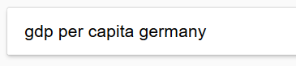
1. Go to Google.

2. Type in GDP per Capita followed by the name of the country.

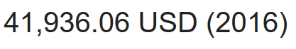
3. If you do this correctly, the answer should appear in bold.

How do you find the average life expectancy of a country?

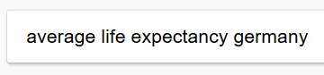
1. Go to Google.

2. Type in average life expectancy followed by the
name of the country.
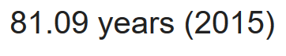
3. If you do this correctly, the answer should appear in bold.

How do you find the literacy rate of a country?
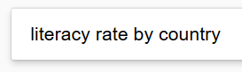
1. Go to Google.

2. Search literacy rate by country.

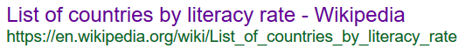
3. Click on this one.

4. Use the search function to find the country’s literacy rate. The easiest way to access the search tool is by pressing ctrl and f at the same time.
Name:

Block: Research Reflection

Teacher:

1. The Middle East is known for having countries that are both really rich and really poor. Provide a summary of the research your team did and describe the process of how you ranked countries by their data. In your answer, explain what standard of living, literacy rate, GDP per capita, and life expectancy are. Why are these specific numbers/data points helpful when trying to compare and contrasting countries?

____________________________________________________ ____________________________________________________
____________________________________________________
____________________________________________________
____________________________________________________
____________________________________________________
____________________________________________________
____________________________________________________
____________________________________________________
____________________________________________________
____________________________________________________
____________________________________________________
____________________________________________________
____________________________________________________
____________________________________________________
____________________________________________________
____________________________________________________
____________________________________________________
____________________________________________________

2. After gathering the research and ranking the countries, your team was asked to examine a country in the Middle East. What country did you look at it? What was going on in the country that changed/shaped its standard of living?
____________________________________________________
____________________________________________________
____________________________________________________
____________________________________________________
____________________________________________________
____________________________________________________
____________________________________________________
____________________________________________________
____________________________________________________
____________________________________________________
____________________________________________________
____________________________________________________
____________________________________________________
____________________________________________________
____________________________________________________
____________________________________________________
____________________________________________________
____________________________________________________
3. List five things that you learned from the video. Link

OPEC Simulation Previous Home Next
Taxonomy Level | Learning Targets (What are students learning?)
Knowledge Utilization– Decision Making  Comprehension –Symbolizing  Comprehension - Integrating | While playing an academic game, teams will develop a winning strategy when all options appear equal.  Students will graph the game data.  Students will annotate their graphs by showing how trends correlate to the economic principles of supply and demand. (Trade can bring about both positive and negative effects.)

Day 3/4
Learning Target: While playing an academic game, teams will develop a winning strategy when all options appear equal.

Opening Discussion:
OPEC Simulation (W)  Students will play OPEC simulation and complete the reflection. Make sure to save bid slips. | Resources/Materials/Extension  Video or charades to end?

Day 5
Learning Target: While playing an academic game, teams will develop a winning strategy when all options appear equal.

Opening Discussion: Explain the concepts of supply and demand using the seesaw (See visuals).
Debrief with the reflection sheet. Students will graph the oil prices from the academic game. If teams have lost their slips, a class copy is already created in the simulation document. Introduce OPEC vocab  -Ask them, what do they notice about the price of oil overtime? Debrief with the reflection sheet.  -Explicitly go over the slips of the paper in the envelopes. Have students look at text. Explain what would happen to supply and demand. Include similar question  Show diamond clips link and Charizard link, | Resources/Materials/Extension  Graph paper  Planet Money –Magic Gathering cards?  Play Oiligarchy game with time remaining.

1973 Oil Crisis Previous Home Next
Taxonomy Level | Learning Targets (What are students learning?)
Analysis - Specifying | As a class, students will speculate on how countries could use the supply-demand seesaw as an economic weapon. Teams will make predictions about what conditions would be necessary for this strategy to be successful. Students will examine the 1973 Oil Crisis. Teams will reflect on the accuracy of their predictions and will determine if the 1973 Oil Crisis was successful in bringing about change. (Include looking at crude oil prices overtime. Has this tactic been repeated?)

Day 6
Learning Target: As a class, students will speculate on how countries could use the supply-demand seesaw as an economic weapon.

Opening Discussion: Seesaw being used as an economic weapon. Complete the first two steps on the checklist for this part of the unit.
Students will read the article about the brief history of OPEC. They will gather research from the article and videos add it to their chart. | Resources/Materials/Extension  Class set of computers and headphones  Zimbabwe Hyperinflation Discussion?

Day 7
Learning Target: As a class, students will speculate on how countries could use the supply-demand seesaw as an economic weapon.

Opening Discussion: Layer density lab to show how oil is cleaned and separated. (Possibly look at crude oil prices overtime. Has this tactic been repeated?)
Finish OPEC Chart  (Include looking at crude oil prices overtime. Has this tactic been repeated?) | Resources/Materials/Extension  Class set of computers and headphones  Oiligarchy when finished

Brief History of OPEC – Document F
Vocabulary
OPEC- is a club of oil producing countries that try to control the price of crude oil/gas.

Introduction
OPEC is a club of countries that was created in 1960. The club was created so that countries that have a large amount of oil, could work together to make sure that they could make enough money to raise their citizens’ standard of living. OPEC does this by getting countries to agree on how much oil they want to sell.

By agreeing on how much oil they are going to sell, OPEC is able to balance supply and demand to maximize the amount of money each country in their club could make.

By 2014 OPEC club is made up of twelve members: Algeria, Angola, Ecuador, Iran, Iraq, Kuwait, Libya, Nigeria, Qatar, Saudi Arabia, the United Arab Emirates and Venezuela. According to the United States government, the amount of oil that OPEC club members decide to sell is an important reason that determines oil prices around the world. If they decide to sell a lot of oil, the price goes down. If they decide to sell only a tiny bit, it makes the price go up.

Before OPEC was created in 1960, the oil supply was controlled by a group of oil companies known by the nickname of “seven sisters.” The “seven sisters” oil companies were mostly American and British companies. OPEC countries wrote laws stating that these companies had to do what they wanted, if they didn’t do that, than their companies and oil would taken from them. Due to these laws/rules, OPEC club member countries became incredibly powerful. In December 2014, OPEC country ambassadors (leaders) were named in the top 10 most powerful people in the world.
Document G
BBC Video – 1 minute summary
http://bbc.in/1zrzGx3

1973 Oil Embargo (Ban)
In October 1973, OPEC declared an oil ban in response to the United States and Western Europe's support of Israel. The result was a rise in oil prices from $3 per barrel to $12 starting.

American gas stations put a limit on the amount of gasoline that could be bought by a person, closed on Sundays, and limited the days gasoline could be purchased based on license plates. Even after the embargo (ban) ended, gas prices continued to rise over the following years.

The Oil Embargo (ban) of 1973 had an important effect on the United States. The government got involved made it illegal to drive faster than a 55 mph limit at the end of 1973. Daylight saving time was extended year round to reduce electrical use in the American home. Smaller, more fuel-efficient cars were built. People were asked to decrease their thermostats to 65 degrees and factories changed their main energy supply to coal. All of these different things were supposed to lower the amount of oil/gas that Americans used. By following these new rules, Americans were safer and polluted less.
1
One of the most lasting effects of the 1973 oil embargo (ban) was a global economic turndown. A global economic turndown is a phrase you’ll learn more about in high school but is essentially when countries around the world have lower standards of living.

The amount of people looking for work rose, what you could buy for a dollar declined. Americans stopped buying cars that used a lot of gas. Although the embargo only lasted a year, during that time oil prices had quadrupled (x4) and OPEC nations discovered that their control over the supply of oil was a powerful.

Document H Document I
1973 Nightly News – 6 min. video Yom Kippur War – article/pictures
http://bit.ly/1AV8Ktr http://bit.ly/1AodCnc

Document K
Document J
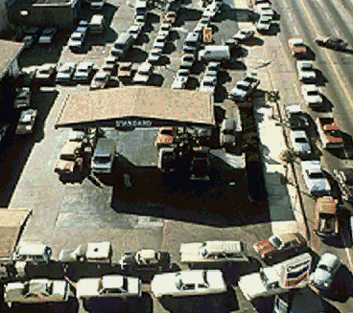
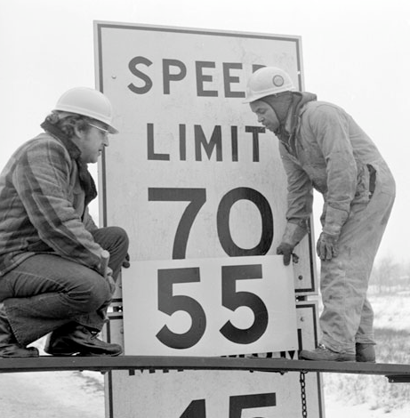

Important OPEC Facts
- OPEC countries agree on how much oil should be available for people to supply. The smaller the supply, the higher the price of oil.
- OPEC member countries supply about 40% of the world's daily oil.
- OPEC members have 75% of all oil still in the ground.
- OPEC members must all agree to raise or lower the supply. Saudi Arabia is the most powerful country in the organization.
- OPEC countries promise to follow the amount the supply limit they agree on, however they are supposed to follow the honor system. Most people think that OPEC countries often sell more oil than they are supposed to.
Document L
NPR Article – Overview of 1973 Oil Embargo
and its long term impact on the United States
http://n.pr/1vKPrUp
2
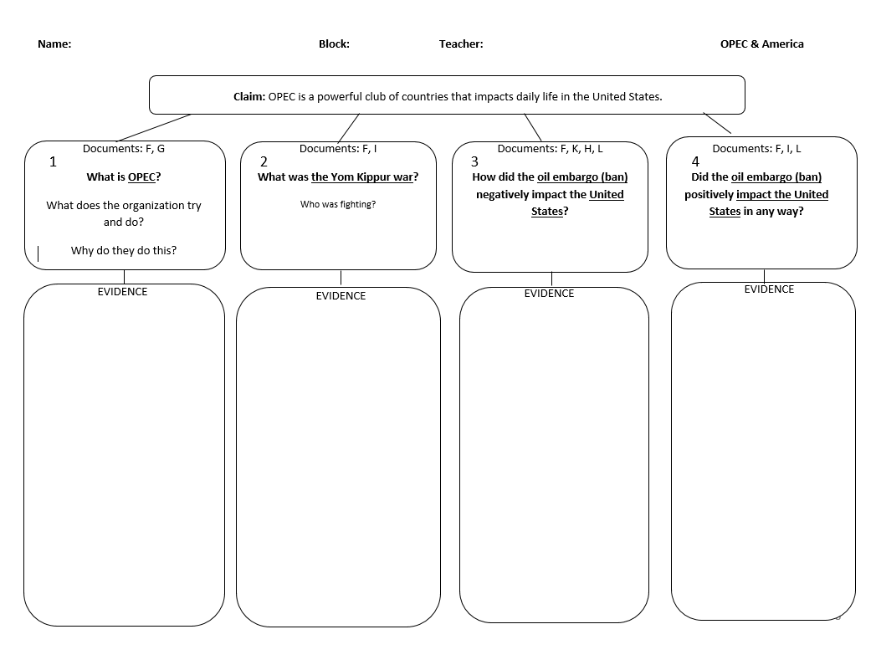

Oiligarchy Game Previous Home Next
Taxonomy Level | Learning Targets (What are students learning?)
Knowledge Utilization – Problem Solving  Retrieval - Recalling  Analysis - Generalizing | Students will create and test a strategy to get a high score in an online video game.  Students will reflect on what they did as the CEO of the oil company.  Based off research, students will identify what is plausible and what implausible about their actions as an oil CEO.

Day 8
Learning Target: Students will create and test a strategy to get a high score in an online video game.

Opening Discussion:
Oiligarchy Game  -introduce the game to the students. Explain that eventually as a team they will need to complete the reflection. Suggest that they should use the first day to figure out how to play the game. | Resources/Materials/Extension  Encourage students to watch YouTube tutorials, if they are confused.

Day 9
Learning Target: Based off research, students will identify what is plausible and what implausible about their actions as an oil CEO.

Opening Discussion: Have students list off some of the messed up things they were able to do. Next to each thing that they share out, write search sample Google searches.
Oiligarchy Game  -Students continue to play the game and attempt to get a high score. When students get bored with the game, search what is plausible and implausible. | Resources/Materials/Extension  Students can make step 3 in to a PowerPoint presentation, finding visuals of examples.  Discuss origins of the name Oiligarchy.

Name:

Block: Oiligarchy! Game
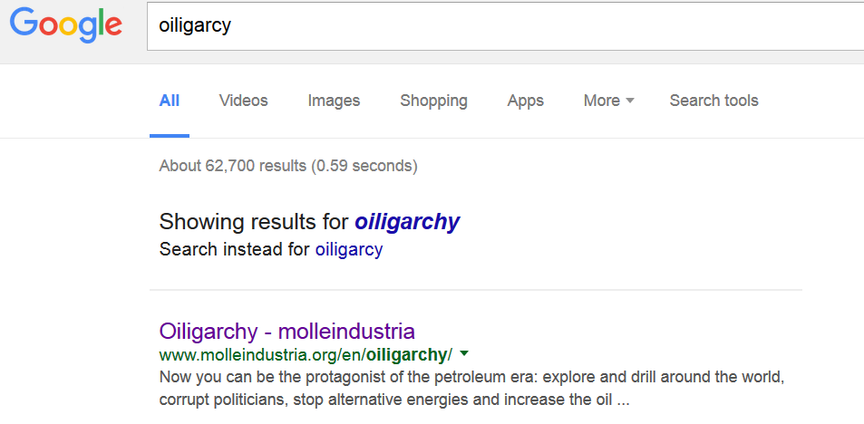
Teacher:

Part 1 – Open the Game
1. Go to Google
2. Search for Oiligarchy
3. Click on the top result
4. You will have to watch an ad before you can start playing the game.

Part 2 – Playing the Game
There is no way for you to save the game. If you log off the computer or click the refresh button, all of your progress will be erased.

Tutorial Questions – Don’t write in complete sentences.
What is your job? Who do you work for?

“Politics is the shadow cast on society by big business.” What will the “oiled” representatives help you do?

Map of the World
Why can’t you drill in Alaska at the beginning of the game?

Why can’t you drill in Iraq at the beginning of the game?

How to Play the Game
What does this button do?

What does this button do?

What does this button do?

There are villagers in Nigeria who don’t like it when you drill in their country. What can you do to stop them?

Bills that Congress passes
Name of Law/Act | Purpose (How does this affect oil addiction?)
1.

2.

3.

4.

5.

Part 3
After finishing the game, play it again but concentrate on paying the politicians.
What does this button do?

What did you have to do get Iraq open for drilling?

What does Venezuela do to your oil wells?

What is a M.A.D. world? Why are people fighting?

What you high score that you finished with? Did you beat Mr. Patterson?

List five terrible things you did as a CEO of an oil company.

Do you think that these things happen in real life? Explain your answer.
____________________________________________________________________________________________________________________________________________________________________________________________________________________________________________________________________
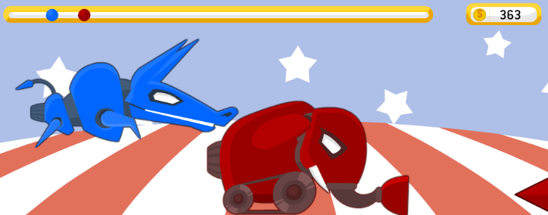
During this part of the game, what were supposed to do?
________________________________________________________________________________________________________________________________________________________________________________________________________________________________________________________________________________________________________________________________________________________________________________________________________________________________

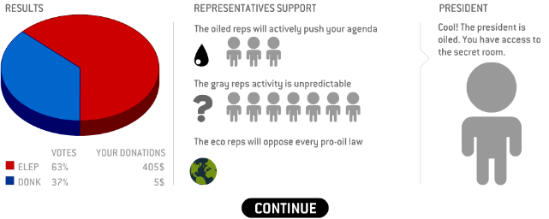
Why did you want to get the politicians to like you?
____________________________________________________________________________________________________________________________________________________________________________________________________________________________________________________________________________________________________________________________________________________________________________
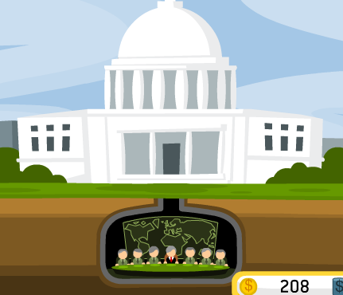
What could you get this group of people to do?
________________________________________________________________________________________________________________________________________________________________________________________________________________________________________________________________________________________________________________________________________________________________________________________________________________________________
An oligarchy is a government controlled by a small group of people. Why did the game designers call this game Oiligarchy?
________________________________________________________________________________________________________________________________________________________________________________________________________________
________________________________________________________________________________________________________________________________________________________________________________________________________________
________________________________________________________________________________________________________

Summative Assessment Previous Home
Taxonomy Level | Learning Targets (What are students learning?)
Retrieval – Executing  Analysis – Classifying  Knowledge Utilization - Investigating | Students will identify and gather economic data points for OPEC countries.  Using data, students will identify the four OPEC countries most impacted by sustained low oil prices.  Based on their data investigation, teams will take a stance about which OPEC country is impacted the most by low price of crude oil and what should be done to help people living there. Students will debate another team and refine their policy position. Students will research current events in that country and take a position on where they are agree with the U.S. response.  Investigate how international trade and rules between countries, companies, and people can help improve quality of life.

Days 11 - 14
Learning Target: Based on their data investigation, teams will take a stance about which OPEC country is impacted the most by low price of crude oil and what should be done to help people living there.

Opening Discussion: Semi-truck/motor cycle, math oil problem, some numbers, high others low
Oil summative assessment (W). Identify what country is most impacted by the sustained low price of oil. If you identify the correct country and articulate your answer correctly, you get a 4 and don’t have to take assessment. If you don’t identify the country correctly, you still get to use your research on the assessment. | Resources/Materials/Extension  Settlers of Catan?  Invesitage Current events in Venezuela?  Oman, Iran Bourdain?  Jamal Khashoggi Death and Saudi 2030 Campaign  Videos on next page  Iran Crash Course - Link

Videos to show class or to watch to prep for assessment.

1. Planet Money – Radio
Oil in Saudi Arabia Episode
https://www.npr.org/sections/money/2016/02/03/465476188/episode-681-the-oil-kingdom
What is the resoruce curse?
How has/is Saudi Arabia trying to end its sole reliance on oil?
How does the person interviewed think that taxes will change Saudi Arabia?

2. North Dakota and Fracking – John Oliver
https://www.youtube.com/watch?v=jYusNNldesc
How is North Dakota impacted by fracking? Describe both the good and bath things.
Are the workers being safe?
How is the environment being changed?

3. Venezuela – John Oliver Link
NEED QUESTIONS and link

4. Planet Money - Radio
Fracking Episode – Start at 5 minutes
https://www.npr.org/sections/money/2016/08/17/490375230/oil-3-how-fracking-changed-the-world
What is fracking? How did it change the oil business?

5. Saudi Arabia Uncovered - Documentary
http://www.pbs.org/wgbh/frontline/film/saudi-arabia-uncovered/
What is life the OPEC country of Saudi Arabia? How are the men and women of the country being treated?

OPEC Country Data Chart Name: Block: Teacher:

Document-> | A | A | B | B | D | E | Totals | Ranking
Category-> | Annual Value* | Share of GDP** | Oil $ to Balance | # of Barrels a day. | Cash Reserves | # of Coups***
Algeria
Angola
Ecuador
Iran
Iraq
Kuwait
Libya
Nigeria
Qatar
Saudi Arabia
U.A.E.
Venezuela

*The yearly value of the oil sold by the country.
**The percentage that oil that country relies on.
***Number of times the government’s been overthrown since 1960
1

OPEC, Can it survive?

Question: In your opinion, which countries are most impacted by the low price oil?

Country #3
Country #4
Country #2
Country #1

2
EVIDENCE
EVIDENCE
EVIDENCE
EVIDENCE
OPEC Research Documents

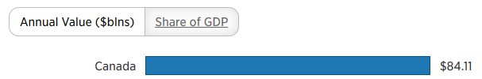

1. Document A - http://cnb.cx/1M6p5yo

This document includes an article and video. There is a chart halfway thought the article that provides most of the information, however make sure you take your time.

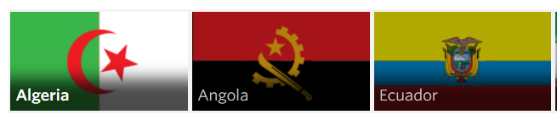
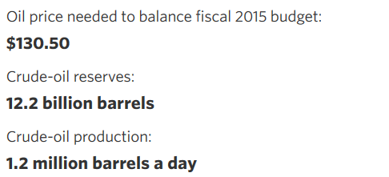

2. Document B - http://bit.ly/1zYJC2i

This document has a rotating flags at the top. These flags represent countries in OPEC. For each country, read the profile, fill out the information

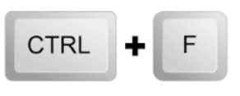
3. Document D – https://goo.gl/ccfdU5

Cash reserves is how much cash/money your country has in its back accounts to spend. Only record this number in the millions.

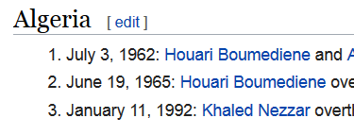
4. Document E- http://bit.ly/2SZXuco

Use this website to figure out how
many coup d’états a country has had.

Name:

Block: OPEC and Oil Quiz

Teacher:
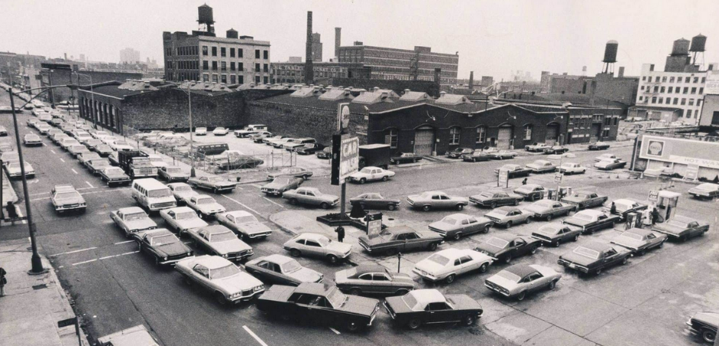
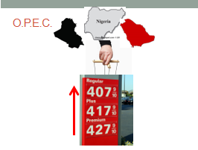

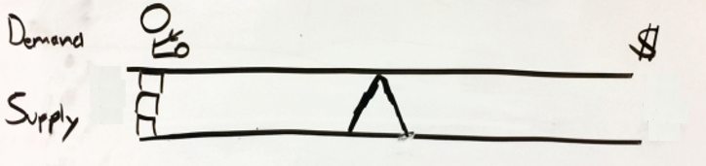

1. Explain what the organization/club called OPEC tries to do. Explain how they accomplish this. Why are there so many cars waiting for gas at the gas station? What does this have to do with OPEC? In your answer, you need to write about each of the pictures above.

_____________________________________________________________________________________

_____________________________________________________________________________________

_____________________________________________________________________________________

_____________________________________________________________________________________

_____________________________________________________________________________________

_____________________________________________________________________________________

_____________________________________________________________________________________

_____________________________________________________________________________________
More room on the back…
1
_____________________________________________________________________________________

_____________________________________________________________________________________

_____________________________________________________________________________________

_____________________________________________________________________________________

_____________________________________________________________________________________

_____________________________________________________________________________________
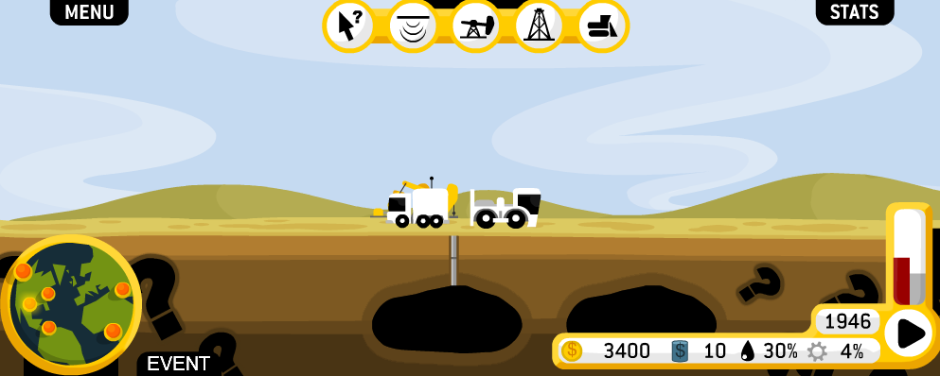

2. In the online video game called Oiligarchy, what were you trying to do? What was your goal? Occasionally you could give money to two animals racing each other. Why did you want this to happen? Can you make any connections between the Oiligarchy game and the oil company SOCO in Virunga? In your answer, you need to write about each of the pictures above.

_____________________________________________________________________________________

_____________________________________________________________________________________

_____________________________________________________________________________________

_____________________________________________________________________________________

_____________________________________________________________________________________

_____________________________________________________________________________________

_____________________________________________________________________________________

_____________________________________________________________________________________
2
More room on the back…

_____________________________________________________________________________________

_____________________________________________________________________________________

_____________________________________________________________________________________

_____________________________________________________________________________________

_____________________________________________________________________________________

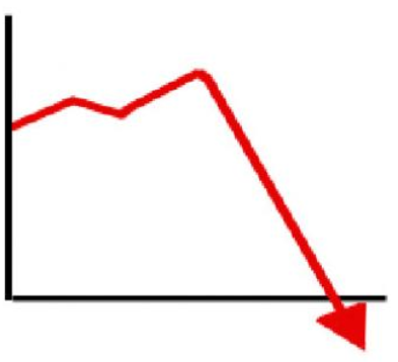
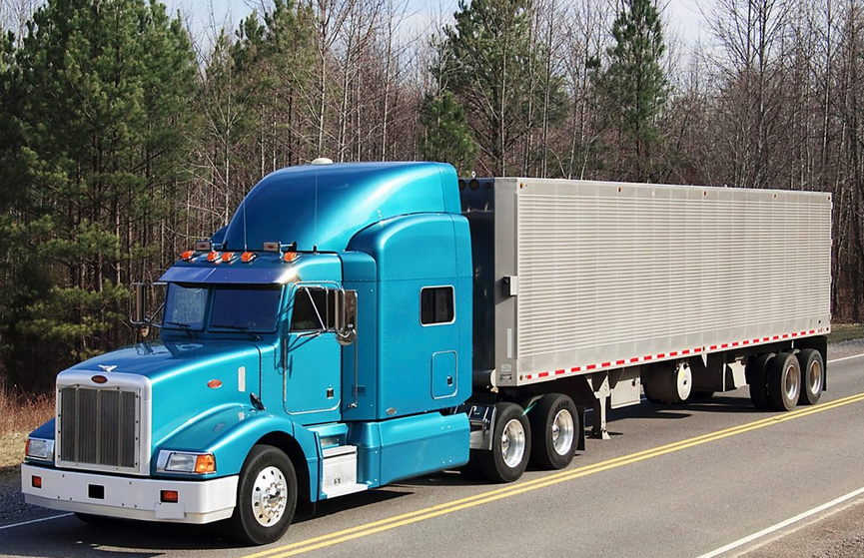

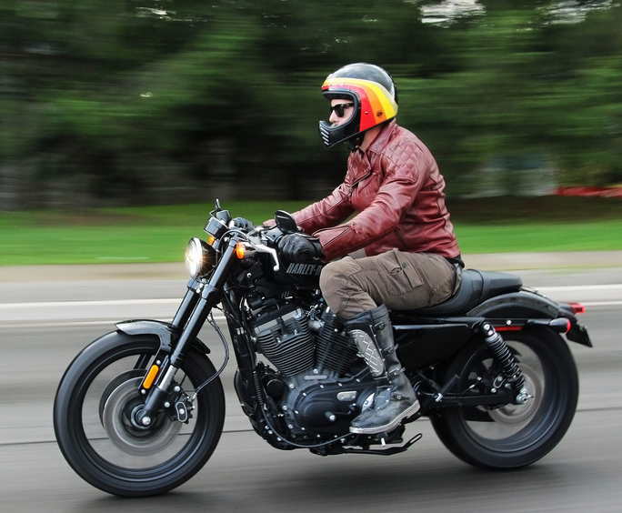
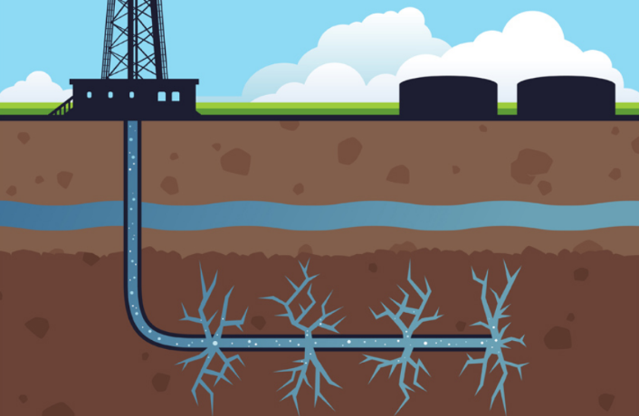

3. What is fracking? Why is it bad for the environment? Why did it cause the price of oil to fall? Why is that really bad for countries who are motorcycles like Qatar? What is not as bad for countries like the United States who are semi-trucks? In your answer, you need to write about each of the pictures above.
3
Room to answer on the back…
3

_____________________________________________________________________________________

_____________________________________________________________________________________

_____________________________________________________________________________________

_____________________________________________________________________________________

_____________________________________________________________________________________

_____________________________________________________________________________________

_____________________________________________________________________________________

_____________________________________________________________________________________

_____________________________________________________________________________________

_____________________________________________________________________________________

_____________________________________________________________________________________

_____________________________________________________________________________________

_____________________________________________________________________________________

_____________________________________________________________________________________

_____________________________________________________________________________________

_____________________________________________________________________________________

_____________________________________________________________________________________

_____________________________________________________________________________________

_____________________________________________________________________________________

_____________________________________________________________________________________

_____________________________________________________________________________________

_____________________________________________________________________________________

_____________________________________________________________________________________
4
Name:

Block: Oil Quiz

Teacher:
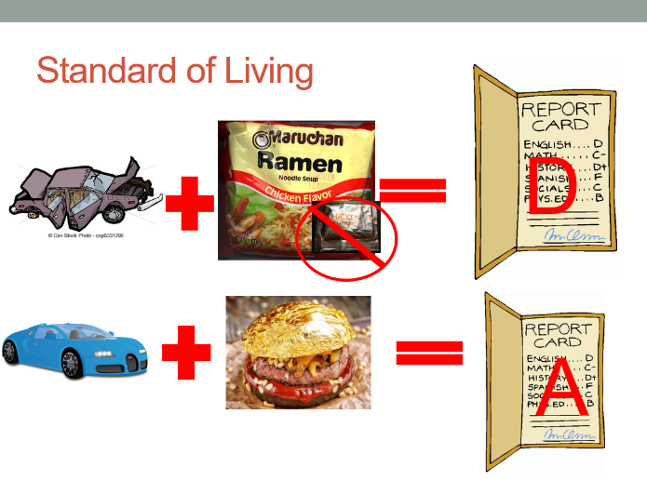
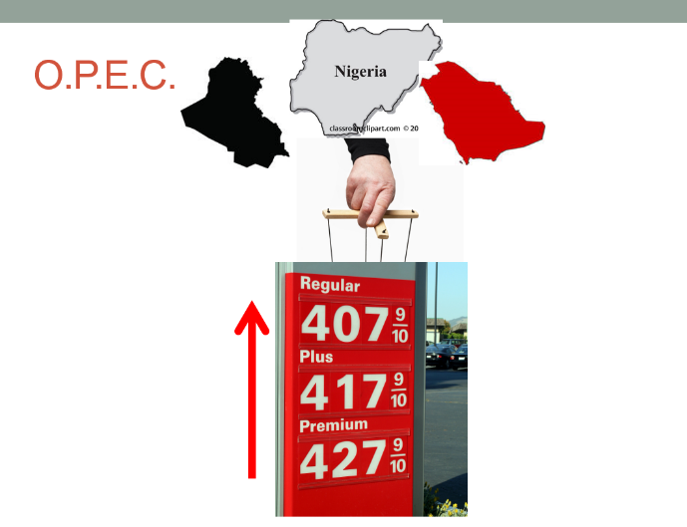

2

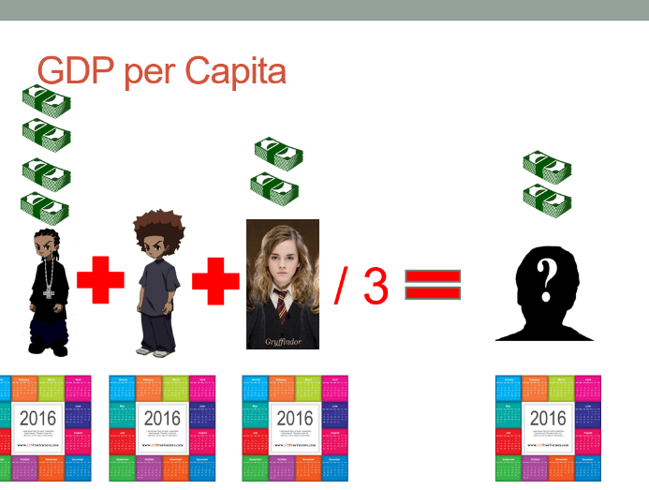
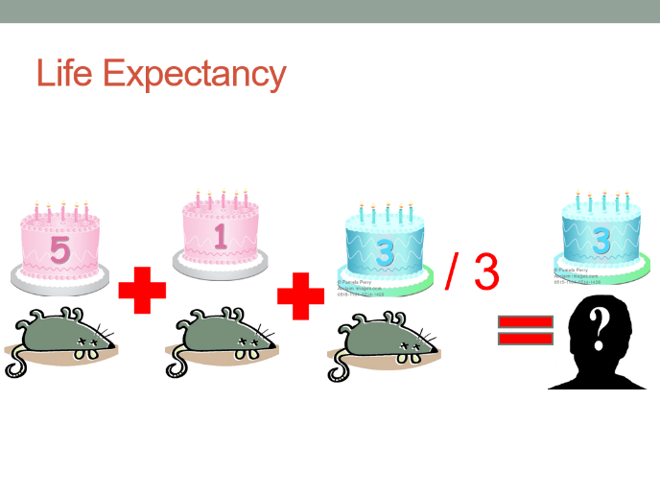

1. OPEC is a…

2. Standard of living means…

3. Life expectancy is…

4. GDP per capita is…
1
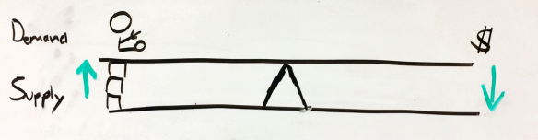

5. What does the drawing above show/mean? What does it have to do with oil?
____________________________________________________
____________________________________________________
____________________________________________________
____________________________________________________
____________________________________________________
Category | Meaning of Category | Yemen | Qatar
GDP per Capita | Average Income per person | 1,070 | 80,440
Life Expectancy | Average life span of person | 65 years | 79 years
Literacy Rate | % of people that can read | 54% | 100%
Oil/Gas | Amount of natural resources | None | Large Amount
6. Based off the chart above, compare the standard of living of Yemen and Qatar. Using specific numbers in your answer, explain which one is richer. Does a country have an advantage? Explain your thinking?
____________________________________________________
____________________________________________________
____________________________________________________
____________________________________________________
________________________________________________________________________________________________________
____________________________________________________
7. Using your data chart, what are some OPEC countries that are hurt by the low price of oil? Include specific numbers in your answer. What is something that you would recommend to the leaders of the country?
____________________________________________________
____________________________________________________
____________________________________________________
____________________________________________________
____________________________________________________
____________________________________________________
2

