**Monotheistic Religions** – 8 Days

Find or make religion example poster

**Middle East**

**Patterson**

(W) Means on website

Underline what should be said to the class

If there is a blue word click on it while holding down “ctrl”

The purpose of this lesson cycle is for students to gain a general understanding of the monotheistic religions found in the Middle East. Students will learn how religion can provide a moral and social code that influence an individual’s thoughts and behaviors. In the summative activity, students will respond to Trump’s proposed limitation of Muslim immigration (analyzing errors). This lesson cycle sets up difference in SOL between Jewish and Muslim communities.

**Iowa Core**

SS.7.13. Identify social, political, and economic factors that can influence our thoughts and behavior.

**District Language**

SS.7.13 Identify factors that influence our thoughts and behaviors.

|  |  |  |  |  |  |  |  |  |  |  |  |  |  |
| --- | --- | --- | --- | --- | --- | --- | --- | --- | --- | --- | --- | --- | --- |
| **Standard of Living** | |  |  |  |  |  |  |  |  |  |  |  |  |
| 3A – Compare and contrast the standard of living in different parts of the world (SS.7.14). | | | | | | | | |  |  |  |  |  |
|  | Describe how the standard of living is measured (income and access to education and healthcare). | | | | | | | | | |  |  |  |
|  | Explain how a higher or lower standard of living effects people’s lives. | | | | | | |  |  |  |  |  |  |
|  |  |  |  |  |  |  |  |  |  |  |  |  |  |
| 3B – Evaluate factors that contribute to countries becoming more developed (SS.7.18 & SS.7.19). | | | | | | | | | |  |  |  |  |
|  | Describe factors that increase the development of a country (education, health care, access to improved sanitation, gender equality). | | | | | | | | | | | | |
|  | Explain how countries have changed their policies/laws to increase access to these factors. | | | | | | | | |  |  |  |  |
|  | Describe the result of increasing access on a country’s economy. | | | | | | |  |  |  |  |  |  |
|  |  |  |  |  |  |  |  |  |  |  |  |  |  |
| 3C – Evaluate the attainability of the Sustainable Development Goals (SS.7.15) | | | | | | | |  |  |  |  |  |  |
|  | Describe sustainable development | | | |  |  |  |  |  |  |  |  |  |
|  | Describe how the Sustainable Development Goals are different from the Millennium Development Goals. | | | | | | | | | | |  |  |
|  | Explain how the SDGs will be implemented and monitored | | | | | |  |  |  |  |  |  |  |

|  |  |
| --- | --- |
| **Day 1** | |
| **Opening Discussion –** Display visuals of the president, have students answer first two questions of the test. Have a conversation with students about emotions/Trump, can they articulate specific policy decisions that justify their beliefs? Explain that the next couple of days, we are going to learn about religion and their final quiz will be to respond to one of the president’s policies. They will be expected to make a claim, use evidence, provide an explanation, and write a conclusion. Make sure to save these reflections so students can revisit them on their summative assessment. | |
| MonothesticReligionVisuals (W)  -page 15  Clean Folders  Anthony Bourdain – Egypt Watch  Answer 3rd question  No Reservations, Amazon, Season 4, Episode 12 | **Resources/Materials/Extension** |

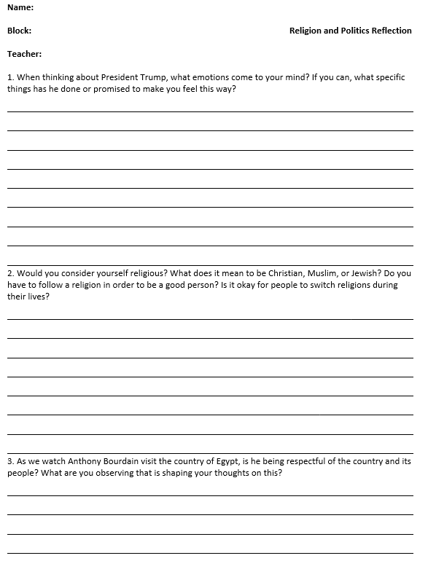

|  |  |
| --- | --- |
| **Day 2** | |
| **Opening Discussion –** What do you notice about the countries marked in red? | |
| **Religion Power Point (W)**  **Monotheistic Religion Visuals (W)**  Introduce the unit and discuss religion. Have students write down what they think the vocabulary words mean. Students watch video, instructions are on the sheet.  -pages 4-5 | **Resources/Materials/Extension**  -computers  [Link](https://www.youtube.com/watch?v=m6dCxo7t_aE) |

**Name:**

**Block: Intro to Middle East**

**Teacher:**

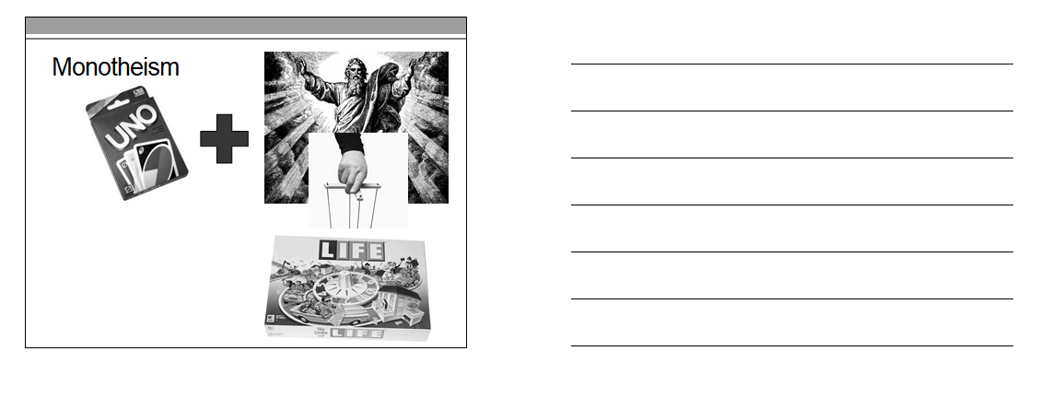

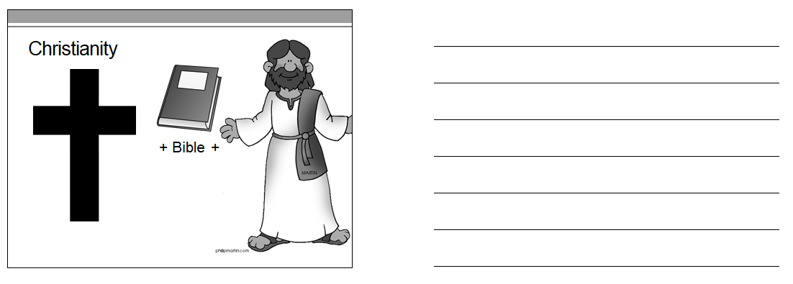

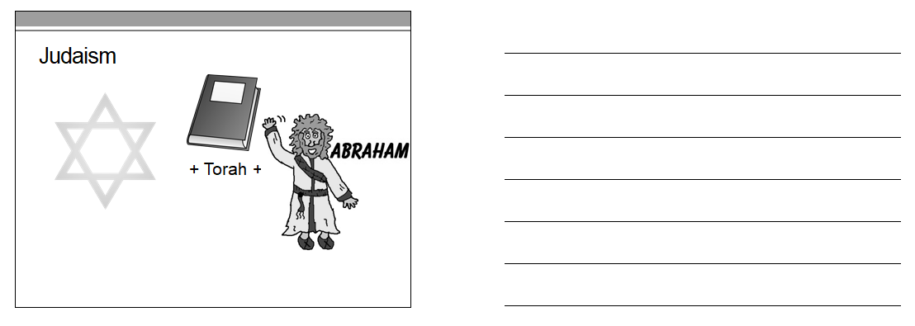

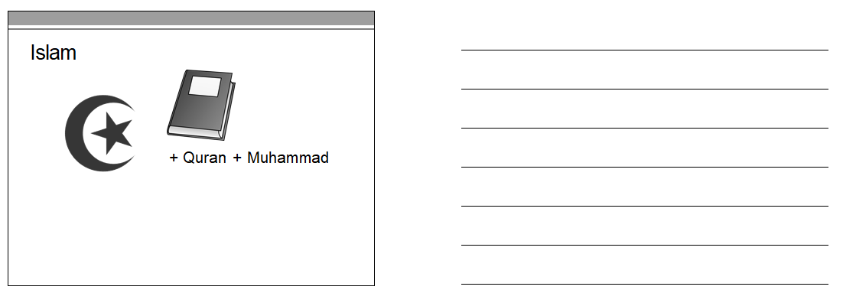

**Directions:** While watching the video about religion, list out three things you learned for each religion.

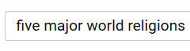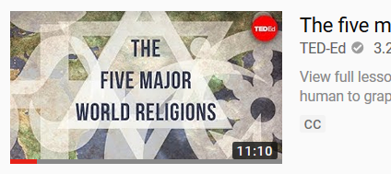

**Judaism**

**Christianity**

**Islam**

**Confucianism**

**Buddhism**

|  |  |
| --- | --- |
| **Day 3** | |
| **Opening Discussion –** See below* | |
| -Pass out papers/readings, computers at the beginning of class to ensure smooth transition.  *Religion Organizer*, pages 8 - 10  Flocabulary Religion Lyrics (W)  **High School Option\*\***  Have documents ready in drawer marked with blue tape, upload OneNote instructions,  -Religion Advanced Readings (W) | **Resources/Materials/Extension**  -Computers, headphones, color notecards, and dice  Flocabulary Log In  [Rachel.smith@dmschools.org](mailto:Rachel.smith@dmschools.org)  callananflo |

**Warm Up\***

**YouTube** –[Link](https://www.youtube.com/watch?v=U0lcyNxdzn8&t=14s)

Ask for volunteers, show how religions started at the same table and spread through war/trade. Show with different colored notecards. Use visuals on boards to illustrate timelines, discuss prophets and links. Possibly use dice to show expansion. Three to start, one after. Religions replace each other.

**Advanced Group\*\***

-Students that can self-regulate and handle advanced independent work, should be given the opportunity to work on the independent project outlined in the monotheistic religion visuals.

|  |  |
| --- | --- |
| **Day 4** | |
| **Opening Discussion -** Why is the Christian prophet Jesus in the Muslim holy book the Quran but not in the Jewish holy book the Torah? | |
| **On Level Group**  Religion Reading Stations (W)  Flocabulary Video [Link](http://www.flocabulary.com/major-world-religions/)  Login: Rachel.smith@dmschools.org  Password: callananflo  Discuss: What were some of things that you filled out in your religion organizer so far?    **Advanced Group\*\***  Monotheistic Religion Visuals (W)  -research/Videos | **Resources/Materials/Extension**  Computers/headphones  Need addition modality switch, video for students to watch?  Play Simon Says with five pillars of Islam.  Nitrotype/Prodigy when students are done with two? |

|  |  |
| --- | --- |
| **Day 5** | |
| **Opening Discussion -** Catholics and Protestants are both Christian if they… ( religion visuals) | |
| **On Level Group**  Religion Station Readings  Start on religion poster on page 11, display example poster, modality shift needed  **Advanced Group\*\***  Monotheistic Religion Visuals (W)  -research/videos, if done early, have students start watch John Oliver  Exit slip religion terminology, page 13, grade in class, if time allows | **Resources/Materials/Extension**  Computers, headphones, posters  Buy candy, play Simon Says with five pillars of Islam. |

|  |  |
| --- | --- |
| **Day 6** | |
| **Opening Discussion -** Why did people attack the United States on 9/11?* | |
| Students finish posters. Play Quizlet. Research Trump’s anti-Muslim rhetoric.  John Oliver – Sharia Law  See directions and questions in visuals  Immigrants and Refugees [Link](https://www.youtube.com/watch?v=umqvYhb3wf4) | **Resources/Materials/Extension**  Computers Needed**,** Poster Paper  Follow up research question, about how Germany is doing with accepting so many refugees? |

Warm Up*

Simple question with a complex answer. Valid concerns about how America has acted in its own self-interest, also this idea that we are accepting, we don’t force an ideology or religion on people, makes some people upset. This idea that multiple viewpoints are okay. Terrorists at times use religious symbols and books to justify their actions and to recruit new people. To provide a messed up code of what is right and wrong that most people in the religion don’t agree with. Similar to the… KKK. Most Christians say that the KKK doesn’t represent them. Show West Wing [link](https://www.youtube.com/watch?v=21eaubatLGc&t=17s) after 9/11.

|  |  |
| --- | --- |
| **Day 7** | |
| **Opening Discussion –** What do you notice about the flags in the Middle East? | |
| In small groups, students fill out a Venn Diagram as much as possible. Guiding questions to fill in every bubble. Your assessment will center on comparing and contrasting different religions.  Anthony Bourdain – Saudi Arabia Watch  No Reservations, Amazon, Season 4, Episode 13 | **Resources/Materials/Extension**  Computers Needed**,** Poster Paper  Five pillars game for Teach five pillars of Islam – Simon/Says  Create Kahoot? |

**Name:**

**Block: Religion Organizer**

**Teacher:**

**Part 1**

**Directions:** Based on our class discussion, please finish the following sentence prompts.

**Jews** are people who follow the religion of _____________.______________ is their leader.

**Christians** are people who followthe religion of_____________.______________ is their leader.

**Muslims** are people who follow the religion of _____________.______________ is their leader.

The purpose of religion is to answer…_____________________________________

__________________________________________________________

__________________________________________________________

__________________________________________________________.

**Part 2 - Judaism**

|  |  |
| --- | --- |
| **Questions to Answer** | **Evidence** |
| Who founded/started the religion? What was the name of this leader? What year did this take place?  What do people in this religion believe?  What is the book that guides the religion called? What are the places called that people pray in?  What/where are the holy sites for this religion?  People who practice this religion are expected to do?  What symbols are connected with this religion? |  |

**Part 3- Christianity**

|  |  |
| --- | --- |
| **Questions to Answer** | **Evidence** |
| Who founded/started the religion? What was the name of this leader? What year did this take place?  What do people in this religion believe?  What is the book that guides the religion called? What are the places called that people pray in?  What/where are the holy sites for this religion?  People who practice this religion are expected to do?  What symbols are connected with this religion? |  |

**Part 4 –Islam**

|  |  |
| --- | --- |
| **Questions to Answer** | **Evidence** |
| Who founded/started the religion? What was the name of this leader? What year did this take place?  What do people in this religion believe?  What is the book that guides the religion called? What are the places called that people pray in?  What/where are the holy sites for this religion?  People who practice this religion are expected to do?  What symbols are connected with this religion? |  |

**Religion Poster**

**Middle East Class Copy**

**Patterson**

**Directions**: Choose one of the three main world religions to do a poster. Remember, if you decide to focus on the religion of Islam, you should not draw a picture of the Prophet Muhammad.

Your poster must meet the following requirements:

**Content Expectations**

* Title of Religion
* Symbols of religion
* Place of worship
* Holy book
* Other interesting facts

**General Poster Expectations**

* Quality of poster represents the time you work on the project
* Rough draft sketched out in pencil
* Words are spelled correctly
* Proper punctuation
* Text evidence from articles.
* Name, block, teacher in the bottom right corner

**Example:**

|  |
| --- |
| **C:\Users\pattersoan\AppData\Local\Microsoft\Windows\Temporary Internet Files\Content.IE5\4VUTU2X7\MC900384256[1].wmfC:\Users\pattersoan\AppData\Local\Microsoft\Windows\Temporary Internet Files\Content.IE5\ACG7N5JZ\MP900384793[1].jpg**  **Christianity**  The Christian holy book is called the…  Christians believe in…  **C:\Users\pattersoan\AppData\Local\Microsoft\Windows\Temporary Internet Files\Content.IE5\ACG7N5JZ\MC900434203[1].wmf** |

N**ame:**

**Block: Religion Diagram – Study Me!**

**Teacher:**

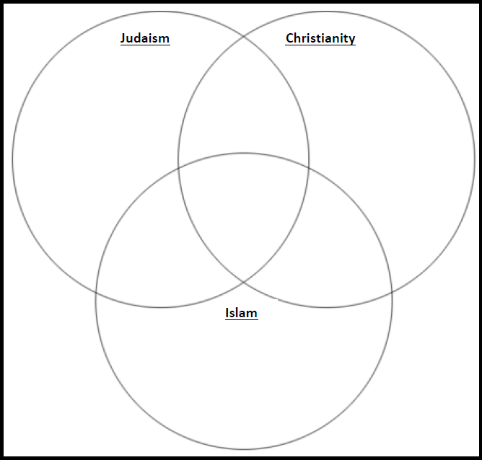

**Name:**

**Block: Religion Vocab**

**Teacher:**

|  |  |  |
| --- | --- | --- |
| **Word List** | | |
| Jews  Muslims  Christians | Abraham  Islam  Christianity | Muhammad  Judaism  Jesus |

1._____________ are people who practice___________________. _________________ is their prophet.

2._____________ are people who practice___________________. _________________ is their prophet.

3._____________ are people who practice___________________. _________________ is their prophet.

**Name:**

**Block: Religion Vocab**

**Teacher:**

|  |  |  |
| --- | --- | --- |
| **Word List** | | |
| Jews  Muslims  Christians | Abraham  Islam  Christianity | Muhammad  Judaism  Jesus |

1._____________ are people who practice___________________. _________________ is their prophet.

2._____________ are people who practice___________________. _________________ is their prophet.

3._____________ are people who practice___________________. _________________ is their prophet.

|  |  |
| --- | --- |
| **Day 8** | |
| **Learning Target** – I will respond to President Trump’s proposed limitation of Muslim immigration.  **Warm Up –** No warm up, five minutes to study, pass out computers | |
| MidEastReligionAssessment (W)  Anthony Bourdain – Saudi Arabia Watch  No Reservations, Amazon, Season 4, Episode 13 | **Resources/Materials/Extension**  Computers needed  Tripholics [Link](http://www.travelchannel.com/shows/tripaholics/video/tel-aviv-israel)  Bourdain – Parts Unknown – Oman [Link](https://www.youtube.com/watch?v=TQZeKmBNzj0&list=PLF27Gb5GI5FwAzFDpXoWonEBAywT0Is_H&index=1)  Hassan Manage Making fun of Anti-Islam sentiment [Link](https://www.youtube.com/watch?v=hSTywVwZCjw) |

**Name:**

**Block: Religion and Politics Reflection**

**Teacher:**

1. When thinking about President Trump, what emotions come to your mind? If you can, what specific things has he done or promised to make you feel this way?

____________________________________________________________________________________________________________________________________________________________________________________________________________________________________________________________________________________________________________________________________________________________________________________________________________________________________________________________________________________

2. Would you consider yourself religious? What does it mean to be Christian, Muslim, or Jewish? Do you have to follow a religion in order to be a good person? Is it okay for people to switch religions during their lives?

________________________________________________________________________________________________________________________________________________________________________________________________________________________________________________________________________________________________________________________________________________________________________________________________________________________________

3. As we watch Anthony Bourdain visit the country of Egypt, is he being respectful of the country and its people? What are you observing that is shaping your thoughts on this?

________________________________________________________________________________________________________________________________________________________________________________________________________________

**Religion Assessment**

**SS.7.13** Identify factors that influence our thoughts and behaviors.

|  |  |  |
| --- | --- | --- |
| **Word List** | | |
| Jews  Muslims  Christians | Abraham  Islam  Christianity | Muhammad  Judaism  Jesus |

4._____________ are people who practice___________________. _________________ is their prophet.

5._____________ are people who practice___________________. _________________ is their prophet.

6._____________ are people who practice___________________. _________________ is their prophet.

7. Explain how religion in the Middle East has changed over time. How are all of three religions connected?

__________________________________________________________

__________________________________________________________

__________________________________________________________

__________________________________________________________

__________________________________________________________

____________________________________________________________________________________________________________________

__________________________________________________________

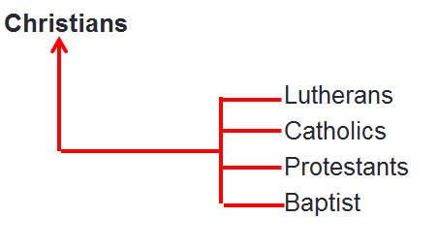

8. Explain this:

________________________________________________________________________________________________________________________________________________________________________________________________________________________________________

**9. Directions**: Fill in the triple Venn diagram below to the best of your ability.



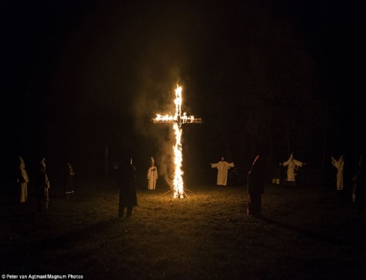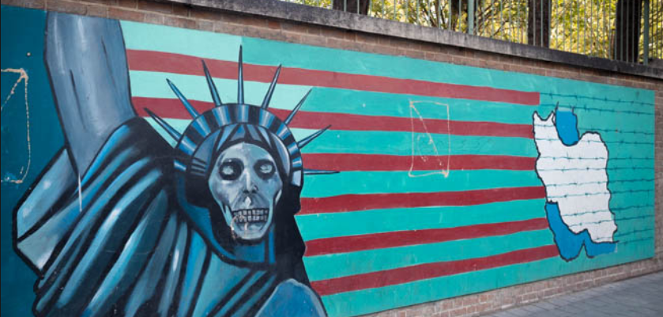

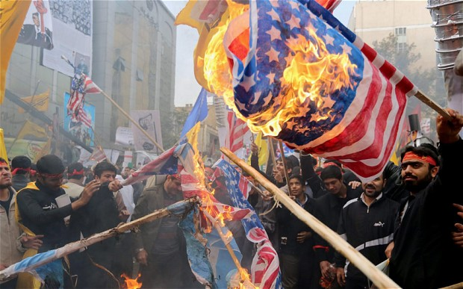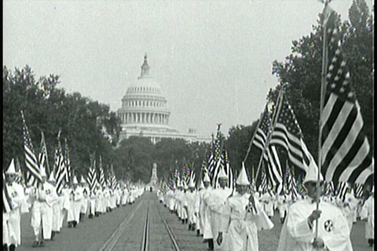

**10. What do the Klu Klux Klan (KKK) and Islamic terrorists have in common? How do most Christians and Muslims feel about their beliefs and actions?**

__________________________________________________________

__________________________________________________________

__________________________________________________________

__________________________________________________________

__________________________________________________________

__________________________________________________________

__________________________________________________________

**11. Reread what you wrote as your answer to the second question. Do you still agree with what you wrote or is there something that you now wish you could change? Explain your thinking.**

__________________________________________________________

__________________________________________________________

__________________________________________________________

__________________________________________________________

__________________________________________________________

__________________________________________________________

__________________________________________________________

__________________________________________________________

12. Critics of President Trump have accused him of using words that are considered anti-Muslim in order to get people to vote for him. During his first year in office, the president attempted to sign a rule/law that some people referred to as a Muslim Ban.

According to people who disagree with the president, what is the so called Muslim ban? How did it work? Why was it considered to be unfair?

According to people who support the president, what is the rule/bill called? How was it supposed to work? Why did some Americans support the president’s actions?

What do you think? What side do you agree with? Do you think that religion can change how people think and act? Should people make rules/laws based on a person’s religion?

__________________________________________________________

__________________________________________________________

__________________________________________________________

__________________________________________________________

__________________________________________________________

__________________________________________________________

__________________________________________________________

__________________________________________________________

____________________________________________________________________________________________________________________

__________________________________________________________

__________________________________________________________

__________________________________________________________

__________________________________________________________

__________________________________________________________

__________________________________________________________

__________________________________________________________

__________________________________________________________

____________________________________________________________________________________________________________________

__________________________________________________________

__________________________________________________________

__________________________________________________________

__________________________________________________________

**Religion Videos –Old Resources From Here on Down**

**Directions**: If you have a cellphone with a QR code reader, scan and watch these two videos. After you watch the videos, use the transcripts that Mr. Patterson has printed off to add to your religion organizer.

If you don’t have a cellphone, log in to a computer. Mr. Patterson has posted this assignment and the videos on Microsoft OneNote.

**Christianity to Judaism Islam and the Five Pillars**

<http://bit.ly/1NhHSKa> <http://bit.ly/1Oo0hTt>



**QuizLet** See OneNote

**Directions**: Follow the below directions, step by step. If you can’t figure out where to go, ask other students around you before asking the teacher.

1. Log in to the computer

2. Click on “ok” to any box that appears

3. Open the Internet in either Google Chrome or FireFox if possible

4. Go to “Google”

5. Search for “Quizlet”

6. Click on the top result

7. Search on quizlet using the following words “pattea42 three main religions”

8. Click on the Quizlet set titled *Three Main Religions* by pattea42

**Religion questions you should know the answer to.**

Why do Muslim women wear veils?

Why do Muslims and Jews not eat pork (pig)?

Are the Amish Christians? Who are they?

Why do Jews wear hats?

How can I recognize a Mosque?

How can I recognize a Church?

How can I recognize a Synagogue?

Why do Muslims not draw the Prophet Muhammad?

Why is the six sided star the symbol for Judaism?

Why is the cross the symbol for Christianity?

Why is the crescent moon the symbol for Islam?

Search “comparison chart between Christianity, Islam, and Judaism” for further help to complete your chart.



**Geography Game**

**Directions**: Follow the below directions, step by step. If you can’t figure out where to go, ask other students around you before asking the teacher.

1. Log in to the computer

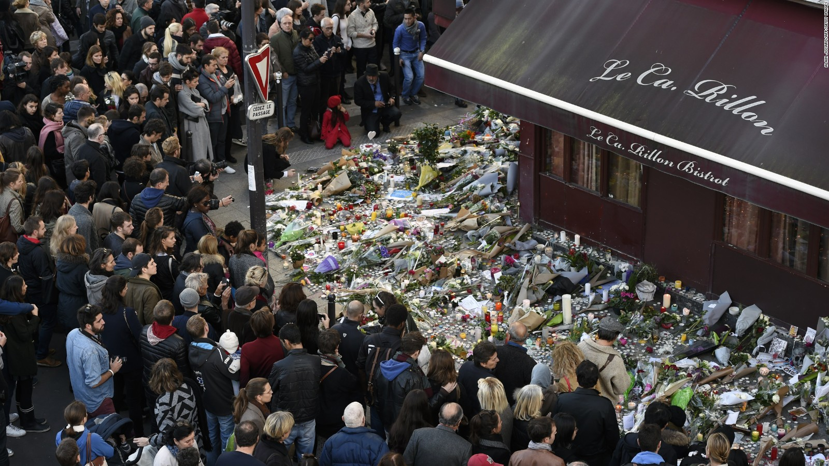2. Click on “ok” to any box that appears

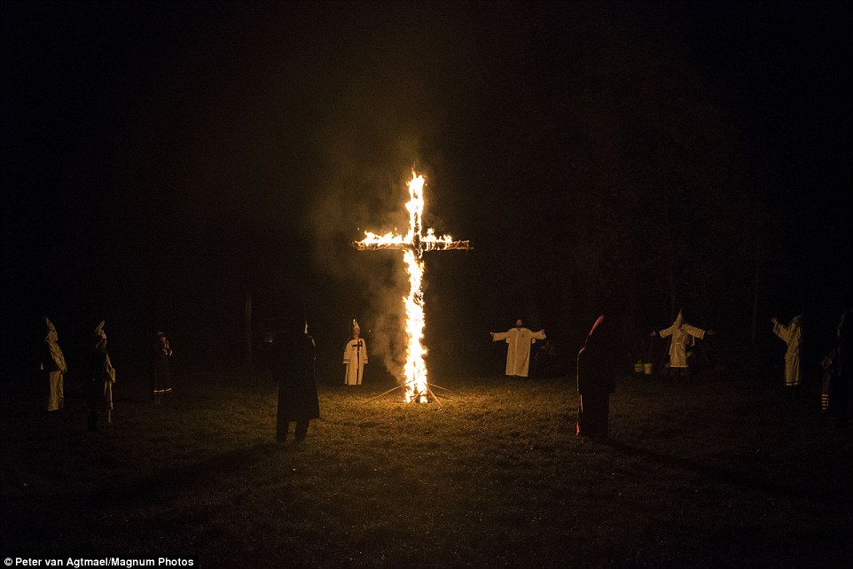3. Open the Internet in either Google Chrome or FireFox if possible

4. Go to “Google”

5. Search for “Sporcle Middle East”

6. Click on the top result

Practice learning the countries of the Middle East.

**Directions:** Write a paragraph or two to answer the questions below. These are opinion questions so as long as you answer the questions and reference the pictures/videos we watched in class, you can’t be wrong. ☺

* Why do people join gangs or terrorists group?
* Why do terrorist groups/gangs often use religious symbols?
* Why did most Americans find Donald Trump’s proposal to temporally stop Muslims from entering the United States offensive?