Name: Block: Teacher:

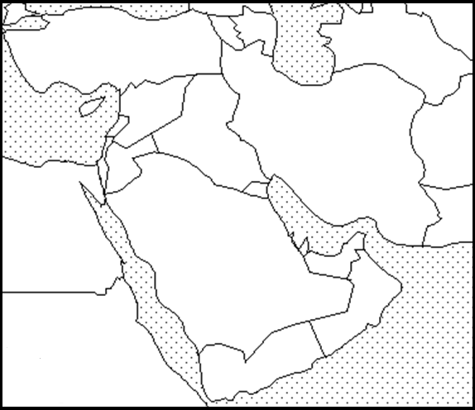
Map Key
Color
Red
Yellow
Blue
Green

(Title) _______________________________________________

Southeast Asia - Thematic Maps

Directions: Create two thematic maps. Remember a thematic area shows an area and an issue within that area. The first map you need to create needs to show the average life expectancy of a person in the Middle East. The second map you will create shows the average earnings of a person in the Middle East.

Average Life- is how long the average person in a country can expect to live.

Average Earning- is how much money the average person in a country can expect to earn in a year.

To help you label these details you may use a purple Africa book, page 260. Make sure your map is presentable. Please do not rush while doing this assignment. Make sure you include a map title and key. Names of countries should be in CAPS. Capitals should be marked with a small star and circle around it.
Example:

Country | Avg. Life | Avg. Earnings  Color Life Expectancy  Red < 69 years  Yellow 70 –75 years  Blue 76 -78 years  Green >79 years  Color Avg. Earnings  Red < $5,000  Yellow $5,001 – 15,000  Blue $15,001 -29,999  Green > $30,000
Afghanistan | 60 | $1,100
Bahrain | 77 | $29,800
Cyprus | 82 | $24,500
Egypt | 71 | $6,600
Iran | 74 | $12,800
Iraq | 70 | $7,100
Israel | 82 | $36,200
Jordan | 74 | $6,100
Kuwait | 78 | $42,100
Lebanon | 75 | $15,800
Oman | 76 | $29,800
Qatar | 79 | $102,100
Saudi Arabia | 76 | $31,300
Syria | 68 | $5,100
Turkey | 75 | $15,300
United Arab Emirates | 76 | $29,900
Yemen | 64 | $2,500

Southwest Asia - Thematic Maps

Directions: Create two thematic maps. Remember a thematic area shows an area and an issue within that area. The first map you need to create needs to show the average life expectancy of a person in the Middle East. The second map you will create shows the average earnings of a person in the Middle East.

Oil Reserves – Is the estimated amount of oil in the ground.

To help you label these details you may use a purple Africa book, page 260. Make sure your map is presentable. Please do not rush while doing this assignment. Make sure you include a map title and key. Names of countries should be in CAPS. Capitals should be marked with a small star and circle around it.
Example:

Country | Oil Reserves by Billions  Color Oil Reserves Billions of Barrels  Red < 5  Yellow 5–75  Blue 76 -149  Green >150
Afghanistan | 0
Bahrain | 0
Cyprus | 0
Egypt | 0
Iran | 136.3
Iraq | 115
Israel | 0
Jordan | 0
Kuwait | 101
Lebanon | 0
Oman | 0
Qatar | 15.2
Saudi Arabia | 262.3
Syria | 2.5
Turkey | 0
United Arab Emirates | 97.8
Yemen | 3

Thematic Maps
Middle East Writing Prompt – Connecting the Dots
Patterson

Part 1
Directions: Please label the following documents:
Document A – Political map of Middle East*
Document B – Thematic map of average life in the Middle East
Document C - Thematic map of average income in the Middle East
Document D- Oil Reserves
Document E- War in the 21st Century (page 59 – State of the World Atlas)

*If you don’t have a political map, open a purple Asian book to page 260. You can use this as your political map; it should still be cited as (Doc A).

Part 2
Directions: Respond to the following prompt. You may either agree with or disagree, but in doing so you must use evidence from all three documents to prove where your way of thinking is correct.

“There is always a connection between the standard of living of a country and the amount of natural resources it within its borders.” – Mr. Patterson

Thematic Maps
Middle East Writing Prompt – Connecting the Dots
Patterson

Part 1
Directions: Please label the following documents:
Document A – Political map of Middle East*
Document B – Thematic map of average life in the Middle East
Document C - Thematic map of average income in the Middle East
Document D- Oil Reserves
Document E- War in the 21st Century (page 59 – State of the World Atlas)

*If you don’t have a political map, open a purple Asian book to page 260. You can use this as your political map; it should still be cited as (Doc A).

Part 2
Directions: Respond to the following prompt. You may either agree with or disagree, but in doing so you must use evidence from all three documents to prove where your way of thinking is correct.

“There is always a connection between the standard of living of a country and the amount of natural resources it within its borders.” – Mr. Patterson

