Lifting the Curtain (Myanmar and Human Rights) - Lesson Cycle
Callanan/Merrill Middle School
Patterson/Smith/Tharp/Westcott

Students take away knowledge should be:
Why is there a need for a Declaration of Human Rights? How does this declaration apply to Myanmar?

(W) = Resource is on 7th Grade Global Studies Website
Highlighted blue word = hold down “ctrl” and click on the blue word to take you to the site/video

Day 1
Intro Myanmar – PowerPoint (W)
As a warm up explain to the students that the next seven days we will be examining the country of Myanmar. As we progress through the lesson cycle we need to keep the following questions in mind. Why is this country the second poorest in all of Asia? What/who is preventing the people of Myanmar from improving the quality of their lives? What responsibly do we have, as global citizens, to change this?

Lifting the Curtain – Netflix (W)
Part 1
For this documentary students will use the instructional strategy called “share the pen.” Students are partnered up with one sheet with both their names on it. One student will write while the other tells them what to do. They alternate every two questions. This will need to be modeled for the students.

Day 2/3
Warm Up – What rights should every man and woman in the world have access to?
Have students come up with a list of the their own rights. Ask them would most people/countries agree with the list?

Declaration of Human Rights Activity
Link – 4:12 minutes
Handout a notecard to each student; explain that in 1972 most countries around the world came together and came up with a list of rights that every man and women should have access to. Play the video and have the students write on one side of the card every right they hear while watching. You may have to replay parts.

Have the students discuss the rights and pick the one that they think is most important. Have them write the right on the other side in block letters and color around the words. Have the students staple their notecards on a bulletin board or tape them to the wall.

Brave and Startling Truth (W)
Maya Angelou wrote this poem on 50th anniversary of the U.N. Her poetry helps us reflect on the idea that none of us are purely “devils or divine.” Handout the sheet Brave and Startling truth sheet explain how in her poem she uses vocabulary that is at upper level. These words are defined on the right side of the page. Play the YouTube clip above as they follow along. If possible handout highlighters to each student so they can highlight passages that either speak to them or confuse them.

*Optional Fluency Lesson
Explain to the students that when reading poetry it’s important to have proper fluency. The words need to be pronounced in a smooth flow so the listener has the experience the poet wanted them to have. Have students break off into groups and practice saying their two stanzas. Play and encourage the groups to develop a rhythm of their own. Encourage friendly competition.

The directions on the 2nd page state that students then need to summarize each stanza into one sentence. This will need to be modeled if the not done before. When students are finished they are to create a poster of the “truth” that Maya Angelou writes about. They should write the last stanza’s sentence on the poster.

Examples of student work:
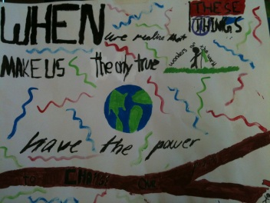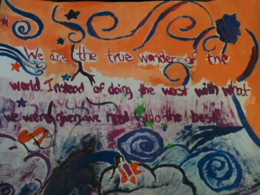

Day 4
Suu Kyi Times Article (W)
Part 1 – Link 6 minutes
Ell and lower level students should have small group instruction and read through the article with the teacher. Some of the content in the article could be difficult to grasp.

Lifting the Curtain – Netflix (W)
Part 2

Day 5
Suu Kyi Times Article (W)
Part 2

Lifting the Curtain – Netflix (W)
Part 3

Day 6/7
Letter to Congressman (W)
Students will write letters to Senator Tom Harkin. In the letter the students will introduce themselves and what they are studying. They will also explain the importance of following the Declaration of Human Rights when it comes to countries like Myanmar. Students should write the letter on the first day and peer edit the second day. The letter should be used as a summative assessment (and should also be mailed). This will be an excellent time to introduce the idea of “civic duty” (your Civics teachers will be appreciative).

Peer Revision
On the second day students should provide feedback on each other’s letters. Instruct the students to check for these three things in the letter that they are editing.
1. Is the letter properly setup? (Indents, name, paragraphs)
2. Does the letter address what life is about in Myanmar?
3. Does the letter mention the Declaration of Human Rights?

Lesson Extension
Burma VJ – Netflix Documentary

