Relative and Absolute Lesson Cycle
Callanan Middle School
Patterson

(W) = Resource is on 7th Grade Global Studies Website
Highlighted blue word = hold down “ctrl” and click

Students take away knowledge should be:
Students will be able to fluently interpret Latitude and Longitude coordinates.

Students will need rulers, blank paper, geography books.

Day 1
Warm Up
Why are coordinates an example of absolute location?

Coordinates are example of an absolute location because with just two numbers you can exactly where you are in the world. Example Link Sometimes this is the only way practical way for people to find certain parts on the Earth, especially when giving relative directions are nearly impossible.

Picture #1
Why would it be difficult to describe this location using relative directions?

Picture #2
Does anyone know what this is a picture of?
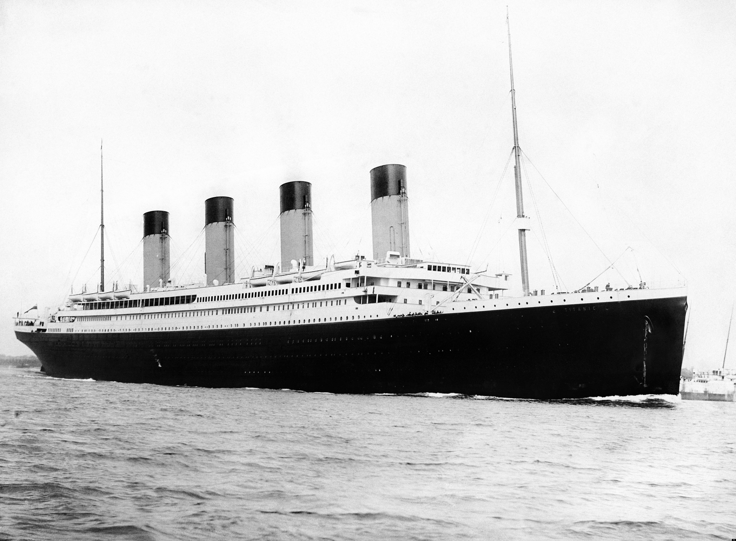
Picture #3
In order to find the Titanic wreckage or other hard to find places we rely on technology that makes use of Latitude and Longitude coordinates that explain exactly where we are on Earth.
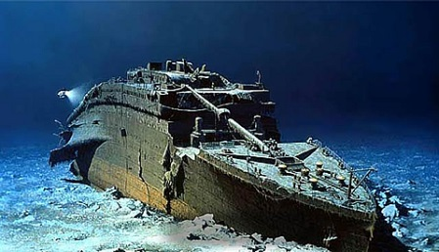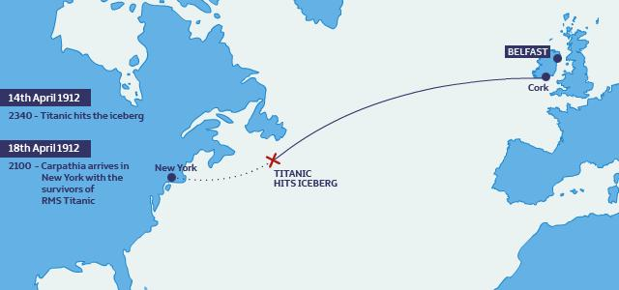

Plotting Coordinates
1. Make sure students can read/use a ruler at the 1 inch mark.

Measuring Practice (W)

2. Using the ELMO show the students how to make a grid on a paper with the lines exactly one inch a apart. Label the Y axis with the alphabet and the x axis with numbers; make sure that they understand how to plot simple coordinates. When completed have the students crumple up the paper and throw into garbage can.

“Latitude goes round and round.
Longitude goes up and down.”

3. Hand out another piece of paper, have the student create lines of Latitude, separated 1 inch apart. Explain the numbers and directions have students practice choosing lines of latitude with the correct directions.

4. Hand out another piece of paper, have the student create lines of Longitude, separated 1 inch apart. Explain the numbers and directions have students practice choosing lines of Longitude with the correct direction. Have the students

5. Have the students make a complete grid, before they practice plotting points they should practice finding the correct quadrant. Use sticky notes to mark the quadrants.

6. Give the students numbers to plot.

Day 2
Warm Up
Latitude goes…
Longitude goes…

Latitude and Longitude USA (W)
As a class work through the above worksheet.
Give students a blank paper; have them work in make a one inch grid, complete with prime meridian, equator directions and numbers by themselves.

Need numbers list

Have them check their work and give then give them coordinates to plot. When students who have finished plotting they should help others around them.

When the majority of the class is finished use the random country generator, practicing using index to find map and plot coordinates of capitols. Link

Plotting/Finding Latitude and Longitude

“Latitude goes round and round
Longitude goes up and down”

Latitude always goes before longitude

Des Moines - 40 N 90 W

Plotting Coordinates | Finding Coordinates
1. Find part of the world we are looking at by matching the direction given to the directions on the side of the map.  2. Identify lines of latitude going from lowest to highest for that direction.  3. Find line that is closest to the number given and mark it with your finger.  4. Find part of the world we are looking at by matching the direction to the direction on the map.  5. Identify lines of latitude going from lowest to highest for that direction.  6. Bring fingers together | Latitude  1. What direction will you use? Write it down.  2. Identify lines of longitude going from lowest to highest.  3. Estimate the closest line of latitude and write it down.  Longitude  1. What direction will you use? Write it down  2. Identify lines of longitude going from lowest to highest.  3. Estimate the closest line of longitude and write it down.

Day 2
Given Coordinates

L&L Student Sheet
Part 1 & 2

Link to flash

Day 2
Warm Up
Latitude lines go…..
Longitude lines go……

Have students create map on the board, go over quadrants/finding directions.

Latitude and Longitude practice sheet
When done have them come up and check their answer, help people at their table

Random Country
Using the link, students find the longitude and latitude of random countries on the back of their latitude and longitude practice sheet

Exit Slip
On a notecard have the students write their name and block. Have them write down the latitude and longitude of

