Intro to Africa Lesson Cycle
Callanan Middle School
Patterson

(W) – on website
Underline- rationale the students should walk away with
Blue Word – Click on blue word and hold down “ctrl” button

The purpose of this lesson cycle is to introduce students to the region, issues, and vocabulary that will be the focus of class for the next couple of weeks.

Day 1
Intro to Region (W)  Vocab: Sub-Saharan Africa, Thematic, Physical, and Political  Africa Political Map (W) | Resources  SubAfricaStudentSheet  IntotoSubAfricaRegion_Vocab (W)  Africa Political Map (W)  Materials  Extension

Day 2
Warm Up  Analyze Thematic Map (Page 2)  -What is this map showing?  -What type of map is this?  Discuss why this map be important for ESPN?  Africa Political Map (W)  -model reading directions,  -marking/showing CAPS  -title, color in the same direction | Resources  Africa Political Map (W)  Materials  Extension  Sporcle  Latitude and Longitude Practice link

Day 3
Warm Up  What type of map did we use for the Division?  -Watch Bear Grylls, Season 2 Zambia  -30 minutes  If you were planning a trip for Bear Grylls, what would have to think about?  -Have students discuss how they would use each type of map,  -Have the students find the maps that would use for filming an episode on Google  -Students would write a paragraph using physical, thematic, and political map, page 3 | Resources  Materials  Bear Grylls, Season 2  Computers  Extension  Finish watching episode  Sub-Africa Vocab Quiz (W)  Stand up, hand up, pair up, share with vocabulary,  Quiz

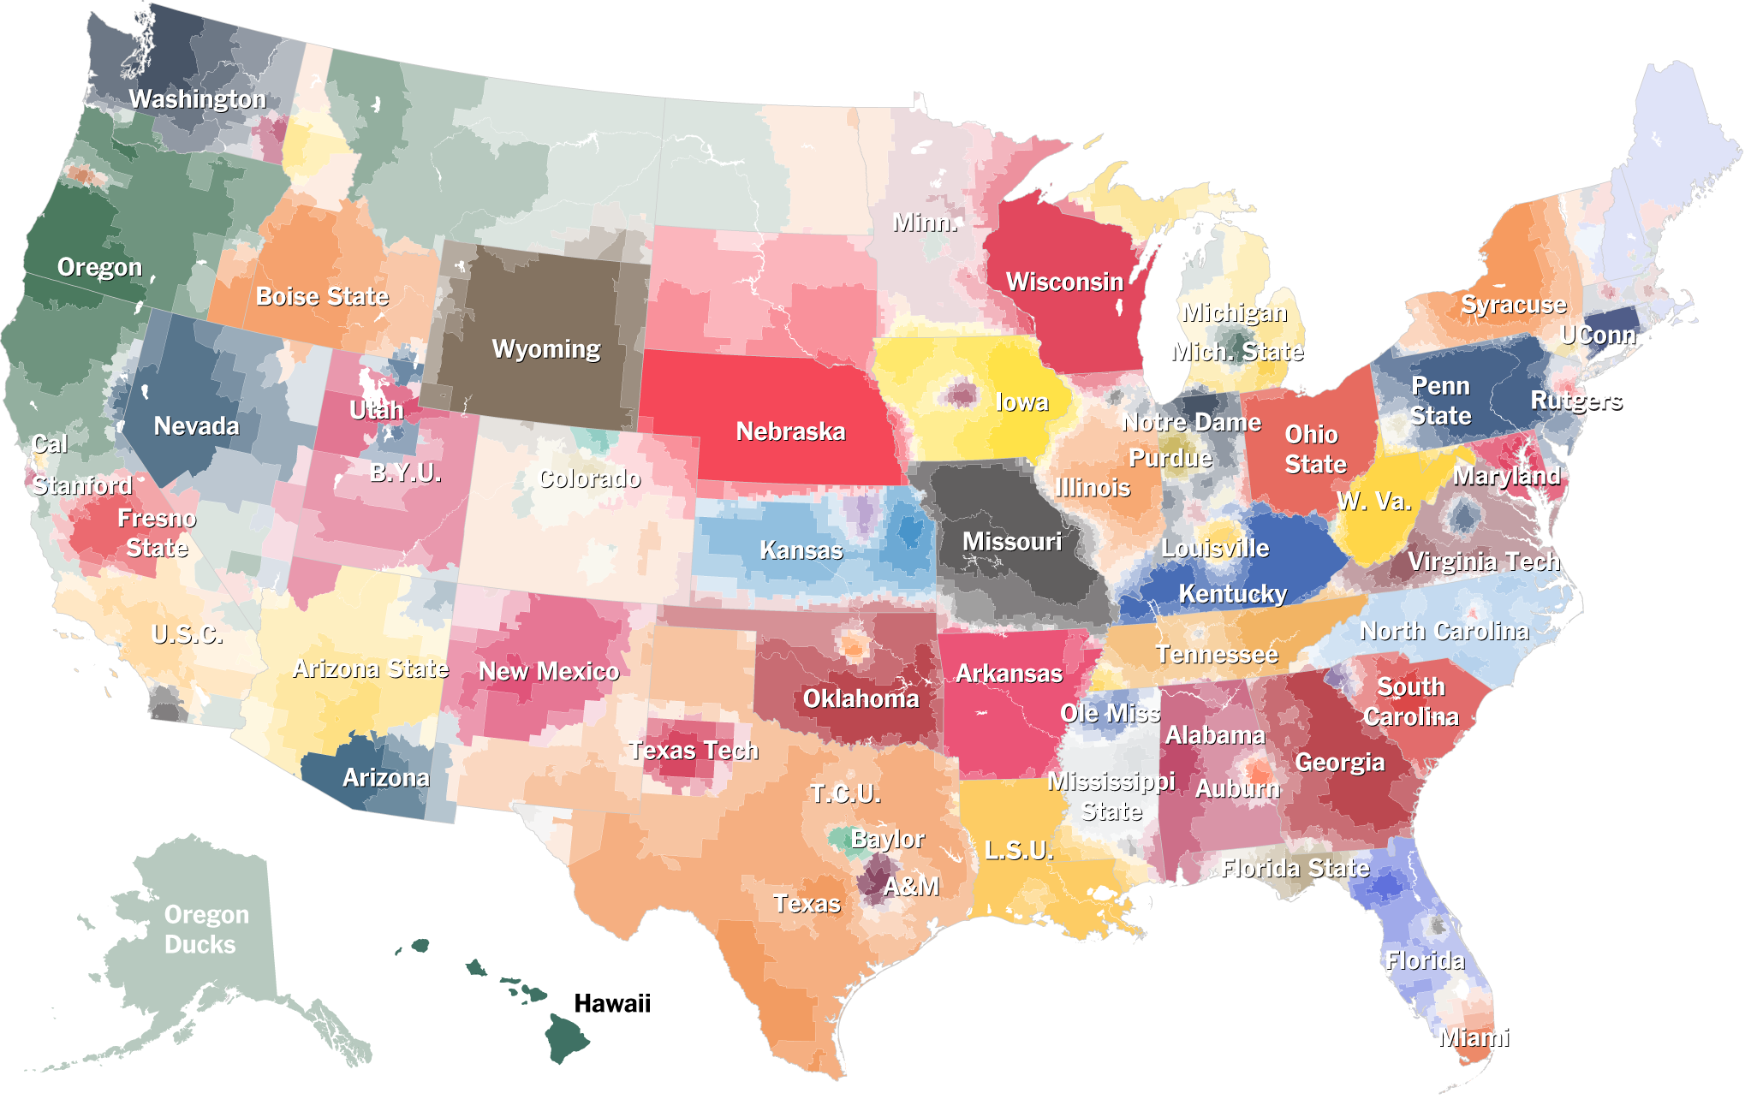
College Football Fan Map
Name:

Block: Man vs. Wild
Teacher:

Directions: Bear Grylls is an adventurer for the Discovery channel that travels to different parts of the world. Choose a place for Bear Grylls to visit for a future episode. Explain how you would use political, physical, and thematic maps in the planning process. Your paragraph should be at least five sentences in length. You should also use and highlight when you write use political, thematic, and physical maps in your writing.

__________________________________________________________
__________________________________________________________
__________________________________________________________
__________________________________________________________
__________________________________________________________
__________________________________________________________
__________________________________________________________
__________________________________________________________
__________________________________________________________
__________________________________________________________
__________________________________________________________
__________________________________________________________
__________________________________________________________
__________________________________________________________
__________________________________________________________
__________________________________________________________
__________________________________________________________
__________________________________________________________
__________________________________________________________
__________________________________________________________
__________________________________________________________
__________________________________________________________

Quizlet
Do you have a smart phone?

If yes, download the app called Quizlet. Search for Callanan and click on the quiz titled Sub-Saharan Africa Callanan. Study the unit vocabulary by playing the scatter game for this quiz set. Your goal is to match all of the vocabulary.

If no, use may use either a computer or an I-pad. Go to Google, search for the website called Quizlet. Search for Callanan and click on the quiz titled Sub-Saharan Africa Callanan. Study the unit vocabulary by playing the scatter game for this quiz set. Your goal is to match all of the vocabulary.

Sporcle

Using a computer, practice your master geography skills by playing Sporcle games. Log in to a computer and type the web address in bold exactly how it appears below.

Oceans and Continents Quiz
http://bit.ly/1Ep30YE

Regions of the World Quiz
http://bit.ly/1h69iYw

African Country Quiz
http://bit.ly/1JVRiLf

Word Wall
Create a poster for the class word wall. Make sure that your word wall poster has these three different parts. Also, make sure you spell every word correctly and make sure you write large enough to read across the classroom.
1. Vocabulary Word
2. Definition
3. A picture showing the meaning of the word

