Give Working Prisoners Respect and Decent Pay
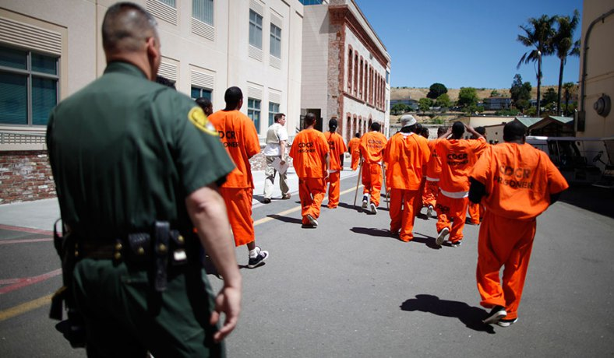
As many as 24,000 prisoners in factories across the country decided to protest the low amount that people in prison are paid last. This country’s largest-ever protest now seems to have not worked, with their demands unmet, prisoners have returned to work. REVISE
A recent study found that the average inmate/prisoner makes 93 cents an hour but it can go as low as 16 cents. I worked for almost six years, working in a prison kitchen. After taxes were taken out, I earned between $5.25 and $8.75 per week.
As someone with who knows what prison is like, I know that prison work is mostly misunderstood by the public/people outside of prison. The first misconception is that all prison work is the same. In fact, there are two types of prison jobs. First, there are ones like mine, where inmates/prisoners work for the prison, and the employer — the government — doesn’t make a profit per se off prisoners’ backs, though it holds down expenses by paying little or nothing to get essential tasks done.
Then there are jobs under the Prison Industry Enhancement (PIE) program, in which inmates/prisoners are put to work by a private business. This second type of jobs holds much more potential for reform/change in ways that will help inmates.
All contracts/agreements between private companies and prisons for inmate/prisoner work must follow the PIE program rules, as written under the Percy Amendment to the Justice Improvement Act. The idea was that if people have nothing to do in prison, they are more likely to fight and get in trouble. PIE outlines a minimum wage of $7.25 an hour for prisoners. It also says if prisoners are allowed to ask for better working conditions.
The problem is that prisoners are charged special fees that take most of their money. This includes taxes, payment of fines, rent and food, and other costs associated with the prisoner’s criminal processing and incarceration, which the prisoner can be made to repay.
Taking 80 percent of someone’s pay/money seems excessive and unreasonable; even courts don’t take 80% of someone’s money for child support.
The most obvious solution to low wages/pay for prisoners is to change the rules about what can be taken from out of their paycheck. The chance of this happening is low; prisons have become used to the money they make on prisoners and tax payers outside of prison don’t want to have to pay more.

How tap water became toxic in Flint, Michigan

Nearly two years ago, the state of Michigan decided to save money by switching Flint's water supply from Lake Huron (which they were paying the city of Detroit for), to the Flint River, a notorious river that runs through town known to locals for its pollution.

"We thought it was a joke," said Rhonda Kelso, a long-time Flint resident. "People my age and older, thought 'They're not going to do that.' "

The switch was made during a financial state of emergency for the ever-struggling industrial town. It was supposed to be temporary while a new state-run supply line to Lake Huron was ready for connection. The project was estimated to take about two years.

What's in the water?

Soon after the switch, the water started to look, smell and taste funny. Residents said it often looked dirty.

"The water would come in brown and my daughter was like 'Mom ... why is the water brown?' "
Kelso thought it was sewage, but it was actually iron. The Flint River is highly toxic: 19 times more so than the Lake Huron supply, according to researchers from Virginia Tech.

According to a lawsuit, the state Department of Environmental Quality wasn't treating the Flint River water with an anti-corrosive agent, in violation of federal law. Therefore, the water was eroding the iron water mains, turning water brown.

But what residents couldn't see was far worse. About half of the service lines to homes in Flint are made of lead and because the water wasn't properly treated, lead began leaching into the water supply, in addition to the iron.

This had been going on for nearly two years, and until September, city and state officials told worried residents that everything was fine. Former Flint Mayor Dayne Walling even drank it on local TV to make the point.

But in August, a group of skeptical researchers from Virginia Tech came up and did in-home testing and found elevated levels of lead in the drinking water and made those findings public. State officials insisted their own research was more accurate.

"You're paying for poison. I'm paying for water that's a toxic waste," Kelso said. She and her daughter and four other families are now part of a class-action lawsuit that alleges not only lead poisoning but several medical conditions resulting from contaminated water after the switch.

Later it became publicly known that certain laws/rules had not been followed. A 2011 study on the Flint River found it would have to be treated with an anti-corrosive agent for it to be considered as a safe source for drinking water.

Adding that agent would have cost about $100 a day, and experts say 90% of the problems with Flint's water would have been avoided. Just a few weeks later, in October, the city went back to using Detroit's Lake Huron water supply, but the damage was done to the lead pipes.

Even with properly treated water flowing in, Virginia Tech researchers still noticed lead levels in water in Flint homes.

The state is now handing out filters and bottled water to people living in the city.

In 2011, Flint was declared to be in a financial state of emergency (the city was broke), and the state took control. Therefore, all the decisions made during the water pollution crisis were at the state level.

"When the governor appointed an emergency manager (in 2011), that person came here ... to simply do one thing and one thing only, and that is to save money, at any cost," said Michigan Congressman Dan Kildee.

"This case shows that you can't treat cities the way you treat some businesses that you might just sort of sell off," Kildee said.

Lead poisoning is irreversible (not curable). Doctors for small children such as Hanna-Attisha fear the Flint babies who tested with high levels of lead will be sick for the rest of their lives

Lead hurts your IQ, it affects your behavior, it's been linked to breaking the law, it has multigenerational impacts. There is no safe level of lead in a child."

There are environmental actions that can help lower these long term consequences such as proper nutrition and early childhood education. But that's made more difficult in a city with inadequate resources and without a grocery store.

Document A – Class Copy

Sesame Street songs were repeatedly played for days on end to torture Guantanamo Bay prisoners, report claims.
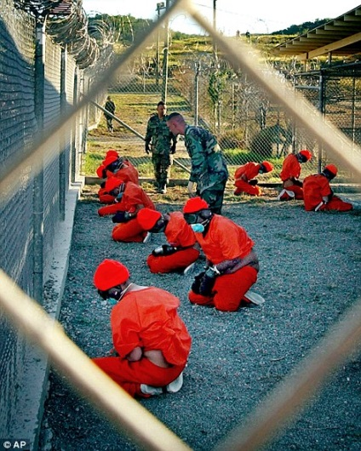
They were written to teach children colors and strange words but versions of catchy Sesame Street songs have been used to torture Guantanamo Bay prisoners for days.
(Guantanamo Bay is the name of a prison outside the United States where suspected terrorists are held.)
According to a report, ‘innocent children's songs, from the popular US children program, were blasted repeatedly into prisoners’ ears.
Christopher Cerf, the man behind the distinctive Sesame Street theme tune, and a further 200 songs used in the show over the years, says he was shocked to discover that his music which was intended for good, was used as a form of torture.
Speaking to reporters, he said: ‘'My first reaction was ‘this can't possibly be true, this is just too crazy,’ it was just didn’t make sense.’’
‘I didn't really like the idea that I was helping to break down prisoners, but it was much worse when I heard later that they were actually using the music in Guantanamo to cause long-term pain on prisoners so that they would talk.’
It is not the first time Sesame Street music was reported as being used to break the will of prisoners.
In 2003, the U.S. military used music to scare Iraqi soliders and terrorists they captured in war.
Mr. Cerf, who has been working for the famous children's television show for four decades added: 'This is fascinating to me because of the horror of music being used to serve evil purposes, but I'm also interested in how that's done and what is it about music that would make it work for that purpose.
'The idea that America would be doing torturing other people, to save our own freedom, is sadly kind of funny.’
A CIA document shown in the documentary titled 'Guidelines for Treating Prisoners' says that the permitted levels and durations for which music can be played to prisoners is the equivalent to being: ‘as loud as the highway for 18 hours a day, the volume of a cranked up motorbike for eight hours or a jackhammer for two hours.'
It is unclear whether or not these guidelines or rules were followed at Guantanamo Bay.
In the program, Thomas Keenan from The Human Rights Project at Bard College in New York claims that sometimes prisoners were left for hours or even days listening to music at Guantanamo Bay, Kabul and other hidden prisons.
_____________________________________________________________________________________
Directions: Read through the article either out loud or with a partner. Answer the following questions in one paragraph. Make sure that you have citations and text evidence.

- What is happening in the article?
- What rights are involved?
- In your opinion, what should be done about it?

Name:

Block: Human Rights Article

Teacher:

Document B - Eleven things women in Saudi Arabia can't do

The country of Saudi Arabia has passed a new rule that forces women to be completely covered when they appear on T.V.
The Saudi Government decided that women should wear "modest" clothes that does not "show off their beauty", according to Arab News.
The move has prompted mixed reaction in the Muslim country, with some arguing that the government shoul=d be focusing on more important issues, while others saying that women should be stopped from appearing on television altogether. "They should not use women to attract more viewers," wrote one journalist.
Saudi Arabia has a terrible history of following human rights, particularly with regards to protecting women. Although in recent years the rights of women have slowly increased.
In a country where a woman cannot open a bank account without her husband's permission, here are several other things women in Saudi Arabia are still unable to do:
Go anywhere without a male chaperone (babysitter)
When leaving the house, Saudi women need to be followed by a male relative.
Drive a car
There is no official law that bans women from driving but deeply held religious beliefs stop it, with Saudi religious leaders arguing that female drivers "would challenge what people would think was right".
In 2011, a group of Saudi women organized the "Women2Drive" campaign, which encouraged women to disregard the laws and post images and videos of themselves driving on social media to raise awareness of the issue in an attempt to force change. It was not a major success.
Saudi journalist Talal Alharbi says women should be allowed to drive – but only to take their children to school or a family member to hospital. "Women should accept simple things", he writes for Arab News. "This is a wise thing women could do at this stage. Being stubborn won't support their cause."
Vote in elections
Saudi Arabia is the only other country in the world, apart from the Vatican City where women are not allowed to vote, but men are, the Washington Post reports.
Compete freely in sports
Last month, Saudi Arabia tried to say have the Olympic Games without women. "Our country can be very traditional," said Prince Fahad bin Jalawi al-Saud, a consultant to the Saudi Olympic Committee. "It has a hard time accepting that women can compete in sports."
When Saudi Arabia sent its female athletes to the London games for the first time, some people in Saudi Arabia started nasty rumors about them.
_____________________________________________________________________________________
Directions: Read through the article either out loud or with a partner. Answer the following questions in one paragraph. Make sure that you have citations and text evidence.

- What is happening in the article?
- What rights are involved?
- In your opinion, what should be done about it?

Document C - 'The deepest circle of hell:' Terrified Yarmouk residents describe ISIS raid

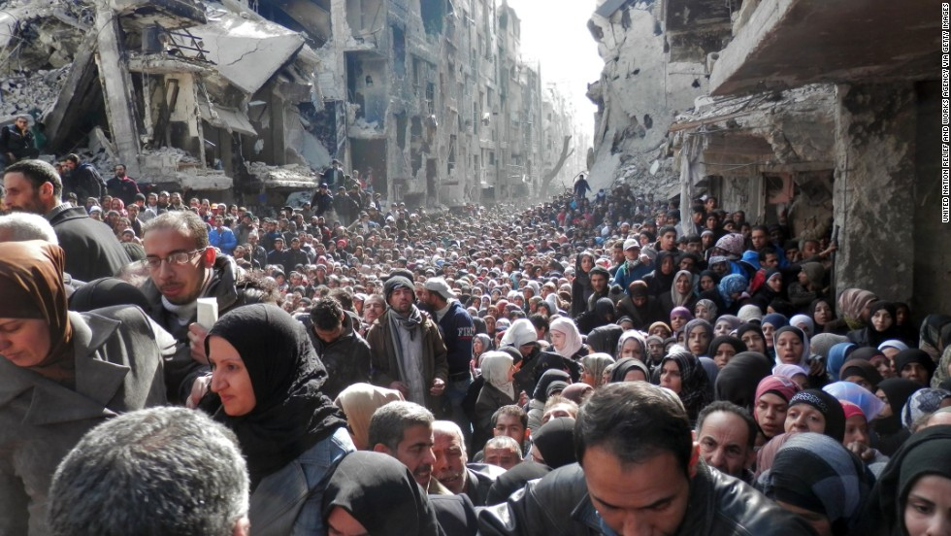
Video - Link
(CNN)In the Middle Eastern country of Yemen, ISIS (a group of terrorists) has attacked a refugee camp called Yarmouk with terrible results.
This city has been attacked/bombed for two for more than two years by the Syrian government, the desperate people of this Palestinian refugee camp near Damascus awoke in early April to a new, even more terrifying reality -- ISIS militants started attacking the city that they live in.
"The ISIS terrorists shot civilians in the streets," one Yarmouk resident, who asked not to be named, told CNN. "ISIS (caught) three people and killed them in the street, in front of people. The Islamic State is now in control of almost all the camp."
An estimated 18,000 people are now trapped inside Yarmouk, stuck between ISIS and Syrian regime forces in "the deepest circle of hell," in the words of U.N. Secretary-General Ban Ki-moon.
Aid agencies briefly managed to break the government's military barrier on the camp last year, and delivered medicine to tens of thousands.
But now, as terror closes in on Yarmouk from all sides, residents have two choices -- to attempt to flee what was their place of safety, or to stay inside what the U.N. says now resembles a camp of death.
"Now I am scared of two things -- I am scared of (ISIS) and the Syrian government," the Yarmouk resident told CNN.
"The Syrian Government now is about to destroy the Yarmouk camp," he said. "And ISIS, I don't know ... they didn't do anything to help us, all they did was change the name of the camp to Yarmouk Camp.

