Great Powers Lesson Cycle
Callanan Middle School
Patterson

(W) Means on website
Underline what should be said to the class
If there is a blue word click on it while holding down “ctrl”

Standard
3B – Explain the economic motivations for colonization around the world (SS.7.22).

Lesson Cycle Overview
In this lesson cycle, students will play a game where European countries go to war with each other. A successful strategy requires teams to focus on acquiring as many resources as possible. During the debrief, students will make connections to how the game reflects real life motivations for colonization.

Informal Unit Goals
Connect the desire to win wars/acquire resources to colonization
Things Fall Apart Disclaimer on violence, infant mortality

Day 1
Opening Discussion – See Logic Flow*

Great Powers Visuals (W)  European Flags and National Anthem  -Post this in OneNote, go over example with students, page 18-21 is an outline of this. Revise words.  -print out examples for both sides of the room | Resources/Materials/Extension  Class set of computer, trifold signs  African History (First six minutes) Link  Flocabulary – Mansa Musa - Link  John Green – Slave Trade – Link  Sporcle Games - Link

Logic Flow
Show video of Whitney Houston singing national anthem. Link, Link Ask students, why do some Americans consider this is the best performance national anthem performance ever? Yes, she can sing but it’s more than that, also the circumstance of the Gulf War. What do you notice about the crowd?

Anthems and flags are extremely important. They serve to unify a country, to get people to forget the times they were divided, and to work together. That’s why, when people are trying to start a new country, they create a flags and anthems. What does the American flag stand for? Show. Explain how the national anthem wants us to think about. Hype this story up as much as possible.

Explain that tomorrow, we are going to play a game. Groups are going to start researching the country they are going to represent in the game. Prewrite countries on notecards. S

Pass out tri-folds while students are doing this. Have students shut their computers, if the computers aren’t thinking.

Explain expectations with tri-fold. When students are playing, have them write name of the writer on the sheet of paper instead of labeling France #1 it is France (Abbie).

Days 2/3
Opening Discussion –

Great Powers Visuals (W)  Great Powers Game (W)  -Have Enrichment students mark on worth on cards  Great Powers Game  -start of day 2, introduce general concept of the game, including basic rules, with example, have groups make alliances, plan first round  Show video while cleaning up/organizing | Resources/Materials/Extension

When explain the Great Powers Game:
1. Overview – of Game
2. Read rules to them
3. Answer questions as a group while you hand out resources
4. They figure out budget/what to spend, have them mark the worth of the chip on the chip
5. They create treaties.
6. Finish tri-folds

Day 4
Opening Discussion – Who lost yesterday in the game?

Great Powers Visuals (W)  Vocab: Colonization, Natural Resources  Great Power Game/Debrief  -page 17 | Resources/Materials/Extension  Mancala, Sporcle, Map?  Great Powers Assessment (W)  Save tri-fold flags  Flocabulary – WW1 and need for resources Link

High Quality Catalan Atlas Map - Link
Atlas Panels Translation - Link

Post Catalan Atlas in OneNote, break up discussion by having students look at it. What do they notice as they click? Do this in partners.

Musings
Connect Great Powers and Scramble for Africa. Whatever European countries they represent in the games, they track the independence.

WWI Game
- Possibly spread of over two days
- Identify three bankers, have bankers hand out money/write checks,
- Potentially start with everyone being equal (already revised to be closer)
- Write checks when it comes to big numbers at the bank.
-Write the value of a colony and industry in the corner when making copies
- Use notecards to write down who you are fighting for, and what you want to buy

Musings:
-Introduce if there is a second day of fighting:
Roll a die – all fight, change sides, show numbers for one side
6 – Everyone must fight
5 – Everyone can change sides
4 – Sea Battle Takes place, every navy slip counts as three armies
3 – Normal Battle
2 – Normal Battle
1 – Normal Battle

-On a note card, write the name of your country, on the back write the total army and navy units.
-Have students finish the first side of the reflection while you clean up.

Class Copy
Great Powers Game

Who is playing this game? The countries of Europe that were powerful around the year 1900, participated in the Great Powers Game.

Goal: The goal for the great powers game is to be the most powerful European country in the room. In order to accomplish this, your country must build up its army, navy, industry, and colonies. Countries will also have to make sure that they are strong enough to win any wars that they may find themselves in.

How the game is played: Each team will represent a European country. You will try to make your country as powerful as possible. Each country has a description sheet that explains its strengths and weaknesses at the start of the game. You will have to wisely use your countries’ allowance/budget to make it stronger than other teams.

Not all countries are the same; some countries are more powerful than others. This cannot be helped, this game is based on real life after all, and countries have different sized armies and navies. However, small countries can do very well in this game, if they spend their money wisely and make the right friends.

Your country will continue to gain power, wealth, and influence until a war breaks out and then you will have to defend it. A key strategy for this game is to make sure that you are friends with other countries, so they will come help you in case someone declares war on you. Like real life, the teacher will not force anyone to follow through on an agreement; countries will be on the “honor system.”

Spending your allowance (money): Every turn, your group will have to decide what to spend your yearly allowance on; try to maintain a balance. For example: don’t spend so much on colonies that you have no army to defend yourself, or don’t spend so much on the navy that you don’t have any industry. See the Great Powers Cheat Sheet on the back of this paper for the descriptions on what each card does.

Wars: Fighting wars in this game is simple. First, each country is asked if they are going to fight or just watch. After the sides are determined, each country adds up their army units. The side with the most army units wins. In the event of a tie, the number of Navy units will decide a winner.

Example:

Attackers | Defenders
Spain - 10  Britain - 30  Belgium -5 | England - 10  Russia – 10
Total= 45 (Winner) | Total= 20 (Losers)

* The winning side gets to take the losers colonies as payment for the troops that died fighting in the war.
1

Great Powers Cheat Sheet

Turn Order
 | Description
1. Planning | Figure out what your group wants to spend its money on. Also, countries can form alliances/agreements with other countries for protection
2. Spend Money | Countries spend their allowances; they can buy army, navy, industry, or colony units.
3. War | Fighting takes place, countries that have the most army and navy unit’s win. The winning side gets to split the loser’s colonies.

Menu
Cost | Label | Description
$ 1 | Army | When countries go to war, whichever side has the most army units will win. The countries that win the war get to take the losers colonies.
$ 1 | Navy | In the event that there is a tie in the amount of armies in the war, the tie breaker will go to whoever who has the most Navy cards.
$ 1 | Industry | For every industry card you have, you get +1 dollar towards your allowance every year.  Example:  3 Industry cards = $3 dollars you can spend
$ 2 | Colony | For every colony card you have, you get +3 dollars towards your allowance every year. There are only 120 colonies available.  Example:  2 Colony cards = $6 dollars you can spend.

2
Great Britain/England – Class Copy

Power: Really strong (like Mr. Patterson strong)

Friends: If possible, Great Britain should try and be friends with Belgium, Spain and/or France.

Enemies: Great Britain has also not got along with most countries in this room at some point. Most recently though, England has been at war with Russia and is worried how powerful Germany is becoming.

Goals: Britain’s primary goal is to keep a balance of power in Europe. Britain doesn’t want any country to become so powerful that they can ignore what Britain wants.

Strengths: Britain has the strongest navy in the world and everyone knows it. England also has a strong economy (lots of industry) and several colonies.

Weaknesses: Other countries know that England is really powerful at the start of the game and as a result, may target the country before it can be a bully.

Allowance:
Industry 3
Colonies 3

Military:
Army 1
Navy 3

Questions
1. How powerful is your country?
2. What are your country’s weaknesses?
3. When the game starts, who should you try and be friends with? Why? What are the names of the students representing these countries?

France – Class Copy

Power: Great

Friends: France has no real friends (so sad!) since at one point it has fought with almost every country in the room. Lately, though, France has started to realize that Belgium will be powerful in the future and that an alliance/team could possibly be formed with them.

Enemies: Recently, France has being arguing with Great Britain and Germany over colonies. Of the two countries, France is most worried about Germany and wants to make sure that Germany doesn’t end the game more powerful than them.

Goals: To be stronger than Germany and become as rich Great Britain by the end of the game.

Strengths: France has a strong army and navy compared to the rest of the world.

Weaknesses: Since France is a powerful country to start the game, it might be targeted by less powerful countries that are worried about them being a bully in the future.

Allowance:
Industry 2
Colonies 2

Military:
Army 2
Navy 2

Questions
1. How powerful is your country?
2. What are your country’s weaknesses?
3. When the game starts, who should you try and be friends with? Why? What are the names of the students representing these countries?

Germany – Class Copy

Power: Strong

Friends: Germany has no true best friend but recently they have started to become closer with Spain and Italy. Both of those countries are weaker than Germany and look up to it protect them from France and Great Britain.

Enemies: Germany’s main rival is France. France is jealous of how strong Germany is becoming and will probably try and get other countries to gain up on Germany (how pathetic of them).

Goals: Be stronger than France by the end of the game. Also, make sure that Great Britain or any other country doesn’t become too powerful.

Strengths: Powerful army and strong industry.

Weaknesses: Germany doesn’t have many colonies so its starting spending money is small compared to France and Great Britain.

Allowance:
Industry 3
Colonies 1

Military:
Army 2
Navy 3

Questions
1. How powerful is your country?
2. What are your country’s weaknesses?
3. When the game starts, who should you try and be friends with? Why? What are the names of the students representing these countries?

Italy – Class Copy

Power: Medium

Friends: Italy has no real friends since it has fought almost every country in Europe. However, lately Germany and Italy have started to get along. Germany is stronger than Italy and has offered to protect the country from France and Britain.

Enemies: Most countries don’t like Italy because they don’t like it how Italy stays out of wars and instead of fighting in them.

Goals: Italy is jealous of its more powerful neighbors and wants to be like them by the end of the game. In order to accomplish this, Italy must try not to fight in unnecessary wars that it could lose. It must gain more colonies!

Strengths: Powerful army and navy for the size of the country.

Weaknesses: Italy needs to spend its money on industry and colonies so it can become more powerful in the future.

Allowance:
Industry 2
Colonies 1

Military:
Army 2
Navy 2

Questions
1. How powerful is your country?
2. What are your country’s weaknesses?
3. When the game starts, who should you try and be friends with? Why? What are the names of the students representing these countries?

Spain – Class Copy

Power: Medium

Friends: Spain doesn’t have a true best friend but recently it has become close with Germany and Italy. Germany is stronger than Italy and has offered to protect the country from France and Britain.

Enemies: Spain’s main rival is Portugal. In recent years, Portugal has tried to get other countries to gang up and attack Spain. Spain must use Germany to help it make sure that Portugal doesn’t become powerful.

Goals: Be stronger than Portugal by the end of the game. Have a big army so it won’t be viewed as an “easy” target.

Strengths: Powerful army and strong industry.

Weaknesses: The main weakness facing Spain is that its allowance is small compared to other countries playing this game. This must be fixed!

Allowance:
Industry 2
Colonies 1

Military:
Army 2
Navy 1

Questions
1. How powerful is your country?
2. What are your country’s weaknesses?
3. When the game starts, who should you try and be friends with? Why? What are the names of the students representing these countries?

Portugal – Class Copy

Power: Great

Friends: Portugal has no true best friend but recently they have become friends with France and Great Britain. Great Britain is stronger than Portugal and has offered to protect it from Germany and Spain.

Enemies: Portugal’s main rival is Spain. In recent years, Spain has tried to get other countries to gang up and attack Portugal. Portugal must use Great Britain to help it make sure that Spain doesn’t become too powerful.

Goals: Be stronger than Spain by the end of the game. Have a big army so it won’t be viewed as a weak country.

Strengths: Powerful army and several colonies.

Weaknesses: The main weakness facing Portugal is that Spain is trying to get other countries to attack it. Since several countries are friendly with Spain so this is a real possibility.

Allowance:
Industry 1
Colonies 2

Military:
Army 3
Navy 1

Questions
1. How powerful is your country?
2. What are your country’s weaknesses?
3. When the game starts, who should you try and be friends with? Why? What are the names of the students representing these countries?

Belgium – Class Copy

Power: Great

Friends: Belgium has no true best friends but has recently found itself liking Italy.

Enemies: Belgium has no real enemies, but it understands that Germany, France, and Great Britain are powerful and therefore represent a risk to its future. Belgium must keep these three countries from forming an alliance because they would surely target Belgium.

Goals: To become as strong as possible, you are willing to make alliances/teams with anyone to get this done.

Strengths: You have the strongest industry in the game. You need to make sure that you use that industry to become as powerful as possible.

Weaknesses: Belgium is quickly becoming powerful and that is making other countries worried. Some countries may gang up and attack Belgium because they are scarred of its industry.

Allowance:
Industry 4
Colonies 1

Military:
Army 2
Navy 2

Questions
1. How powerful is your country?
2. What are your country’s weaknesses?
3. When the game starts, who should you try and be friends with? Why? What are the names of the students representing these countries?

Name:

Block: Great Powers Debrief

Teacher:

Directions: Answer the following questions in complete sentences while throwing back the underline phrases at the reader.

1. What goal was your country trying to accomplish during this simulation/game?
____________________________________________________________________________________________
____________________________________________________________________________________________

2. How did your country go about trying to accomplishing this goal?
____________________________________________________________________________________________
____________________________________________________________________________________________

3. Did your group “win” this game? Explain why or why not.
____________________________________________________________________________________________
____________________________________________________________________________________________
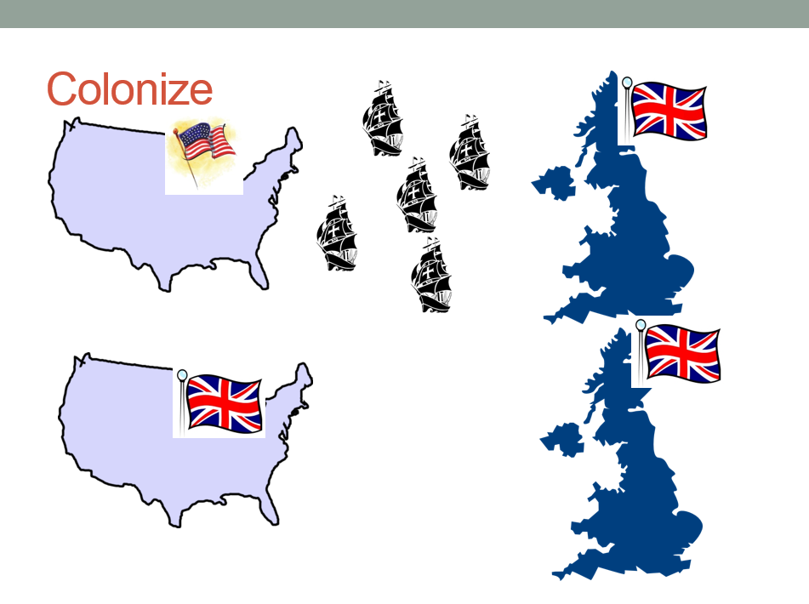
4. What does it mean to colonize?
__________________________________________________________________________________________________________________________________
1
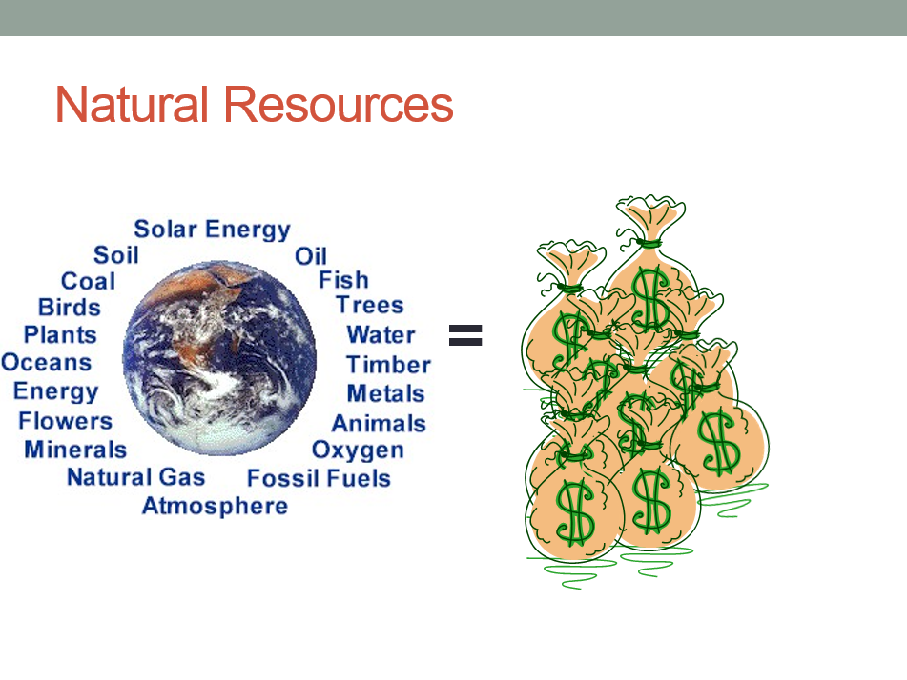
5. What are natural resources?
_______________________________________________________________________________________
__________________________________________________________

6. Why did most European countries decide to spend their allowance on colonies rather than on industries? Why would this help them become more powerful?
____________________________________________________________________________________________
____________________________________________________________________________________________
7. What do you notice about the map? What parts are accurate? What parts aren’t?
____________________________________________________________________________________________
______________________________________________
______________________________________________
______________________________________________
______________________________________________
8. What did the story of Mansa Musa’s wealth cause people to think about Africa? What do you predict will happen next?
____________________________________________________________________________________________
______________________________________________
______________________________________________
____________________________________________________________________________________________
2

