Name: Switch 1 and 2. As it is currently written, this is an incredibly hard assessment.

Block: History in Africa – Level 2/3

Teacher:

Topic | 2 | 3 | 4
History in Africa | Basic Knowledge/skill such as:  Cause and effect  Specific vocabulary such as: colonization, natural resources | Explain the impact of colonization on Sub-Saharan Africa | Analyze how present day Sub-Saharan Africa has been shaped by its past

Level 2 Questions

Directions: Answer the following questions to the best of your ability. Make sure to “throw back” the question at the reader; use the vocabulary words in your written response. Please highlight when you use a vocabulary word in your writing.

1. How did Mansa Musa’s wealth accidentally lead to the colonization of Africa?
Vocabulary: gold, salt, and natural resources
____________________________________________________________________________________________
______________________________________________
______________________________________________
____________________________________________________________________________________________
______________________________________________
______________________________________________
____________________________________________________________________________________________

2. Why was it important for European countries to acquire colonies in the game? How was the game we played similar to what happened in real life?
Vocabulary: natural resources, colonization

____________________________________________________________________________________________
______________________________________________
______________________________________________
____________________________________________________________________________________________
______________________________________________
______________________________________________
____________________________________________________________________________________________
______________________________________________
______________________________________________

Level 3 Question

3. Using the thematic map of French-speaking countries in Africa, make an inference about what happened to these countries in their past? How could this past affect students like you in these countries?
(Making an inference is coming to a conclusion based on either text or picture evidence.)
______________________________________________
____________________________________________________________________________________________
______________________________________________
______________________________________________
______________________________________________
____________________________________________________________________________________________
______________________________________________
______________________________________________
______________________________________________

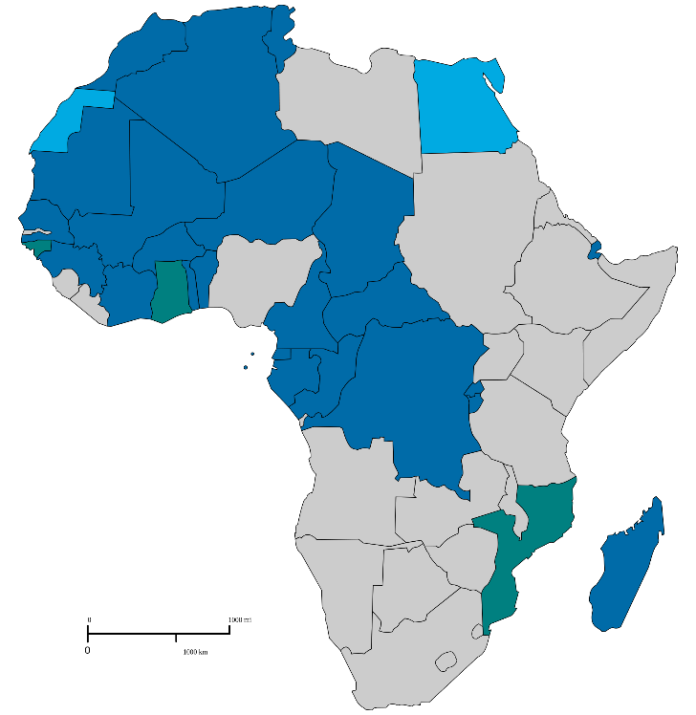
Class Copy

Document A

Document A is a thematic map of Africa. Countries where most of the people who live there speak French are marked in blue.

Class Copy

Document A

Document A is a thematic map of Africa. Countries where most of the people who live there speak French are marked in blue.

