Level Three
What do you notice about the locations of the countries that colonized Africa? Why do you think they are dispersed like this?
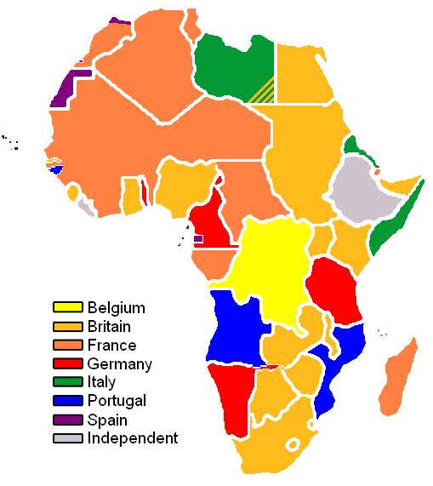

Level Four
The following is a THEMATIC MAP that shows climate zones.

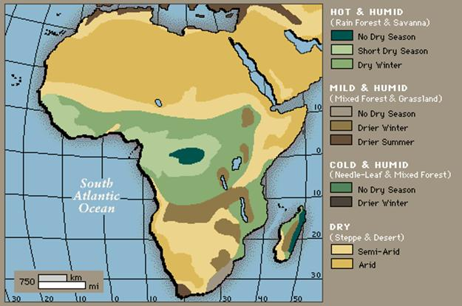

The following is a THEMATIC MAP that shows population density.

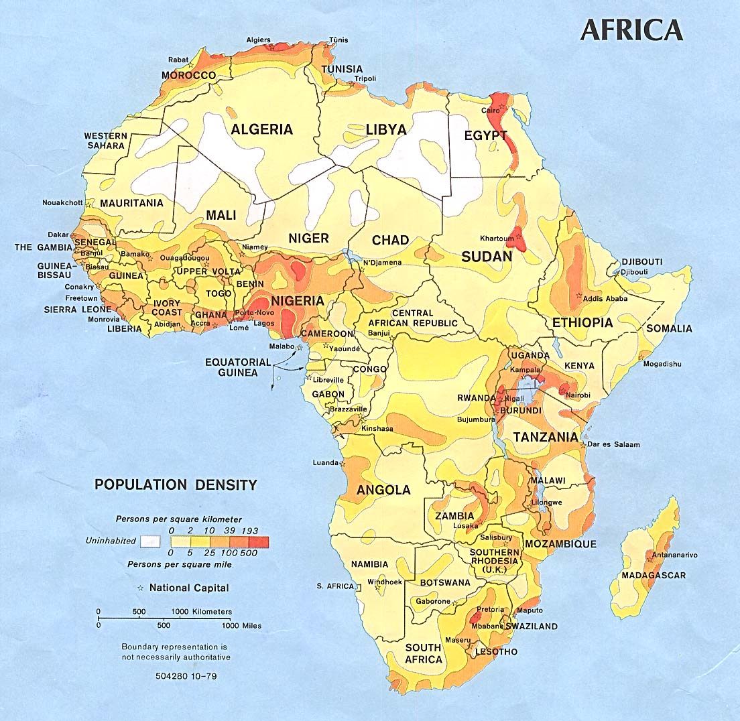
When you look at the two different maps and compare areas, what do you see? What conclusions can you draw from the two different maps? What does climate have to do with population? What else would be a factor in population density?
