Making Your Country Sign - Directions

Directions: Take a blank piece of paper and fold it into thirds.

The top part of your paper should be the name of your country in all capital letters.

The middle part should be a neat, colored picture of your country’s flag. You should also include an explanation of what colors and symbols are used.

The bottom part should describe the national anthem. What is the song asking the people of the country to do and think about?

__________________________________________________________________________________

Part 2 - What does my country’s flag look like? What do the colors mean?

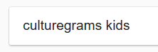

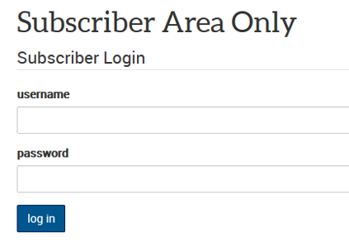

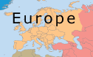
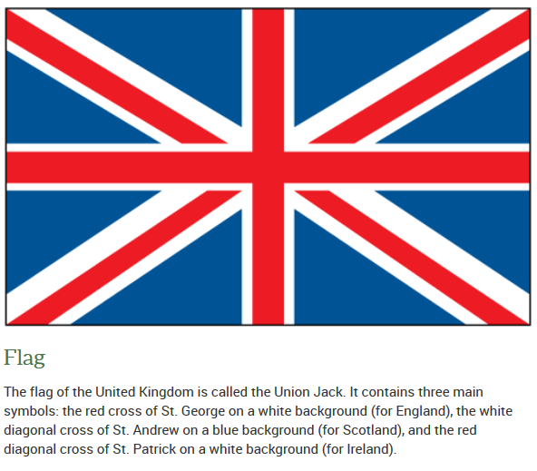
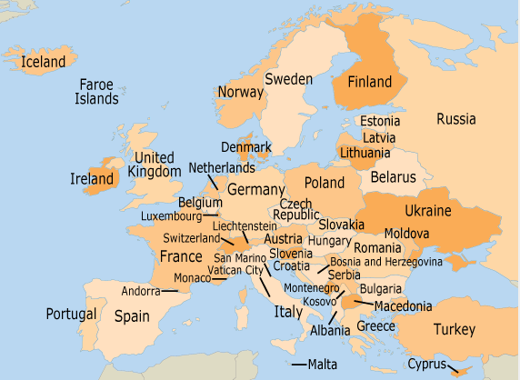
haea11
1737callan
What is the song asking the people of the country to do? What is the song trying to get people to think about?

Belgium National Anthem
Loved Belgium, important land to our family,
Our heart and bodies are dedicated to you.
We offer our strength and blood to you,
We must work together to help Belgium, in work and battle.
So that good things may happen through our teamwork,
Let us hope Belgium will always be free.
Trust each other that, we are not scared, together we say:
For our leaders, for Freedom and for rules
For our leaders, for Freedom and for rules
___________________________________________________________________________________
United Kingdom/England National Anthem
God save our loving Queen,
Long live our Queen,
God save the Queen!
Let her win at everything she tries,
Happy and proud,
Long to control us,
God save the Queen!

God help us,
Make our enemies go away,
Make sure they die!
Make them confused),
Make it so they can't work together,
We believe in our leader,
God save the Queen!
___________________________________________________________________________________
French National Anthem
Grab your weapons,
Make your army
Let's march, let's march!
Let our unworthy enemies bleed
All of our farmland!

What does this group of traitors and kings want?
Why do our enemies carry handcuffs?
They have carried them for a long time! (repeat)
Friends, they are for us! That is absurd!
We must become angry!
If they win, they will take away our rights.
If you love France, grab your weapons!
___________________________________________________________________________________
Germany National Anthem
Germany, Germany over all
Over everything in the world!
When it comes to protecting and defending,
What connects us as a people, makes us super strong!

Work together for freedom and what is right in the world!
For the country!
Let us all work together for that,
If we do so, it will make us all really happy.
May our country always be strong!

Germany, Germany over all
Over everything in the world!
When it comes to protecting and defending,
What connects us as a people, makes us super strong!
______________________________________________________________________________
Portugal
We are really good sailors and are a proud people.
Since we are brave, our country will never go away,
Now is the hour to raise up on high once more
Our country is super rich.
From out our memories,
May the old people who died hear our voices,
We were super powerful in the past, and will become powerful again.

Grab your weapons,
We shall fight by land and sea,
Grab your weapons,
To fight for our Homeland! (To fight for our country)
To march against the enemy guns!

Wherever our flag is, we shall always win.
In the bright light of your sky!
Cry out to all Europe and the whole world
Our country will always live on.

_____________________________________________________________________________________
Spain
Long live Spain!
We sing together,
with different voices,
We are united by love).

Long live Spain!
From the green valleys,
to the big seas,
Song/prayer of friendship.

Love the country,
a country that will take care of us,
below the blue sky,
people in freedom.

Honor and praise to the people,
Who to the world we have created,
The idea of being fair
And letting the people vote for their leader.

United States Example

UNITED STATES OF AMERICA
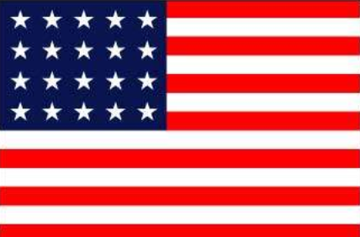 | Stars- There is a white star for every state in the country.  Stripes- There are 13 stripes which stand for the original states/colonies.  Red- stands for honor  Blue- stands for justice and doing what is fair.  White- doing the right thing
National Anthem – Star Spangled Banner  The lyrics or words in the American national anthem want us to think about what our flag would like the morning after a big battle. It is trying to get us to feel love for our country and a sense of doing what is right. | Values Important to America  I think that the values that are important to the United States are equality, honor, and doing what is right. What will help us will have pride in our country.

