Name:

Block: East Asia

Teacher:

Part I
Directions: Provide a definition for each vocabulary word below. The definition must show mastery of the vocabulary word before it can be marked correct. You may provide an example or use the word in a sentence if you feel necessary.

Economy
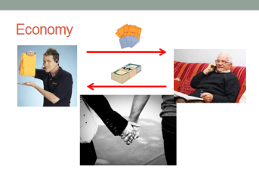

GDP per capita
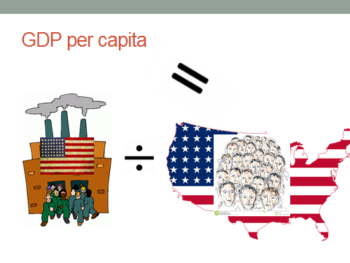

Command Economy
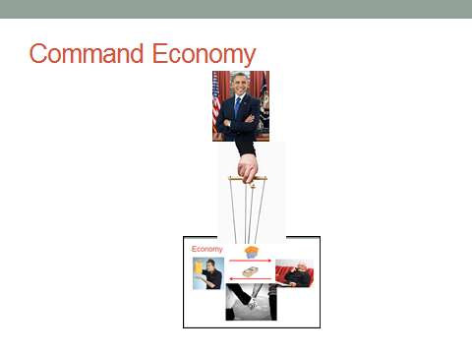

Market Economy
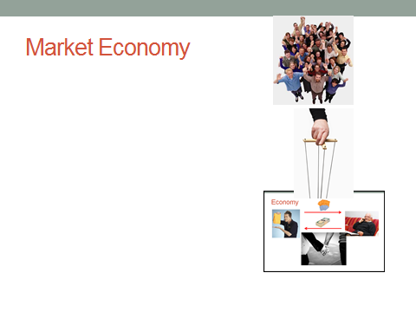

Communism
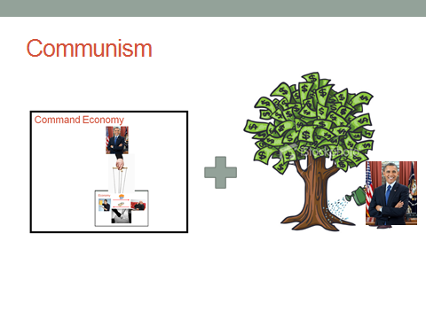

Capitalism
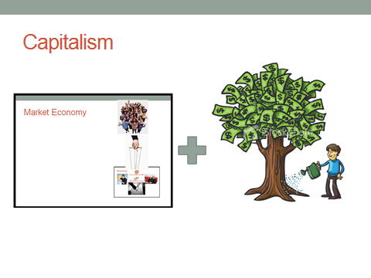

Propaganda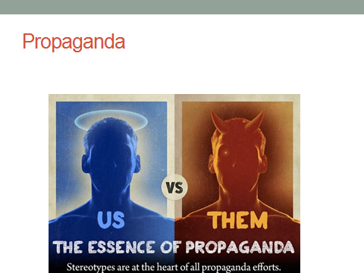

Part II
Directions: Include each vocabulary word in a sentence. The vocabulary word must be underlined and used in a way that shows mastery of the definition.

East Asia Vocab Game
Callanan Middle School
Patterson/Young

Directions: Write the name of the vocab word on at the top of the card; write the banned word list below the word. Students should work in groups, describing the vocab word without using the words from the banned list.

Vocab Word | Banned word list
Economy | Buyers, sellers, prices, things
GDP per capita | Everything, production, buying, selling, dividing
Command Economy | Government, own, property, money, prices, economy
Market Economy | Government, own, property, money, prices, economy
Communism | Government, own, property, money, prices
Capitalism | Government, own, property, money, prices
Propaganda | Biased, information, poster

