Name:

Block: Thematic Maps of the Middle East

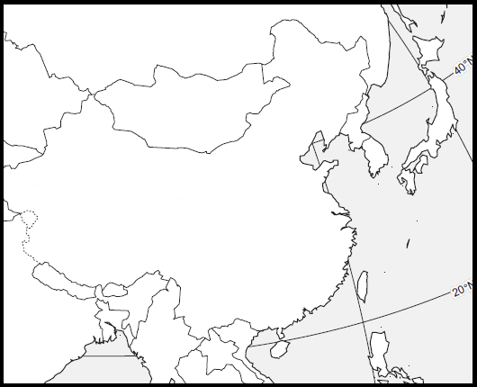
Teacher:

Color | Dollars
 | $10,000 +
 | $9,999- 5,000
 | $4,999-801
 | $800 -

Color | Years
 | 71+
 | 61-70
 | 53-60
 | 52 -

East Asia - Thematic Maps – Document A

Step 1
Directions: Using Google, gather information on East Asian countries in order to fill out the chart below.
For example: Russia GDP per capita

Average Life- is how long the average person in a country can expect to live in a certain country.
GDP Per Capita- is how much money the average person in a country can expect to earn in a year.

Step 2
Directions: Create two thematic maps. Remember a thematic area shows an area and an issue within that area. The first map you need to create needs to show the average life expectancy of a person in the East Asia. The second map you will create shows the average earnings of a person in East Asia.

To help you label these details, you may use a purple Africa book (page 260, the yellow atlas (page 86), or Google. Make sure your map is presentable. Please do not rush while doing this assignment. Make sure you include a map title and key.

Color | Years
 | 71+
 | 61-70
 | 53-60
 | 52 -

Life Expectancy

Country | Avg. Life | GDP per Capita
Russia
Mongolia
China
North Korea |  | GDP per Capita  Color Dollars  $10,000 +  $9,999- 5,000  $4,999-801  $800 -
South Korea
Japan
Taiwan
Philippines

Part 3 - Directions: On a lined piece of paper, answer the following questions in one big paragraph. Make sure that you specific evidence and properly cite the document. Make sure you use both citations and text evidence.

Define standard of living. What is the richest country in East Asia? Provide specific evidence (numbers). What is the poorest country in East Asia? Provide specific evidence (numbers).

East Asia - Thematic Maps

Directions: Create two thematic maps. Remember a thematic area shows an area and an issue within that area. The first map you need to create needs to show the average life expectancy of a person in the East Asia. The second map you will create shows the average earnings of a person in East Asia.

Average Life- is how long the average person in a country can expect to live in a certain country.

Average Earning- is how much money the average person in a country can expect to earn in a year.

To help you label these details, you may use a purple Africa book (page 260, the yellow atlas (page 86), or Google. Make sure your map is presentable. Please do not rush while doing this assignment. Make sure you include a map title and key.

Step 1

Color | Years
 | 71+
 | 61-70
 | 53-60
 | 52 -

Country | Avg. Life | Avg. Earnings
Russia | 70 | 14,611
Mongolia | 67 | 4,056
China | 75 | 6,807
North Korea | 69 | 1,800
South Korea | 81 | 25,976  Color Dollars  $10,000 +  $9,999- 5,000  $4,999-801  $800 -
Japan | 83 | 38,633
Taiwan | 79 | 32,000
Philippines | 68 | 2,765

