Name:

Block: Internationalism Assessment

Teacher:

Topic | 2 | 3 | 4
Internationalism  In South Asia | Define/explain key vocab:  Human rights, globalization | Explain, with examples, how different countries treat their citizens when it comes to human rights.  Explain/justify the role the United States should take in world affairs when it comes human rights. | What is the real price of you t-shirt?

Directions: Define the following vocabulary words. You can but are not required to connect the word to something we did in class.

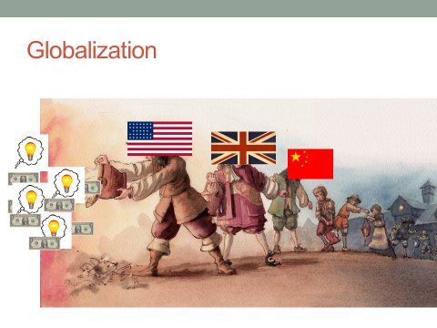
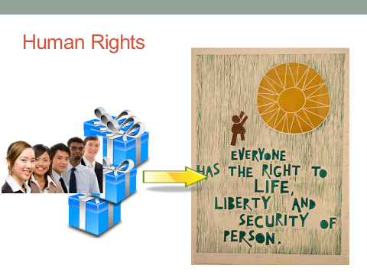

1. What are human rights?
________________________________________________________________________________________________________________________________________________________________________________________________________________
2. Explain the idea of globalization.
________________________________________________________________________________________________________________________________________________________________________________________________________________
Universal Declaration of Human Rights

We are all Born Free and Equal | We’re Always Innocent Till Proven Guilty | The Right to Democracy  (Choose their leaders)
Don’t Discriminate  (Don’t target people) | The Right to Privacy | Social Security  (Be taken care of when older)
The Right to Life | Freedom to Move | Worker’s Rights  (Safe and welcoming place to work)
No Slavery  (People should be paid for their work.) | The Right to Seek a Safe Place to Live | The Right to Play  Play
No Torture  (Don’t hurt people you have control over) | Right to a Nationality  (People should be able to form their own country). | Food and Shelter for All
You Have Rights Everywhere | Marriage and Family  (People should be able to choose who they marry.) | The Right to Education  (For everyone, regardless of identities)
We’re All Equal Before the Law | The Right to Your Own Things | Copyright  (Your ideas should be protected)
Your Human Rights are Protected By Law  (If people break these rules, there should be a punishment.) | Freedom of Thought  (People shouldn’t be brainwashed or tricked into believing something.) | A Fair and Free World
No Unfair Detainment  (Shouldn’t be put in jail for no reason.) | Freedom of Expression  (People should be able to choose what they write.) | Responsibility
The Right to Trial  (Everyone | The Right to Public Assembly  (Get together to protest.) | No One Can Take Away Your Human Rights

3. Explain, with examples, how different countries treat their citizens differently when it comes to human rights. Think of the investment game we played, the documentary watched, the articles we have read, and what you learned about breaking your
___________________________________________________
4. What should the United States do about human rights violations happening around the world? No country is perfect. The United States government has been accused of human rights violations. As people who buy things, what is our responsibility to people who live around the world? You will need to state your opinion and then justify it with examples from class and/or the news.
___________________________________________________
5. Write a response to the question below. In your response, you can but are not required to use the following phrases: human rights, outsourcing, globalization, and NGO’s. Please underline, highlight or put boxes around if you use these academic words in writing

What is the real price of your t-shirt?

