Natural Disaster Lesson Cycle
Geography
Patterson

(W) Means on website
Underline what should be said to the class
If there is a blue word click on it while holding down “ctrl”

SS.7.19 Geography - Explain how and why people move from one part of the world to another and why communities exchange goods and ideas.

L.2 Thinking Critically - Creates a product by integrating visual information (i.e. charts, graphs, maps, etc.) with other information in print text by clearly showing connections between them. Product created uses a variety of relevant sources and makes reference to each source used.

In teams, students will create an evacuation plan for refugees fleeing a natural disaster/terrorist attack in the United States. Students will propose solutions to resolve potentional complications that could endanger communities along their route. Students will create a product/presentation that uses visual information to add validity to their plan.

Topic | Estimated Length
Map Skills | 3 Days
Emergency Route | 6 Days

Map Skills Home Next
Taxonomy Level | Learning Targets (What are students learning?)
Retrieval – Executing  Retrieval – Executing  Retrieval – Executing | As a team, students will examine a political map of Iowa to answer who, what, when, where, and why questions.  When prompted, students will correctly restate/throw back the question.  As a team, students will practice geographic skills by accurately solving riddles. Visuals: When finished, check with another group. Put in black bin when finished.

Day 1
Opening Discussion: See logic flow below*
Disaster Visuals (W)  -Map Research #1, pages 4- 6  Students create group agreement, talk with students about checking their answers with another group | Resources/Materials/Extension

Logic Flow* Link
Let’s pretend there is an actual zombie or virus outbreak. The only people you know for sure that aren’t affected are the people in this room. What would your group do? Where would the safest place to go? How would you survive? As a team, come up with a plan of how you would keep yourself group alive. You have ten minutes to plan….
Teacher: What if I told you that when the outbreak starts, the people working at the power plants want to go home and protect/see their family. They leave, the power shuts off, you can no longer swipe a credit card or get gas. How does that change your plan? Give five minutes for revision…
Have a group share their story…
Now the likelihood of a zombie outbreak is hopefully relatively small, but natural disasters and terrorists attacks do happen. The government has people who their whole job is to create plans for not only how they are going to survive but also how they can save others.
Now it seems, simple, get in a car and drive to safety but it probably isn’t that simple. People freak out during disasters. Over the course of this project, you are going to take the role of a government official tasked with getting people to safety. We are going to use the map on your table to plan out our evacuation route. This map is your group’s…. Start scavenger hunt/research….

Day 2
Opening Discussion: Why are action movies usually set in large cities? See logic flow*
Disaster Visuals (W)  Map Research #2, pages 7-8 | Resources/Materials/Extension

Logic Flow*
Transformers 3 - Link Show students Transformers 3 trailer. Ask them, why are most movies set in large cities? (Why is it interesting? Why is it cool?) Why do terrorists attack places in large cities? More targets, important, more people. Disasters in happen in the US every year to some extent, most are naturally occurring. They cause the biggest problems when it happens to major metropolitan areas. The government has to be prepared for it or people get hurt and they get fired. War of the Worlds Trailer - Link in that movie, a bomb goes off that destroys all electronics, let’s say that this happens. What is life like in the city? Make a list. How can the government solve these problems? What are people going to want to do in the city? Ideally want students to understand that people can’t just stay in a disaster area. They need to leave.

Day 3
Opening Discussion – Why do people want to leave disasters area? See logic flow*
Dice Game (W)  -Finish map research  -Students can start circling cities that have a population large than 7,000, visuals needed.  -Put name, block, teacher on maps, make compass rose on sticky note.  Centered on how often times cities grow together, similar to the bubble game, resources should be easier to share | Resources/Materials/Extension

Logic Flow*
Show map picture. Ask, if there is a natural disaster in Chicago, what border of Iowa would people start coming to first? Chicago’s population 2.7 million, they leave the area that is destroyed, why would a city in eastern Iowa called Davenport (102,000) not want all 2.7 million people to stay there? Link for crowd scale. What do you do with the people? GPS is taking everyone the same way, traffic would be bad, real bad. There has to be a plan to get people to safety. Move them to other populated places but need to do so strategically. Population distribution map?

An important skill in life and this project, is how to use coordinates to locate cities. Include visuals.

Names of Groups Members:
Block: Group Agreement

Teacher:

____________________________________________________________________________________________________________________________________________________________________________
________________________________________________________________________________________________________________________________________________________________________________________________________________________________________
______________________________________________________________________________________________________________________________________________________________________________
____________________________________________________________________________________________________________________
________________________________________________________________________________________________________________________________________________________________________________________________________________________________________
____________________________________________________________________________________________________________________
________________________________________________________________________________________________________________________________________________________________________________________________________________________________________
____________________________________________________________________________________________________________________
________________________________________________________________________________________________________________________________________________________________________________________________________________________________________

Name:

Block: Map Research #1

Teacher:

Directions: The answers to these questions can be found on the back of the Iowa Highway Map. You need to answer these questions in complete sentences and throwback/restate the underlined parts.

Part 1
1. Who is the governor of Iowa?
______________________________________________________________________________________________________________________________________________________________________________
2. Who is the lieutenant governor of Iowa?
______________________________________________________________________________________________________________________________________________________________________________
3. How many welcome centers are there in Iowa?
______________________________________________________________________________________________________________________________________________________________________________
4. What do some of the welcome centers have that others don’t?
______________________________________________________________________________________________________________________________________________________________________________
5. What is the name of the website for state park information?
______________________________________________________________________________________________________________________________________________________________________________
6. What phone number would you call for travel information in Iowa?
______________________________________________________________________________________________________________________________________________________________________________
7. Amtrak is the name of a railroad company. How many stops does Amtrak have in Iowa?
______________________________________________________________________________________________________________________________________________________________________________
8. What does the acronym DNR stand for?
______________________________________________________________________________________________________________________________________________________________________________
9. In what city is the Iowa Tourism Office located?
______________________________________________________________________________________________________________________________________________________________________________
10. How many individual city maps are shown on the back of this map?
______________________________________________________________________________________________________________________________________________________________________________
11. What large river is near the city of Burlington?
______________________________________________________________________________________________________________________________________________________________________________
12. What was the population of the state of Iowa in the year 2010?
______________________________________________________________________________________________________________________________________________________________________________
13. What river runs along the north edge of Marshalltown?
______________________________________________________________________________________________________________________________________________________________________________
14. What is the number of the main highway that runs east and west through the city of Burlington?
________________________________________________________________________________________________________________________________________________________________________ ______

When you think you are finished with this assignment, make sure to reread the directions. Check your answers with another person not at your table.

Who did you check your answers with? Please have that person clearly write their name.
Group Names:

Block: Map Research #2

Teacher:

Part I
Directions: Using your map, follow the road directions for each question and see where your trip takes you. Use the back of the map to find what area of Iowa you need to look for your starting location.

1. a. Begin at Fairfield
b. Follow Highway 34 west to Albia.
c. Go South from Albia on Highway 5 to Centerville.
d. At Centerville, go west on Highway 2 to Highway 25.
e. Take Highway 25 north to Highway 34.
f. Go northeast on Highway 34 until you come to a town.
g. What is the name of the town?

2. a. Begin at Harlan
b. Go east on Highway 44 to Panora.
c. At Panora, go north on Highway 4 until you come to Jefferson.
d. At Jefferson, go west on Highway 30 to Carroll.
e. What lake is just south of your location?

3. a. Begin at Dubuque
b. Go south on Highway 61 until you come to Interstate 80.
c. Go west on Interstate 80 to Highway 38.
d. Go north on Highway 38 until it intersects with Highway 30.
e. Go west on Highway 30 until you come to Highway 1.
f. Go south on Highway 1 towards Solon.
g. What lake is just west of your location?

4. a. Begin at Spencer.
b. Go south on Highway 71 to the intersection with Highway 20.
c. Go west on Highway 20 to Correctionville.
d. At Correctionville, take Highway 31 south until it runs into Highway 141. What is the name of the town where these two roads meet?

5. a. Begin at Sidney
b. Go east on Highway 2 until you reach Highway 63.
c. Go north on Highway 63 until you come to Highway 34.
d. At Highway 34, go west to Highway 14.
e. What town is located where Highway 34 and Highway 14 meet?

6. a. Begin at Dyersville
b. Go west on Highway 20 to Interstate 35.
c. Go north on Interstate 35 to Highway 3.
d. Go east on Highway 3 to Highway 14.
e. At Highway 14, go south to Highway 57.
f. What town is located where Highway 14 and Highway 57 meet?

7. a. Begin at Birmingham
b. Go south to Highway 16.
c. Follow Highway 16 east to Highway 61.
d. Go south on Highway 61 until it ends at Highway 218.
e. What city are you at?

Part II
Directions: Start at Marshalltown and provide step by step instructions for a path that will take you to the town Spencer. Be sure to include the name of the roads people should take as well as the direction you travel. Don’t use the phrases such as turn right or turn left, instead use directions and exact mileage. There are several routes that you could plan, but your challenge is to complete the trip in exactly six steps.

For example: Go South on Highway 13 for 10 miles until you reach Spencer.

1.

2.

3.

4.

5.

6.

When you think you are finished with this assignment, make sure to reread the directions. Check your answers with another person not at your table.

Who did you check your answers with? Please have that person clearly write their name.
Emergency Route Previous Home
Taxonomy Level | Learning Targets (What are students learning?)
Retrieval – Executing  Retrieval – Recognizing  Retrieval – Executing  Retrieval - Recalling | As a class, students will create a list of requirements for a safe evacuation routes across Iowa.  As a team, students will identify Iowa cities that can handle a large influx of refugees.  As a team, students will use geographic tools to develop a safe evacuation route.  As a team, students will create a presentation/product that uses visuals to convince people to take their evacuation route in the case of an emergency.

Day 4
Opening Discussion: – Why would you not want to sleep along the side of the highway? Discuss idea of leap frogging from safe place to place. Use kickball bases from gym. Display the visual from the step by step directions and reference it during discussion. -See logic flow for other points* Show visuals from Georgia snow LINK, Day After Tomorrow, Link Walking Dead. Show picture of people in cars, buses, light rail. Project visuals somewhere in the room. Offer to color while we talk?

Disaster Visuals (W)  -pages 11-13 | Resources/Materials/Extensions  Give out directions as need be, keep it as simple as possible.  Show visuals of base hopping.

Logic Flow*
If there is a disaster in Chicago, what border of Iowa would people start to show up on? Plans should start on the eastside.

What type of roads should people travel on? Why is today to have different routes?
Immediately after a disaster that destroys large city, what are some things will happen? What will happen to the people that survived? What happened to the people who lost their homes? What should the government do to help? How will they get the aid to the affected areas? Discuss how some people don’t have cars in big cities. Gov. will use interstates to get aid, airports will be compromised. Why don’t interstates have sidewalks? Plans should avoid interstate travel, especially since some people are going to be walking.

If people were walking on foot, why can’t we ask everyone to them to get across in one day? (Iowa is 200 miles wide.) The government also need to know where to send supplies. The emergency plan needs to take seven days and can’t exceed a hundred miles.

Why might it be a problem if the government has 7,000 people spend the night in a town like Carbon, Iowa with a population of 34? What would happen if everyone at Callanan had to spend the night here but there was only bathroom and drinking fountain working? Towns that are too small can’t support large groups of people, think about the bathrooms, police, etc… Stops must take place in cities with 7,000 people.
Day 5-7
Opening Discussion – How many miles is it from Orange City to Akron?

Explain that on certain maps, there are tiny black and red numbers. These show how the mileage between different places. Red has stars and black is just off the road. Display the visual from the step by step directions and reference it during discussion. Draw on front board. Practice finding the coordinates for Orange City and Akron. Take them through that process. See fallout visuals for picture.
-pages 11-13 | Resources/Materials/Extension  -Boot camp survey  -Sporcle games, create leaderboards  -TBQ practice  -Map quizzes

Day 8/9
Opening Discussion: Go over project. See logic flow*

-page 14  Decide and create visuals for how want teams to submit work. | Resources/Materials/Extension  -Sporcle games, create leaderboards  -Map quizzes, sheet  Bizarre Foods Iowa – Showing places are sometime shown as extremes, is that fair? Season 2, Episode 3  -Culture collage?  Nitro type?  Students can start Robbery Alibi when finished with project.  Spotify playlist

Teacher: As a class, go over the presentation requirements on page 14. Explain that if groups are working hard and can complete the project by BLANK day, you will be able to count this presentation as the grade instead of taking a written reflection on page 15 - 16. Explain that presentation is easier than the reflection. Talk up how hard they have been working and how important it is to have a great start. Want everyone to have an A or a 3.
Day #
Route Logistics  1st  Starting Point (Bigger than 7,000 people)  Rest Point (Bigger than 500 people)  Ending Point (Bigger than 7,000 people) | Directions:  3rd
Total Daily Miles:
2nd
Name and Phone Number of Hospital:
4th

Name and Phone Number of Police Department:

Day #
Route Logistics  1st  Starting Point (Bigger than 7,000 people)  Rest Point (Bigger than 500 people)  Ending Point (Bigger than 7,000 people) | Directions:  3rd
Total Daily Miles:
2nd

Name and Phone Number of Hospital:
4th

Name and Phone Number of Police Department:

Class Copy
Natural Disaster Planning

Step 1
Looking at the front of your map, find cities that have large spots of yellow. If these cities have a population larger than 7,000, make a neat circle around them. When you have 25 cities circled, you can move on.

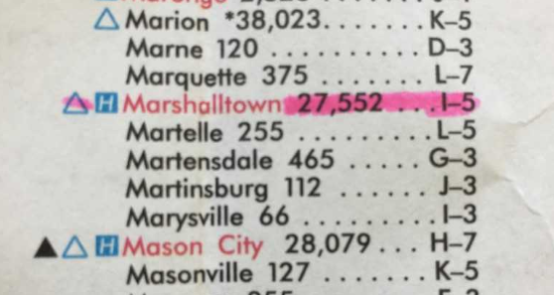
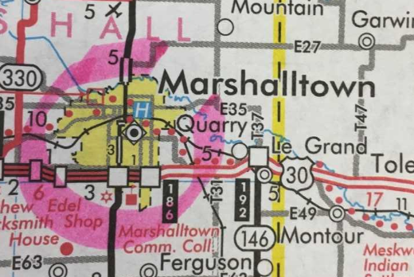

_____________________________________________________________________________________
Step 2
Figure out the start, end, and rest points for each day. Start and end points need to have more than 7,000 people. Rest points need to have population larger than 500. Once you have finished this step, complete box #1 for all days. Lightly highlight/mark the path that you are planning. Only use the red and black roads.

Day 1 Start Day 1 Rest Day 1 End Day 2 Start Day 2 Rest Day 2 End

_____________________________________________________________________________________
Step 3
Using the black and red numbers, add up the total number of miles that you are asking people to walk each day. Complete box #2 for all days.

For example, if you were traveling from Dundee to Omaha, you would be traveling 11 miles.

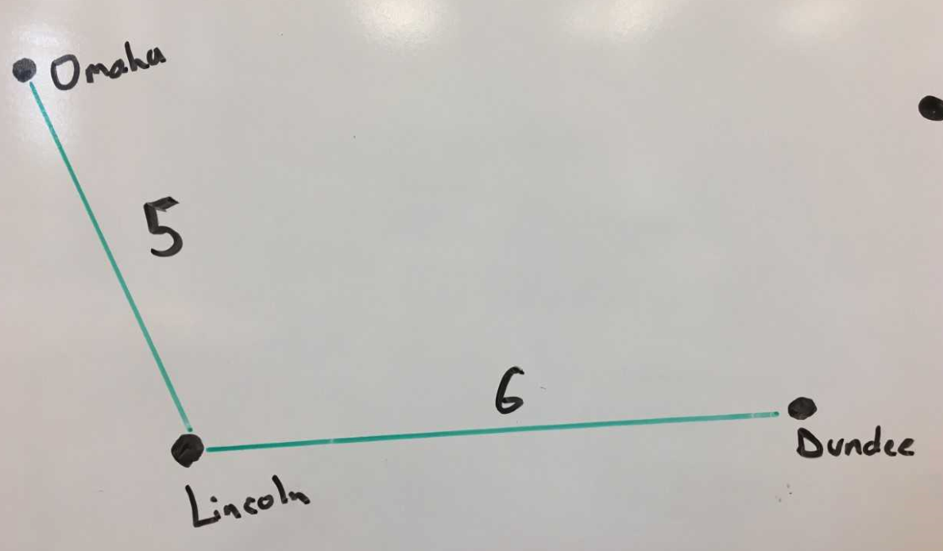

Step 4
Write down the directions that people should follow along your route. I strongly suggest that you use the sentence template below. Complete box #3 for all days.

Template: Go_______________ on ______________ for _______________.
Direction Road Miles

Example: Go_____North______ on __Highway 80____ for ______10______.
Direction Street Miles

_____________________________________________________________________________________
Step 5
Using a computer, identify the highest rated hospital along the travel route and include the phone number. For the city that has the highest rated hospital, include the contact information for the police department (including phone number).

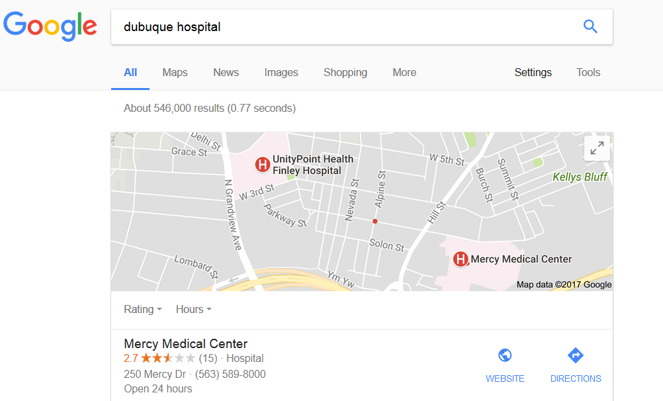
Hospital Research Suggestion:
Name of city, hospital

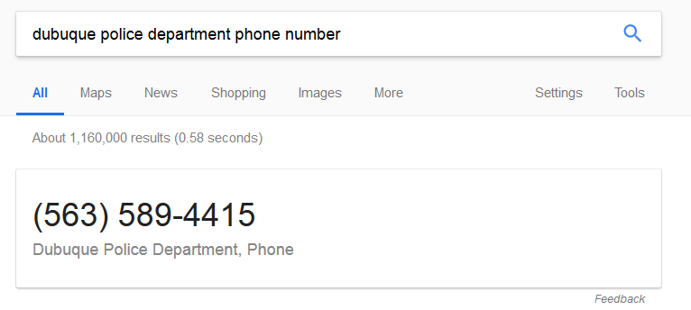

What determines our grade?
Presentation Requirements Class Copy
As a team, create a presentation that uses pictures, maps, and graphs that convinces people that the route your team planned will get them to safety in the event of a natural disaster. Most of this information we have discussed in class or you have written out on your project sheet.

What do you mean by presentation?
That’s a great question. Your group can decide what they can create. You could create a PowerPoint, poster, brochure, rap, etc… You can do this as a group or individually.

What information should we include?
Why are large cities like Chicago more likely to be attacked by terrorists/impacted by natural disasters?
Why would people want to leave large cities like Chicago, if there was no power/a big disaster?
Why would the government tell people that they need to leave the city instead of just having them stay in their homes?
Why couldn’t everyone in Chicago stay/live in the city of Davenport which has 102,000 people living there?
Why did our evacuation plan start on the east side of Iowa and end on the west side?
Why did our evacuation plan ask people to travel less than 100 miles a day?

Do we actually have to present this in front of the class?
Nope! You are simply creating the presentation and will turn it in along with all the project materials your group used.

What determines our grade?
Presentation Requirements Class Copy
As a team, create a presentation that uses pictures, maps, and graphs that convinces people that the route your team planned will get them to safety in the event of a natural disaster. Most of this information we have discussed in class or you have written out on your project sheet.

What do you mean by presentation?
That’s a great question. Your group can decide what they can create. You could create a PowerPoint, poster, brochure, rap, etc… You can do this as a group or individually.

What information should we include?
Why are large cities like Chicago more likely to be attacked by terrorists/impacted by natural disasters?
Why would people want to leave large cities like Chicago, if there was no power/a big disaster.
Why would the government tell people that they need to leave the city instead of just having them stay in their homes?
Why couldn’t everyone in Chicago stay/live in the city of Davenport which has 102,000 people living there?
Why did our evacuation plan start on the east side of Iowa and end on the west side?
Why did our evacuation plan ask people to travel less than 100 miles a day?

Do we actually have to present this in front of the class?
Nope! You are simply creating the presentation and will turn it in along with all the project materials your group used.
Name:

Block: Disaster Project Reflection
Teacher:

L.2 Thinking Critically - Creates a product by integrating visual information (i.e. charts, graphs, maps, etc.) with other information in print text by clearly showing connections between them. Product created uses a variety of relevant sources and makes reference to each source used.
Does your disaster plan do the following?

_____ Start on the eastside of Iowa, end on the west

_____ Avoids interstates (roads marked in green)

_____ Last for seven days

_____ Ask people to travel less than 100 miles a day

_____ Start and end points be in cities with 7,000+ people

SS.7.19 Geography - Explain how and why people move from one part of the world to another and why communities exchange goods and ideas.

Directions: Answer the following questions in complete sentences and to the best of your ability. Please use the words that are underlined in the question, in your answer.

Why are most disaster movies set in large cities? Why do most terrorist attacks occur in large cities?
________________________________________________________________________________________________________
____________________________________________________
____________________________________________________
____________________________________________________

If there was a disaster in Chicago that destroyed everything that used power, what would life be like in the city?
________________________________________________________________________________________________________
____________________________________________________
____________________________________________________
____________________________________________________
Why would the government tell people that they need to leave the city instead of just having them stay in their homes?
________________________________________________________________________________________________________
____________________________________________________
____________________________________________________
____________________________________________________

Why couldn’t everyone in Chicago stay/live in the city of Davenport which has 102,000 people living there?
________________________________________________________________________________________________________
____________________________________________________
____________________________________________________
____________________________________________________

Why did our evacuation plan start on the east side of Iowa and end on the west side?
________________________________________________________________________________________________________
____________________________________________________
____________________________________________________
____________________________________________________

Why did our evacuation plan ask people to travel less than 100 miles a day?
________________________________________________________________________________________________________
____________________________________________________
____________________________________________________
____________________________________________________

Random Musings

Over the next couple of days, each group is going to plan out an evacuation route in case of an emergency. In order for people to survive, we need to plan for the problems that we discussed.

Natural Disaster and Geography
Show pictures and trailers of natural disaster aka Chicago getting destroyed, brainstorm what will happen to the people of Chicago and how it would happen in the United States, start the program
Possibly Frye Fest details

Within the Project
Breakout Kit
Sporcle and map quizzes

Suggested Basic Route Requirements
- The planned route must start on the eastern border of Iowa and finish on the western border.
- The route must take exactly seven days to complete.
- You need to choose towns where people leaving Chicago can rest and spend the night,
- These rest places must have a population larger than 10,000, rest points must have a population larger than 500.
- Since the military will be sending tanks and troops to restore order in Chicago, we need to keep the interstates clear of people. Therefore, your proposed path should never ask people to walk along major interstates, usually marked in green.
- The total amount traveled can never exceed 100 miles

Contracts, different color
Within the Project
Breakout Kit
Sporcle and map quizzes
General Lesson Cycle Musings
Major Medical Supplies possibly located
Outbreak of disease
Major Unviersities

Students are given codes to solve.
Intercepting numbers over a frequency.
Steal supplies and return
Description of medical supplies

