If more than 50% of people in your country live in poverty LOSE 2 points | If your country has access to an ocean or sea GAIN 3 points | If your country’s economy is mostly based on industry GAIN 2 points | If your country’s economy is mostly based on agriculture LOSE 3 points | If your country’s economy is mostly based on services GAIN 4 points
If your country spends more than 5% of its money on education GAIN 2 points | If your country’s life expectancy is 60 years or less  LOSE 2 points | If your country ranks in the top 50 in the world in providing health care GAIN 2 points | If your country ranks below 50th in the world in providing health care LOSE 2 points | If your country’s citizens are at a high risk for disease LOSE 2 points
If more than 1% of the population has HIV/AIDS LOSE 1 point | If less than 90% of your country’s population can read and write LOSE 2 points | If more than 5% of children in your country have a job LOSE 1 point | If your country ranks in the bottom 100 in Gross Domestic Product (GDP) LOSE 2 points | If your country ranks in the top 100 in Gross Domestic Product (GDP) GAIN 2 points
If your country has very limited access to TV and radio LOSE 1 point | If your country’s life expectancy is over 70 years GAIN 2 points | If more than 90% of the population has access to clean water GAIN 3 points | If more than 90% of your country’s population can read and write GAIN 2 points | If more than 40% of your country’s citizens have internet access GAIN 1 point
If your country has a large number of TV and radio stations GAIN 1 point | If your country has many natural resources  GAIN 2 points | If your country’s citizens have a low risk of getting a disease  GAIN 1 point | If less than 1% of your country’s population has HIV/AIDS GAIN 1 point | If children in your country attend school for more than 11 years  GAIN 2 points

CI 480 Developed Countries Lesson Plan
Objectives: Students will gain a basic understanding of what it means for a country to be developed, developing, or underdeveloped. Students will determine if an African country they have been assigned is developed, developing, or underdeveloped.
Materials:
- Handout with the instructions for the activity
- Handouts needed to complete the activity which includes: a paper with facts about each individual country and a sheet of questions with which they will determine if their country is developed, developing, or underdeveloped.
Anticipatory Set: I will ask students a general question about their knowledge of developed countries. They have previously learned about this concept so this will serve to activate prior knowledge.
Introduction: One or two students will participate in the anticipatory set, telling me what they know about developed countries. I will then indicate that we will be doing an activity today concerning developed, developing, and underdeveloped countries. I will then go over vocabulary terms that will likely be new to the students, and ask if they have any further questions.
Procedure:
- Students will be given the materials needed to complete the assignment and will pair up with the student sitting next to them.
- Students will be assigned one of four countries, each at a different level of development.
- They will then work with their tablemate, going through the game board I have developed, which asks the students questions about their country. The answers to these questions are on a separate handout which they will use to determine the status of their country.
- When the students have determined the status of their country, they will fill out a worksheet with questions about their country and make inferences to determine why some countries are more developed than others.
- When the worksheet has been filled out, I will give directions for the students to do a quasi-jigsaw activity where partners with one country find partners of a different country and talk about their findings.
- When this has been accomplished, I will transition to a large group discussion and ask students questions designed to expose the larger group to facts about, and the status of, the four individual countries.
Conclusion: I will conclude the lesson by comparing the countries the students have studied in Africa with the same facts about the United States. I will also ask the general class to tell me one new thing they have learned about developed, developing, or underdeveloped countries.

Developed Countries Activity Instructions
You and your partner have been assigned a country in Africa and will determine whether it is a developed, developing, or an underdeveloped country. You will do this by going through a series of questions that ask you to think about the facts political scientists use to determine whether a country is developed or not. Each question has a point value attached to it. The more points your country gets, the more developed it is. For some questions, your country will not gain or lose any points!
Step 1: Pick someone to keep track of the points, which will be used to determine the status of your country.
Step 2: Go through each question. You can find the answers on the handout with facts about your country. Make sure that for each question you record the points your country gets.
Step 3: When you have completed step 2, fill out the worksheet with questions about your country.
Step 4: Find a group that has a different country than you do and talk with them about your answers. Whose country is more developed? Why?

Name:
What is the name of your group’s country?

Do you think your country is developed, developing, or underdeveloped?

Why? Be specific.

What are three factors that make a country developed?

What are three factors that make a country underdeveloped?

Why do you think that so many countries in Africa are underdeveloped?

Why do you think some facts were worth more points than others?
Chad
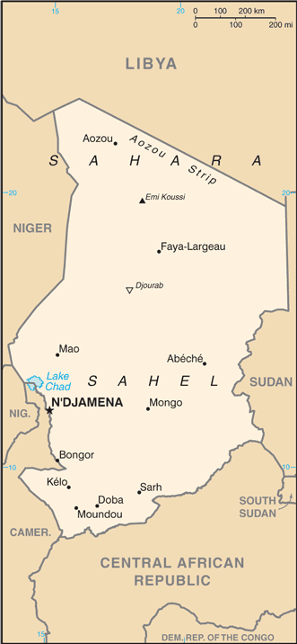
Economy
- Chad has a Gross Domestic Product of $29.53 billion. This ranks 126th in the world.
- Agriculture accounts for 54% of economic output
- Industry accounts for 13% of economic output
- Services accounts for 32% of economic output
- 47% of the population lives in poverty
- 48% of children age 5-14 have a job
- Unemployment rate is unknown but likely very high
- Relatively few natural resources including: oil, gold, salt
Education
- Chad spends 2.3% of its money on education
- Children go to school for an average of only 7 years
Living Conditions
- 51% of the population has access to clean water
- 40% of the population can read and write
- Life expectancy is 49.8 years. This ranks 224th in the world.
- There is 1 TV station and 11 radio stations in use
- 2% of the population has access to the internet
Health Care
- 2.5% of the population is afflicted with HIV/AIDS
- Chad spends 4% of its money on health care services. This ranks 174th in the world.
- The risk of contracting an infectious disease like is very high.

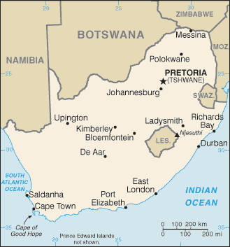
South Africa
Economy
- South Africa’s Gross Domestic Product is $704.5 billion. This ranks 31st in the world.
- 36% of the population lives in poverty
- Agriculture accounts for 2% economic output
- Industry accounts for 29% of economic output
- Services accounts for 69% of economic output
- South Africa has many natural resources including: gold, natural gas, coal, iron ore, rare earth metals, platinum, copper, tin
Education
- South Africa spends 6% of its money on education
- Children attend school for an average of 14 years
Living Conditions
- Life expectancy is 62 years. This ranks 191st in the world.
- 94% of the population can read and write
- There are 556 TV stations and 362 radio stations
- 93% of the population has access to clean water
- 47% of the population has internet access
Health Care
- South Africa spends around 9% of its money on health care. This ranks 42nd in the world.
- 19% of the population is afflicted with HIV/AIDS
- There is an relatively low risk of contracting an infectious disease

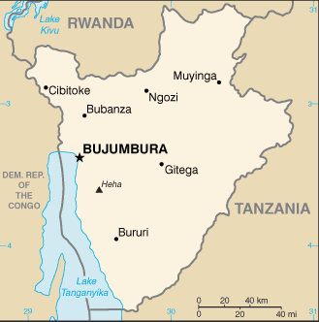
Burundi
Economy
- Burundi’s Gross Domestic Product is $8.3 billion. This ranks 162nd in the world.
- 68% of the population lives in poverty
- 19% of children between age 5-14 have a job
- Services account for 42.5% of economic output
- Industry accounts for 17% of economic output
- Agriculture accounts for 40% of economic output
Education
- Burundi spends 5.8% of its money on education
- Children attend school for an average of 10 years
Living Conditions
- Average life expectancy is 60 years
- Only 76% of the population has access to clean water
- 1% of the population has internet access. This ranks 165th in the world.
- 86% of the population can read and write.
- There is only 1 TV station and 4 radio stations
Health Care
- Burundi spends 8% of its money on health care services. This ranks 56th in the world.
- 1.1% of the citizens in Burundi have HIV/AIDS.
- There is a very high risk of contracting an infectious disease such as malaria, rabies, or dengue fever

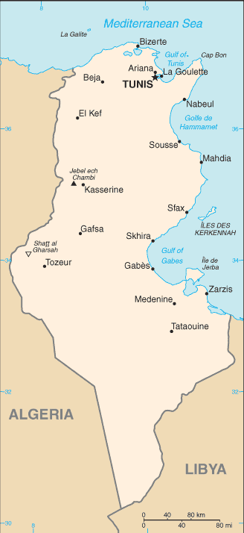
Tunisia
Economy
- Tunisia’s Gross Domestic Product (GDP) is $124.3 billion. This ranks 77th in the world.
- Services accounts for 62% of the economic output
- Agriculture accounts for 9% of the economic output
- Industry accounts for 29% of the economic output
- Only 4% of people live in poverty
- Tunisia has many natures resources including: olives, grain, tomatoes, fruit, almonds, beef, and dairy products
Living Conditions
- Life expectancy is 76 years
- 98% of the population has access to clean drinking water
- 82% of the population can read and write
- 45% of the population has internet access. This ranks 65th in the world.
- There are many TV and radio stations in use throughout Tunisia
Health Care
- Tunisia spends 7.1% of its money on health care services. This ranks 80th in the world.
- Only 0.04% of the population has HIV/AIDS
- There is a relatively low risk of contracting an infectious disease
Education
- Tunisia spends 6.2% of its money on education
- Children attend school for an average of 15 years

