Class Copy

Official African Languages
Country | Languages
Algeria | French
Angola | Portuguese
Benin | French
Botswana | English
Burkina Faso | French
Burundi | French
Cameroon | German
Cape Verde | Portuguese
Central African Republic | French
Chad | French,
Comoros | French
Congo | French
Congo, Democratic | French
Ivory Coast | French
Djibouti | French
Egypt | Arabic
Ethiopia | English,
Gabon | French
Gambia | English
Ghana | English
Guinea | French
Guinea-Bissau | Portuguese
Kenya | English
Lesotho | English
Liberia | English
Libya | Arabic
Madagascar | French
Malawi | English
Mali | Arabic
Mauritania | Arabic
Morocco | Arabic
Mozambique | Portuguese
Namibia | German
Niger | French
Nigeria | English
Rwanda | English
Senegal | French
Sierra Leone | English
Somalia | Italian
South Africa | English,
Sudan | English
Swaziland | English,
Tanzania | English
Togo | French,
Tunisia | Arabic
Uganda | English
Zambia | English
Zimbabwe | English

Language | Color
English/British | Red/Pink
French/France | Yellow
German/Germany | Blue
Italian/Italy | Light Purple/Red
Portuguese/Portugal | Dark Purple
Spanish/Spain | Light Green
Arabic | Black

Directions: Compare your finished Official African Language map to the map of Africa on page 55 of the red textbook. What similarities do you notice? What are somethings that are different? How does this map show cultural diffusion? Write your answers on a lined piece of paper and staple it to the back of your completed map. Please use complete sentences in your answers.

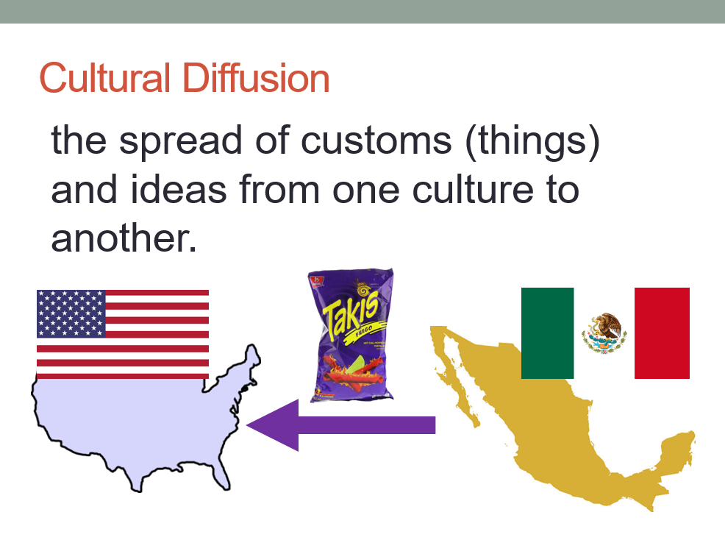

Name: Block: Teacher:
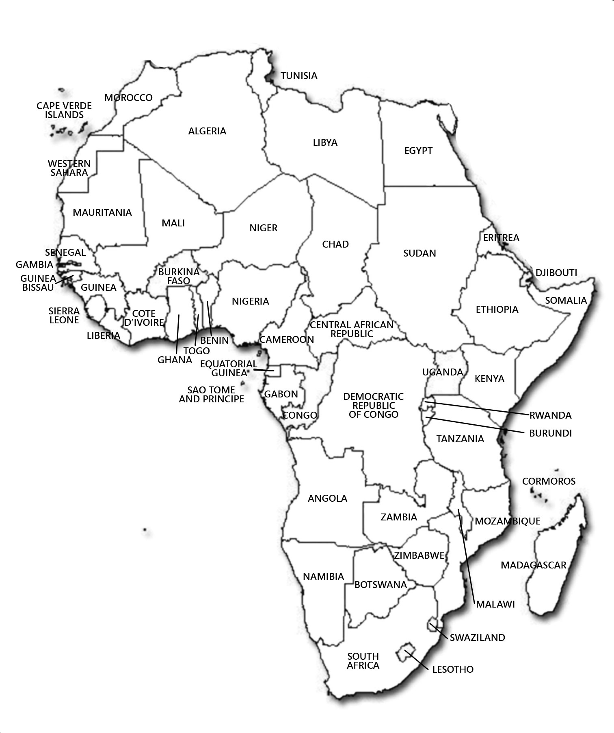
Map Title:

