Don’t do Communism project, have everyone create propaganda posters. Give the option of making one for the 6th graders that is Orwellian in nature. Change the test to include a question accordingly about their propaganda posters.

Essential Question
How can a man kill millions of his own people but still be thought of as a hero in his own country?

SS.7.17 Explain how supply and demand impacts standard of living.
SS.7.15 Describe how different groups shape people’s lives.

Pictures of Asia, Essential Question, Summative Assessment, Vocabulary

Communism Lesson Cycle, Gap Minder Level 4 and World in the Balance Documentary combined.

Explain how Chinese history is separated in three different parts
Chinese History Split into Three Sections
Emperors
Mao (Pure Communism)
China Today with blend of communism and capitalism
Stock market crashing

Create Unit Plan
Spread Vocabulary Out so you teach it after a day
Revise Assessment
Riley Type readings

Video of Chinese Economy Transition
https://www.youtube.com/watch?v=fZwEDa9TrfE

East Asia (Communism)
Southwest Asia
Patterson

(W) Means on website
Underline what should be said to the class
If there is a blue word click on it while holding down “ctrl”

SS.7.17 Explain how supply and demand impacts standard of living.
SS.7.15 Describe how different groups shape people’s lives.

Day 1
Learning Target – I will become familiar with our next region of study, East Asia.

Warm Up

Logic Flow
Ask students, why did Europeans colonize Africa? (Natural resources, power) In doing so, they conquered all of Africa and where the European countries stopped, that’s where/how borders were created. So why are most African countries connected to water? (Transport, boats with sails)

Students should watch this video, what do you notice about China and Africa? Link Why do you think that China wasn’t colonized, if I told you that it did have resources? (It was powerful, big, organized through King/Emperors, and super far away. Europeans wanted Chinese goods but they had to trade, show with pennies how this lead to wealth leaving Britain and going to China. So Britain came up with a smart/messed up plan to get money out of China that changed the course of history. Explain how the opium trade worked and its devastating impact. Link

Communism Readings (W)  -End of Emperors  -page 1 and 2 | Resources/Materials/Extension

https://www.youtube.com/watch?v=PMgjDUt-2f8
https://www.youtube.com/watch?v=kd2CYPdYwcY
https://www.youtube.com/watch?v=Nc0-mHagWiU
Find the actual episode of Mankind story of us, the one above stutters at parts.
Day 2
Learning Target – I will play an academic game to understand why most people were open to the idea of communism.

Warm Up – No Warm Up
Starburst Communism Game  -page 9  Debrief with visuals/ w/ Cartoon, if need be actually use the reflection sheet.  Reflection/ discuss and show political cartoon  -page 10/11 | Resources/Materials/Extension  Dixie Cups, Starbursts  Great Wall Fly Over - Link  Flocabulary Video link  Login Rachel.smith@dsmchools.org  Password callananflo

Day 3
Learning Target – I will become familiar with the definition of academic words.

Warm Up - Why did most people in China like the idea of communism? Connect the warm up to the ideas in the Starburst game yesterday. Show display and discuss vocabulary words of communism and capitalism.
Communism Readings (W)  -Students should finish their paragraphs from day 1 along with reflection from the game. When students have finished, have them work on page 3/4 of the communist John Green reading (insert link into OneNote) or possibly watch as a class.  John Green Video Ancient Chinese History - Link | Resources/Materials/Extension  Crash Course and the Mandate of Heaven - Link  Include pictures/questions accordingly, transcript is already created.

Day 4
Learning Target – I will analyze how Mao transformed communism into a religion.

Warm Up – Ask students, what do Judaism, Christianity, and Islam have in common? They all have a symbol, book, and a main prophet. Write symbol, book, and leader on the white board. Explain that you are going to show some YouTube videos showing what life was like under Chairman Mao. After watching the videos, you are going to have them try and identify what symbol, book, and leader are parts of the “communist” religion. Mention that you will hear how Mao wanted to people to have a common enemy to work against. It unified them. Show students this video clip: Video – 5:45- 9 Link

Warm up question, what is the symbol of communism?
Symbol – Red Book - Little Red Book Leader - Chairman Mao
Political Cartoon/Videos  -page 12/13, post link in OneNote  Communism Readings  -John Green China’s Revolutions  -pages 5-7, need time stamps Link | Resources/Materials/Extension  Computers/headphones  Rise of Modern China – page 28-29  ISBN: 15881092-6  Make sure you underline Mao, Little Red Book, Red, vocab in reading.  If students finish, have them start on the GLF.

Day 5
Learning Target – I will analyze (examine closely) how Mao tried to raise the standard of living of China.

Warm Up – What three measurements do we use when analyzing (looking at) standard of living? GDP per capita, life expectancy, literacy rate because they show us a glimpse
Communism Readings – (W)  -page 8, Great Leap Forward  Watch the videos and show the below Great Leap Forward videos (actually watch them and adjust questions accordingly).  Great Leap Forward Videos: Link | Resources/Materials/Extension  Communism Visuals (W)  Display questions for students to take notes on, they will use this on Day 6  How to Make Steel  https://www.youtube.com/watch?v=v6Y4Ce5aeXQ

Day 6
Learning Target – I will evaluate (identify the advantages and disadvantages) of the Great Leap Forward.

Warm Up – According to the reading and video from yesterday, how many Chinese people died because of Chairman Mao?

Setup the video, talk about how large numbers are hard to think about. The video that we are going to watch is a focus is about WWII but it helps us visualize how many people died under Mao’s world. Link
Great Leap Forward – OneNote Created  Revise GLF to include something with video.  Have students find political cartoon with Great Leap Forward, explain symbolism. | Resources/Materials/Extension  Crash Course History Revolutions - Link  Students can start working on a propaganda poster.

Day 7
Learning Target – I will analyze a propaganda video to identify the author’s purpose.

Warm Up – What is the commercial suggesting that you can do if you don’t do drugs?
Education for Death - Link  Exit Slip – page 6/7  North Korean Link | Resources/Materials/Extension

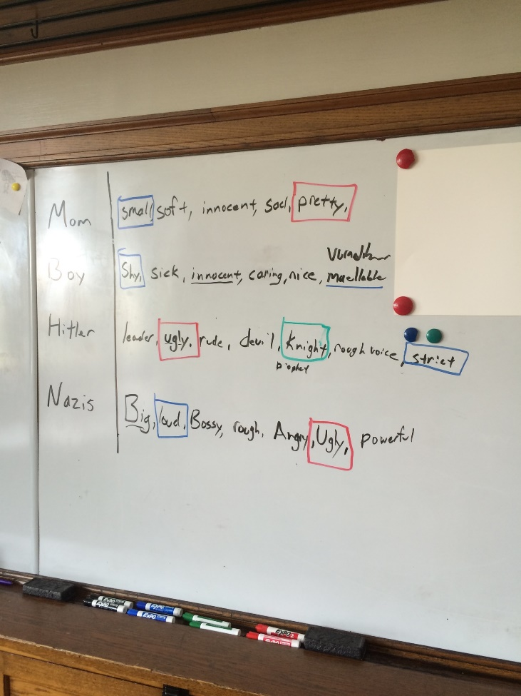
What is the commercial suggesting that you can do if you don’t do drugs?

D.A.R.E Video - link

Talk about how the propaganda videos only show one side. It isn’t a fair debate. You are going to show the students an anti-Drug commercial. Have them respond to the warm up question. Talk the conversation one step further by asking what how does the director of the video accomplish this?

Be up front with the students that you are going to show the Nazi video twice. The first time through, have the students write down all of the bad things that the Nazi’s (Hitler) are doing to the little boy to shape his thinking. Have the students share out their answers. Ask them is this fair or right for people to be manipulated?

Tell the students that you are going to play the video a second time. Write a list of the main characters on the board. Have them jot down lists of adjectives that describe the character. Give examples.

Have students share out their findings. Talk about how Disney is trying to manipulate the viewers. Including the manipulation of religious symbols. If time remains, show students CNN news.

Day 8
Learning Target – I will create a propaganda poster that uses symbols to convey (show) a message.

Warm Up – Show video with linked with the market reaction, discuss with students their answers. Why do students think that China still celebrates Mao? How is this different than Germany celebrating Hitler?
Tiananmen Square, OneNote  Communism Readings, page 14/15  Communism Poster  -page | Resources/Materials/Extension  Statue of matche?  Statue of Freedom/Tiananmen Square Visuals needed  3 minutes, bodies/bloody  https://www.youtube.com/watch?v=kMKvxJ-Js3A  start watching at 3:50 minutes  https://www.youtube.com/watch?v=PdGDoCAVSs4

For the propaganda posters, explain that the Chinese lettering system is really, really complicated. It doesn’t neatly match up with the English alphabet. The cheat sheet is helpful. If they want, they could use Google Translate for a more accurate translation. Google Chinese Propaganda Posters, walk the students through raised arms, red books, smiles, looks of determination, red books, Mao and massive amounts of people! All symbols that the students could include in their posters.

Day 9
Learning Target – I will play an academic game to better understand the stock market.

Warm Up – No Warm Up
Stock Market Crash Game/Reflection (W)  -Have students finish 1-2 as an exit slip | Resources/Materials/Extension

Day 10
Learning Target – I will create a propaganda poster that uses symbols to convey (show) a message. I will

Warm Up – Show with gap minder, how China’s bubble is large and rising. Debrief Stock Market game. Link
Modern Issues Facing China  Male vs. Female Disparity in China  Communism Propaganda Posters | Resources/Materials/Extension  Blocks 1,3 –Half Open Door, OneNote  Communism Readings, page 12/13

Day 11
Learning Target – I will show my understanding through writing how communism impacts modern China.

Warm Up – Why does propaganda usually target children?
One Child Policy?  Modified District Assessment (W) | Resources/Materials/Extension  Bizarre Foods China  (See note about which one to watch)

Possible Lesson Cycle Extensions
One Child Policy and the Issues of Population Growth
DBQ Extra day for Jeopardy
Growing too big DVD
Name:

Block: Propaganda Video
Teacher:

Mom
Boy
Hitler
Nazis (Teacher)

Name:

Block: Propaganda Video
Teacher:

Mom
Boy
Hitler
Nazis (Teacher)
North Korean Propaganda Video
1. What is the video trying to make America look like?
____________________________________________________________________________________________________________________________________________________________
2. How are they trying to accomplish this? What do you see? Does the commentary (words) match the pictures?
________________________________________________________________________________________________________
________________________________________________________________________________________________________
3. In your opinion, who is the target for this video propaganda? The anti-Drug video was targeted to young people who skateboard. ________________________________________________________________________________________________________
____________________________________________________

North Korean Propaganda Video
1. What is the video trying to make America look like?
____________________________________________________________________________________________________________________________________________________________
2. How are they trying to accomplish this? What do you see? Does the commentary (words) match the pictures?
________________________________________________________________________________________________________
________________________________________________________________________________________________________
3. In your opinion, who is the target for this video propaganda? The anti-Drug video was targeted to young people who skateboard. ________________________________________________________________________________________________________
____________________________________________________

Starburst Simulation

Rock vs. Paper
Activity helps students understand why poor people like the idea of wealth distribution.

Randomly pass out Dixie cups filled with varying amounts of Starburst candies. Fill 2-3 cups up to the top and give the rest smaller amounts (some cups only put one piece).

Tell the students to do the following things:

1. Do not eat the money until told to do so.

2. Do not trade, steal, or borrow money. Once you run out of money, sit down at your desk.

3. Play rock-paper-scissors with your classmates. Loser gives up a piece of “money.”

Let the game go until half of the class is sitting down. Ask the students how the game went. Inevitably the students that started off with little money will complain that they were at a disadvantage. Explain redistribution of wealth and link back to conditions in China during World War II to what they just went through.

Redistribute candy and let the students play.

Discuss how Communists in China promised to do this with money, power, education, land… etc.

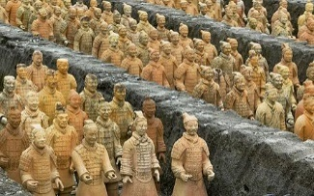
*Label the bottom of the cups with LO for landowners and E for emperor
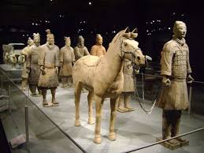
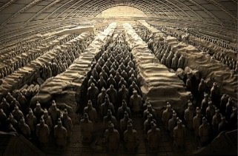
https://www.youtube.com/watch?v=BpEWKBB6lYw

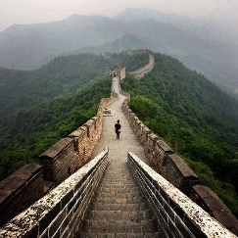
Name:

Block: Starburst Game

Teacher:

1. Describe the game we played today in class.
____________________________________________________
____________________________________________________
____________________________________________________
____________________________________________________
2. What did the starbursts represent or stand for?
____________________________________________________
____________________________________________________
____________________________________________________
____________________________________________________
3. Why did certain people start with more starbursts than others?
____________________________________________________
____________________________________________________
____________________________________________________
____________________________________________________
4. What did Mr. Patterson do after a couple of minutes? Why did he do this?
____________________________________________________
____________________________________________________
____________________________________________________
____________________________________________________
5. What happened to the total number of starbursts when Mr. Patterson collected them and then redisrubted them? Why did this happen?
____________________________________________________
____________________________________________________
____________________________________________________
____________________________________________________

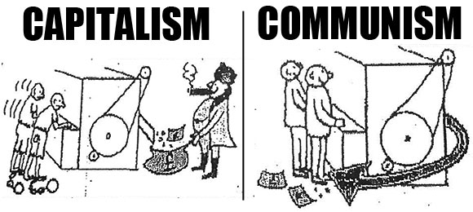

4. Political cartoon artists often use symbols to get their message across to the viewer. A symbol is a something that stands for something else. For example, the American flag often stands for America. Circle and number any symbols you recognize in the cartoon above.

5. What point is the artist trying to make in this political cartoon? In your response you should explain and cite the symbols found in the cartoon.
____________________________________________________
____________________________________________________
____________________________________________________
____________________________________________________
____________________________________________________
____________________________________________________
____________________________________________________
____________________________________________________

6. What does this cartoon have to do with starburst game we played in class?
____________________________________________________
____________________________________________________
____________________________________________________
____________________________________________________
____________________________________________________
Name:

Block: The Great Leap Forward

Teacher:

Part 1
Besides being monotheistic (believing in one God), what do Judaism, Christianity, and Islam all have in common?
____________________________________________________
____________________________________________________
____________________________________________________
____________________________________________________
Some people have accused the communist leader, Mao Tse Tung, of creating a religion in China. Why did they believe this?
____________________________________________________
____________________________________________________
____________________________________________________
____________________________________________________
____________________________________________________

Part 2
Step 1: Previewing Text- Look over what you are about to read; in order to better prepare yourself for success. Highlight the answers to the below questions.
Highlight Color | 1. If there is an article title, what is it?
 | 2. If there are sections titles, what are they?
 | 3. What vocabulary words are in the text? Vocab words are underlined.
Step 2: Read Text- Read the documents either by yourself or out loud with your group.

Step 3: Text Evidence – After reading, go back through the text and highlight the part of the text you would use to answer the following questions.
Highlight Color | 1. What was the purpose of the Great Leap Forward?
 | 2. Scared of disappointing Mao, what good things did people say were happening?
 | 3. What bad things were actually happening in China?

Step 4: Writing to Inform- Use the highlighted text to respond to the prompt below in paragraph form. Make sure that you use proper citations.

What was the purpose of the Great Leap Forward? How did Mao accidentally kill millions of people?

Name:

Block: Propaganda Poster

Teacher:

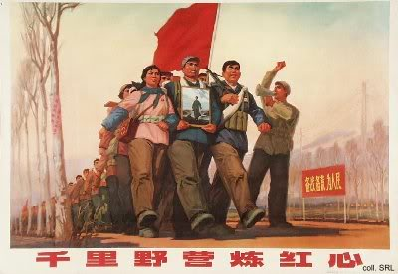

1. Political cartoon artists often use symbols to get their message across to the viewer. A symbol is a something that stands for something else. For example, the American flag often stands for America. Circle and number any symbols you recognize in the cartoon above.

2. What point is the artist trying to make in this poster? In your response you should explain and cite the symbols found in the cartoon.
____________________________________________________
____________________________________________________
____________________________________________________
____________________________________________________
____________________________________________________
____________________________________________________
____________________________________________________
3. After you get your answer to number 2 checked by Mr. Patterson, grab a computer and watch the video at the following website link: http://bit.ly/19w6pvm

Mr. Patterson would suggest you start watching it at 4:30. The link is also posted on OneNote. You do not need to write in complete sentences.

Three Things I Learned From the Video…

Two Things That I Found Interesting…

One Question I Still Have…

Propaganda Poster – Class Copy

Directions: Grab a poster paper and fold it in half. Half of the paper will be a poster and the other half will be your explanation.
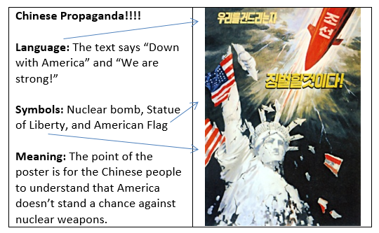

Create a propaganda poster that could have been found in China. Just like my example above, you will need to explain what the Chinese letters mean (language), what symbols you included, and the meaning of the poster.

In the past, most students searched on Google for Chinese propaganda posters for ideas. Students in years past have created propaganda posters that urged people to make steel so they could raise the standard of living.
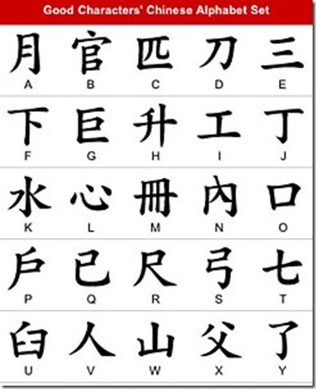

Mini-Communism Project Old Version

Option #1
Directions: If you choose to work on this option, you will eventually need to answer the question, what did you learn about? How do you do this is up to you. It can be a PowerPoint, a paragraph on OneNote, etc.…

China’s One Child Policy
One of Mao’s “great” ideas was to encourage everyone to have as many babies as possible! (China already had tons and tons of people.) When Mao died, communist leaders soon realized that there were going to be too many people to take care of. As a result, the Chinese government created something called One Child Policy. What was the One Child Policy? Was it successful? What problems did it create in China?

Links are on OneNote! Link, Link

United States and Cuba
The United States is a democracy. Cuba is a communist country. A couple of months ago, Obama visited Cuba. The meeting was super awkward. Each leader took the opportunity to criticize (attack) the other group’s (style of government). What did each president say? Why don’t Cuba and the United States get along? What was the Bay of Pigs (Yes, this has something to do with Black Ops.)?

Links are on OneNote! Link, Link

Choose your own Option
If it’s appropriate and it’s about China, you have Mr. Patterson’s permission study whatever it is. This can be anything from the Olympics, to heroin in China, cyberterrorism, China’s hatred with Japan, China’s hatred for Taiwan, to China’s hatred for American Chinese food!
_____________________________________________________________________________________
Option #2
Create a Chinese propaganda poster that could have been found in China. On the other side of the paper will be the propaganda poster and on the other side explains the purpose. If you need help, Mr. Patterson suggests grabbing a computer and searching for Chinese propaganda posters for ideas. If you still have no idea, create a poster that convinces people to create steel in their backyards that could have been found during the Great Leap Forward.

Prepare for Level 4 Question
Old Resources
In a couple of days you will take an assessment that will demonstrate your ability to analyze different styles of governments and their impact on the standard of living of their people. Instead of creating a propaganda poster, you can prepare for the level 4 question. While the level 4 question on the assessment is slightly different than the one in the scale below, it is incredibly similar.

Topic | 2 | 3 | 4
Economic Interdependence | Define/Explain key vocabulary words:  capitalism, communism, democracy, propaganda | Apply the ideal economic system for each of the following:  -wealthy business owner; minimum wage worker  Explain, with examples, why the Chinese embraced communism.  Explain, using examples, why China failed to develop economically under the leadership of Chairman Mao.  Analyze how modern issues can affecting China. | Should the United States become communist?

If you decide to work on this option, Mr. Patterson will give you a pink piece of paper. You can use this piece of paper when answering the level 4 question on your assessment. You can put research, text evidence, and/or talking points that will guide your writing.

Research Suggestions
Topics | Descriptions | Links
GDP per Capita | Create a graph of China’s GDP per Capita. When does the graph show significant growth? What happened in China to bring about this growth? | Link
End of Communes | What are communes? Why did the Chinese government end communes?
Is China even communist? | Is China even a communist country anymore? Is it just like the United States where people decide what to buy and people have different standards of living? | Link
Cuba vs. United States | When the president visited Cuba (a communist country), both Obama and Castro exchanged criticism of each other’s types of governments. What were these criticism? Who was right? | Link
Starburst Simulation | Thinking back to the Starburst game, why were the Chinese people unhappy with the Emperor? Is something similar happening now?
Bill of Rights | In the United States, citizens are guaranteed certain rights and protections. Look up the Bill of Rights. Do Chinese citizens enjoy the same protections? | Link

