Name: _________________________________ Block: __________ Date: __________________________

(Title)_______________________________

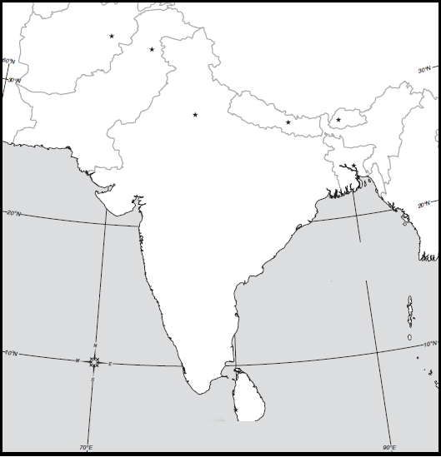

Map Key:

Directions: Include the below details on your South Asia climate map. To help you label these details you should use pg. 32, and 46 in the purple Asia book. If the color you are supposed to use is being used by someone else it is okay to use a different color.

Make sure your map is presentable. Please do not rush while doing this assignment.

Label: Pakistan  India  Nepal  Bangladesh  Bhutan  Afghanistan  China | Climates: Topical wet (dark green)  Tropical wet and dry (yellow)  Semiarid (light brown)  Arid (dark brown)  Humid subtropical (light green)  Highland (purple) | Map Features: Map Key  Compass  Title

