Caste System (India)
Callanan Middle School
Patterson

W) – separate resource on weebly
Underline- rationale the students should walk away with
Blue Word – Click on blue word and hold down “ctrl” button

The purpose of this lesson cycle is for students to understand how the caste system help organize Indian society and the attempts at reforming the policy.

Level 2 | Level 3 | Level 4
Specific vocabulary such as:  Caste system, Five parts of the caste system, social mobility | Explain, with examples, how different levels of the caste system affect people’s daily lives. | Do you believe a caste system exists in the United States? Justify your position

Day 1
Warm Up  What is culture?  Pull up vocabulary picture from Sub Africa  India Documentary – Link  Actually watch documentary  Elements of Culture Sheet  -page 3 | Intro to Indian culture

Day 2
Warm Up  Simulation – Day 1  Have the untouchables rip up small pieces of paper. Have the warriors throw it everywhere and then force the untouchables to clean it all up.  -page 8-9 | Students define Caste System  Reincarnation  Roles/Expectations  Simulation  Assume Groups

Day 3
Warm Up  Simulation – Day 2  Depending on the total number of karma students get placed into new Caste system  Caste1.pdf (W)  -differentiate readings, have students make a poster of what happened in class, show/explain what is going on  Debrief simulation  Level 2 Assessment  -page 5 | Hinduism/reincarnation  Caste System – Historical Systems (Stability) reincarnation  Historically

Day 4 - Computers Needed
Warm Up  Who has an email that they remember the password to? If no…. it’s homework  Central Idea of Primary and Secondary Sources Assessment (W)  Split into Groups  -groups are separated into two or threes, depending on class size, separation is based on group work data  Show How to Register and Use Class Jump  Teach how to respond to each other’s argument  Register  Work on Sample Thread  Post links | Essential Question  Gandhi  Caste System Today in India  Affirmative Action in India

Day 5 – Computers Needed
Warm Up  Register  Day 1 – Potential Discussion Board Questions  Does the Caste System exist today?  Who was Gandhi and what role did he play in ending the Caste System?  Show clip of Gandhi of nonviolence from movie | Caste System in the United States?  American Dream and Social Mobility  Raw Data/Affirmative Action  Gandhi and MLK  Come up with potential links

Day 6 - Computers Needed
Warm Up
Does the United States have a caste system?
How would we know if one exists?

Day 2 – Potential Discussion Board Questions
How are MLK and Gandhi similar?
What did they fight for?
How did they try and achieve their goals?
Who was more successful?

Day 7 - Computers Needed
Warm Up  Does the United States have a caste system?  How would we know if one exists?  Day 3 - Potential Discussion Board Questions  Does the United States have a caste system?  How would we know if one exists?  What can be done to increase social mobility?  Affirmative Action | Political Cartoon?

Day 8
Warm Up

Discussion Board Review & Rank Teammates
-page 14

Economic Interdependence Assessment
-page 3-4

CNN News

Lesson Extensions

Name:

Block: Indian Culture

Teacher:
 |  | Definition | Indian Culture
1. | Social Organization | How the community is organized.
2. | Customs and Traditions | Way people act, wear, what they eat, and their laws.
3. | Language | How people communicate with each other.
4. | Religion | What you believe in and your understanding of the meaning of life.
5. | Art and Literature | The ways people entertain themselves.
6. | Forms of Government | The people or group that control the population and provide/enforce the laws.
7. | Economic Systems | How people make money and earn a living

Name:

Block: Economic Interdependence

Teacher:

Level 2 | Level 3 | Level 4
Specific vocabulary such as:  Caste system, Five parts of the caste system, social mobility, reincarnation | Explain, with examples, how different levels of the caste system affect people’s daily lives. | Do you believe a caste system exists in the United States? Justify your position

Level 2 Understanding/Skills_____________________________________________________________
Directions: Define the below vocabulary words using complete sentences. Your answer must show mastery of the word.

1. Caste System- (Include a drawing)

2. Reincarnation-

3. Social Mobility-

Name:

Block: Economic Interdependence

Teacher:

Level 2 | Level 3 | Level 4
Specific vocabulary such as:  Caste system, Five parts of the caste system, social mobility, reincarnation | Explain, with examples, how different levels of the caste system affect people’s daily lives. | Do you believe a caste system exists in the United States? Justify your position

Level 2 Understanding/Skills_____________________________________________________________
Directions: Define the below vocabulary words using complete sentences. Your answer must show mastery of the word.

1. What is the Caste System?

_____________________________________________________________________________________

_____________________________________________________________________________________

_____________________________________________________________________________________

_____________________________________________________________________________________

2. Label and describe the five different levels of the Caste System.
 | Role Name | Role Description
1.
2.
3.
4.
5.

3. What is reincarnation?

_____________________________________________________________________________________

_____________________________________________________________________________________

_____________________________________________________________________________________

_____________________________________________________________________________________

4. What is social mobility?

_____________________________________________________________________________________

_____________________________________________________________________________________

_____________________________________________________________________________________

_____________________________________________________________________________________

Level 3 Understanding/Skills_____________________________________________________________
Directions: Answer the following questions in complete sentences. Your answer must show mastery of the material.

5. Explain, with examples, how different levels of the caste system affect people’s daily lives.
_____________________________________________________________________________________

_____________________________________________________________________________________

_____________________________________________________________________________________

_____________________________________________________________________________________

_____________________________________________________________________________________

_____________________________________________________________________________________

Level 4 Understanding/Skills_____________________________________________________________
Directions: Write a response to the prompt below. To receive credit for having level 4 understanding, you must show your mastery of the material and of the questions being asked. Responses are not necessarily limited to paragraph form and can include maps, charts, graphs, etc. You are assessed on the quality of your ideas, not your use of punctuation, grammar, etc.

Do you believe a caste system exists in the United States? Justify your beliefs by providing specific evidence to support your stance.
Caste System Simulation
Callanan Middle School
Patterson

Introduction
The caste system has helped define Indian culture over the decades. It provided stability for the Indian people by grouping people together and providing purpose in their lives.

Activity Rules
1. Each person begins the game with 9 karma points. (Many Hindus believe nine is a lucky number)
2. Each person will draw a card from the “Basket of Karma” with his or her role.
3. Players may gain karma points for a number of right actions.
-Proper respect for members of higher castes.
-Kind and generous treatment towards other members of the same caste.
- Joyful completion of tasks assigned to you.
4. Players may lose karma points for a number of inappropriate actions.
-Being mean to other students
-Not calling people above you “Mam” or “Sir”
-Failing to show proper respect for individuals in higher classes.
-Failing to complete the tasks assigned to you.
5. Mr. Patterson is playing the role of Brahma, the World Soul which pervades all life and controls all actions in the universe. He controls who earns and loses Karma points

Steps
1. Pick roles
-pick roles out of the Basket of Karma, make nametags.
2. Brainstorm
-separate by groups and discuss your new role, come up with extra tasks they want done
3. Assigned Tasks
-complete assigned tasks on the back of this sheet
4. Reading/Questions

Caste System Roles

Brahmins - Priest
Description- You are the priests of society and spend most of your time in religious thought.
Task- You are at the top of Indian society. If you need something done you may ask the warriors to carry it out (be creative). You will need to tell the artists what to create (a play, a drawing, folding paper)

Kshatriyas – Warrior
Description- You are the elite warrior class who rules over society and helps Mr. Patterson enforce the rules of the simulation.
Task- When you see people not acting like they should report it to Mr. Patterson and he will make remove a karma point from the offending individual.

Vaishyas – Business Person or Artist
Description- The members of your class are either business men or artist.
Task- Your job is to create a piece of art worthy of the class. The priests/Brahmins will tell you what to do if you need help.

Shudras - Worker
Description- You are a worker who does hard work for the class.
Task- Your first job is to sharpen color pencils. When you finish ask the Brahmins what they want done next.
Reading- Your job is to write down the answer to the questions.

Pariahs - Untouchables
Description- Nobody likes you…..you are below Justin Bieber and Yellow Laffy Taffy’s. People believe that they will become dirty if they talk to you.
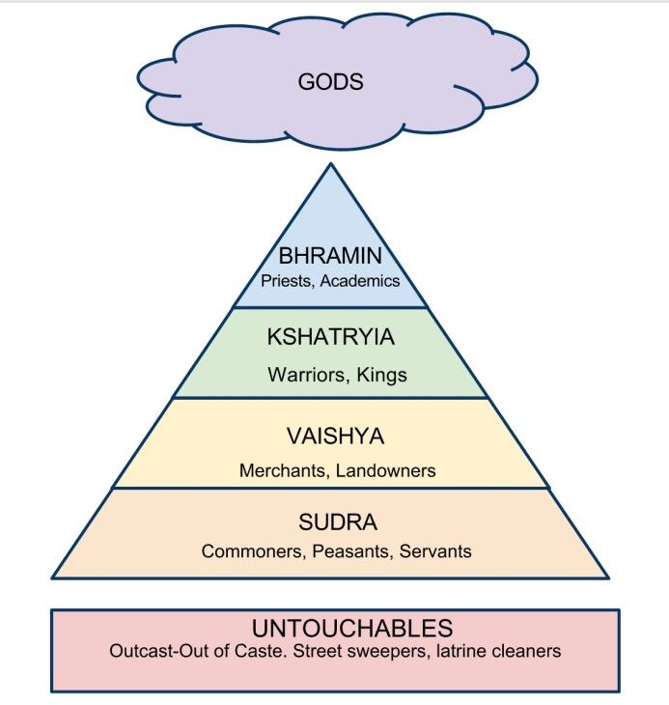
Task- You may not leave your taped area. Rip up pieces of paper the size of pennies until you are told to stop.

Karma Tracker

Name | Role | Points

Class Jump
Directions  1. Log in to the computer  2. Go to Google  3. Search “Class Jump”  4. Click on the top result  5. Search for “Callanan”  6. Click Mr. Patterson  7. Register for your block  Your username should be the first names of you group members….  NellyKanyeCurtisJackson  8. Turn in the bottom slip when completed | 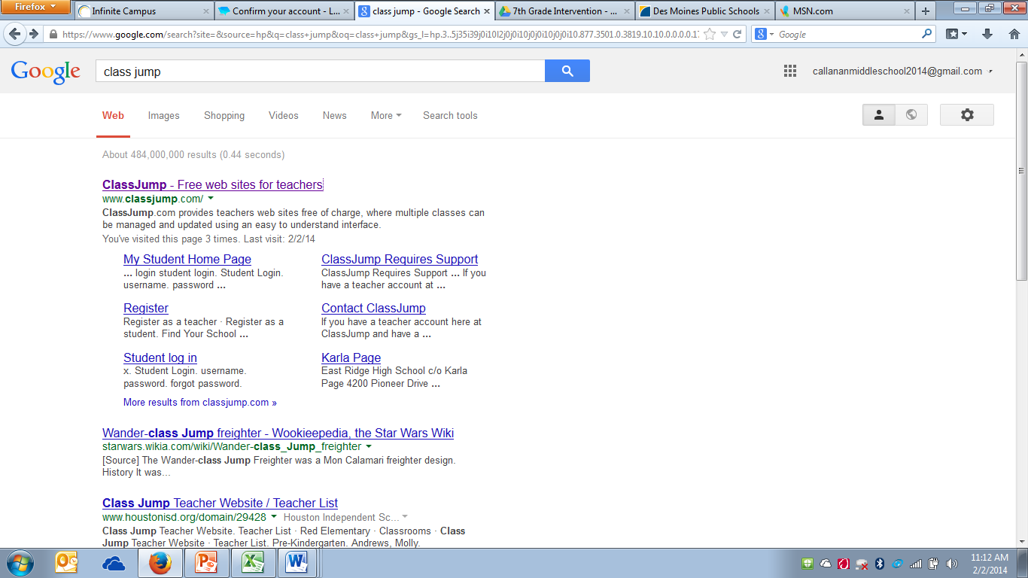  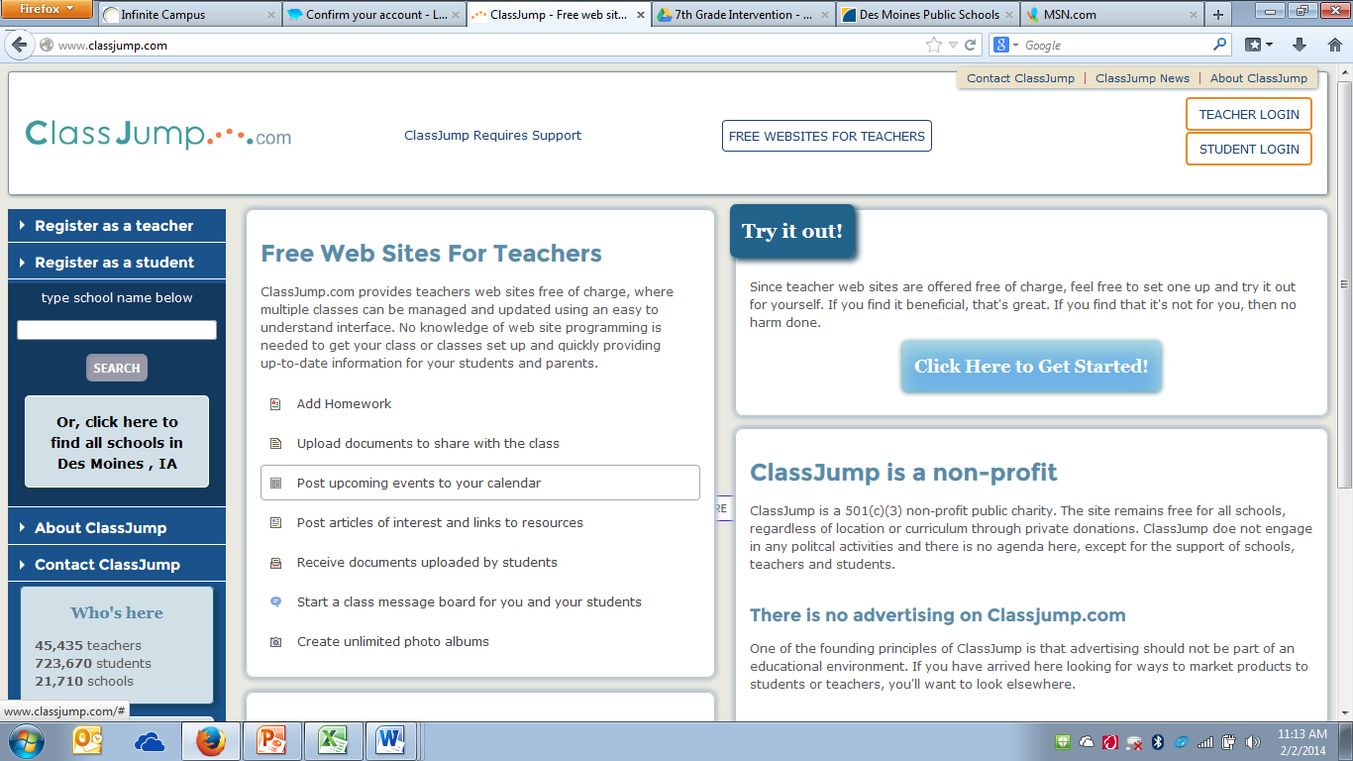  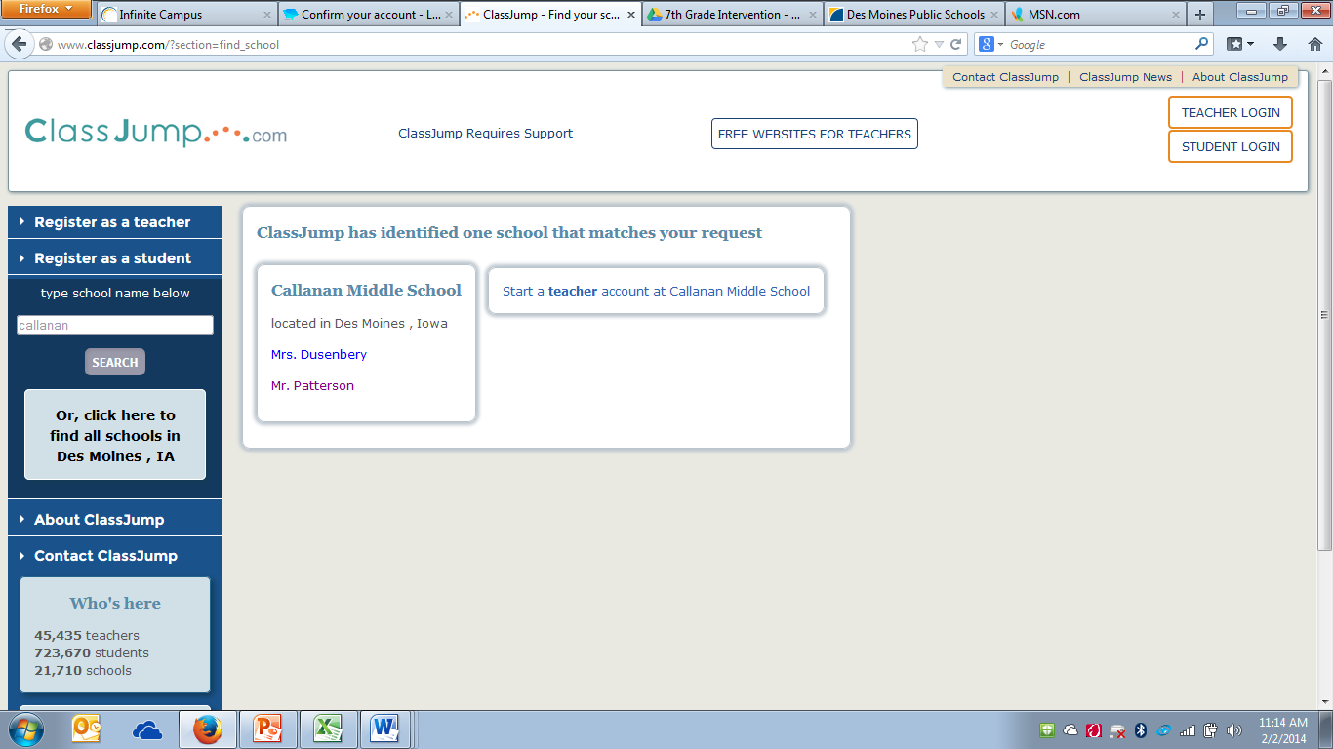  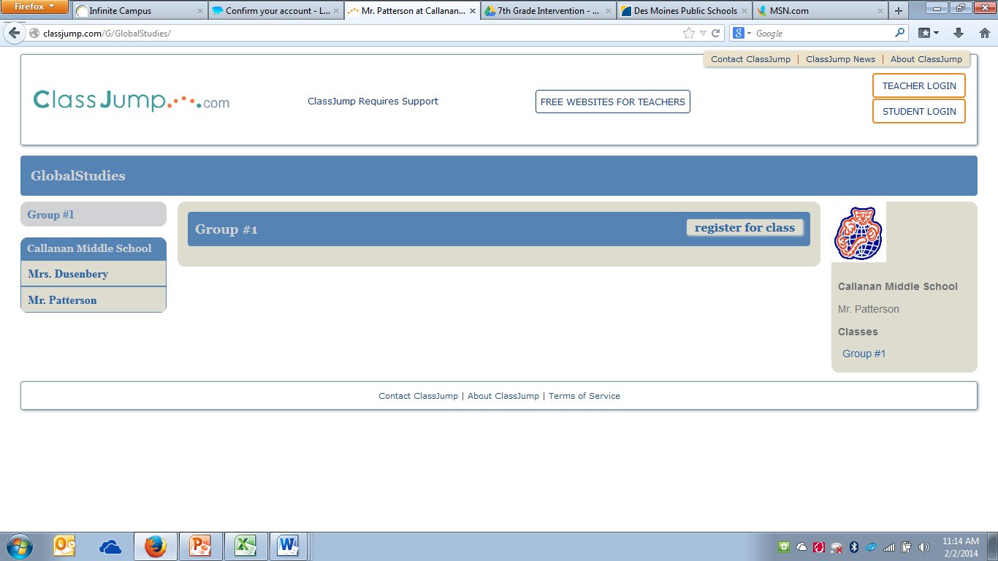

Cut Paper Here
Group Member Names:

Username:

Email:

Password:

Class Jump Login Information

Block | Group Member Names | Email | Password

Name:

Block: Discussion Board Feedback

Teacher:

What did you like about using the discussion board?

What did you not like about using the discussion board?

What can I change to make it easier?

