UNIT 0: Boot Camp

CLUSTER: Geography TOPIC: Geographic Applications

LEVEL 2 UNDERSTANDINGS/SKILLS

A. continents 1. ______ an exact location on Earth, designated by its Latitude and Longitude coordinates

B. oceans 2. ______ imaginary lines that intersect at the North and South Poles

C. hemispheres 3. ______a location based on the location of another place

D. latitude 4. ______halves of the Earth separated by the Equator and the Prime Meridian

E. relative location 5. ______largest land masses on Earth

F. absolute location 6. ______imaginary lines that are parallel to the Equator

H. longitude 7. ______largest bodies of salt water on Earth

Name the continents and oceans.
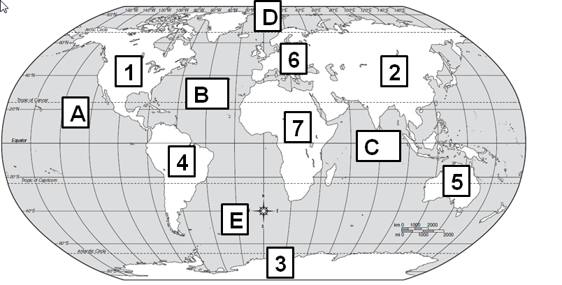

Word Bank:
Africa
Antarctica
Asia
Australia
Europe
North America
South America

Arctic Ocean
Atlantic Ocean
Indian Ocean
Pacific Ocean
Southern Ocean
8. Continents: 1._______________________ 9. Oceans: A.___________________________
2.______________________ B.___________________________
3.______________________ C.___________________________
4.______________________ D.___________________________
5.______________________ E.___________________________
6.______________________
7.______________________

LEVEL 3 UNDERSTANDINGS/SKILLS

Use the map below to answer questions 11-14.

10. Find the distance between Albany, NY and Augusta, ME using the map scale. _____________________________

11. Find the distance between Springfield, IL and Little Rock, AR using the map scale. __________________________

12. When traveling from Helena, MT to Sacramento, CA what direction are you headed? _______________________

13. If you leave Tallahassee, FL and you travel about 750 miles west, what city will you land in? : __________________

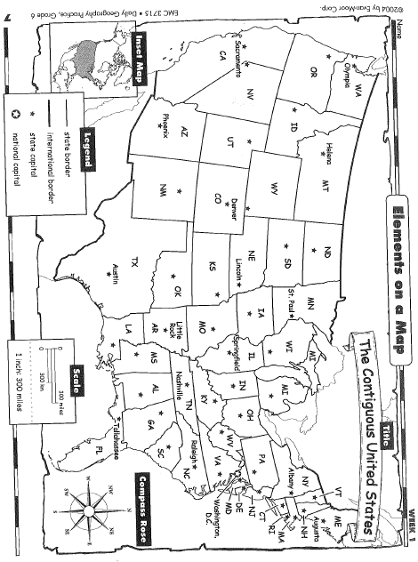
Scale
1 inch: 300 miles

Use the map below to answer questions 15-17.

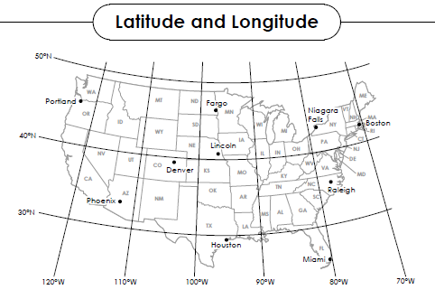
Name the city at the given latitude and longitude coordinates.

14. 33°N latitude, 112°W longitude _______________________________________________

15. 45°N latitude, 122°W longitude________________________________________________

16. 25°N latitude, 80°W longitude_________________________________________________

LEVEL 4 UNDERSTANDINGS/SKILLS

Directions: To receive credit for having level 4 understanding, you must show your mastery of the material and of the questions being asked. Responses can include writing, visuals, maps, charts, graphs, etc. You are assessed on the quality of your ideas, not your use of punctuation, grammar, etc.
You are an explorer of uncharted territory. Use the following terms correctly to write a narrative about your travels in this new land:

map key map scale compass rose hemispheres continents latitude longitude

