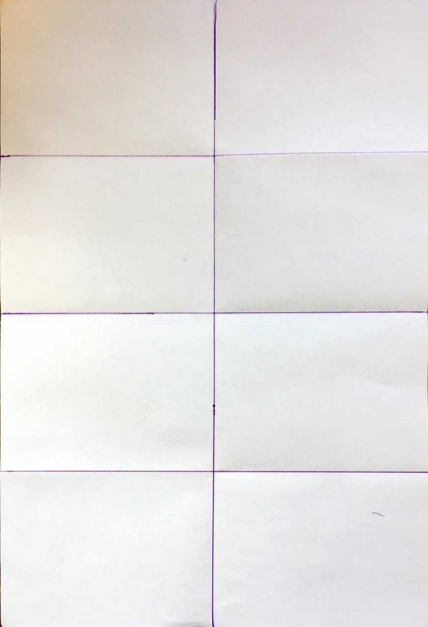
Class Copy make/find example, label on board
Battleship Board Game Instructions

Step 1
Orient the poster paper vertically. Put your name, block, and teacher in the bottom right hand corner.

Step 2
Fold your poster paper into eighths. Unfold the paper and flatten out the edges/creases. Use a ruler and mark the edges of the boxes. Similar to this example:

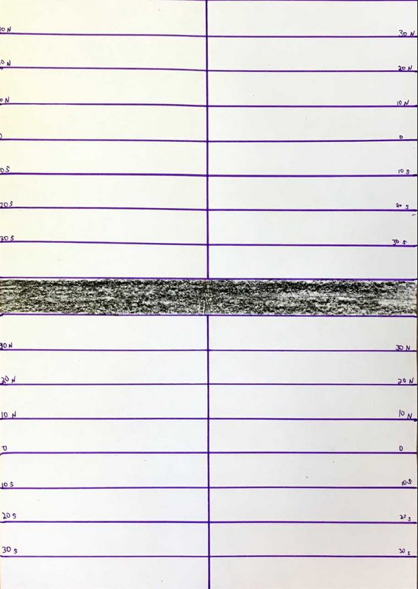

Step 3
Make horizontal lines that are 1 inch apart. You will need to look closely at the example on the whiteboard to serve as a guide for how these lines should be labeled. Make sure to use a ruler.

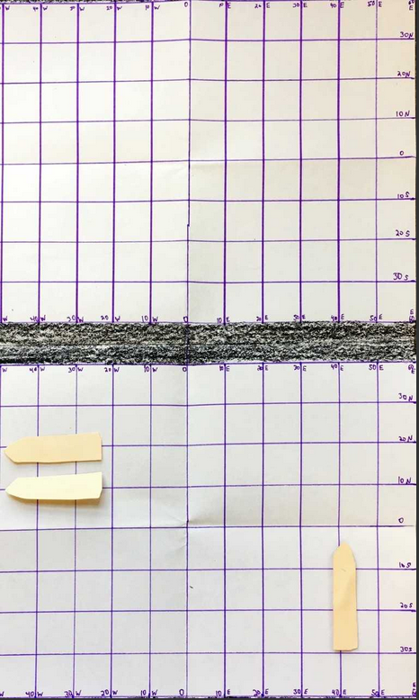
Step 4
Measure and label the vertical lines similar to the example on the whiteboard. They are 1 inch apart and count by ten.

Step 5
Create three ships that are an inch wide and two inches long. Make sure to color them and cut them out.

