Name:

Block: Author’s Point of View - Article

Teacher:

Topic | 2 | 3 | 4
Author’s Point of View | Identifies author’s purpose or point of view, but with some misconceptions within the context/unit of study. | Demonstrates the ability to accurately identify and explain an author’s purpose or point of view using textual and/or contextual evidence. | Demonstrates the ability to accurately identify and explain an author’s purpose or point of view using textual and contextual evidence and can justify or challenge it.

1. Read through the entire article. Underline and label the text that explains the who, what, when, where, and why of the article.

2. What point is the author trying to make in this article? In your response you should explain and cite text evidence.

3. Who (individuals or groups) would agree/disagree with the article?

4. Do you agree with the author’s message? Explain your answer.

____________________________________________________
____________________________________________________
____________________________________________________
____________________________________________________
____________________________________________________
____________________________________________________
____________________________________________________
____________________________________________________
____________________________________________________
____________________________________________________
____________________________________________________
____________________________________________________

The Case for School Uniforms

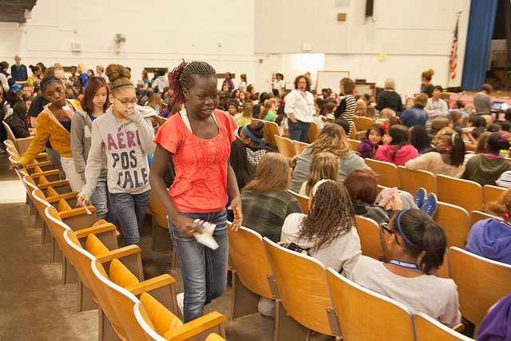
School uniforms may prevent crime and increase student safety. In Long Beach, CA, after two years of a district-wide K-8 mandatory uniform policy, reports of assault and battery in the district's schools decreased by 34%, assault with a deadly weapon dropped by 50%, fighting incidents went down by 51%, sex offenses were cut by 74%, robbery dropped by 65%, possession of weapons (or weapon "look-alikes") decreased by 52%, possession of drugs went down by 69%, and vandalism was lowered by 18%. A 2012 peer-reviewed study found that one year after Sparks Middle School in Nevada started a uniform policy, school police data showed a 63% drop in police reports, and decreases were also noted in gang activity, student fights, graffiti, property damage, and battery. [25] A 2010 peer-reviewed study found that schools with uniform policies had 12% fewer gun incidents and 15% fewer drug-related incidents than schools without uniforms. A 2007 peer-reviewed study found that, in schools with historically higher rates of sexual violence, sexual attacks were less likely if uniform policies were in place. School uniforms also prevent students from concealing weapons under baggy clothing, make it easier to keep track of students on field trips, and make intruders on campus more visible. Frank Quatrone, superintendent in the Lodi district of New Jersey, stated in Feb. 2011 that "When you have students dressed alike, you make them safer. If someone were to come into a building, the intruder could easily be recognized."
School uniforms keep students focused on their education, not their clothes. A paper published by the National Association of Secondary School Principals stated that "When all students are wearing the same outfit, they are less concerned about how they look and how they fit in with their peers; thus, they can concentrate on their schoolwork." A 2010 University of Houston study found that elementary school girls' language test scores increased by about three percentile points after uniforms were introduced. Former US Secretary of State Hillary Clinton, when she was a 2008 US presidential candidate, advocated school uniforms as a way to help students focus on learning: "Take that [clothing choices] off the table and put the focus on school, not on what you're wearing." Chris Hammons, Principal of Woodland Middle School in Coeur d'Alene, ID, stated that uniforms "provide for less distraction, less drama, and more of a focus on learning."
School uniforms create a level playing field among students, reducing peer pressure and bullying. When all students are dressed alike, competition between students over clothing choices and the teasing of those who are dressed in less expensive or less fashionable outfits can be eliminated. In a 2013 survey by the National Association of Elementary School Principals (NAESP) and uniform manufacturer Lands' End, 86% of school leaders said uniforms make "a significant, positive impact on peer pressure," and 64% said uniforms reduce bullying. Arminta Jacobson, Founder and Director of the Center for Parent Education at the University of North Texas, stated that uniforms put "all kids on the same playing field in terms of their appearance. I think it probably gives them a sense of belonging and a feeling of being socially accepted." Virginia B. Draa, Assistant Professor of Human Ecology at Youngstown State University, said uniforms can decrease peer pressure and blur class lines between students.

Alternative article https://goo.gl/N6OcC1

