Name: _________________________________ Block: __________ Teacher: __________________________

(Title)_______________________________
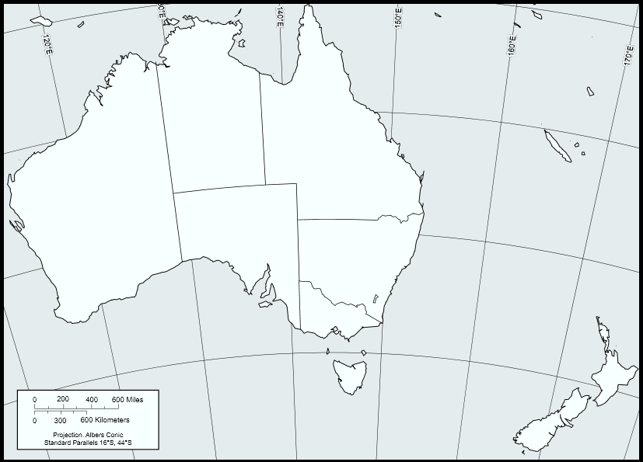
Map Key:

Australia and New Zealand: Physical Map

Directions: Include the following details on your Australia and New Zealand Asia physical and political map. To help you label these details you may use an atlas or purple Asia book using page 262. If the color you are supposed to use is being used by someone else than use a different color.

Make sure your map is presentable. Please do not rush while doing this assignment.

Map Features:
- Map Key
- Compass
- Title

Political Features:
- Australia
  - Label
- New Zealand
  - Label
- Canberra
  - Label
- Melbourne
  - Label
- Christchurch
  - Label
- Wellington
  - Label

Physical Features:

- Great Barrier Reef
  - Label with triangles

Elevation:
- 6,500 -13,000 Brown
- 1,600 – 6,500 Yellow
- 650 – 1,600 Light Green
- 0-650 Dark Green
- Pacific Ocean
  - Label
- North Island
  - Label
- South Island
  - Label
- Great Dividing Range
  - Label
- Lake Eyre
  - Label
- Great Sandy Desert
  - Label
- King Leopold Ranges
  - Label

