Aswan Dam Lesson Cycle – 14 days (13 days planned)
Adapt first part of lesson cycle to be more aligned to 3A and 3B.
Label all documents
Kenya Bourdain Episode
Common resources and readings
Settlers of Catan Extension
Immigration to Europe
Merit Based Immigration?
Water Rights in Iowa
John Oliver Video List, Vice News Documentaries, World 101 bookmark

Callanan Middle School
Patterson

(W) Means on website
Underline what should be said to the class
If there is a blue word click on it while holding down “ctrl”

Yellow = still needs work
Blue = side thoughts

The purpose of this lesson cycle is for students to understand how geography and access to natural resources shapes modern Africa. Students work in groups to learn about how countries need to share water from the Nile River and participate in an African Union summit to resolve the rebuilding of the Aswan Dam. Culminating activity requires students to understand population distribution patterns in North Africa. Students must also grasp the significance of the region relying on one communal water source. Students will evaluate a scenario where one country’s decision can impact the quality of life for the entire region.

Scarcity
3A - Describe the challenges countries face to feed their growing populations (SS. 7.18 & 7.23).
3B - Explain how countries are responding to issue of food security (SS. 7.14 & 7.17).
3C - Evaluate the role of the government in protecting water sources (SS. 7.17 & 7.26).

Students will learn about challenges to food and water supply faced by different countries. Students will examine the effectiveness of different programs designed to improve food security. Students will evaluate the role of governments to protect the water supply.

Topics | Resources
Quality of Life | Link
Communal Resources | Link
Aswan Dam Research | Link
Aswan Dam Debate | Link

Quality of Life – 3 Days Home Next

Students will create a way to rank the countries of North Africa by quality of life (Analysis – Generalizing).

Students will create a trifold that shows important information about the country they are representing (Retrieval – Executing).

Days 1/2
Warm Up – If we were interested in the average quality of life for a person in the country, what would we measure?
Aswan Dam Visuals (W)  Intro to region/topic, student will gather research on the standard of living of countries in the area. Students will create a way to rank the countries. Depict on a map. | Resources/Materials/Extension  Computers

Day 3
Warm Up –
See Awan Dam Visuals (W)  -Finish thematic Aswan Dam map, respond to writing prompts.  -Students will create/research a trifold for | Resources/Materials/Extension  Computers, Importance of Water Research

For this lesson cycle, you are going to want to be strategic when assigning African countries. My suggestion is to assign countries so that it mirrors a map of African’ countries that rely on the Nile River. If you have extra countries, they can represent Egypt. Pre write names of countries on notecards, place these notecards on tables. Pick up notecards while students are working.

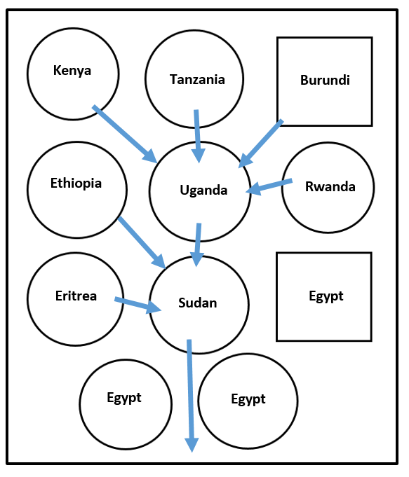
Name:

Block: Ranking Countries of North Africa

Teacher:

Country |  |  | Ranking
Burundi

Democratic Republic of Congo

Egypt

Eritrea

Ethiopia

Kenya

Rwanda

Sudan

Tanzania

Uganda

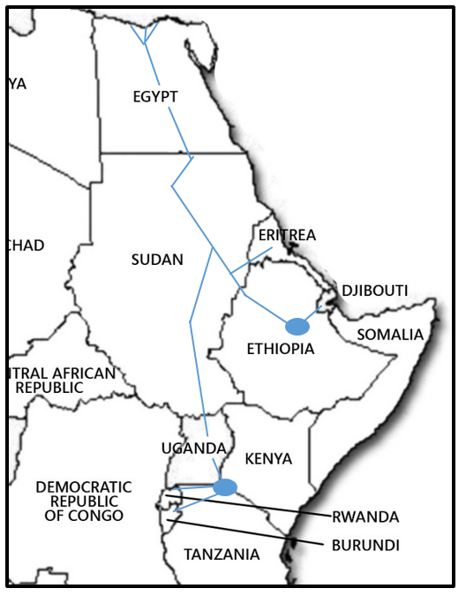
Class Copy - Paragraph Suggestions
1. Introduce to the reader the goal/purpose of your work. In this case, you can use the learning target as a starting point.

2. Explain what two things we decided to look at as a class. Explain why those two things are good data points/things to look at to determine a country’s quality of life.

3. On the list of things to be successful, it asks you to check your work with another group. Who did you check your work with? Was your data the same? If it was different, why was it?

3. Explain the ranking system that your group used/came up with

4. What conclusions did your group reach about the countries? Are the countries that are richer/poorer grouped together? Does the size of country matter?

Class Copy - Paragraph Suggestions
1. Introduce to the reader the goal/purpose of your work. In this case, you can use the learning target as a starting point.

2. Explain what two things we decided to look at as a class. Explain why those two things are good data points/things to look at to determine a country’s quality of life.

3. On the list of things to be successful, it asks you to check your work with another group. Who did you check your work with? Was your data the same? If it was different, why was it?

3. Explain the ranking system that your group used/came up with

4. What conclusions did your group reach about the countries? Are the countries that are richer/poorer grouped together? Does the size of country matter?

Class Copy - Paragraph Suggestions
1. Introduce to the reader the goal/purpose of your work. In this case, you can use the learning target as a starting point.

2. Explain what two things we decided to look at as a class. Explain why those two things are good data points/things to look at to determine a country’s quality of life.

3. On the list of things to be successful, it asks you to check your work with another group. Who did you check your work with? Was your data the same? If it was different, why was it?

3. Explain the ranking system that your group used/came up with

4. What conclusions did your group reach about the countries? Are the countries that are richer/poorer grouped together? Does the size of country matter?

United States Example

UNITED STATES OF AMERICA
Stars- There is a white star for every state in the country.

Stripes- There are 13 stripes which stand for the original states/colonies.

Red- stands for honor

Blue- stands for justice and doing what is fair.

White- doing the right thing
National Anthem – Star Spangled Banner  The lyrics or words in the American national anthem want us to think about what our flag would like the morning after a big battle. It is trying to get us to feel love for our country and a sense of doing what is right. | Values Important to America  I think that the values that are important to the United States are equality, honor, and doing what is right. What will help us will have pride in our country.

Communal Resources – 3 Days Previous Home Next

Teams will answer who, what, when, and where questions while examining case studies related to food supply (Retrieval – Recalling).
Teams will identify patterns/patterns from across food supply case studies (Analysis – Generalizing).
Teams will explain why it is important for different communities to work together when sharing the same water source (Analysis – Generalizing).

Day 4
Warm Up – See below.
Aswan Visuals (W) | Resources/Materials/Extension

Read pages 5-7 to students, as leaders of an African country you should care about the issue of food supply. It affects everyone in your country.

ISBN: 978-07362-9757-8, Green (Above), page 16-21, Hunger in the Ivory Coast

Why are some West African cocoa farmers poor?
How are cocoa growers increasing their food security?

ISBN: 978-07362-9756-1, Orange (At), page 16-21, Mali, Harsh Farmland

What is the greatest threat to the food supply in Mali?
What are the advantages of the green manure and cover crop system employed by the Dogon?

ISBN: 978-07362-9758-5, Blue (Below), page 16-21, Crisis in the Horn of Africa

What factors are making it hard for the Somalis to feed their people? Paragraph answer

Teams should read through passage and come up with answers. Teacher can synthesize answers and identify important points for students to know. (Type answers in bullet points). Discuss quote about conflict turning drought in to famine.

Days 5-6
Warm Up – See below.
Aswan Visuals (W)  OneNote Importance of Water | Resources/Materials/Extension  Spray bottle, big sheets of paper, red/blue markers, blue tape, computers, headphones

Before class starts, put blue arrows on the floor, showing the direction that the Nile River flows in real life. See Picture.

What direction does water flow? Have students write answer on notecard and collect them.

Discuss with class how water flows down, it doesn’t care about North and south. Take a big piece of paper with a black water color and tape it to the white board. Ask the students what would happen to the water if you sprayed this over and over again (a puddle would form.) Display the map of Louisiana from visuals. Water is forming here in the ocean. The easiest way to determine the directions is to find the river and track it. The bigger the body of water, that’s the direction the water is flowing.

Students pass out red Africa textbooks, what about the Nile? What direction is it flowing?

On your big piece of paper, draw a second red line, ask students if you started to spray this, what would happen to the color? Why does this happen? The color is carried with the water. This can happen with pollution too. Show how Sudan can affect Egypt, how Eritrea can affect Sudan, and so on…
Show students video link of watershed/basin,

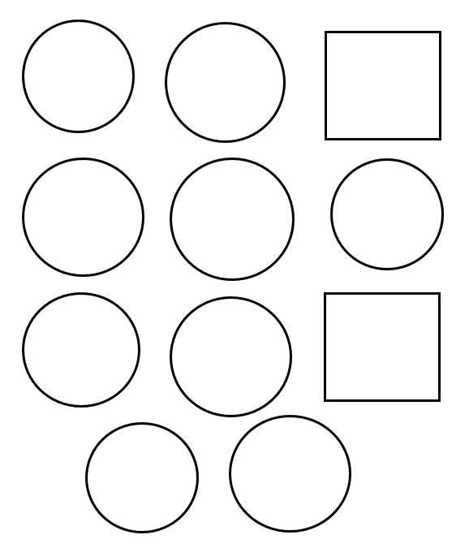
Country Assignments by Class Layout
Egypt
Tanzania
Uganda
Eritrea
Ethiopia
Kenya
Burundi
Rwanda
Egypt
Sudan
Egypt
Aswan Dam Research – 2 Days Previous Home Next

Teams will analyze the importance of the Nile River and the Aswan Dam to the region (Comprehension – Integrating).
Teams will evaluate the good and the bad things that resulted from building the Aswan Dam (Analysis – Classifying).
Day 7
Warm Up – How do you grow crops/plants without rain?

Discuss how you would do this on a large scale. Talk about in North Africa that didn’t have to do it. The Nile River would overflow and change desert into farmland. And you can see this… Aswan Visuals PBL and show link. Get beaker from science filled up with the amount of average rainfall compared to Iowa.
AswanHighDamDocuments (W)  -Graph population and dam height, make sure to discuss the Awan Dam isn’t impressive because of how big it is, it is more about how much water it is holding back.  Climbing Pyramid 2 mins - Link | Resources/Materials/Extension  * Have political cartoon printed and ready or clean out folders

Day 8
Warm Up – Show America Story of Us – Statue of Liberty Link Hoover Dam Link
Why are people proud of buildings like the Statue of Liberty and the Hoover Dam? Discuss feeling pride in your country

AswanHighDamDocuments (W)  -Give Egypt groups pro argument  -Give the rest of the groups the negative argument. Use pictures in visuals to guide discussions. Proof read article and questions | Resources/Materials/Extension  -Finish watching videos from Day 4

Aswan Debate - 4 Days Previous Home

Given a specific proposal, decide if your African country would support changing the environment. Using evidence, advocate what is best for your country in a debate. Reevaluate your team’s originals stance based on other team’s feedback (Knowledge Utilization – Investigating).

Summative Assessment - Evaluate how and why countries should protect water resources (SS. 7.17 & 7.26).

Days 9-10
Warm Up – Why is it important that multiple people and groups participate during the debate?
Email Chain Concerning Earthquake  -page 6  AswanHighDamDocuments (W) Proof  -each country gets its own information section  Have groups come up with a list of reasons of why they are against the building the dam. Try and get them to see the need for them to back up their point with specific evidence.  Have them write on piece of paper, they can use this on the upcoming test. | Resources/Materials/Extension  African Union Video Link  Consensus in principal.

Document | REDO LABELS
A | Country Research
B | Nile River Thematic Map
C | Importance of Water
D | Planet Money – Lesotho
E | Population Thematic Map
F | Country Slip/Information
G | Pros of Building Dam
H | Cons of Building Dam
I | Population Graph
J | Modern Marvels Documentary

Extra
Warm Up -
Planet Money Link  -directions to listen to podcast are in the Aswan dam visuals. Have students listen to the podcast, answer questions. They can share out their findings to the larger class. Show picture of Lesotho, tie in question to Scramble for Africa game. | Resources/Materials/Extension/Musings

Extra
Warm Up –
National Geographic Dams - Link  -directions to watch to documentary are in the Aswan Dam visuals. Have students listen to the podcast, answer questions. They can share out their findings with the larger class. | Resources/Materials/Extension/Musings

Days 11 - 12
Warm Up – Video of Ukraine Parliament Fight – Link Warm Up about why there aren’t fights in the U.S. Congress, try to get at people respect the rules and feel like their voices are being heard.
African Summit  -Reflection on page  Depending on the timing/pace of the lesson cycle, teams can have table debates or a whole class discussion. | Resources/Materials/Extension  Visuals ready for students to draw on  An Inconvenient Truth?  Bourdain Kenya

Extra
Warm Up –
Proposal #2  Uganda also want to help their farmers. They want to build series of new water ways that will take away 15% of the flow of the Nile River for use in farming. Should they be able to do this?  ISBN: 978-07362-9748-6, Orange (At), page 16-21, China’s Powerful Rivers | Resources/Materials/Extension/Musings  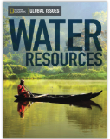

Day 13
Warm Up –
Geography Assessment (W)  Anthony Bourdain – Congo?  Nitro Type? | Resources/Materials/Extension  Create flags of Africa?  Flint Michigan question? Level 4, research?  Settlers of Catan  Political map of Africa?  Inconvenient Truth
_____________________________________________________________________________________
https://thewaterproject.org/resources/lesson-plans/water-water-anywhere

You need some sort of simulation to show the destructive force of the water and how each country relies on each other. Include population, rain water, evaporation, irrigation, flooding, drought, use dice.

Warning Earthquake
WARNING…….. WARNING……. WARNING

This is an automated message. The African Seismic Center has detected an 8.0 magnitude earthquake. The epicenter of this earthquake is in southern Egypt. Expect large scale destruction and massive aftershocks!

WARNING…….. WARNING……. WARNING
_____________________________________________________________________________________
Civil Engineer
To: African Union President

My name is Malak Salim; I’m the chief civil engineer at the Aswan Dam.

The recent 8.0 earthquake, and its subsequent aftershocks, severely damaged the foundation of the Aswan Dam. My team and I are working around the clock to hold the dam together. With a combination of rubber cement and duct tape, we should be able to make an emergency repair; however, this quick fix will only last for a year.

I know that many African countries rely on the Nile River to exist. You will need to have a conference or meeting to discuss what should happen with the dam. We must act soon if the Aswan Dam is going to be rebuilt.

Malak Salim
Chief Civil Engineer
Aswan Dam L.L.C.
_____________________________________________________________________________________
To: African Leaders

As I’m sure you are aware, recently there has been a massive natural disaster in Northern Africa. In two weeks’, time, we will have a meeting to protect the Nile River, an important natural resource, from future disasters. At this conference we will decide whether Egypt’s Aswan Dam should be rebuilt, among other issues important to the region’s stability.

You, and a two-person team, will represent your African country at the African Union conference. In the span of two short weeks, your team will need to become experts of recent North African history, along with brushing up on your map skills.

Thank you in advance for you hard work, for both country and continent.

Mr. Andrew Richard Patterson III
Secretary for the Great and Powerful African Countries
“We are all Mandela!”

Proposal #1
The African Union is convening (meeting) an emergency session to decide whether or not the Aswan Dam should be rebuilt after a massive earthquake.

Your group must decide, should the dam be rebuilt? Will it threaten the safety of your country? What other information do you need to gather to before voting yes or no? Who will this dam positively or negatively impact?

Proposal #1
The African Union is convening (meeting) an emergency session to decide whether or not the Aswan Dam should be rebuilt after a massive earthquake.

Your group must decide, should the dam be rebuilt? Will it threaten the safety of your country? What other information do you need to gather to before voting yes or no? Who will this dam positively or negatively impact?

Proposal #1
The African Union is convening (meeting) an emergency session to decide whether or not the Aswan Dam should be rebuilt after a massive earthquake.

Your group must decide, should the dam be rebuilt? Will it threaten the safety of your country? What other information do you need to gather to before voting yes or no? Who will this dam positively or negatively impact?

Proposal #1
The African Union is convening (meeting) an emergency session to decide whether or not the Aswan Dam should be rebuilt after a massive earthquake.

Your group must decide, should the dam be rebuilt? Will it threaten the safety of your country? What other information do you need to gather to before voting yes or no? Who will this dam positively or negatively impact?

Name:

Block: Letter to Leader (Debate Reflection)

Teacher:

Dear Benevolent (lovable) Leader,

Once again, I want to thank you for the opportunity of representing our great country at the emergency African Union Conference! I’m writing to keep you informed of what was discussed over the last couple of days. In the following letter, I will explain what issues we talked, which way our country voted, and our reasons for doing so.
____________________________________________________________________________________________________________________________________________________________________________________________________________________________________________________________________________________________________________________________________________________________________________________________________________________________________________________________________________________________________________________________________________________________________________________________________________________________________________________________________________________________________________________________________________________________________________________________________________________________________________________________________________________________________________________

I know that I only have my job as long as I’m keep making you happy.
Sincerely,
Your Humble Servant

Name:

Block: Awan Dam Quiz

Teacher:

Directions: For the river above, draw the following things: a dam, a lake, a house where it will be safe, and warning sign where there is danger. These can all be stick buildings/people and Mr. Patterson won’t judge you too much for you drawing.
If building dams creates danger/disease, why would people want to do it? Can you think of another way people use the environment to improve their lives?
____________________________________________________
____________________________________________________
____________________________________________________
____________________________________________________
____________________________________________________
____________________________________________________________________________________________________________________________________________________________________________________________________________________________________________________________________________________________________________________________________________________________________________
Most of African countries aren’t directly affected by the Aswan Dam, why should they care what happens between Egypt and Sudan? We should we care in Des Moines?
____________________________________________________
____________________________________________________
____________________________________________________
____________________________________________________
____________________________________________________
____________________________________________________________________________________________________________________________________________________________________________________________________________________________________________________________________________________________________________________________________________________________________________
Emergency Meeting Old Resource
Aswan Dam Conference
African Union

Per the African Union Constitution (plan), “each country group will be provided with a conference schedule that will outline expectations step by step.” The the person running the meeting, will make it clear to each team what step the conference is currently on.

*Steps 1-4 will be repeated for every issue examined during the conference.

Conference Schedule
Step 1 - Research prompt
Step 2 - Delegate Discussion
Step 3 - Voting Process/Rules
Step 4 - Tally of Votes/Email to Leader

Research Prompt
Groups are presented with a problem, they will need to read and decide how their country wants to respond to the prompt. They will need to find and organize evidence to support their stance so during the debate they can justify their position to the other delegations.

Delegate Discussion
During the delegate discussion process delegates representing their countries will try and get other countries to agree with their way of thinking. The easiest way to get other countries to get to agree with your position is to provide research/evidence that backs up your opinion. It is also okay to make alliances at this time with other countries.

Voting Process/Rules
Each country present at the conference will vote during this step. For votes to count, each country must clearly label their ballot with a “yes” or “no” and explain why they are voting that way. Votes will be submitted, the moderator will count the votes, and show who voted for which side and why.

For a vote to pass, the following requirements need to be met.
    - A majority of countries need to vote yes.
    - Egypt must vote yes

Tally of Votes/Outcome
The moderator will lead a discussion about what countries “won” and which countries “lost.” Delegates will write an email to the leader of their country explaining what happened during the debate and whether or not their countries goals were met. Delegates will then wait to hear back from their country leaders to see whether or not their performance was adequate.

Country Research – Old Resource

Directions: In a couple of weeks, you will be attending an emergency summit (meeting) of the African Union. It will be extremely important for you to know the strengths and weaknesses of your country. Therefore you should use the remainder of the day to find the answers to the following questions. Work together as group. If you finish early (which would be incredibly difficult because there are books written on these question), start researching other countries attending the conference. Bullet point your answers on the back of this paper.

- What is the African Union? Is your country a member of the African Union? Watch this video: Link
- Which European country colonized your country?
- When did your country get its independence?
- How many coup d’états has your country gone through since its independence?
- What type of government does your country currently have?
- What is your country’s average life expectancy?
- What is your country’s GDP per capita?
- Has your country fought any other countries since it gained its independence?
- What issues are facing your country?
- How strong is your country’s military?

_____________________________________________________________________________________

Culture Grams (general information about your country)
1. Go to Google
2. Search for CultureGrams
3. Click on kids’ culture grams
4. If your country is listed on the kids section, use it
5. If your country wasn't listed, use the regular version

Login
1737callan

Password
haea11
_____________________________________________________________________________________

Google (simple research facts)
Search Google with the name of your country followed by what you're looking for.

For example:
South Sudan GDP per Capita

Topic | 2 | 3 | 4
Geographic Analysis | Basic Knowledge/skill such as:  -identify and explain the importance of key features in a region/area | Explain how physical features allowed societies to emerge  Describe how physical features kept North Africa culturally unique  Explain, with examples, why North African try to modify their physical environment. | Given a scenario, explain how a community would adapt if an important physical/political feature was threatened or changed.

The following project is a level 4 task for the Geographic Analysis social studies standard. If you have any questions while working on this project over the holiday break, feel free to email Mr. Patterson at: Andrew.patterson@dmschools.org. If you want to, you can create/write your proposal in OneNote. This will allow Mr. Patterson to provide suggestions while you work!

_____________________________________________________________________________________

Memo: Twitter Housing Grant

Name: OLD RESOURCE

Last year, Facebook announced that they will build a new data collection center in Altoona, Iowa. When the data center opens, it will create over thirty high paying jobs. These jobs, along with taxes brought in by the data center, will bring in millions of dollars to the community.
http://bit.ly/1mAiRBw

Since the Facebook deal was finalized, the mayor of Des Moines has been trying to get other high profile tech companies to invest in central Iowa. The social media company Twitter has been extremely receptive to the mayor’s outreach. One incentive that the mayor is offering to potential investors is something called the Twitter Housing Grant. The Twitter Housing Grant states that the city of Des Moines will help pay for housing for employees for tech companies that invest in Iowa.

However, the Twitter Housing Grant will cost the tax payers a lot of money and as a result could prove to be quite controversial. That is where you come in; the mayor has had me collect thematic maps of Des Moines that I’m attaching to this email. He needs you to analyze the thematic maps and develop a proposal that meets the specifications below. The mayor’s reelection hangs in the balance, so he will need your proposal to be based on cited evidence gathered from the thematic maps. I can assure you that your hard work will be amply rewarded.

Identify which neighborhood best meets the following requirements:
- Ethnically diverse (the grant needs to help a diverse community)
- Relative balance between females to males (when there is a male imbalance, there is usually a higher crime rate)
- Emphasis on a high median income (high average earning in a neighborhood)
- Emphasis on neighborhoods with 30-49 years olds
- Emphasis on neighborhoods with higher education
- Emphasis on less amount of nuisances (times police were called for people being too loud)

This link will take you to a map of Des Moines that shows the boundaries and names of neighborhoods with the city: http://bit.ly/1u3esqZ

Remember, there probably isn’t a neighborhood that will meet all of the requirements listed above. Try and choose which one in your opinion is the best. Please don’t hesitate to send me an email if you any questions or if you want me to look at your proposal. My email is Andrew.patterson@dmschools.org.

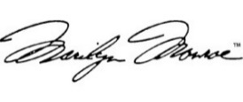

Mr. Andrew Richard Patterson III
Associate Mayor of Des Moines
“In the Service of Humanity”

pages 7, 12, 14, 18, 24, 36

