African Indicators of Development
Sub-Saharan Africa
Patterson

(W) Means on website
Underline what should be said to the class
If there is a blue word click on it while holding down “ctrl”

Yellow = still needs work
Blue = side thoughts

The purpose of this lesson cycle is for students to understand the concept of standard of living (GDP per capita, life expectancy, and adult literacy). They will write an informative paper linking these abstract concepts to life inside Ghana.

Day 1
Learning Target – I will collect data in order to make inferences about the quality of life in a country.

Warm Up – No Warm Up or Make a list of the things that the government pays for. Write on large scratch paper, tell students we will come back to it.
African Country Research  -pages | Resources/Materials/Extension

Day 2
Learning Target – I will analyze data in order to make inferences about the quality of life in a country.

Warm Up –
Give students cut up notecards, have them write a number on it between 65 - 85, have them make a line to the board. As student come up, record the numbers on the board. Come up with an average. Use dice/sticks to have students change their numbers based off things that negatively impact health of population. These include: Gender (riskier behaviors), genetics (history of disease in family), money, education, lifestyle (working out/diet), security, and access to healthcare (living in the country, not having a car, or being able to pay for it).

What happened to the average life expectancy after we made the changes?

Finish/analyze research, turn in. Save exemplars for day 4 warm up.  OneNote  Research outliers of GDP per capita, what makes the country so rich or poor? | Resources/Materials/Extension

Day 3
Learning Target – I will watch part of a documentary and identify what impacts the standard of living (quality of life) of the protagonist (good guy).

Warm Up – Using specific data, which African country has the highest standard of living?
Display vocabulary:  Average Life Expectancy  GDP per Capita  Literacy  Burner Boys  Note sheet tracking GDP per Capita, life expectancy, and literacy rate | Resources/Materials/Extension  The Insider, Reggie Yates, Ghana, Burner Boys  Use a VPN (VPN unlimited, change IP to England, and then use IBBC player). Have this ready on a second computer.

Day 4
Learning Target – I will create an outline/plan to guide my informative writing.

Warm Up – Pass out research exemplars. How does Ghana’s standard of living compare to other African countries? Can anyone push back about why the documentary is being unfair to the country as whole? Watch video link or use pictures to reference skid row
Finish watching Burner boys, have groups add to their tri fold.  Plan out writing with group. Do this on separate paper. Have groups talk about how they feel about the quote. Have groups share out their thoughts on this prompt. Have them generate a list. As group then they come up with a plan which organizes their thoughts. Have them respond to this prompt:  It is in my opinion that if you want to be happy in Ghana, all you have to do is work hard, and you will live a long and happy life. | Resources/Materials/Extension

Day 5
Learning Target – Using an outline, I will write an informative response to bias quote.

Warm Up – If we wanted to find pictures about the documentary, what would we search for? Generate list and have on board.
Write Rough Draft, 7 minutes to get start with group, 7 minutes of silence. As students finish, they can put their name on the board and type final draft on OneNote w/ picture. | Resources/Materials/Extension  Have scale ready to display…

Name:

Block: Africa – Indicators of Development

Teacher:

Country | GDP per Capita | Life Expectancy | Literacy Rate | Total
Egypt

Ghana

Angola

South Africa

Kenya

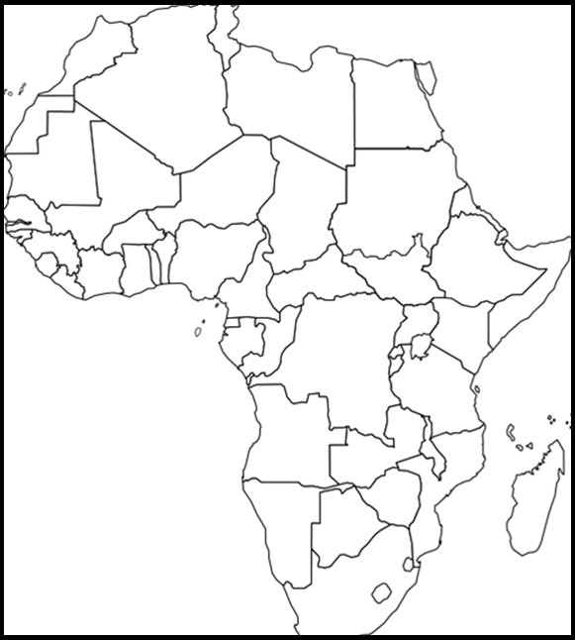
Class Copy
How do you find GDP per capita of a country?

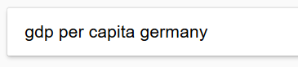
1. Go to Google.

2. Type in GDP per Capita followed by the name of the country.

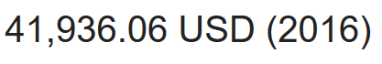
3. If you do this correctly, the answer should appear in bold.

How do you find the average life expectancy of a country?

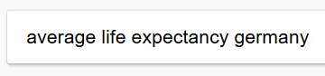
1. Go to Google.

2. Type in average life expectancy followed by the
name of the country.
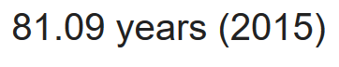
3. If you do this correctly, the answer should appear in bold.

How do you find the literacy rate of a country?
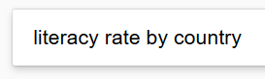
1. Go to Google.

2. Search literacy rate by country.

3. Click on this one.

4. Use the search function to find the country’s literacy rate. The easiest way to access the search tool is by pressing ctrl and f at the same time.

