**Name**

**Block Thematic Map:** African Coup D’états

**Teacher**

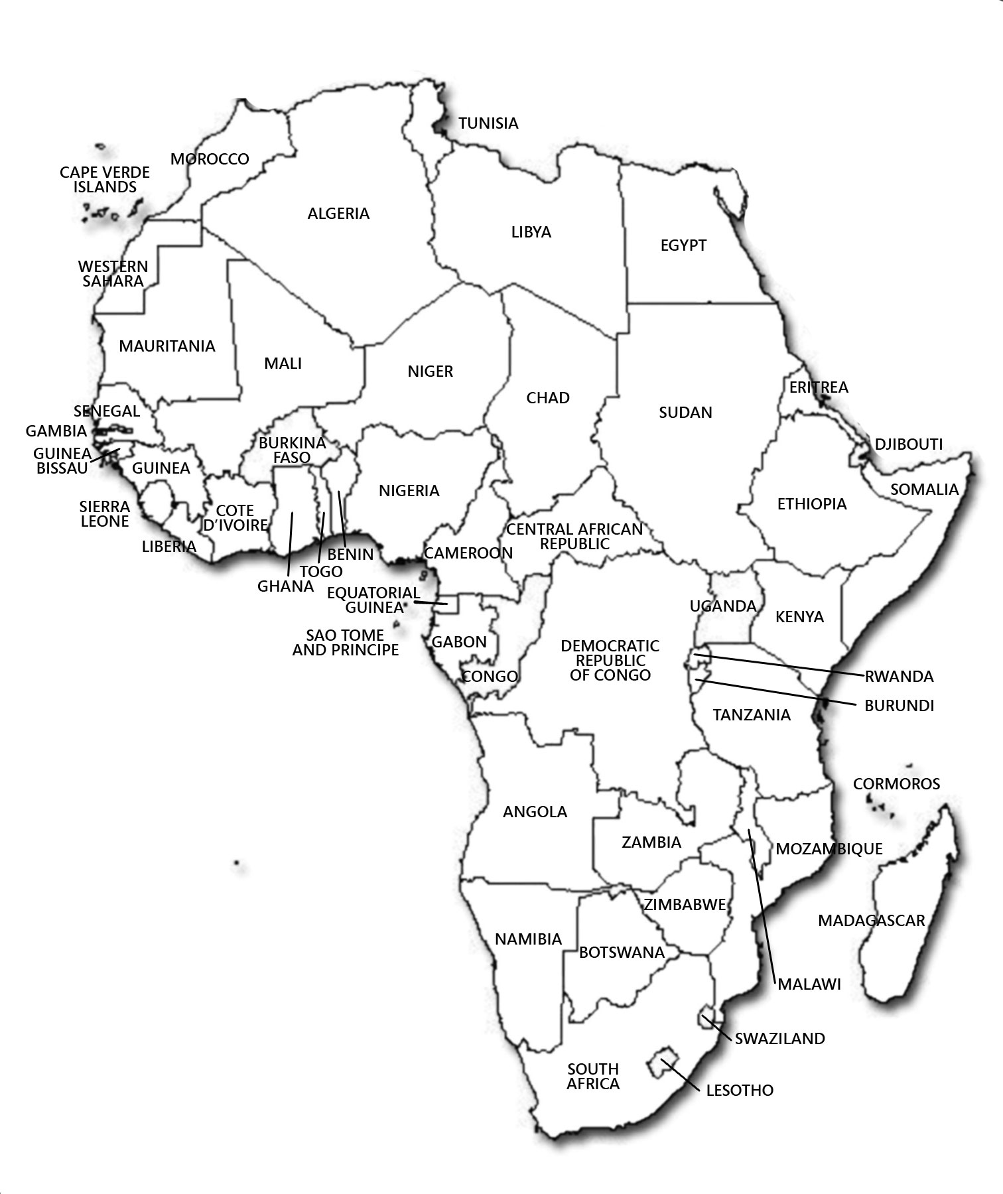**Directions:** Using the data provided to you, write down the number of **attempted** and **successful** Coup d’états that have occurred in every country in Africa. You may skip the countries that an **“x”** in them. Angola has already been done for you as an example. On the back of this paper, use the data that you collected to make a thematic map.

**Coup d’état**- means overthrowing a country’s leadership so new people can rule.

**2**

ALEKS, glue, blue posters,

ALEKS, glue, blue posters,

ALEKS, glue, blue posters,

ALEKS, glue, blue posters,

**African Coup D’états: 1946-2004**

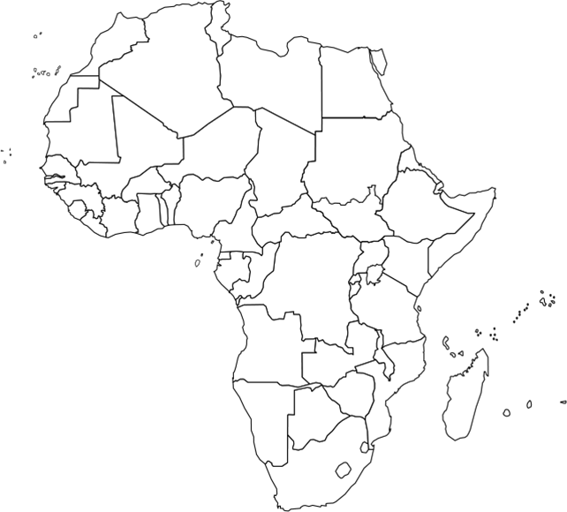

**Map Key**

= 0 Coup D’états

= 1-3 Coup D’états

= 4-7 Coup D’états

= 8 or more Coup D’états

**Name**

**Block Thematic Map:** African Coup D’états

**Teacher**

**Directions:** Using the data provided to you, add the total number of civilian deaths that have occurred in each country because of coup d’états. Ethiopia has already been done for you as an example. On the back of this paper, use the data that you collected to create a thematic map.

**Coup d’état**- means overthrowing a country’s leadership so new people can rule.

**3,466**

**African Coup D’états: 1946-2004**



Blue

Green

**Map Key**

= 0 – 1,000 deaths

= 1,001 – 5,000 deaths

= 5,001 – 10,000 deaths

= 10,001 + deaths

Red

Yellow