20 October 2018
CONFIDENTIAL
13:23:00
CODE 999
OPERATION WORLD-END

TO: SURVIVORS

URGENT MESSAGE…

DESPITE BEING DISPLACED IN NORTH AMERICA, IF YOU HAVE FOUND THIS FILE, YOU HAVE SURVIVED.

WE CANNOT KNOW THE STATE OF THE WORLD.

WE CANNOT KNOW THE EXTENT OF THE DAMAGE.

YOU ARE OUR LAST, AND ONLY, HOPE FOR CONTINUING CIVILIZATION.

TAKE THE IMAGES FROM THIS FILE. THEY ARE THE MOST RECENT SATELLITE IMAGES TAKEN FROM SPACE. WE BELIEVE THE VIRUS HAS CAUSED GREAT CHANGE IN THE GEOGRAPHY OF OUR WORLD.

IT IS UP TO YOU TO INVESTIGATE THE STATE OF THE WORLD. COMPLETE A SETTLEMENT MAP USING ALL THE INFORMATION YOU CAN FIND: PHYSICAL FEATURES, WATER, RESOURCES, LANDMARKS, ANY POSSIBLE SURVIVING PLANTS, ANIMALS, AND PEOPLE.

ONCE THE MAP HAS BEEN COMPLETED, CREATE A REPORT RECOMMENDING AREAS FOR HUMAN SETTLEMENT AND SURVIVAL. INCLUDE JUSTIFICATION FOR YOUR DECISIONS FROM THE MAPS YOU HAVE ANALYZED, DETERMINING WHICH INFORMATION IS THE MOST IMPORTANT FOR YOUR SURVIVAL.

BROADCAST ALL MAPS AND REPORTS THROUGH THE CIA PLATINUM SECURITY ALERT SCANNER.

WATCH THE FOLLOWING BROADCAST TO AID YOU IN YOUR MISSION
https://www.youtube.com/watch?v=Ixu_Gn5tWMw

YOU WILL BE SAVING THE HUMAN RACE.
GOOD LUCK.

SIGNED: AGENT 4490

Security Report
Current state:
Explain how resources, physical features, and human characteristics influence movement of people, goods, and ideas. In other words, why would a person want to live in one place over another and what does a person bring with them when they move?
Post-Apocalypse:
- Map of your continent, locating three security bases
- Thinking Critically: Justification for the choice of each security base including
- Physical features
- Resources
- Thematic Map
- Choose one security base that you believe is the best option for resettlement. Based on resources, physical characteristics and a map of your choice:
- Geography: What are the push and pull factors for this location? In other words, why would people want to come to this location over other bases around the world?

- Geography: How will people on your base have to DEPEND on, ADAPT to, and MODIFY the environment and its resources for survival?

- Economy: What will you use to trade for other necessary items? Who will you trade with?
- Research report: What goods may come from that area of your country?
      - How will these resources and goods benefit your base?
- How will the ideas (belief systems, technology, innovations, culture) in this area of your country influence your base?
- Which other settlements will depend on you for resources?
      - Why is that beneficial?
      - What issues could arise because of that dependence?

*ALL PARTS OF QUESTION 3 MUST BE INCLUDED IN YOUR SECURITY REPORT
**Include support from your maps
***Include information from class or your own research

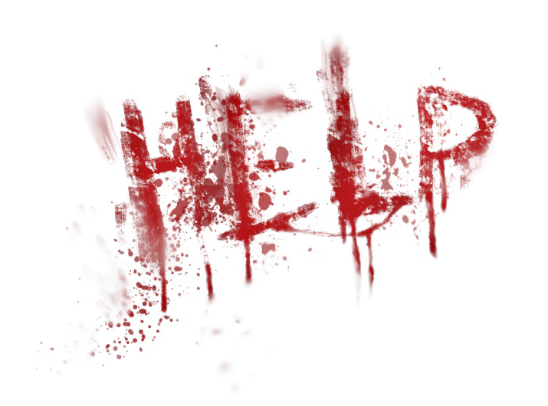

MAPS FOR SETTLEMENT
Based on these three maps, shade and explain the relative location of three possible security bases on your continent.
Country Location | Relative location  Absolute location | What are you basing your decision on? What resources or human or physical features make it a desirable location?
1. |  | __________________________________________________  __________________________________________________  __________________________________________________  __________________________________________________  __________________________________________________
2. |  | __________________________________________________  __________________________________________________  __________________________________________________  __________________________________________________  __________________________________________________  __________________________________________________  __________________________________________________
3. |  | __________________________________________________  __________________________________________________  __________________________________________________  __________________________________________________  __________________________________________________  __________________________________________________  __________________________________________________  __________________________________________________

NEW INFORMATION HAS JUST BEEN RECEIVED
Based on your new information, justify for each Security Base how this information will help you survive. If this information proves that your location will no longer be successful in sustaining the human race, use the new information to find a new location.
Country  Location | Physical Map | Resource Map | Thematic Map
1. | ________________  ________________  ________________  ________________  ________________  ________________ | ________________  ________________  ________________  ________________  ________________  ________________ | ________________  ________________  ________________  ________________  ________________  ________________
2. | ________________  ________________  ________________  ________________  ________________  ________________ | ________________  ________________  ________________  ________________  ________________  ________________ | ________________  ________________  ________________  ________________  ________________  ________________
3. | ________________  ________________  ________________  ________________  ________________  ________________ | ________________  ________________  ________________  ________________  ________________  ________________ | ________________  ________________  ________________  ________________  ________________  ________________
Based on the intel that you gathered above, determine which base will be your main base. If your intel leads you to believe there is a better base, please include information on the new base below.
Replacing #_______  With  ________________  Absolute Location:  Relative Location: | ________________  ________________  ________________  ________________  ________________  ________________ | ________________  ________________  ________________  ________________  ________________  ________________ | ________________  ________________  ________________  ________________  ________________  ________________
Physical Map Resources Map Thematic Map
Due to your excellent map skills, the leadership team has tasked you with finding additional information of your choice. This may be an article, map, encyclopedia, etc. You must find the same information for each of your bases.
Title:________________________________________________________________
Source:____________________________________________________________________
Information gathered:
Base 1 ________________________________________________________________________________________________________________________________________________________________________________________________________________________________________________________________________________________________________Base 2 ________________________________________________________________________________________________________________________________________________________________________________________________________________________________________________________________________________________________________Base 3 ________________________________________________________________________________________________________________________________________________________________________________________________________________________________________________________________________________________________________

Name:________________________ Core:______
Zombie Project Assessment
Geography
4 | 3 | 2
In addition to meeting the learning goal, the student demonstrates in-depth inferences and applications that go beyond the goal. | Explain why people live in certain areas in the world and how they try and change their environment to better suit their needs. | Fails to meet the learning goal in one or more ways.
Thinking Critically
4 | 3 | 2
In addition to meeting the learning goal, the student demonstrates in-depth inferences and applications that go beyond the goal. | Create a product by integrating visual information (charts, graphs, maps, etc.) with other information in print text by clearly showing connections between them. Product created uses a variety of relevant sources and makes reference to each source used. | Create a product by using visual information in print text, but fails to meet the learning goal in one or more ways.

Please answer the questions below as part of your assessment.
- List sources that you used to help you determine your base location(s). What sources where the most useful in your decision making? Explain.
____________________________________________________________________________________________________________________________________________________________________________________________________________________________________________________________________

- What additional source(s) did you use? How did this support or change your decision?
____________________________________________________________________________________________________________________________________________________________
____________________________________________________________________________________________________________________________________________________________

- Circle the above grades you believe you have earned. How does my project reflect this grade? (use scale above)
____________________________________________________________________________________________________________________________________________________________________________________________________________________________________________________________________
Emergency Report

We are sorry to report that your water supply has been contaminated. A virus has gotten into the water. It doesn’t affect the fish, but it continues to be viable enough to affect humans if they drink it. Please explain how this problem effects your base and how you will address it in an emergency security report.

_________________________________________________________________________

Emergency Report

- We are sorry to report that there is a food shortage. Someone from the group came to the security base unknowingly with maggots in her spare shoes. The fly is not native to the area and started laying eggs on the crops, ruining them. Please explain how this problem effects your base and how you will address it in an emergency security report.

_________________________________________________________________________

Emergency Report

- There has been a disaster – Someone left a water bottle in the hot sun next to a car on base. The water bottle acted as a magnifying glass and started a small fire. After it wasn’t put out right away, the car exploded, spreading the fire through the base. 2/3 of the shelters are gone. Please explain how this problem effects your base and how you will address it in an emergency security report.

