Class Copy

Pictures are worth a thousand words… Day 1
Vietnam War Photographs

Directions: Southeast Asia, similar to other regions, experienced a period of conflict that affects it to this day. Examining primary sources, like pictures, helps us understand that occurred decades ago. Your job is to conduct research on the point/picture that you were assigned. Tomorrow your group will explain what they have found to the entire class…. (Yes everybody will be presenting). Your group doesn’t have to answer the questions below but should use them to drive your research.

1. Dien Bien Phu
What was Dien Bien Phu?
Why were the French in Vietnam?
What is this a picture of?
Helpful Search Terms - “French Vietnam War,” “Street without Joy”
2. Different Kind of War
What does the phrase “winning hearts and minds” mean?
What is this a picture of?
How did each side try and control the population?
Helpful Search Terms - “Strategic Hamlet Program,” “Propaganda and Vietnam War”
3. Puppet Government
Who was Diem?
How many governments did South Vietnam have between 1960-1975?
What is this a picture of?
Helpful Search Terms - “Diem South Vietnam Government,” “Ngo Dinh Diem Coup”
4. Without Borders
How did the Vietnam War impact the other countries of Indochina (Laos and Cambodia)?
What is this a picture of?
Helpful Search Terms – “U.S. invades Cambodia,” “Laos and U.S. relations”
5. End of the “American War”
What happened in 1975?
What happened to the Vietnamese people that helped the United States?
How many Vietnamese-Americans are there in the United States?
What is this a picture of?
Helpful Search Terms – “Fall of Saigon 1975,”
6. Future of the Region
How did the war affect the Vietnamese population?
How do Vietnamese people feel about the United States?
What is this a picture of?
Helpful Search Terms – “Agent Orange,” “Vietnamese reeducation camps”

1. Surrender at Dien Bien Phu  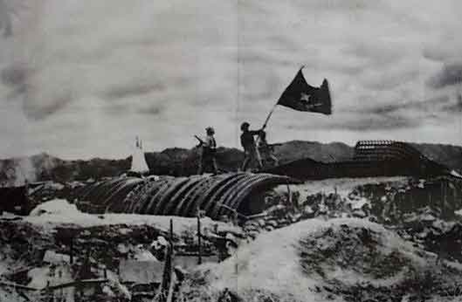 | 2. Different Kind of War  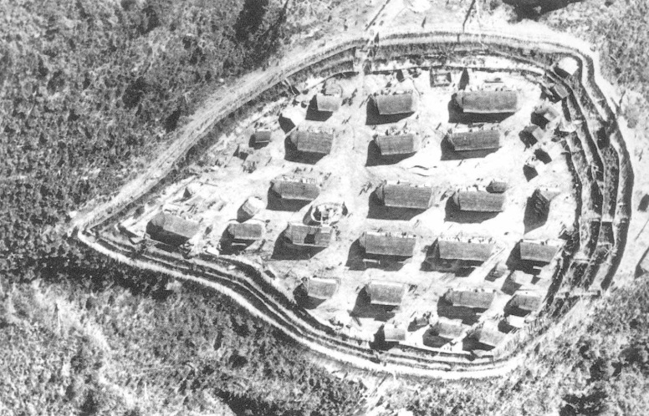
3. Puppet Government  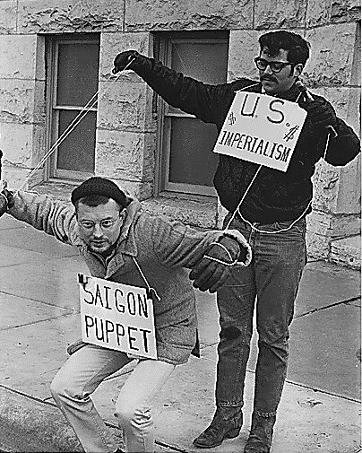 | 4. Without Borders  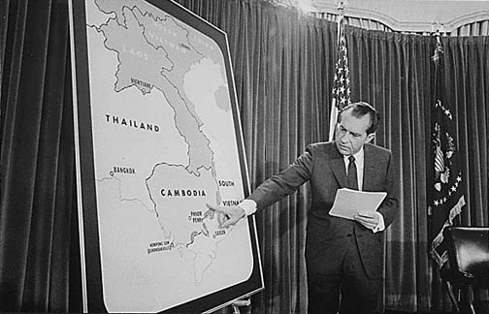
5. End of the “American War”  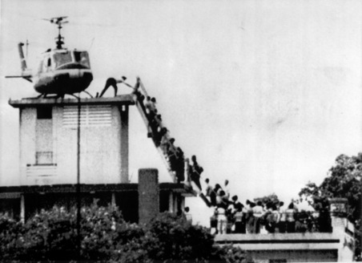 | 6. Future of the Region  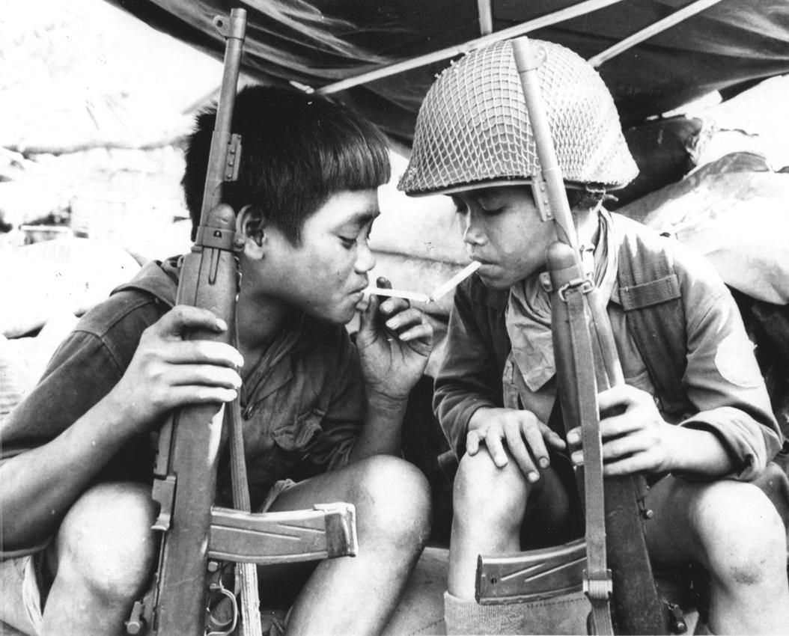

Name: Teacher Copy

Block: Pictures are worth a thousand words… Day 2

Teacher:

Directions: Take notes about each picture as groups present. The more you write down the more you will remember for the quiz.

Surrender at Dien Bien Phu | This is a picture of the French surrendering  France was fighting because they wanted to colonize Indochina  The U.S. paid for most of France’s fighting expenses because they were killing communists
Different Kind of War | The Vietnam War was fought over who could control the people  South Vietnam told people to build fences around their village  North Vietnam who should join us because we promise equality and farmland
Puppet Government | The leader of South Vietnam was named Diem  Treated his people poorly, anybody that spoke out against him would be killed and/or put in jail.  We liked him because he was anticommunist but he was a terrible person
Without Borders | President Nixon invaded Cambodia and bombed countries around Vietnam  This has led to problems in countries in Indochina.

End of the “American War” | 1975 the war in Vietnam was ending  The people helping the United States were brought back and are now Americans  1,500,000 Vietnamese-Americans

Future of the Region | During the war +1,000,000 people died  The effects of the war still effect the region to this day  This picture is a metaphor for Agent Orange and how it causes long term cancer/problems

Name:

Block: Pictures are worth a thousand words… Day 2

Teacher:

Directions: Take notes about each picture as groups present. The more you write down the more you will remember for the quiz.

Surrender at Dien Bien Phu

Different Kind of War

Puppet Government

Without Borders

End of the “American War”

Future of the Region

