Name: Block: Teacher:

(Title)_______________________________

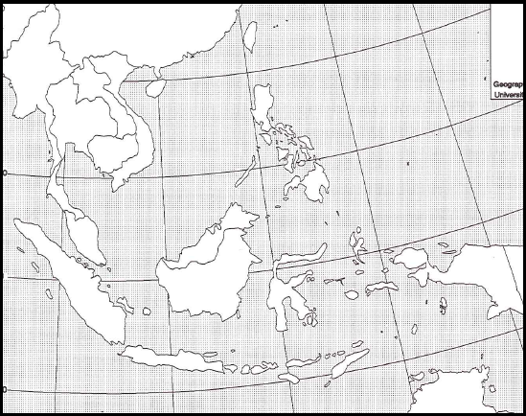

Map Key:

Southeast Asia - Political Map

Directions: Include the below details on your Southeast Asia political map. To help you label these details you may use a purple Asia book using page 260. If the color you are supposed to use is being used by someone else than use a different color.

Make sure your map is presentable. Please do not rush while doing this assignment. Make sure you include a map title and key. Names of countries should be in CAPS. Capitals should be marked with a small star and circle around it.
Example:

Color | Label Country & Capital
Orange | Cambodia
Yellow | Myanmar
Orange | Malaysia
Purple | Laos
Pink | Vietnam
Green | Thailand
Purple | Indonesia
Green | Philippines

Latitude and Longitude
1. Yangon, Burma Latitude- Longitude-

2. Manila, Philippines Latitude- Longitude-

3. Hanoi, Vietnam Latitude- Longitude-

4. Tehran, Iran Latitude- Longitude-

5. Kabul, Afghanistan Latitude- Longitude-

6. Beijing, China Latitude- Longitude-

7. Tokyo, Japan Latitude- Longitude-

