Name:________________________ Central/South Asia Map Skills CFA – Week 3 Block:_____
Learning Objective - Identify Physical Features Color:
Green - Advanced | Blue - Proficient | Yellow – Close to Prof. | Orange – Far from Prof. | Red – Below expectations.
Students can spell correctly the six major physical features of Central/South Asia and identify them on a map. | Students can spell correctly the five major physical features of Central/South Asia and identify them on a map. | Students can identify four major physical features of Central/South Asia. | Students can identify two major physical features of Central/South Asia. | Students cannot identify any physical features of Central/South Asia.

Learning Objective - Identify Major Central/South Asia Countries Color:
Green - Advanced | Blue - Proficient | Yellow – Close to Prof. | Orange – Far from Prof. | Red – Below expectations.
Students can spell correctly the five countries of Central/South Asia and identify them on a map. | Students can spell correctly the four countries of Central/South Asia and identify them on a map. | Students can identify four countries of Central/South Asia on a map. | Students can identify two countries of Central/South Asia on a map. | Students cannot identify any countries in Central/South Asia on a map.
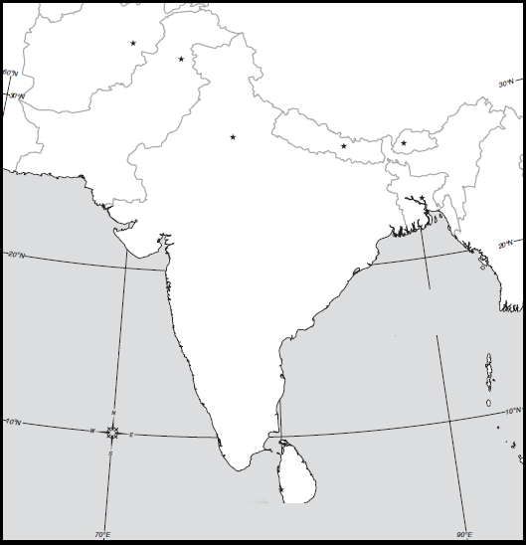
6
4
3
5
B
C
A
E
1
2
D
Physical Features Major Countries
1. A.

2. B.

3. C.

4. D.

5. E.

6. #____________ Identified Correctly (If spelling didn’t . count how many would they have gotten right?) . . #____________ Spelled correctly
#____________ Identified Correctly (If spelling didn’t count how many would they have gotten right?)

#____________ Spelled correctly

