UNIT 4: Central/South Asia Name: ____________________
CLUSTER: Using Primary/Secondary Sources TOPIC: Central Idea of a Source

LEVEL 2 and 3 UNDERSTANDINGS/SKILLS

2 | 3 | 4
The student demonstrates a basic understanding of the main idea of the primary or secondary source, with some misconceptions. | The student demonstrates an ability to determine the main idea of a primary or secondary source and the ability to provide an accurate summary of the source. | The student demonstrates an ability to accurately determine the main idea of a source and the ability to provide an accurate summary of the source including evidence and analysis. The student demonstrates an ability to determine the significance of the source.
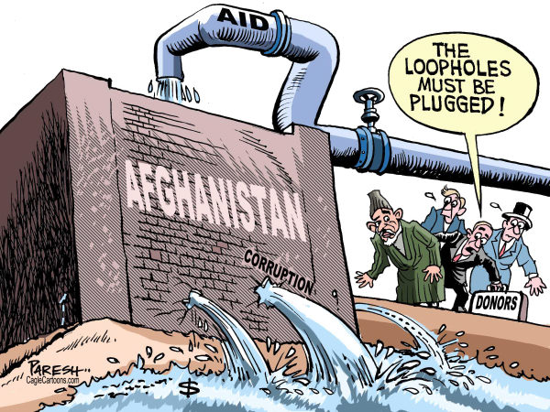

Level 2: What is the main idea or purpose of the political cartoon?

__________________________________________________________________________________________________

__________________________________________________________________________________________________

__________________________________________________________________________________________________

__________________________________________________________________________________________________

Level 3: Provide a summary of the what is going on in the cartoon.

__________________________________________________________________________________________________

__________________________________________________________________________________________________

__________________________________________________________________________________________________

__________________________________________________________________________________________________

LEVEL 4 UNDERSTANDINGS/SKILLS

Directions: Use the chart to write a response below. To receive credit for having level 4 understanding, you must demonstrate an ability to determine the significance of the source – using evidence and analysis to support your response.

Explain the significance (the importance) of the source, using evidence and analysis to support your response.

__________________________________________________________________________________________________

__________________________________________________________________________________________________

__________________________________________________________________________________________________

__________________________________________________________________________________________________

__________________________________________________________________________________________________

__________________________________________________________________________________________________

__________________________________________________________________________________________________

__________________________________________________________________________________________________

__________________________________________________________________________________________________

__________________________________________________________________________________________________

__________________________________________________________________________________________________

__________________________________________________________________________________________________

__________________________________________________________________________________________________

UNIT 4: Central/South Asia Name: ____________________
CLUSTER: Using Primary/Secondary Sources TOPIC: Central Idea of a Source

LEVEL 2 and 3 UNDERSTANDINGS/SKILLS

2 | 3 | 4
The student demonstrates a basic understanding of the main idea of the primary or secondary source, with some misconceptions. | The student demonstrates an ability to determine the main idea of a primary or secondary source and the ability to provide an accurate summary of the source. | The student demonstrates an ability to accurately determine the main idea of a source and the ability to provide an accurate summary of the source including evidence and analysis. The student demonstrates an ability to determine the significance of the source.
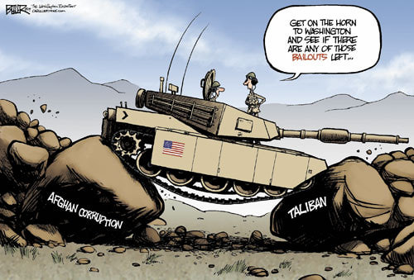

Level 2: What is the main idea or purpose of the political cartoon?

__________________________________________________________________________________________________

__________________________________________________________________________________________________

__________________________________________________________________________________________________

__________________________________________________________________________________________________

Level 3: Provide a summary of the what is going on in the cartoon.

__________________________________________________________________________________________________

__________________________________________________________________________________________________

__________________________________________________________________________________________________

__________________________________________________________________________________________________

LEVEL 4 UNDERSTANDINGS/SKILLS

Directions: Use the chart to write a response below. To receive credit for having level 4 understanding, you must demonstrate an ability to determine the significance of the source – using evidence and analysis to support your response.

Explain the significance (the importance) of the source, using evidence and analysis to support your response.

__________________________________________________________________________________________________

__________________________________________________________________________________________________

__________________________________________________________________________________________________

__________________________________________________________________________________________________

__________________________________________________________________________________________________

__________________________________________________________________________________________________

__________________________________________________________________________________________________

__________________________________________________________________________________________________

__________________________________________________________________________________________________

__________________________________________________________________________________________________

__________________________________________________________________________________________________

__________________________________________________________________________________________________

__________________________________________________________________________________________________

