Introducing Project – Teacher Steps

Day 1
Clean folders
Have students collect/staple unit calendars
Read through strand menu synopsis
Discuss how/show vocabulary and how it is the driving force behind choose your own option
Let students start working on strand menu assignment

Day 2
Students continue to work on strand menu assignment
Go over calendar

Day 3
For whatever strand students chose, they need to create three pages in OneNote, they need to copy down the guiding questions/targets
Show how to write Warm Ups

Show Level 4 and exemplar if students ask

Revision Suggestions
-fix grammatical errors
-suggestions should be comments

-explain vocabulary in the context of bringing a bag of Takis to school, supply, demand, scarcity, inequality it creates

-make sure that you sign off on finished work on calendar

-no need for exit slips
-display examples of timeline segments

-folders in the back need to labeled with the name as the strand

South Asia
Blended Learning Concept Map Teacher Explanation
Patterson

Yellow = Still needs completion
Blue = Musings to myself
(W) = Posted on the district website

Structured Autonomy

Vision
This unit is the culmination of work my involvement with a program called DMPS Trailblazers which supports for teacher implementing blended learning in the classroom. For the last couple of months, I have been slowly integrating a program called Microsoft OneNote into my classes. This program allows teachers to create assignments, post links, and moderate discussion topics. Students can access this content, have an existing collaboration space, and create documents/new pages. One of the major benefits of using OneNote is that teachers can provide instant feedback on student progress without the students emailing or printing off a draft.

Building off the students’ familiarity with OneNote, I began to embrace the radical idea of creating the purest form of blended, individualized learning possible in a middle school classroom. An entire unit where students determine what, how, and when they demonstrate the standards. OneNote is going to be an integral component of this process. It will allow me to guide student inquiries and provide instant feedback.

My work mapping out the unit was hindered initially, by the way, the district interpreted one of the standards for the unit. The way the scale was originally written, it limited student choice by forcing them to study a certain topic within a certain time period.

My natural inclination would to be just give students the standard itself. But even a cursory glance at the wording reveals that is both incredibly vague and confusing. In an attempt to unpack the standard but also keep it more closely aligned to its original intent, I created the Blended Learning South Asia scale that is the foundation for this entire unit.

The original standard, district provided scale, and the modified scale I used for this blended learning unit can be found on page 2.

Assessments
One of the first problems I had to wrap my brain around was how was I going to track student progress. I wanted to make sure that the students still had as much choice as possible. So what I created was a series of skill/standard checkpoints that slowly increased in rigor. Students are encouraged to meet these checkpoints by the suggested day. This work would culminate with a Level 4 task for both Individual in the Economy and the Author POV standards.

Musing
Students that “finish” early should can be given the ThematicMapofSouthAsia which examines the standard of living of South and Central Asian countries.

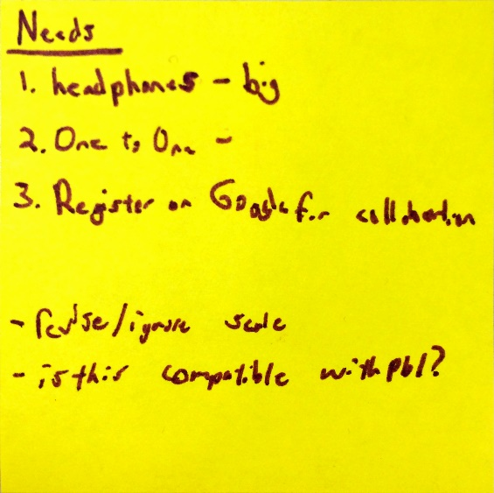
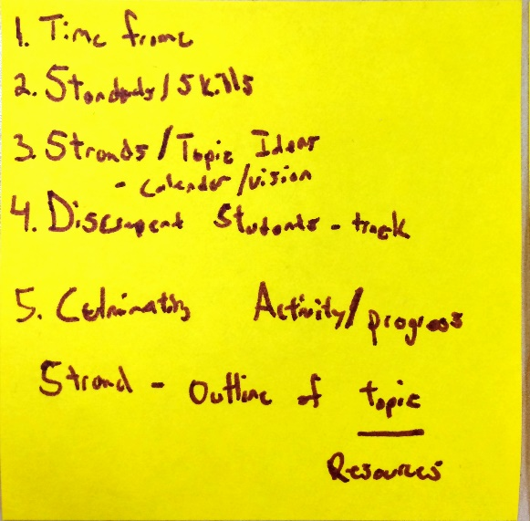
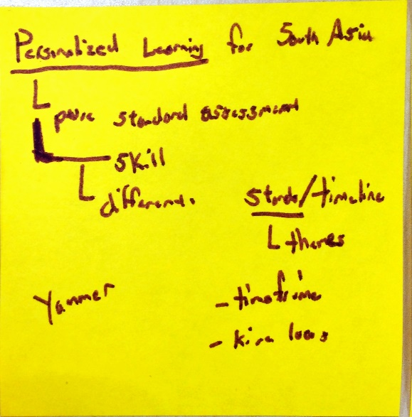

Standard
Topic | 2 | 3 | 4
Individual in the Economy |  | a) Understand the role of scarcity and economic trade-offs and how economic conditions impact people’s lives.  b) Understand the functions of economic institutions. | *Using the Revised Bloom’s Taxonomy, level 4 tasks must target a more rigorous cognitive and procedural knowledge then specified in standard.

District Scale for South Asia
Topic | 2 | 3 | 4
Economy in Central and South Asia | Basic knowledge/vocabulary such as:  -define the caste system  -distinguish between microloans, foreign aid, and affirmative action  -identify economic indicators  -scarcity, social mobility financial inequality, developed countries, developing countries | Explain, with examples, how South Asian history has created inequalities in different communities.  Describe how financial inequality limits social mobility (i.e. people who are poor often stay poor.)  Explain, with examples, how financial instruments such as microloans, foreign aid, and affirmative action can help alleviate inequalities. | Is your future determined at birth?

Modified Blended Learning Unit Scale
Topic | 2 | 3 | 4
Individual in the Economy | a) scarcity, trade-offs, supply, demand  b) economic institutions | A1.) Understand/describe how resource imbalance leads to economic problems within a region.  A2.) Understand/describe what determines a person’s quality of life.  B1.) Evaluate an organization/group that is trying to bring about change to A. | Is your future determined at birth?

Strand Menu
South Asia Student Explanation
Mr. Patterson

The next two weeks of class will probably be unlike anything that you have experienced before. Mr. Patterson is involved in a program where he is gone three days a year 😢. In this program, teachers learn about how students should be given as much choice as possible in what and how they learn. As you know by now, Mr. Patterson can be rather eccentric (and bring down the rain…seeds….seeds). So instead of slowly introducing this into our classroom over the next couple of months, we are going to do it all at once.

What could possibly go wrong? ;)

Here are the skills that that we are going to be working with for this unit:
Topic | 2 | 3 | 4
Individual in the Economy | A.) scarcity, trade-offs, supply, demand  B.) economic institutions | A1.) Understand how resource imbalance leads to economic problems within a region.  A2.) Understand what determines a person’s quality of life.  B1.) Evaluate an organization/group that is trying to bring about change to A. | Is your future determined at birth?

Topic | 2 | 3 | 4
Author’s Point of View | Identifies author’s purpose or point of view, but with some misconceptions within the context/unit of study. | Demonstrates the ability to accurately identify and explain an author’s purpose or point of view using textual and/or contextual evidence. | Demonstrates the ability to accurately identify and explain an author’s purpose or point of view using textual and contextual evidence and can justify or challenge it.

Your work these skills/scales will be centered around what strand you choose to focus on. Each day you will have access to a computer, headphones, and most importantly almost all of the class time. Mr. Patterson will keep the amount of time he steals from you to a bare minimum. It will be your job to make sure that they you identify the learning target, create/write an exit slip, make to-do list, and choose the resources you’re going to use to demonstrate the skills above.

Daily Schedule
Time Allocated | Task | Explanation
7 minutes | Warm Up | Students will grab their assigned computer and log in. While they are logging in, they will identify what their learning target for the day will be. For their warm up, students will then specifically plan how they plan on meeting their learning target.
15 minutes | Silent Work Time | There will be 15 minutes of silent work time at the beginning of every class session. The purpose of this time is to allow students to focus on their strand while also allowing other students to take assessments as needed. All assessments need to be taken/started during this time.
20 minutes | Collaboration Time | Collaboration time is for students to work with/problem solve with their peers (other students). Based on the previous day’s exit slip, Mr. Patterson might bring together a small group of students to practice a specific skill/scale.
7 minutes | Exit Slip | Students will log off their computers and plug them in. Students will then complete an exit slip. Students will have four prompts to respond to:  - Do you need help with a specific scale/skill?  - Do you have a specific question about your strand?  - Do you want to use silent work time to take an assessment the next tomorrow? If so, which one?  - Explain/describe something that you learned that changed your thinking about your strand.

Over the course of these next two weeks, I will learn just as much as you do. I feel confident in trying something so radical because I know you’re all capable of embracing a unit like this. However, please start this unit with the understanding that if you choose not to work as hard as possible, every single day, Mr. Patterson will limit the amount of choice available to you in the weeks ahead. You know by now that Mr. Patterson is indeed quite strange, but he also follows through on what he says.
_____________________________________________________________________________________
*Assessments
If you want to take an assessment, you must write it down on your exit ticket. You also may only take on assessment per day.

Name:

Block: South Asia Calendar

Teacher:

Week | Day 1 | Day 2 | Day 3 | Day 4 | Day 5
1 | Project Overview  Intro to Strands/Vocabulary | (I.E.) #1 Due |  | (I.E.) #2 Checkpoint | (POV Cart.) #1 Checkpoint
Week | Day 6 | Day 7 | Day 8 | Day 9 | Day 10
2 |  | (POV Art.) #1 Checkpoint |  | (POV Cart.) #2 Checkpoint | (POV Art.) #2 Checkpoint
Week | Day 11 | Day 12 | Day 13 | Day 14 | Day 15
3 | (I.E.) #3 Checkpoint |  | (I.E.) #4 Checkpoint
(POV Cart.) Authors P.O.V. Political Cartoon
- 2.5+ assessment provided by Mr. P
- 2.5+ on assessment chosen by you

(POV Art.) Authors P.O.V. Political Article
- 2.5+ assessment provided by Mr. P
- 2.5+ on assessment chosen by you

(I.E.) Individual in the Economy
- Strand Choice Assignment
- Level 2 Vocab Quiz
- Finish pink sheet
- 3+ on assessment provided by Mr. P
- Submit level 4 Task

Scales/Skills
Topic | 2 | 3 | 4
Individual in the Economy | A.) scarcity, trade-offs, supply, demand  B.) economic institutions | A1.) Understand how resource imbalance leads to economic problems within a region.  A2.) Understand what determines a person’s quality of life.  B1.) Evaluate an organization/group that is trying to bring about change. | Is your future determined at birth?

Topic | 2 | 3 | 4
Author’s Point of View | Identifies author’s purpose or point of view, but with some misconceptions within the context/unit of study. | Demonstrates the ability to accurately identify and explain an author’s purpose or point of view using textual and/or contextual evidence. | Demonstrates the ability to accurately identify and explain an author’s purpose or point of view using textual and contextual evidence and can justify or challenge it.

Daily Schedule
Time Allocated | Task | Explanation
7 minutes | Warm Up | Students will grab their assigned computer and log in. While they are logging in, they will identify what their learning target for the day will be. For their warm up, students will then specifically plan how they plan on meeting their learning target.
15 minutes | Silent Work Time | There will be 15 minutes of silent work time at the beginning of every class session. The purpose of this time is to allow students to focus on their strand while also allowing other students to take assessments as needed. All assessments need to be taken/started during this time.
20 minutes | Collaboration Time | Collaboration time is for students to work with/problem solve with their peers (other students). Based off the previous day’s exit slip, Mr. Patterson might bring together a small group of students to practice a specific skill/scale.
7 minutes | Exit Slip | Students will log off their computers and plug them in. Students will then complete an exit slip. Students will have four prompts to respond to:  - Do you need help with a specific scale/skill?  - Do you have a specific question about your strand?  - Do you want to use silent work time to take an assessment the next tomorrow? If so, which one?  - Explain/describe something that you learned that changed your thinking about your strand.

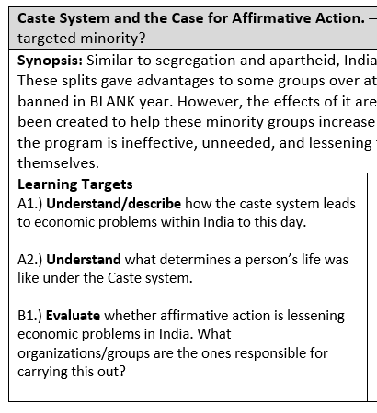
Warm Up Directions
Before you start working on your warm up, start logging into your computer.

Learning Target
Identify and write down what your learning target for the day will be. The most efficient way to do this is to write down the first sentence of the learning target you’re working on as labeled in your strand.

Warm Up Question
What specific things are you going to do to accomplish your learning target today?

Warm Up Directions
Before you start working on your warm up, start logging into your computer.

Learning Target
Identify and write down what your learning target for the day will be. The most efficient way to do this is to write down the first sentence of the learning target you’re working on as labeled in your strand.

Warm Up Question
What specific things are you going to do to accomplish your learning target today?

Exit Slip Directions
Before you start working on your exit slip, log off your computer and plug it in to the correct slot.

Exit Slip
Choose at least one of the following to respond to:
- Do you need help with a specific scale/skill?
- Do you have a specific question about your strand?
- Do you want to use silent work time to take an assessment the next tomorrow? If so, which one?
- Explain/describe something that you learned that changed your thinking about your strand.

Turn in your Warm Up/Exit Slip into the black bin before you leave.

Exit Slip Directions
Before you start working on your exit slip, log off your computer and plug it in to the correct slot.

Exit Slip
Choose at least one of the following to respond to:
- Do you need help with a specific scale/skill?
- Do you have a specific question about your strand?
- Do you want to use silent work time to take an assessment the next tomorrow? If so, which one?
- Explain/describe something that you learned that changed your thinking about your strand.

Turn in your Warm Up/Exit Slip into the black bin before you leave.

South Asia Strand Menu - Ghandi vs. Great Britain
Print on different colored sheets

How does a man in his underwear defeat one of the strongest countries in the world?
Synopsis: It is no small feat to inspire the likes of Nelson Mandela and Martin Luther King Jr. The story of how Gandhi was able to use nonviolent protest to oust (kick out) the British government has been immortalized in history. What drove Gandhi to lead his campaign? Did the British government help India in any way? Was granting India its freedom a mistake?

Learning Targets | Guiding Questions/Statements | Links
A2.) Describe what life was like under Great Britain’s rule in South Asia? How did the British maintain control of the continent? | -Define colonization  -Create a timeline of who controlled India since 1848.  -How did Great Britain control and conquer India? What tactics and technologies did these use? What was the British Raj? Why did Great Britain want to control India? | Link,  Link, Link, Link, Link, Link
A1.) Describe how Great Britain’s colonization lead to wealth imbalance in South Asia. How did this lead to a lower standard of living in the region? | -Define standard of living  -What were some of the problems/events that affected Indians’ daily lives when they were being controlled by Great Britain?  -Did Great Britain help India in anyway? When they controlled the region, what did they build? | Link, Link,  Link, Link
B1.) Describe/evaluate how Ghandi’s nonviolent movement, especially his salt march threatened, the profits for the company/Great Britain. | -What was nonviolent resistance? Who was its leader? What was the salt march? Why was it successful? Why did Ghandi never dress up?  -What happened when India gained its independence from Great Britain? What is the Kashmir region? Why is it so important? | Link, Link, Link, Link, Link, Link  Link,
_____________________________________________________________________________________
Italics – is a question that requires you to make an inference
No italics – text evidence can help you answer the question.

The Caste System and the Case for Affirmative Action

Is it reverse racism or a needed protection for a targeted minority?
Synopsis: Similar to segregation and apartheid, Indian society was split into several major categories called the caste system. These splits gave advantages to some groups at the expense of others. The caste system was banned in 1950 year however, the effects of it are still felt to this today. In response, the Indian government created something called affirmative action. Affirmative action was supposed to help these minority groups increase their standard of living. Critics though claim that the programs are ineffective, unneeded, and lessens the incentive (desire) for these groups to make progress (advance) by themselves.

Learning Targets | Guiding Questions/Statements | Links
A2.) Understand what determines a person’s life was like under the Caste system. | -What was the Caste System? What was life like for each group? | Link, Link
A1.) Understand/describe how the caste system leads to economic problems within India to this day. | -Why was the caste system abolished? Is it still around today?  -If a community embraced the idea of a caste system, why would they be less likely to join a revolution? | Link,  Simulation in class
B1.) Evaluate whether affirmative action is lessening economic problems in India. What organizations/groups are the ones responsible for carrying this out? | -What programs were created to help the poor people of India raise their standard of living?  -Are these programs working? Look at people who both like and dislike them.  What would constitute success? | Link, Link  Link, Link

_____________________________________________________________________________________
Italics – is a question that requires you to make an inference
No italics – text evidence can help you answer the question.

Opium in Afghanistan

Who is to blame for Afghanistan exporting BLANK% of the world’s opium?
Synopsis: Afghanistan is one of the poorest countries in the entire world. Landlocked and positioned in between great powers, it has been a country constantly ravaged by war. In response to the September 11 terrorist attacks, the United States invaded Afghanistan. Fifteen years later, the U.S. still has troops in the country and has given BLANK billions of dollars in aid. A small part of the complex situation is that Afghanistan produces BLANK% of the world’s opium. This drug has destabilized not only communities in Afghanistan but also other countries in the region. What motivates Afghan farmers to grow this drug? Why doesn’t the government do anything to stop them? What natural resources does Afghanistan have access to? Compare the standard of living to other countries in the region.

Learning Targets | Guiding Questions/Statements | Links
A1.) Understand/describe how resource imbalance leads to economic problems within a region. Specifically on why Afghanistan farmers grow opium (heroin). | -Make a timeline that shows major events of Afghanistan’s history since 1979.  -When was the last time Afghanistan had a working government that helped its people?  -What natural resources are available in Afghanistan? Are these resources currently being used to increase the standard of living of the country?  -Where does Afghanistan’s government get most of its money? Is it making good decisions with the money? | Link, Link,  Link,  Link  Link
A2.) Understand/describe what determines a person’s quality of life when they are choosing to produce opium in Afghanistan. Why are rural (country) Afghan farmers so poor? What has be done to increase their standard of living? | -Why are Afghanistan’s farmers on average so poor?  -What is opium? Create a graph that traces opium production in the country.  -Why does Afghanistan produce so much opium?  -How does opium effect a community? How are these problems worse in community with a low standard of living? | Link  Doc. A  Link  Link  Link,
B1.) Evaluate an organization/group that is trying to bring about change. How has the United States and other groups tried to stop farmers from growing opium? Has this aid been successful? Should the farmers be stopped? | -What efforts have been made to stop the production of opium?  -How has the United States and other groups tried to stop farmers from growing opium?  -Has this aid been successful? Should the farmers be stopped?  -What are opium brides? | Doc. B  Doc. B  Doc. B, Link  Link

_____________________________________________________________________________________
Italics – is a question that requires you to make an inference
No italics – text evidence can help you answer the question.

Developing Countries

Should underdeveloped countries care what we think?
Synopsis: Europe and America have colonized most of the developing world. We know from studying Sub-Saharan Africa that colonizers main motivation are to steal natural resources. Should these countries listen to Europe and America on issues like climate change, nuclear weapons, and human rights? *For this strand you will need to focus on an issue that affects poorer countries more than developed ones.

Learning Targets | Guiding Questions/Statements | Link
A1.) Understand/describe how resource imbalance leads to economic problems within a region. Describe the issue you choose. Why does it affect countries with a lower standard of living? | -Create thematic maps that allow you to compare the standard of living of South Asia and Europe.  -Define colonization. What are some of the long term impact on South Asia and Africa? What is the V.O.C.?  -Great Britain did build some things that proved helpful (like a train network) when India gained its independence. Why did they do this? | Doc. C  Link, Link,  Link, Link, Link,
A2.) Understand/describe what determines a person’s quality of life in South Asia as compared to Western Europe. Why do countries in South Asia have a lower standard of living then most countries in Western Europe?

B1.) Identify/evaluate how are developed countries trying to bring about change in a developing world country. | -What are developed countries?  -What are developing countries?  -How are developed countries trying to change the behaviors of the developing countries when it comes to issues like climate change, piracy, nuclear weapons, and human rights?  -If the developed country gets what it wants, will it have a positive or negative impact on the average person developing countries? Does a developed country have a right to try and make changes in another country? Are they being hypocrites? | Link,  Link, Link,  Link, Link, Link  Link,

_____________________________________________________________________________________
Italics – is a question that requires you to make an inference and won’t
No italics – text evidence can help you answer the question.

Other Topics

Bored with Mr. Patterson? Who needs him? We don’t.
Synopsis: Identify your topic that you want to work with. Your main guideline is that your topic must deal with an imbalance of power or resources. Some suggestions include: are women are second class citizens? What are the consequences of arranged marriages? What is the best way to help poor people? Do KIVA loans help disadvantage communities?

Learning Targets | Guiding Questions/ Statements | Link
A1.) Identify and describe an imbalance. This imbalance can be resources, wealth, or power between communities, countries, religions and/or genders.

A2.) Identify and describe what the effect of this imbalance on everyone evolved.

B1.) Evaluate an organization/group that is trying to lessen or widen this imbalance. Is this organization/group actions effective?

_____________________________________________________________________________________
Italics – is a question that requires you to make an inference and won’t
No italics – text evidence can help you answer the question.

Level 4 Task

“For your generation to live in a better world, there is so much more our generation can do. Today, your mother and I are committing to spend our lives doing our small part to help solve these changes.”

And with that post on Facebook, Mark Zuckerburg, the CEO of Facebook, pledged to donate over $30 billion of his personal fortune to help make the world a better place. Zuckerburg is hardly alone; there has been a philanthropic trend (giving habit) over the last decade (ten years +) where wealthy individuals such as Warren Buffet, and Bill Gates have pledged vast sums (large amounts) of money to help bring about meaningful change.

These individuals though often don’t oversee these changes on a day to day basis, rather they create an organization, usually called a foundation, which makes sure that money is being spent wisely.

Here are links to some of the largest American foundations:

- Bill & Melinda Gates Foundation - http://www.gatesfoundation.org/

- Ford Foundation - http://www.fordfoundation.org/

- J. Paul Getty Trust - http://www.getty.edu/

- Robert Wood John Foundation - http://www.rwjf.org/

*If you want to find your own foundation to work with, here is a helpful link: http://goo.gl/AePoZz

After examining the different websites, choose a foundation that you want to work with. Using your research, you’re going to draft an email in OneNote (create a rough draft).

In this email you need to have the following points:
- Write your response to the three learning targets that are outlined in your strand. Make sure you use text evidence and cite your sources.
- In an attempt to grab the readers’ attention, you should title this email “Is your future determined at birth?” Your email should then explain at some point whether or not this imbalance could ever be eliminated or should. Include information about how the foundation could/should try and fix the imbalance that you studied.
- Add validity (strength) to your argument by incorporating a video, diagram, pictures, etc… that you created to help prove your thesis (the point you’re trying to make). https://goo.gl/sG891u

The unit will end when Mr. Patterson gives his approval of your email and you send it to the foundation. As far as Global Studies is concerned, I will use the following scales to assess where you’re at for the following skills:

Topic | 2 | 3 | 4
Using Information from Different Sources | Begins to create a product by integrating visual information with other information in print/digital text, but needs to do more to show connections between sources. | Creates a product by integrating visual information (i.e. charts, graphs, photographs, maps, etc.) with other information in print/digital text by clearly showing connections and making meaning between sources. | In addition to meeting the level 3 expectation, the product includes the use of extended, content-specific vocabulary and makes connections to history or modern-day concepts.

Topic | 2 | 3 | 4
Individual in the Economy | A.) scarcity, trade-offs, supply, demand  B.) economic institutions | A1.) Understand how resource imbalance leads to economic problems within a region.  A2.) Understand what determines a person’s quality of life.  B1.) Evaluate an organization/group that is trying to bring about change. | Is your future determined at birth?

